**A Review of the Longitudinal Surveys of Australian Youth**



Australian Government

Department of Education

June 2014

### Publisher’s note

This paper was completed in June 2014 and was current at the time of writing. It was compiled by the former Australian Government Department of Education and reports on the Longitudinal Surveys of Australian Youth (LSAY) review conducted in 2013-14.

The remit of the LSAY review was to consider how the LSAY survey has been used, whether it provided value for money and how it could be improved and made more useful for the evolving policy environment.

Additional information relating to this research is available in *Enhancements to the Longitudinal Surveys of Australian Youth*. It can be accessed from the LSAY website < http://www.lsay.edu.au/publications/2843.html>

**© Commonwealth of Australia, 2016**

G:\pub_prod\PublicationComponents\logos\Creativecommons\CC BY logo.eps

With the exception of the Commonwealth Coat of Arms, the Department’s logo, any material protected by a trade mark and where otherwise noted all material presented in this document is provided under a Creative Commons Attribution 3.0 Australia <http://creativecommons.org/licenses/by/3.0/au> licence.

The details of the relevant licence conditions are available on the Creative Commons website (accessible using the links provided) as is the full legal code for the CC BY 3.0 AU licence <http://creativecommons.org/licenses/by/3.0/legalcode>.

Table of Contents

[Recommendations 1](#_Toc437609673)

[Executive Summary 2](#_Toc437609674)

[Aim 2](#_Toc437609675)

[Methodology 2](#_Toc437609676)

[Context 2](#_Toc437609677)

[The value of LSAY 3](#_Toc437609678)

[Operational issues 7](#_Toc437609679)

[Options and recommendations 14](#_Toc437609680)

[1 Background 22](#_Toc437609681)

[Overview of LSAY 22](#_Toc437609682)

[Review aims and methods 26](#_Toc437609683)

[Structure of this report 28](#_Toc437609684)

[PART 2 – CONTEXTUAL ISSUES 29](#_Toc437609685)

[2.1 LSAY’s contribution to understanding youth transitions 30](#_Toc437609686)

[Australian data on youth transitions 30](#_Toc437609687)

[Strengths and weaknesses of different data types 37](#_Toc437609688)

[Youth longitudinal surveys in other countries 41](#_Toc437609689)

[2.2 The use and impact of LSAY 43](#_Toc437609690)

[Stakeholder interviews 43](#_Toc437609691)

[User survey 45](#_Toc437609692)

[Downloads and citations 54](#_Toc437609693)

[Case studies 59](#_Toc437609694)

[2.3 Recent findings 65](#_Toc437609695)

[Changing youth experiences 68](#_Toc437609696)

[Better use of data 69](#_Toc437609697)

[Shifting focus of analysis 71](#_Toc437609698)

[2.4 Future research priorities 74](#_Toc437609699)

[Stakeholder and user views 74](#_Toc437609700)

[Changing youth transitions 76](#_Toc437609701)

[Policy priorities 78](#_Toc437609702)

[Conclusions 79](#_Toc437609703)

[2.5 Value for money 80](#_Toc437609704)

[Cost 80](#_Toc437609705)

[Value 81](#_Toc437609706)

[PART 3 – OPERATIONAL ISSUES 83](#_Toc437609707)

[3.1 Scope of data 84](#_Toc437609708)

[Current scope 84](#_Toc437609709)

[Possible areas of change 86](#_Toc437609710)

[School achievement before age 15 87](#_Toc437609711)

[Family background and parental engagement 87](#_Toc437609712)

[Child and adolescent learning and development 90](#_Toc437609713)

[Broader youth outcomes 93](#_Toc437609714)

[Possible rationalisation of some data 97](#_Toc437609715)

[Conclusions 98](#_Toc437609716)

[3.2 Data collection methods 100](#_Toc437609717)

[Current arrangements 100](#_Toc437609718)

[Comparison with other youth and longitudinal surveys 101](#_Toc437609719)

[Data collection options 104](#_Toc437609720)

[Conclusions 112](#_Toc437609721)

[3.3 Adding new cohorts 113](#_Toc437609722)

[Stakeholder and user views 113](#_Toc437609723)

[Purpose of cohort comparisons 113](#_Toc437609724)

[Linking to PISA 117](#_Toc437609725)

[Conclusions 120](#_Toc437609726)

[3.4 Age to which cohorts are followed 122](#_Toc437609727)

[Stakeholder and user views 122](#_Toc437609728)

[Overseas youth surveys 122](#_Toc437609729)

[Arguments for longer follow-up 124](#_Toc437609730)

[Conclusions 126](#_Toc437609731)

[3.5 Sample size and design 127](#_Toc437609732)

[Stakeholder and user views 127](#_Toc437609733)

[Characteristics of the PISA sample 128](#_Toc437609734)

[Samples in other longitudinal studies 130](#_Toc437609735)

[Sampling issues for LSAY 132](#_Toc437609736)

[Conclusions 134](#_Toc437609737)

[3.6 Response rates and attrition 136](#_Toc437609738)

[Stakeholder and user views 136](#_Toc437609739)

[Why attrition matters 136](#_Toc437609740)

[Patterns of attrition in LSAY 137](#_Toc437609741)

[Attrition in other longitudinal surveys 142](#_Toc437609742)

[Managing attrition 143](#_Toc437609743)

[Conclusions 147](#_Toc437609744)

[3.7 Commissioning and disseminating research 149](#_Toc437609745)

[Current arrangements 149](#_Toc437609746)

[Stakeholder views 152](#_Toc437609747)

[User survey 153](#_Toc437609748)

[Timeliness 156](#_Toc437609749)

[Quantity and source 157](#_Toc437609750)

[Selecting research topics 160](#_Toc437609751)

[Conclusions 162](#_Toc437609752)

[3.8 Governance and funding 164](#_Toc437609753)

[Stakeholder views 164](#_Toc437609754)

[Governance 165](#_Toc437609755)

[Funding 166](#_Toc437609756)

[Conclusions 167](#_Toc437609757)

[References 169](#_Toc437609758)

[APPENDICES 179](#_Toc437609759)

[Appendix A: Terms of reference 180](#_Toc437609760)

[Appendix B: LSAY User Survey 182](#_Toc437609761)

[Appendix C: Downloads and citations 185](#_Toc437609762)

[Appendix D: Stakeholder interviews 189](#_Toc437609763)

[Appendix E: Case studies of LSAY use in policy development 190](#_Toc437609764)

[Appendix F: Summary of LSAY findings since 2008 207](#_Toc437609765)

[Appendix G: LSAY Y03 cohort – topic map by wave / year 220](#_Toc437609766)

List of figures

[Figure 1: Major Australian data sources on youth outcomes and transitions 31](#_Toc437609767)

[Figure 2: Familiarity with LSAY 46](#_Toc437609768)

[Figure 3: Ever and never used LSAY by respondent organisational type 46](#_Toc437609769)

[Figure 4: Importance of LSAY when of most help in last two years 48](#_Toc437609770)

[Figure 5: Importance of LSAY by organisational type 48](#_Toc437609771)

[Figure 6: Importance of LSAY for policy and research users 49](#_Toc437609772)

[Figure 7: Respondents using other data sources in preference to LSAY 50](#_Toc437609773)

[Figure 8: Whether other sources than LSAY could have been used as effectively 50](#_Toc437609774)

[Figure 9: Most useful aspect of LSAY by organisational type 51](#_Toc437609775)

[Figure 10: Reasons for never using LSAY 52](#_Toc437609776)

[Figure 11: Reasons for never using LSAY by organisational type 53](#_Toc437609777)

[Figure 12: Nominated strengths of LSAY 53](#_Toc437609778)

[Figure 13: Nominated weaknesses of LSAY 54](#_Toc437609779)

[Figure 14: LSAY website activity – average views and downloads per report 56](#_Toc437609780)

[Figure 15: LSAY media references 57](#_Toc437609781)

[Figure 16: LSAY research citations by publication 58](#_Toc437609782)

[Figure 17: Respondents expressing a strong interest in particular policy areas in LSAY 75](#_Toc437609783)

[Figure 18: Enhancements to LSAY’s scope of most benefit 76](#_Toc437609784)

[Figure 19: LSAY topic areas Y09 cohort 85](#_Toc437609785)

[Figure 20: Impact of cohort frequency on data availability 116](#_Toc437609786)

[Figure 21: Importance of following cohorts to age 30 by organisational type 123](#_Toc437609787)

[Figure 22: Percentage of LSAY cohorts in full-time study and full-time employment 124](#_Toc437609788)

[Figure 23: Percentage of LSAY cohorts living or not living at home 125](#_Toc437609789)

[Figure 24: Importance of sample size related enhancements 127](#_Toc437609790)

[Figure 25: PISA achieved student sample as a percentage of the target population 129](#_Toc437609791)

[Figure 26: PISA achieved Indigenous and remote samples as percentage of target 130](#_Toc437609792)

[Figure 27: Full-time school enrolment as a percentage of year age groups 2011 133](#_Toc437609793)

[Figure 28: Remaining LSAY sample in each wave as a proportion of Wave 1 138](#_Toc437609794)

[Figure 29: Wave on wave retention rate for LSAY cohorts 139](#_Toc437609795)

[Figure 30: Sub-populations as a proportion of the LSAY sample over time 141](#_Toc437609796)

[Figure 31: Remaining sample in selected longitudinal surveys compared to LSAY 142](#_Toc437609797)

[Figure 32: Percentage of users rating LSAY outputs as very useful or useful 154](#_Toc437609798)

[Figure 33: Most useful enhancements to LSAY dissemination 155](#_Toc437609799)

[Figure 34: Number of LSAY research publications by source, 2008 to date 158](#_Toc437609800)

[Figure 35: Number of LSAY research reports and briefing papers 1996-2013 159](#_Toc437609801)

List of tables

[Table 1: Summary of potential enhancements to LSAY 15](#_Toc437609827)

[Table 2: Cohorts of LSAY and its predecessors 23](#_Toc437609828)

[Table 3: Pros and cons of different data types in understanding youth transitions 38](#_Toc437609829)

[Table 4: Youth longitudinal surveys in other countries 42](#_Toc437609830)

[Table 5: Case studies of significant LSAY contributions to policy reviews and initiatives 60](#_Toc437609831)

[Table 6: LSAY findings since 2008 66](#_Toc437609832)

[Table 7: Family background data collected in selected surveys 89](#_Toc437609833)

[Table 8: Child and adolescent learning and development data in selected surveys 91](#_Toc437609834)

[Table 9: Broader outcomes in selected youth and household surveys 94](#_Toc437609835)

[Table 10: Aspects of data collection in selected longitudinal surveys 102](#_Toc437609836)

[Table 11: Pros and cons of different data collection methods 109](#_Toc437609837)

[Table 12: Summary of LSAY research comparing multiple cohorts 115](#_Toc437609838)

[Table 13: Advantages and disadvantages of starting LSAY from NAPLAN 119](#_Toc437609839)

[Table 14: Overseas youth longitudinal surveys 123](#_Toc437609840)

[Table 15: PISA 2009 achieved sample of schools and students by state and sector 128](#_Toc437609841)

[Table 16: Sample size and structure in selected longitudinal surveys 131](#_Toc437609842)

[Table 17: LSAY Y09 cohort – sample loss from Wave 1 to Wave 2 139](#_Toc437609843)

[Table 18: Use of incentives in selected longitudinal surveys 145](#_Toc437609844)

[Table 19: LSAY analytical program 2011-13 triennium 150](#_Toc437609845)

[Table 20: Time required to complete recent LSAY research outputs 156](#_Toc437609846)

[Table 21: LSAY governance structure 165](#_Toc437609847)

[Table 22: Estimated LSAY commitments (incl. GST) 167](#_Toc437609848)

List of acronyms

|  |  |
| --- | --- |
| ABS | Australian Bureau of Statistics |
| ABSTUDY | Aboriginal Study Assistance Scheme |
| ACER | Australian Council for Educational Research |
| ACLD | Australian Census Longitudinal Database |
| ADA | Australian Data Archive |
| AEDI | Australian Early Development Index |
| AEEYSOC | Australian Education, Early Childhood Development and Youth Affairs Senior Officials Committee |
| AHELO | Assessment of Higher Education Learning Outcomes |
| AIFS | Australian Institute of Family Studies |
| AIHW | Australian Institute of Health and Welfare |
| ALLD | Australian Longitudinal Learning Database |
| ALS | Australian Longitudinal Survey |
| ANU | Australian National University |
| ARACY | Australian Research Alliance for Children and Youth |
| ARC | Australian Research Council |
| ATSI | Aboriginal and Torres Strait Islander |
| AYAC | Australian Youth Affairs Coalition |
| AYS | Australian Youth Survey |
| CAPI | Computer-assisted personal interviewing |
| CATI | Computer-assisted telephone interviewing |
| COAG | Council of Australian Governments |
| CRC | COAG Reform Council |
| CSF | Census Sample Files |
| DAE | Deloitte Access Economics |
| DEEWR | Department of Education, Employment and Workplace Relations |
| the Department | Australian Government Department of Education |
| DERP | Departmental Education Research Program |
| DES | Disability Employment Services |
| DEST | Department of Education, Science and Training |
| DOHA | Department of Health and Ageing |
| DSS | Department of Social Services |
| FAHCSIA | Department of Families, Housing, Community Services and Indigenous Affairs |
| GFC | Global Financial Crisis |
| HE | higher education |
| HILDA | Household, Income and Labour Dynamics in Australia |
| IEP | Indigenous Employment Policy |
| JSA | Job Services Australia |
| LFS | Labour Force Survey |
| LSAC | Longitudinal Survey of Australian Children |
| LSAY | Longitudinal Surveys of Australian Youth |
| LSIC | Longitudinal Study of Indigenous Children |
| LSS | Labour Supplementary Survey |
| LSYPE | Longitudinal Survey of Young People in England |
| MCEECDYA | Ministerial Council for Education, Early Childhood Development and Youth Affairs |
| MCEETYA | Ministerial Council on Education, Employment, Training and Youth Affairs |
| MCTEE | Ministerial Council for Tertiary Education and Employment |
| MIAESR | Melbourne Institute of Applied Economic and Social Research |
| MPHS | Multi-Purpose Household Survey |
| NAPLAN | National Assessment Program – Literacy and Numeracy |
| NCVER | National Centre for Vocational Education Research |
| NEET | Not in education, employment or training |
| NLSCY | National Longitudinal Survey of Children and Youth (Canada) |
| NLSY | National Longitudinal Survey of Youth (USA) |
| NSOC | National Senior Officials Committee |
| NSSC | National Schools Statistics Collection |
| NVETR | National Vocational Education and Training Research Program |
| OECD | Organisation for Economic Co-operation and Development |
| PIACC | Program for International Assessment of Adult Competencies |
| PIRLS | Progress in International Reading Literacy Study |
| PISA | Programme for International Student Assessment |
| PPM | Post-Program Monitoring |
| PSID | Panel Study on Income Dynamics |
| RED | Research and Evaluation Database |
| RIEF | Research Innovation and Expansion Fund |
| SAC | Strategic Advisory Committee |
| SCOTESE | Standing Council on Tertiary Education, Skills and Employment |
| SCSEEC | Standing Council on School Education and Early Childhood |
| SEIFA | Socio-Economic Indexes for Areas |
| SES | Socio-economic Status |
| SEW | Survey of Education and Work |
| SLCD | Statistical Longitudinal Census Dataset |
| STEM | science, technology, engineering and mathematics |
| TAFE | technical and further education |
| TER | Tertiary Entrance Rank |
| TETIA | Transforming Education and Training Information in Australia |
| TIMSS | Trends in International Mathematics and Science Study |
| TREE | Transitions from Education to Employment (Switzerland) |
| VET | vocational education and training |
| VETiS | VET in schools |
| YiF | Youth in Focus (Australia) |
| YIT | Youth in Transition (Canada) |
| YITS | Youth in Transition Survey (Australia) |
| Wallis | the Wallis Consulting Group |

## Recommendations

|  |
| --- |
| **Recommendation 1:** LSAY should continue since it provides a unique Australian source of data about youth pathways that cannot be gained from other collections. Discontinuing it would lead to a significant loss of information at a time when demand for policy oriented research to understand youth transitions is set to grow. |

|  |
| --- |
| **Recommendation 2:** If it is not possible to increase the existing funding envelope for LSAY at the present time, then LSAY should continue with the addition of a new cohort based on PISA in 2015 and some low cost but high value enhancements to:   * reduce the significant loss of sample members between PISA and LSAY; and * improve the timeliness, accessibility and relevance of research. |

|  |
| --- |
| **Recommendation 3:** LSAY should be rejuvenated through a number of high priority enhancements that would enable it to better meet future needs for policy research about youth pathways. This could include:   * broadening the scope of LSAY data through data linkage with NAPLAN for a new LSAY cohort starting from PISA 2015; * including a survey of the parents of LSAY participants for the new 2015 cohort; and * making LSAY more accessible, timely and relevant through reviewing and simplifying data sets so that they are easier for researchers to analyse and undertaking an expert review of future directions for the technical design of LSAY. |

## Executive Summary

This review of LSAY commenced in June 2013 with the Terms of Reference at Appendix A. The intention was that the review should make no assumptions about value for money, continuation or structure. A review of this kind has not been undertaken since the commencement of LSAY in 1995, although evaluations of its effectiveness and efficiency were completed in 2000 and 2010.

### Aim

The aim of this report is to provide systematic evidence to underpin decision making on the future of LSAY by:

1. Making an objective assessment of the value for money and limitations of LSAY as presently constituted to policy makers, researchers and the wider community;
2. Identifying the feasibility, implications and cost of enhancements or changes, including improvements to make LSAY a better and more agile policy tool; and
3. Identifying options, timelines and, where possible, costs for continuance or discontinuance.

### Methodology

The information on which this report is based is drawn from:

* a review of existing LSAY documentation;
* a survey of over 200 LSAY users, supplemented by 25 interviews with key stakeholders;
* a literature review of more than 60 research papers published since 2008 based on LSAY;
* analysis of data on LSAY usage based on web downloads, citations and related statistics;
* eight case studies of LSAY’s contribution to policy and research;
* a review of longitudinal surveys in Australia and overseas with relevance to youth; and
* technical and cost analysis of options for LSAY enhancement.

The report uses principally descriptive analytical techniques. It makes qualitative assessment of costs and benefits. Some indicative modelling of costs of options is included.

### Context

LSAY and its antecedents arose from the shocks to the Australian economy and the economic restructuring of the 1970s and 1980s with rising unemployment and particularly high youth unemployment, leading to concerns about permanent alienation of youth with consequent social security dependence and loss of productivity. In this context the protective value of education and training was recognised. School retention rose through the period and continuation to university started to rise, accelerating in the 1990s and rising further since.

LSAY originated as an ACER research activity in 1995 funded by the Commonwealth and the States and Territories. It has been fully publicly tendered since 2007, with interviews conducted by Wallis Consulting (Wallis) and the data preparation, research and analysis and dissemination component conducted by the National Centre for Vocational Education and Research (NCVER). Since its commencement a wider variety of sources of data on youth has become available, including Australian longitudinal studies of households and children.

Except for the shift in 2003 to following the PISA age 15 cohort rather than a Year 9 cohort, LSAY design, scope and data collection has not changed much since its inception. This has been both a strength – because it has provided a long period of highly comparable data – and also a weakness – because it has meant limited evolution to meet changing needs. A range of development options have been identified over time, particularly in the 2010 evaluation, but technical and cost implications have constrained implementation.

### The value of LSAY

#### LSAY is used by many and of critical importance to some

A survey of 207 LSAY users pointed to a high level of awareness and use across a relatively small group of policy makers, researchers and general users:

* Of all respondents:
* 86% were very familiar or somewhat familiar with LSAY or had at least a general knowledge of what it is about.
* 70% reported having used LSAY research or data in their work.
* Of those who had used LSAY:
* 74% used LSAY at least several times a year.
* 66% had been using LSAY for two years or more.
* On the occasion in the last two years when LSAY information was of the most help to their work, almost two thirds regarded it as critical or very important.
  + LSAY was especially strongly rated as critical or very important among users very familiar with the survey with 73% of policy users and 85% of research users in this group regarding LSAY as critical or very important.
* On those occasions when LSAY was used, 49% agreed that other sources could rarely or never have been used as effectively.

Analysis of NCVER website statistics showed that an average of around 1,700 users have accessed each LSAY report released since 2010 from the NCVER website. Media references to LSAY reports when they are released have been growing over time. Academic citations are highest among the oldest reports, reflecting the time taken for citations to build up over 3-4 years after publication.

Eight policy case studies (four policy reviews, one Parliamentary inquiry, an evaluation of a policy initiative and a project to identify good practice) illustrate the use of key information or data for which LSAY was either the only or the best and most robust source. This was especially the case for transition or pathway information, where LSAY was the pre-eminent source of information. LSAY was the key information source across a large part of the report in four of the case studies and was critical for parts of the report or supportive in others. For example:

* In the Review of Higher Education (2008) and follow-up inquiries including the Review of Student Income Support Reforms research from LSAY provided key information key evidence that low SES rather than locational factors was the major reason for lower participation in higher education in regional areas. LSAY data was also used to analyse the relationship between increased rates of taking gap years and eligibility for Youth Allowance.
* In COAG Reform Council reporting on youth transitions (ongoing since 2009) LSAY was the first and pre-eminent source of quantitative information on patterns of youth transitions, in particular: how youth transitions are influenced by individual, family, school and other factors; pathways from school; and the impact of work experience and vocational education while at school.

#### The value derived from LSAY at present falls short of its potential

The overall view expressed in stakeholder interviews was that LSAY was of national significance and should be preserved and continued in the future, but that its potential impact was not realised in the actual value derived from its use at present.

Stakeholders saw LSAY as existing in an increasingly contested landscape of data, especially in schooling. Although the value of a longitudinal survey was widely acknowledged, for some LSAY was less useful than other data sources. Support for continuation of LSAY was strongest among Australian Government agencies, researchers and non-government bodies and weakest among state government agencies, especially where they conduct their own school leaver survey or are able to meet their more specific data needs from their own data. Many shared the view that LSAY had experienced a decline in status and value with the growth of other data sources including other longitudinal surveys that were seen as delivering better value. In contrast, LSAY was thought of by many as reflecting past policy concerns and as having difficulty moving quickly enough to respond to new or emerging issues. An interviewee from the OECD noted that LSAY provides a significant additional data source on youth that is not available in many other countries and that it is particularly valuable in filling in the gaps from broader cross-sectional surveys and in following the paths of cohorts of young people.

Several areas in particular were seen to need improvement by key stakeholders:

* LSAY was seen as conservative and averse to exploring novel topics. As a result, its findings are less relevant to a broad spectrum of policy-makers and less appealing to young researchers interested in exploring new areas of policy.
* This narrowness, together with the cumulative effects of attrition, limits the questions able to be investigated to broad “cause and effect” studies, when finer grained analysis of outcomes for sub-groups of interest is needed.
* Advanced users generally considered that the LSAY dataset is difficult to work with and poorly documented and that the investment of time needed to become proficient is much greater than in some other longitudinal surveys.
* Commissioned research topics and reports were seen as too accommodating of Australian Government interests. Greater independence in commissioned research from other surveys was felt to give more credibility to their findings.
* The close involvement of the Department of Education in managing the commissioned research program was also perceived to reduce timeliness and contribute to delays in release of research and to act as a disincentive to explore wider and more relevant topics.
* Governance arrangements were felt to not effectively engage other stakeholders and LSAY was seen mostly as a survey designed primarily to meet Australian Government information needs.

The fundamental value of LSAY has been recognised by the Australian Bureau of Statistics, which has included LSAY in its listing of Essential Statistical Assets (ESA) for Australia. The ESA aims to support effective prioritisation of investment, focus and effort within the National Statistical Service by identifying those essential statistical assets which are critical to decision making in Australia (ABS 2013). Apart from LSAY, the ESA includes a number of key datasets in the fields of education and youth such as NAPLAN (ACARA), PISA (ACER), the National Schools Statistics Collection Education (ABS) and the Survey of Education and Work (ABS). LSAY’s inclusion reflects its importance in showing the relationship between the attainment of educational outcomes and participation in the labour market.

#### Recent LSAY findings have broadened somewhat the analysis of youth transitions

LSAY research shows much continuity and evolution in the experiences of and influences on young people. A literature review of 66 research papers published over the last five years using LSAY data shows that it has contributed to a better understanding of contemporary Australian youth transitions in a number of ways.

* LSAY has enabled changes in the experiences of different cohorts of young people to be captured. Mapping and understanding changing experiences has involved projects exploring the gap between Indigenous and non-Indigenous Year 12 completion rates, the increased incidence of taking a gap year between school and post-school study, the effects of increased participation in VET in school programs, the impacts of the increased frequency of combining full-time school and post-school study with employment and the long term effects of recession on youth employment.
* More sophisticated analysis of existing data has occurred by examining the relationship between adolescent occupational plans and later attainments, the impact of personality traits on dropping out of school and patterns of post-school education and employment, the impact of social capital networks on youth transitions, incentives for New Apprenticeships and the self-reported well-being and happiness of young people.
* New perspectives have also arisen from joining up LSAY with other data sets and creating synthetic data sets within LSAY, for example linking with PISA and Youth in Focus (YIF). Some examples include:
* Linking YIF data on disadvantage with LSAY schooling data has helped to provide fresh insights about the factors influencing school completion.
* Linkage of PISA with LSAY data has enabled exploration of school characteristics and their effects on progress to university.
* Statistical techniques have been used to identify comparison groups within the LSAY data which share the same background characteristics as a group affected by a policy change of interest, thus allowing its impact to be considered using LSAY data.
* LSAY has also contributed to a more nuanced understanding of transitions and pathways. For example, the impact of disadvantage due to being Indigenous or low SES on educational outcomes and the identification of direct and indirect influences on outcomes (such as school achievement, intentions, career aspirations and peer attitudes) and their relationships. The influence of choice of maths and science subjects at school on career paths, the meaning of ‘at risk’ youth and the dynamics of young people’s labour market status over time have also been explored.

#### LSAY remains relevant but needs to adopt a wider focus in future

The core purpose of LSAY was and continues to be to describe and explain the educational, training and employment dimensions of youth transitions and the pathways young people take.

In the 2010s the same concerns remain but the profiles of youth education, training and work have changed considerably. The duration of post school education and training has lengthened. Young people are staying in the family home – or returning to it – to a far greater degree and forming families later. In parallel with these changes the service industries have become the dominant employers and manufacturing continues to decline. Unskilled work is less common and highly casualised. Full time employment is becoming more difficult to secure at younger ages and increasingly requires post-school qualifications. Long term careers with one employer are no longer the norm. Communication technologies are rapidly changing modes of social engagement. Disposable income has increased markedly for many but not all. Social attitudes on many matters, including diversity and multiculturalism, are evolving rapidly.

Among some stakeholders there was interest in broadening LSAY’s research focus beyond the narrowly economic and educational to include civic participation and youth wellbeing. For some, the model of transitions centred on education and employment outcomes on which LSAY has been based was seen as outdated and restrictive with social dimensions and impacts now just as important. This sense of LSAY being narrow in scope contrasted with the breadth of topics covered in other longitudinal surveys such as HILDA and LSAC. For others, LSAY was seen as having too great a focus on youth making poor transitions and not enough on those who are successful, especially where this occurs in spite of their circumstances or background. However, this was balanced with concerns that broadening the research focus and the scope of data would lead to greater respondent burden, which could affect participation and attrition or require trade-offs in other regards given limited resources, e.g. fewer new cohorts. Some believed that other enhancements might be of greater value, for example, extending the age to which cohorts are followed to thirty years.

The future research focus for LSAY needs to be shaped by shifts in the interests of policy makers, the changing nature of youth transitions and emerging opportunities to capitalise on the development of data collections. While this does not require different research methods per se, it will require more extensive and richer information about respondents including, for example, greater differentiation of their skills, aptitudes and non-cognitive skills.

#### The value for money offered by LSAY needs to be increased

At present, LSAY is of high value to some stakeholders and of some value to many but not all. It has potentially higher value if certain practical limitations, particularly on policy relevance, accessibility and ease of use and design restrictions such as the range of data items collected, can be overcome. LSAY is used in a number of policy and research contexts and is irreplaceable in a few. Results have a reasonably wide dissemination. Nevertheless the use of LSAY has been restricted to a relatively small group of policy makers and researchers and there are a range of views about its usefulness.

The cost of LSAY averages about $1.7m a year excluding the research and analysis component ($0.4m) for comparability with other longitudinal surveys. For its design and implementation LSAY costs would appear to be on or a little lower than market rates. By comparison, the annual costs of HILDA and LSAC would appear to be around $7-8m a year each. The difference in cost is attributable to several factors:

* interview methods – HILDA and LSAC primarily use face to face methods whereas LSAY is telephone and online;
* range and depth of data items – HILDA and LSAC are both very extensive in range and depth of information collected, whereas LSAY is very focused on its core purpose; and
* extent of data preparation – HILDA and LSAC put a good deal more effort into making datasets easy for researchers to use.

The balance of high value to a restricted stakeholder group and relatively low cost indicates that LSAY has been adequate value for money on the whole. However, the increasing availability of data on youth from other sources, including HILDA and LSAC, together with interest in a wider set of policy issues and the limitations of LSAY in its current form suggest that value for money has been static or begun to decline and is at risk of continuing to do so unless the survey is revamped.

### Operational issues

#### Some broadening of the scope of data collected is needed

One part of rejuvenating LSAY is to broaden the scope of data it collects. A number of extensions to LSAY (also canvassed in the 2010 evaluation) would directly enhance its capacity to support its core purpose without placing an onerous burden on respondents.

* Matching to NAPLAN and My School records for a new Y15 cohort (and potentially in future to the Australian Early Development Index (AEDI) for later cohorts) would provide a record of attainment and school factors from childhood. In time this would strengthen LSAY’s capacity to separate the longer term effects of school achievement relative to other factors, e.g. family and community environments and individual capabilities.
* Surveying parents directly would yield more accurate and wider data on family and parental background and engagement in education. The principal benefits would be a better understanding of the effects of parental engagement and family background on student and youth outcomes and more accurate data about parental education, occupation, expectations and involvement with their children’s education. It would also provide an opportunity to promote LSAY to parents who could then encourage their children to participate.
* Collecting data on social capital, physical and mental health and risk behaviours and attitudes would help to capture broader youth outcomes. There are differences between each of these dimensions in the extent to which LSAY has already collected data and could do so in future as well as the challenges and sensitivities in collecting it, but these should be considered in future.
* LSAY with a parent questionnaire added could in principle be used to collect information on childhood and adolescent learning and development beyond formal school achievement. However, timing considerations mean that it would be impractical to collect such data in 2015 from young people and their parents for a new LSAY cohort. LSAC will collect relevant data in this area and whether LSAY should also do so could be reconsidered for new cohorts in 2018 or beyond depending on need at that point.
* The LSAY questionnaire, designed for computer aided telephone interview, has proved highly effective for its purpose but has largely been reviewed only incrementally since its first use in 1995. The last full review of its scope occurred in 2002. The wider range of contact options now available, along with the interest in collecting a wider scope of data, indicate that it would be timely to consider fundamental redesign while maintaining its core purpose and good comparability over time.

#### A broader scope of data also has implications for how data is collected

LSAY is comparatively a very lean and efficient survey because it interviews by telephone and online and because interviews generally take between 15 and 20 minutes. This is possible because of the concentrated focus on employment and education outcomes, but resource constraints and the limits of a telephone interview format constrain what can be collected.

* Linking LSAY to earlier NAPLAN results could be a relatively inexpensive way of broadening the value of LSAY within tight resource constraints without adding to respondent burden. The principal challenges to overcome would be obtaining agreement from state/territory governments and school authorities as well as consent from respondents and protecting privacy and confidentiality. The recent implementation of data linkage between LSAC and NAPLAN with the agreement of education authorities and the consent of 95% of interviewed families shows that these challenges can be overcome.
* A parental survey could involve Australia participating in the PISA parental survey (estimated to cost around $30,000 in 2015) or instituting a separate parental survey as part of LSAY in an early wave of the 2015 cohort, e.g. 2016 or 2017. The latter could use ACARA’s online platform for parent surveys or involve a telephone survey by the LSAY data contractor. The PISA parental questionnaire or one using the ACARA platform would be lower cost than a separate telephone survey within LSAY. There may be concerns about adding to the burden of PISA on schools and students and possible low response rates. For PISA 2015 a decision not to take up the parental questionnaire option has already been made, so consideration should be given to a separate parental survey within LSAY in a subsequent early wave of a new 2015 cohort, e.g. 2016 or 2017.
* Broadening the scope of LSAY to gather data about a wider range of youth outcomes requires a more sophisticated capacity to collect sensitive data. The experience of other longitudinal surveys that also use telephone interviewing suggests that, with care, it is feasible to collect at least some more sensitive data, but further developmental work and extensive testing would be required to define the most useful and achievable items.

The use of supplementary data gathering on specific topics or themes would also be possible and would need to be assessed on a cost-benefit basis.

#### A new LSAY cohort should be added in 2015 linked to PISA

Cohort frequency should be determined by the policy and research needs that LSAY data and analysis helps to meet balanced against available resources. There are three considerations.

* It is desirable to at least follow two cohorts some years apart in age to ensure that the survey always includes young people at different key stages of transition to adulthood between the ages of 15 and 25 so that the impact on them from significant and unforeseen events can be captured, as this is important for policy.
* It is prudent to time new cohorts so that information is captured about cohorts at different points in the economic/business cycle. In accordance with the core purpose of LSAY this allows analysis of the impact of changing economic circumstances and youth responses to them.
* Cohorts do not always need to be three years apart (though it is not useful for them to be less) and they do not have to be equally spaced in time.

If it were financially sustainable, commencing a new cohort from PISA every three years would be desirable, because this would provide maximum responsiveness to both policy and research needs and make the most of the opportunity with each PISA cycle to investigate in depth the impact of its major domain on transitions. From a strictly research perspective commencing new cohorts every six years would be adequate, but such a gap could be seen as a long time to wait for results by policy makers concerned about the short to medium term impact of policies and events. Commencing a new cohort every six years could, however, free up resources for other improvements to LSAY.

The link to PISA has provided an economical and effective starting point for LSAY cohorts, providing robust measures of school achievement and minimising administrative overheads for schools. It is highly desirable that a new LSAY cohort commence based on the 2015 PISA sample, especially since no LSAY cohort commenced from the 2012 PISA cohort. If a new LSAY cohort does not commence in 2015 there will be at least a nine year gap between the 2009 cohort and any new one. As a result the LSAY program may be at risk of falling to an unsustainable level of activity given that the user survey conducted for this review suggests that government users in particular regard the ability to compare the experiences of different cohorts as an important aspect of LSAY. A decision on whether to commence a new cohort in the next PISA cycle in 2015 will need to be made early in 2014 to enable the necessary design negotiations to occur.

PISA faces pressures to accommodate both international and national requirements. Additional questions necessary for LSAY must compete with these and there are some options for dealing with this. If it proves impractical to continue with the PISA link then a new cohort could be selected from the Year 9 NAPLAN cohort and separate arrangements would need to be made to collect similar background and school data as PISA does. This would be a second best outcome given the robust nature of PISA achievement measures, extensive additional costs and the added burden reverting to a separate survey would place on schools.

Consideration could also be given to not commencing an LSAY cohort in 2015, relying instead on Longitudinal Survey of Australian children (LSAC) cohorts, which are now starting to enter the same age range as LSAY. While LSAC has the potential to provide richer data that covers the whole education journey from infancy onwards, relying on LSAC would be at the cost of a significant loss of analytical power due to its much smaller sample size and the selection of the sample not being school based.

#### There is a good case for following LSAY cohorts to age 30 rather than 25

This would more effectively capture lengthening youth transitions and allow for better explication of the pathways taken as well as to more accurately measure outcomes in adulthood. These longer transitions result from a number of social and economic trends as well as government policies.

If a decision were made immediately to allow the necessary contact with participants, the 2003 cohort, which would not otherwise be followed after reaching 25 in 2013, could be followed for some further years. However, this may not be a realistic option as a decision would need to be made very quickly or there could be a 2 year gap before they are contacted again. The 2006 cohort turns 25 in 2016 and an extension to age 30 could occur from then. Alternatively, an extension could be limited to any new cohort beginning in 2015. Attrition rates have been higher in more recent cohorts and any judgement about the value of extending the age of follow-up will need to take this into account.

Because it would increase the number of cohorts active at any one time, cost constraints may mean that consideration would need to be given to conducting surveys every second year after the critical years of transition, for example after 21 or 25 years. Biennial surveying could however have a negative effect on sample retention and timeliness of findings.

The approximate cost of following the Y03 cohort beyond age 25 is $0.5m over four years if the interview occurs every second year. If the extension were limited to a new LSAY cohort in 2015 because of concerns about attrition, then costs could be deferred to the period beyond 2025. However, this would also delay LSAY’s capacity to better identify transition pathways.

#### The initial LSAY sample size based on PISA is generally adequate

The use of cluster-based school sampling is the most appropriate methodology for a survey with LSAY’s objectives. This allows multi-level models to be used to investigate the impacts of school-level and peer characteristics.

The current PISA and hence LSAY sample sizes are adequate at the commencement of a cohort for making robust population-based estimates at the state, sector and national levels. With attrition over time the margin of error increases to unacceptable levels for smaller jurisdictions and sub-populations. The sample of Indigenous students in PISA is adequate to make robust predictions at the national level at commencement, but this sub-sample is rapidly reduced by attrition, limiting LSAY’s capacity to analyse outcomes in this area.

If the starting point for LSAY is not PISA, then there would be greater flexibility in sampling strategy and size to reflect the requirements of a longitudinal survey. This could allow for a re‑prioritising the different elements of LSAY.

#### Reducing attrition needs to be a priority, especially from PISA to LSAY

The highest annual rate of attrition is from PISA to the first year of the LSAY survey (for the 2009 cohort 38% of the original PISA sample was lost at this point). This attrition is greater for lower performing students, lower socio-economic groups and Indigenous students. By most standards, retention in LSAY in later waves is good at around 90% per annum, but the cumulative effective in combination with significant attrition immediately after PISA is to reduce the sample size significantly by age 25. At the current rate of attrition, as little as 20% to 22% of the original 2006 and 2009 samples could be left by age 25. A recent review of LSAY attrition concluded that a final sample size less than 25% of the original should be used with extreme caution. The evidence indicates that attrition is becoming worse in more recent cohorts.

If LSAY remains linked to PISA, first priority should be given to remedying the initial attrition from PISA. Several options could be considered while being mindful of privacy requirements, minimising the ‘ask’ on schools to undertake additional work and cost implications for PISA:

* Securing better contact details for students, e.g. by schools:
* pre-populating PISA student questionnaires with student contact details or
* checking details filled in by students to ensure they are accurate and complete or
* supplying student contact details direct to the Australian PISA contractor once students consent to participate in LSAY.
* Following up PISA with a contact survey later in the same year in which PISA testing occurred. Doing so appeared to result in a markedly lower attrition rate for the Y03 cohort, although for that cohort contact details were missing for only around 300 students compared to around 3,000 in the Y09 cohort. This could cost up to an additional $0.5m per cohort.
* If a parent survey is introduced, making contact with parents before the first wave of LSAY to check contact details and promote the value of their children participating in LSAY.

These options would require the co-operation of the Australian PISA team and the OECD PISA managers and relevant state governments and non-government school authorities. Any strategies and cost implications would mean changes to the existing implementation of PISA in Australia for 2015 and would need to be negotiated and agreed as soon as possible. As a first step, the Department would need to discuss the options with stakeholders immediately to see if any of these options are possible.

In the medium term consideration should also be given as part of the ongoing work of the data contractor to a number of other strategies to reduce the effects of attrition beyond Wave 2, e.g. further investigation of targeted data collection methods (telephone, online, smartphone) supported by probability analysis of individual response patterns.

Associated with this, an expert panel could be formed to advise on the most suitable future sample design, modes of interview and questionnaire, limited not only to the main questionnaire but also to supplementary modules, including perhaps some for separate interview. This could also consider measures to improve response rates and attrition and occur in association with a detailed review of the scope of the questionnaire.

#### The independence, timeliness and accessibility of LSAY research need to be strengthened

While the Department has undertaken some one-off initiatives in recent years to promote LSAY and derive greater value from its investment, what is required to reinvigorate LSAY is a consistent and sustained effort over a period of years. Four specific areas need attention:

* the length of time required to draft, complete and publish reports and other products;
* the involvement and engagement of a wider group of stakeholders in research topic selection and overall survey design, subject to funders having a final say on research priorities and topics;
* the limitations in the structure and organisation of LSAY datasets which present a barrier to third party analysis of the data; and
* the variable quality and usefulness of commissioned research. A smaller, more tightly focussed program might be better suited to the needs of the Department and others.

While the reasons for specific problems with timeliness are varied, these are areas for which the Department has ultimate responsibility under present arrangements. To address this and perceptions of lack of independence, consideration should be given to reducing the Department’s role and relocating the prime responsibility for research and analysis and dissemination with the contractor. The NCVER administered National Vocational Education and Training Research Program (NVETR) could provide a model for this type of arrangement. The one-off Research Innovation and Expansion Fund (RIEF) for LSAY when active (2010-11) operated in a somewhat similar way although on a limited scale.

Encouraging more researchers to analyse LSAY data requires a number of initiatives:

* improving the ease of use of the LSAY datasets through better database structures, variable naming and documentation – a target could be to help researchers reach ‘first extracted results within a day’. An expert external review of the LSAY data files setup and documentation could be considered to help to ensure that as far as possible it reflects contemporary best practice and ease of use for longitudinal social surveys. A review of dataset rules and conventions would incur a one-off cost as well as implementation costs for existing datasets;
* providing joined up data sets, such as PISA/LSAY/NAPLAN and parent surveys (if pursued) to provide greater material for background and contextual analysis; and
* conducting seminars, policy forums and data workshops more regularly.

While the mix of research reports and briefing papers has been broadly effective in meeting some stakeholder needs, a smaller number of topics over three years (perhaps two rather than three research reports per annum) may allow greater focus. The possible addition of key fact summaries would meet a growing need among policy makers for short and sharp analyses and results that can be understood and used immediately. These measures would complement the recently completed website table generating facility as well as work already underway on an updated research compendium and the development of prototypes for an annual/statistical report.

#### LSAY’s governance arrangements do not engage stakeholders effectively

LSAY is a Commonwealth, State and Territory program managed by the Commonwealth Department of Education and funded approximately 95% by the Commonwealth and 5% by the States and Territories. Ideally, both levels of government would be fully engaged in the governance and funding of LSAY as part of a broad research agenda covering youth outcomes in education and employment.

The LSAY Strategic Advisory Committee (SAC) advises the Department on all aspects of the LSAY program to ensure its relevance to current and emerging policy needs. Membership includes nominees from key intergovernmental committees of senior officials for the school and vocational education and training (VET) sectors, the independent schools sector, and Australian Government departments with relevant policy interests. Experts with relevant academic and technical expertise are also involved, including nominees from the NCVER, the Australian Council for Educational Research and the Melbourne Institute.

While LSAY’s governance structures are similar to those of other longitudinal surveys, stakeholder interviews suggested that generally stakeholders other than the Department had a low level of engagement with LSAY. This was reflected in comments about the limited relevance of research findings together with a level of disinterest in shaping how LSAY could be redirected. This lack of engagement presents a considerable hurdle to overcome in rejuvenating LSAY.

In the current constrained fiscal environment, it is important to be able to demonstrate that LSAY delivers value for money. The total existing funding for LSAY (including the Commonwealth and state/territory contributions) was $2.1m in 2013-14 (including GST). The Commonwealth component has been sourced from departments responsible for education and employment. The state/territory component is sourced from the Australian Education, Early Childhood Development and Youth Affairs Senior Officials Committee (AEEYSOC) funds and goes towards LSAY research and analysis.

A longitudinal youth survey is an important part of the national data infrastructure to support evidence based policy development. As such, all governments have an interest in ensuring that high quality, policy relevant data such as that which has been collected through LSAY continues to be available in future and is accessible and useful to a wide range of users. In particular, the value of a longitudinal survey cumulates over time and requires a long-term funding commitment that reflects the importance of the data and the willingness of all levels of government to invest both money and time in it.

### Options and recommendations

A number of possible options including enhancements have been identified and considered against the background of the fiscal constraints that all governments are currently facing:

1. Discontinue LSAY.
2. Business as usual – Continue LSAY within existing funding adding a new cohort in 2015.
3. Make some additional investment in LSAY to implement highest priority enhancements.

Key considerations on the identification of options include:

* The range of options should assist decision makers by illustrating in a manageable way some of the possible choices to be made between ceasing, maintaining or enhancing LSAY depending on available funding.
* If LSAY does not continue, then there is a small but real risk that some evidence needs for policy will not be able to be met, necessitating ad hoc data collection or a new longitudinal survey. The estimated annualised cost of such collection should be treated as the contingency cost of discontinuance.
* For those options where LSAY continues then:
* The core purpose of LSAY and its low cost approach to data collection should be maintained.
* It would be preferable to make some additional investment in youth longitudinal data with the aim of improving the value LSAY delivers for stakeholders through enhancements to address concerns on useability, relevance and timeliness and the changing characteristics of the youth population.
* Enhancements should be considered that extend the value of LSAY to a wider range of policy makers and researchers:
  + enhancements should meet cost-value and relevance criteria; and
  + preference should be given to enhancements that do not require extensive additional data gathering.
* Value for money for LSAY is very sensitive to the funding envelope – there is potential for large value increases from small funding increases.
* The operational management of LSAY, including for research and analysis, should lie as much as possible with the contractors.

Potential enhancements are listed in Table 1.

1. Summary of potential enhancements to LSAY

| Broadening the scope of LSAY data | Approximate cost over next 4 years  $’000 | Priority | Option in which included |
| --- | --- | --- | --- |
| Data linkage with NAPLAN | (a) | High | 3 |
| Add parental survey for new cohort | 30 (b) | High | 3 |
| Develop, test and introduce broader measures of youth outcomes | 300 (c) | Low | - |

| Reducing attrition | Approximate cost over next 4 years  $’000 | Priority | Option in which included |
| --- | --- | --- | --- |
| Better contact details for students in PISA 2015 | n.av. | High | 2 |

| Extend age range | Approximate cost over next 4 years  $’000 | Priority | Option in which included |
| --- | --- | --- | --- |
| Extend age to which cohorts are followed to 30 years | 500 (d) | Low | - |

| Making LSAY more accessible, timely and relevant | Approximate cost over next 4 years  $’000 | Priority | Option in which included |
| --- | --- | --- | --- |
| Accelerate reporting of early results | Nil | High | 2 |
| Increase delivery of seminars, presentations and workshops | Nil (e) | High | 2 |
| Greater engagement on the development of LSAY research priorities | n.av. | High | 2 |
| External review and simplification of the LSAY data file setup | 120 | High | 3 |
| Expert panel to advise on directions for the future technical design of LSAY | 50 | High | 3 |
| Part fund 3 extra research projects a year | 600 | Low | - |
| Widen dissemination and engagement with researchers and the public | (f) | Low | - |

n.av. not available

Notes:

(a) Will depend on results of pilot project underway.

(b) Cost shown is for PISA parental survey. Other options may have higher costs.

(c) Assumes additional questionnaire items are developed and then collected every second year adding 5 minutes to average interview length.

(d) Based on following Y03 cohort every second year after age 25.

(e) No cost if fully recovered through fees.

(f) Cost likely to be low but would depend on specifics to be developed.

#### Option 1 Discontinue LSAY

The principal arguments that might be made for discontinuing LSAY – whether as soon as possible or gradually – include:

* Over almost twenty years the experience of cohorts going through LSAY has been sufficiently similar and the analysis of that experience sufficiently robust that it provides strong evidence for the behaviour of future cohorts, at least for the foreseeable future. Many of the fundamental drivers of youth in their transitions from school are not changing rapidly.
* Policy makers are increasingly interested in a wider range of issues than are covered by LSAY and in being able to track specific sub-groups of young people of interest, such as those in a particular state or from designated smaller areas or who are Indigenous. In particular, there is a need to be able to analyse the pathways they follow and target effective interventions to them. However, as a national survey, LSAY cannot reliably address this need.
* There are better means now of keeping track of what young people are doing and what drives their choices. The aggregation of cross-sectional data available from many sources together with what is available longitudinally in administrative systems would provide a more detailed picture of youth transitions. Also, LSAC will provide a more in depth view of the experiences of the age group LSAY covers for a period of time.
* If LSAY data were not available, the evidential needs of reviews and reports could largely be met from other existing sources such as ABS cross-sectional data and longitudinal surveys such as HILDA and LSAC.

Arguments in favour of retaining LSAY include:

* While data to track and analyse youth and related transitions has grown over time, LSAY still occupies a unique place in Australian data sources because of its capacity to link detailed and consistent data about the background and experiences of individual young people across their schooling, post-school education and training and employment outcomes. While other data sources can provide greater detail on aspects of this transition, there is no other readily available, nationally representative data source that provides access to this breadth of data over such a long period of time and that is able to link experiences, achievement and school and peer characteristics to outcomes. For example, LSAY is able to address issues when other sources could rarely or never have been used as effectively such as, for example, to analyse:
* the effects of school experience and literacy and numeracy achievement at school on subsequent education and employment outcomes;
* the persistence over time of disadvantage and adverse outcomes in the transition from school into further education or employment; and
* the comparative experience of different cohorts of young people over time.
* The knowledge and data LSAY provides about causes and effects in youth transitions cannot be gained easily by other means. In the very long term, data linkage for administrative systems may provide sufficiently comprehensive coverage of the youth population, including those who connect minimally with government services, but that is not the case now and there are significant privacy and consent issues to overcome in collating this data and making it accessible to researchers. As well, administrative datasets lack the breadth of data that is not directly related to program administration, but which can be collected through a survey (e.g. attitudes, motivations and personal history). While LSAY is limited in what it can tell us about the experience of some group by its sample size and scope of topics, there is still a strong policy interest from a national perspective in understanding transition outcomes at the aggregate level.
* The transition experience of young people is in fact changing significantly as a higher proportion stay to Year 12 or go on to university, the expected length of post-school study time rises and the age at completion increases. Associated patterns such as gap years and part time work while studying are changing accordingly. Moving out of the parental home and family formation are also occurring later on average. These changes are occurring against a backdrop of the enduring consequences of the global downturn and uncertainties about Australia’s economic prospects, all of which will impact on the work prospects for young people. In the medium term the gradual exit from the labour market of baby boomers could have significant impacts on the labour market for young people. Comparatively the late 1990s and most of the 2000s were a period of relatively strong labour markets and stability for young people. As a result, past lessons from LSAY may not hold good in the future.
* LSAY continues to be actively used and drawn upon in policy debates over youth transitions:
* Eight policy case studies over the period 2006 to 2013 show that LSAY has provided critical evidence for specific elements of several major reviews and reports.
* In a survey of users, 70% reported having used LSAY research or data in their work, with almost two thirds of these regarding it as critical or very important to their work.
* Over the last five years, research based on LSAY has generated new findings that have contributed to evidence base for good policy making.
* Without LSAY it is likely that at some point in the next decade similar data on young people would be required for policy purposes. Costing discontinuance should include the cost of meeting such a requirement, which would be likely to be a nationally representative survey with a considerably larger questionnaire than LSAY to capture multiple years of activity, which in any case could not be as accurate and high quality as if it had been collected longitudinally. Major one-off ABS surveys of this kind can cost in the region of $4-6m, depending on sample size and interview method. The ongoing cost associated with discontinuing LSAY and meeting the demand for similar information in other ways could run at around $0.5m to $1m pa.

Weighing these arguments turns to an extent on an assessment of risk. The level of risk depends on the extent to which policy might be misdirected without the evidence on changes in young people’s circumstances, decisions and that can only be captured by LSAY. This risk is real. It relates principally to the continuing and potentially lifelong effects of compounding economic and educational disadvantage. The level of risk is higher when the youth population is under economic stress.

There is however no ready means to quantify the level of risk and it is ultimately a matter for judgment. On balance, given that there is no ready alternative data source, patterns of youth transition are continuing to change and that LSAY is actively used by many policy makers and researchers, there is a strong case for continuing the program, noting that discontinuance involves a real though small risk and likely future costs. Ceasing LSAY would remove an important part of the information infrastructure supporting youth policy development and implementation in Australia at a time of growing interest in building the evidence base for youth policy. The need to understand the impacts on young people, their responses and the influences on them is likely to remain a driver of policy relevant research for the foreseeable future.

|  |
| --- |
| **Recommendation 1:** LSAY should continue since it provides a unique Australian source of data about youth pathways that cannot be gained from other collections. Discontinuing it would lead to a significant loss of information at a time when demand for policy oriented research to understand youth transitions is set to grow. |

#### Option 2 Business as usual – Continue LSAY within existing funding adding a new cohort in 2015

Within the existing funding envelope of around $2m pa, the highest priority should be to commence a new LSAY cohort based on the 2015 PISA sample. Longitudinal surveys such as LSAY that follow age cohorts need to periodically add a new cohort or they become unviable. In the recent past new cohorts have been added to LSAY with a spacing of between three and five years. Unless a new cohort is added based on the PISA sample in 2015, LSAY will be reduced to a single cohort after 2016 and the next opportunity to add a cohort based on PISA would be in 2018. While the link to PISA has become riskier as PISA grows in scope and complexity, this remains the most efficient and effective way to select new LSAY cohorts. A new cohort would cost approximately $0.75m in 2016-17 with the first wave of LSAY occurring in the year following PISA. This cost can be managed within provided there is some flexibility to move funds between years to meet peak costs.

Apart from this there should be scope to fund a limited number of enhancements by reprioritising, for example, by reducing from three to two the number of research reports produced each year. Other possible offsets that would allow more extensive reallocation could involve judicious trimming of LSAY data items, reducing the frequency of interviews once cohorts turn 21 or trimming overall sample size. In the longer term but not in the shorter term, reducing the frequency of commencements of new cohorts to every six years could also free up resources.

Depending on the extent of this reprioritisation, a small number of low cost but high value enhancements might be considered. For example:

* The next most urgent priority is to reduce the significant loss of sample from PISA to LSAY, which is primarily due to missing and poor quality student contact details collected in PISA. Addressing this requires the active co-operation of school authorities and the PISA contractor, for example, by schools assisting in supplying or checking student contact details.
* Making LSAY more accessible, timely and relevant is another priority. Low cost steps here could include:
* Increased delivery of seminars, presentations and workshops for which a fee is charged. The Melbourne Institute has used these successfully to promote its research and data collection such as in HILDA.
* Reporting of early results from LSAY could be accelerated through greater use of briefing notes and an annual statistical and operational report (building on current work). Transfer of the responsibility for management of publication approval and quality assurance processes from the Department to the research and analysis contractor would also address concerns about the timeliness of LSAY reports.
* Greater engagement on the development of LSAY research priorities with policy makers using the Commonwealth/State machinery of ministerial and officials committees as well as with researchers and other stakeholders.

Beyond these the scope within existing budgets to enhance LSAY by reallocating substantial funding is likely to be very limited. A risk here is that the usefulness to stakeholders and value for money of the survey might not improve very much or only very slowly. While this outcome may in time lead to further questioning of the value and purpose of LSAY, it would at least enable the survey to remain viable over the next few years by the addition of a new cohort and some other enhancements, after which scope to invest in longitudinal data may be greater. By their nature, longitudinal surveys require a willingness to stay the course and invest resources for the long term before their full value can be realised. Continuing LSAY in the short term within its existing budget would at least keep open the possibility of enhancing it in future, while discontinuing it would close off this option completely.

|  |
| --- |
| **Recommendation 2:** If it is not possible to increase the existing funding envelope for LSAY at the present time, then LSAY should continue with the addition of a new cohort based on PISA in 2015 and some low cost but high value enhancements to:   * reduce the significant loss of sample members between PISA and LSAY and * improve the timeliness, accessibility and relevance of research. |

#### Option 3 Make some additional investment in LSAY to implement highest priority enhancements

If some additional funding were available it would be possible to consider a wider range of enhancements that would improve the value and relevance of LSAY. This would build on those elements identified in Option 2, i.e. a new cohort commencing from the 2015 PISA sample as well as reducing attrition from PISA to LSAY.

The highest priority enhancements are:

* Matching with NAPLAN results to obtain Years 3, 5, 7 and 9 literacy and numeracy achievement results for LSAY participants. This would improve LSAY’s explanatory power by enabling it to take into account the trajectory of achievement growth for each student prior to LSAY commencing. In the longer term, matching with other data sets could be a practical and low cost way to broaden the scope of data available to analyse youth pathways and outcomes. Such matching is increasingly a feature of other longitudinal studies. The existing pilot project will help to resolve technical and consent issues.
* Introducing a parent survey for the 2015 cohort. A parental questionnaire would go a long way to filling a significant gap in LSAY data collection and would greatly extend the usefulness of LSAY for analytical and explanatory purposes in addressing issues such as parental engagement. One survey of parents per cohort would be needed.
* Further steps to make LSAY more accessible, timely and relevant could include:
* review and simplification of the data sets, such as naming conventions, to ease researcher use; and
* appointing an expert panel to advise on future directions for the technical design of LSAY including the most suitable sample design, modes of interview, questionnaire scope issues as well as to suggest ways to improve response rates and attrition.

Some other enhancements could also be considered depending on available funding, but these are considered to be a lower priority for the time being. These include:

* Collecting a wider range of data on broader youth outcomes such as social capital, physical and mental health and risk behaviours and attitudes and, possibly, childhood and adolescent learning and development beyond formal school achievement. The exact data to be collected and how this would occur requires extensive consideration and testing before it can be implemented. Respondent fatigue could be a significant issue and would need to be monitored carefully given the concerns about attrition. There may be other ways of collecting such data than through a telephone interview that would achieve better results, such as online.
* Extending the age to which cohorts are followed to 30 years is a high priority in that transitions seem to be happening more slowly. However, the viability of extension depends on attrition rates, which have been acceptable in the Y03 cohort but higher in more recent cohorts. It may be necessary to return attrition to manageable levels in a new cohort before extending the age of follow-up is worthwhile. There are also trade-offs here between the frequency of commencing new cohorts and the frequency of interviewing. A reduced frequency in both could allow cohorts to be followed for longer, but would have implications for the currency and relevance of LSAY more broadly and may also increase attrition.
* Strengthening LSAY research and analysis by part funding a number of projects specifically for their analysis of the data against agreed research topics. The scale of such a program would be discretionary. An additional $150,000 a year could fund around three projects, doubling LSAY commissioned research output. If the program proved successful over some years, consideration could be given to moving all LSAY funded research to this model, although the research and analysis component is a large incentive for likely contractors.
* Widen dissemination and engagement with researchers and the public by:
* annual get togethers of a small number of selected LSAY participants to function in part as focus groups and in part as showcase for youth experiences; and
* active engagement by LSAY with social media, online survey tools and similar.

The key challenge for the Department in its stewardship of LSAY is to significantly improve the value for money achieved. There is clear potential for large increases in value from relatively small investments in better longitudinal data on youth provided that this effort is well directed and sustained over time. This review has concluded that, in recent years, LSAY has been adequate value for money on the whole because it delivers high value to a restricted stakeholder group at a lower cost than some other longitudinal surveys. However, it appears that this value has been static or begun to decline as stakeholders turn to other data sources that better meet their specific needs and LSAY has not adapted or been rejuvenated to meet changing expectations. In this context there is a real risk that the perceived relevance and usefulness of LSAY will continue to diminish over time.

|  |
| --- |
| **Recommendation 3:** LSAY should be rejuvenated through a number of high priority enhancements that would enable it to better meet future needs for policy research about youth pathways. This could include:   * broadening the scope of LSAY data through data linkage with NAPLAN for a new LSAY cohort starting from PISA 2015; * including a survey of the parents of LSAY participants for the new 2015 cohort; and * making LSAY more accessible, timely and relevant through reviewing and simplifying data sets so that they are easier for researchers to analyse and undertaking an expert review of future directions for the technical design of LSAY. |

## 1 Background

This section describes how the Longitudinal Surveys of Australian Youth (LSAY) data collection and research is organised, funded and managed. It also summarises the processes of analysis and consultation followed in this review.

### Overview of LSAY

LSAY is comprised of a series of nationally representative surveys that collect annual information on young people as they make their way from school to further study and training, work and into young adulthood.

The goals of LSAY are twofold. First, to collect accurate and timely data to increase understanding of the key pathways in the lives of young people in Australia, particularly the transitions from compulsory schooling to further education, training and the labour market. Second, based on this understanding, LSAY helps to inform policy development by governments so that they can provide more effective support to young people when needed.

The investment in LSAY over an extended period of time reflects a recognition by governments of the unique capacity of longitudinal surveys to contribute to our understanding of youth transitions. In contrast to a survey at a single point in time, collecting data from the same individual young people over a decade or more enables successful and less successful transitions to be tracked and identified along with changes in patterns over time. Quantitative statistical analysis also allows estimation of the relative size of a range of individual and background influences that shape those pathways.

While LSAY is funded by Australian governments primarily because of its capacity to contribute to evidence based policy development, the availability of LSAY data and analysis has a significant public good element that informs wider research and understanding of youth transitions. LSAY is of direct interest to a significant number of economists and other social researchers working in fields such as schooling effects, the labour market, program evaluation and youth studies. Other important users of the findings include advocacy groups, peak bodies and education and other service providers.

#### LSAY cohorts

In any longitudinal study the selection of the cohorts to be followed is a key part of the design. While the LSAY program commenced in its current form in 1995, its predecessors stretch back to the late 1970s (see Table 2). LSAY began with Year 9 students (then on average aged 14.5 years) (LSAY cohorts are referred to by their commencement year e.g. the 1995 cohort is Y95). Students completed a written two-hour test at school, followed by a mailed survey in the following year. Telephone interviews were then conducted annually for all subsequent years with the final follow-up of that cohort in 2006. In 1998 a new cohort commenced, following the same approach as the Y95 cohort. In total there were 12 surveys or ‘waves’ of these two cohorts.

In 2003 the Organisation for Economic Co-operation and Development’s (OECD’s) Program for International Student Assessment (PISA) sample comprised the first LSAY Y03 cohort, with subsequent waves conducted by telephone interviews in the same manner as for the Y95 and Y98 cohorts. PISA-based samples are based on a student’s age (15 years) rather than on school year level and are therefore slightly older than the previous LSAY samples. A second PISA-based cohort commenced in 2006 (Y06 cohort), and a third in 2009 (Y09). There are only 11 waves for each of these cohorts as they were slightly older at commencement. A fourth cohort was considered for 2012, but a decision was delayed pending the outcome of a review.

In the predecessors to LSAY, students were at a range of ages when first surveyed from 14 to 17 years and the interval between cohorts varied from 1 to 4 years. Cohorts were followed up until their mid-twenties in most cases, or up to their early thirties in the case of the earliest Youth in Transition Survey (YITS) cohorts.

1. Cohorts of LSAY and its predecessors

|  |  |  |  |  |  |
| --- | --- | --- | --- | --- | --- |
| **Youth in Transition Survey (YITS)** | **Cohort(s)** | **Survey period** | **Age when first surveyed** | **Age range during survey period** | **Initial sample size** |
|  | Born in 1961\* | 1978 to 1994 | 17 years | 17 to 33 years | 6 246 |
| Born in 1965\* | 1981 to 1995 | 16 years | 16 to 30 years | 6 628 |
| Born in 1970\* | 1985 to 1994 | 15 years | 15 to 24 years | 5 472 |
| Born in 1975\* | 1989 to 1996 | 14 years | 14 to 20 years | 5 653 |

|  |  |  |  |  |  |
| --- | --- | --- | --- | --- | --- |
| **Australian Longitudinal Survey (ALS)** | **Cohort(s)** | **Survey period** | **Age when first surveyed** | **Age range during survey period** | **Initial sample size** |
|  | Long-term unemployed youth aged 15 to 24 years | 1984 to 1987 | 15 to 24 years | 15 to 24 years | ≅ 3 000 |
| Young people aged 16 to 25 years | 1985 to 1991 | 16 to 25 years | 16 to 25 years | ≅9 000 |

|  |  |  |  |  |  |
| --- | --- | --- | --- | --- | --- |
| **Australian Youth Survey (AYS)** | **Cohort(s)** | **Survey period** | **Age when first surveyed** | **Age range during survey period** | **Initial sample size** |
|  | Young people aged 16 to 19 years | 1989 to 1996 | 16 to 19 years | 16 to 26 years | 5 350 |
| Young people aged 16^ | 1990 | 16 years |  | 1 501 |
|  | 1991 | 16 years |  | 1 146 |
|  | 1992 | 16 years |  | 1 198 |
|  | 1993 | 16 years |  | 1 088 |
|  | 1994 | 16 years |  | 1 116 |

|  |  |  |  |  |  |
| --- | --- | --- | --- | --- | --- |
| **Longitudinal Surveys of Australian Youth (LSAY)** | **Cohort(s)** | **Survey period** | **Age when first surveyed** | **Age range during survey period** | **Initial sample size** |
|  | Year 9 in 1995 | 1995 to 2006 | 14.5 years | 14.5 to 25.5 years (avg) | 13 613 |
| Year 9 in 1998 | 1998 to 2009 | 14.5 years | 14.5 to 25.5 years (avg) | 14 117 |
| Aged 15 and in PISA 2003# | 2003 to 2013 | 15 years | 15 to 25 years | 10 370 |
| Aged 15 and in PISA 2006# | 2006 to 2016 | 15 years | 15 to 25 years | 14 710 |
| Aged 15 and in PISA 2009# | 2009 to 2019 | 15 years | 15 to 25 years | 14 251 |

Source: Karmel (2013)

Notes: \* Follow-up survey of Australian Studies in School Performance samples.

^ Added to original sample.

# Only includes those who were successfully contacted using follow-up telephone interviews.

#### Data collection

Stability in core constructs/questions is a desirable feature of longitudinal surveys to ensure comparability for interpreting results. The LSAY questionnaires tend to change minimally from year to year, but have been modified incrementally to keep pace with educational and policy change in areas such as the range and names of subjects offered at school, increases in compulsory school ages and the emergence of the internet as a vehicle for study and job search. Each year, there may also be ‘themes’ added to the questionnaire, such as additional modules of questions on careers advice, general health or volunteering. These themes are added at the discretion of the Australian Government Department of Education (the Department)[[1]](#footnote-1), in consultation with the National Centre for Vocational Education and Research (NCVER), the Wallis Consulting Group (Wallis) and other users.

Data collection is currently contracted to Wallis. Telephone interviews occur over the period from August to January each year and are preceded by a small pilot test for each wave in July. Computer-assisted telephone interviewing (CATI) has been used since the Y95 cohort was first interviewed in this manner in 1997. CATI simplifies information recall and customises questions to the circumstances of individual respondents. Typically, the annual telephone interview takes between 15 and 20 minutes per respondent. Average interview length is shorter as cohorts become older and the scope of relevant questions changes from a school and study focus to more of an employment focus. From 2012 an option to complete the survey online has been introduced and take-up has been around 30% so far depending on the cohort.

In order to maximise response rates, considerable effort goes into sample maintenance by tracking respondents, contacting them to secure an interview and trying to minimise refusal and attrition. Before interviews commence, participants are reminded by a letter that includes an information product about LSAY results. Further contact is made with the respondents at the end of each year as a ‘thank you’ and to allow them to update their contact details. Despite the work to achieve maximum response rates, there is still drop-out between survey waves in later years.

#### Research and analysis

The chief products of the research and analysis program are research reports, briefing papers, cohort reports and technical reports and associated documentation to support users of the LSAY data. The research reports are comprehensive pieces of research based on original analysis of the LSAY data. As at November 2013 a total of 64 research reports, dating back to 1996, were available. Briefing papers are summaries on specific topics, usually based on previous LSAY research, with some primary analysis of LSAY and other data where appropriate. The cohort reports are produced annually for each cohort and provide a picture of a group of young people at a particular point in time, and over the period since commencement. All LSAY publications are available without cost via the dedicated LSAY website.

Since 2007 the research and analysis program has been the responsibility of NCVER. Before this the Australian Council for Educational Research (ACER) performed this function.

To guide the research over the latest triennium (2011-13), in 2010 NCVER instigated a consultation process, which resulted in three research priorities:

* Improve the education outcomes of young people: by understanding the factors that impact on participation and completion in education and training, especially for those who are disadvantaged.
* Provide young people with the skills, qualifications and capabilities needed for the contemporary labour market: by investigating whether the skills from, and pathways through, education and training are well matched with labour market demands.
* Ensure that young people lead full and meaningful lives: by gaining a better insight into the wellbeing and social activities of young people.

In 2010 the then DEEWR provided one-off funding to support independent LSAY research and analysis through a small Research Innovation and Expansion Fund (RIEF). LSAY data files are also lodged with the Australian Data Archive (ADA) at the Australian National University (ANU) and so are available to other researchers for analysis. An examination for this review of reports and papers making significant use of LSAY data between 2008 and 2013 identified 26 further publications by researchers outside NCVER in addition to the 40 published as the result of the funded research programs (see Section 2.3).

#### Governance and funding

The survey is funded and managed by the Department with financial and other support from state and territory governments.

The Department is responsible for funding and contract management, overseeing the annual questionnaire development and survey cycle, guiding the development of the analytical program and the preparation of reports, making payments to contractors and managing consultative processes involving key stakeholders. The data collection and research and analysis contracts are re-tendered every three years. The current data collection contract with Wallis expires in March 2015, which covers collection up to and including 2014. The previous three-year research and analysis contract with NCVER expired in June 2013 and the current contract covers the period to December 2014 and is focussed on supporting the LSAY review along with data management plus some enhancements such as an annual report and a table generation facility.

The operational aspects of the survey are formalised through the LSAY Management Group, which is comprised of representatives of the Department and NCVER. Longer term directions are informed by the LSAY Strategic Advisory Committee (SAC). This is chaired by the Department and comprised of representatives from key intergovernmental bodies for the school and vocational education and training (VET) sectors, the independent schools sector, and Australian Government departments with relevant policy interests. Experts with relevant academic and technical expertise are also involved, including nominees from the Australian Bureau of Statistics (ABS), NCVER and ACER. The SAC’s role is to ensure that LSAY continues to be relevant to current and emerging policy needs, including: themes and directions to inform future data collection and analyses; the identification of research topics and proposed scope of research projects; and directions for future survey questionnaire development.

In recent years LSAY has cost approximately $2.1m annually to operate, split more or less equally between the data collection and the research and analysis components. LSAY is funded by a combination of Australian Government and state/territory contributions with the former around 95% and the state/territory share around 5%.

### Review aims and methods

This review of LSAY has been commissioned by the Department with the support of the SAC to:

* examine the case for continuing or not the LSAY collection and analysis program;
* identifying the feasibility, implications and cost of a range of proposed enhancements or changes to LSAY; and
* improving LSAY to make it a better and more agile policy tool.

The full terms of reference are at Appendix A to this report. The review is framed by the role of LSAY in meeting the needs of a broad range of users and potential users including researchers, non-government organisations and policy makers at national and state levels. The review will inform decisions on the future of LSAY affecting contracts and funding for the 2014-15 financial year and beyond.

A combination of methods has been used in the review:

* a survey of relevant literature and sources of information including previous reviews (Markiewicz 2010 and Phillips Curran 2000), LSAY research and technical publications and previous questionnaire and data reviews (Nguyen et al 2010; Stanwick & Liu 2012), including to identify key findings from reports over the last five years (Section 2.3) and to place LSAY in the context of other available data sources on youth transitions (Section 2.1);
* a comparison of the key features of LSAY with those of selected other Australian (see Support Document Appendix 2) and overseas longitudinal surveys (see Support Document Appendix 3);
* twenty five in-depth interviews with key LSAY stakeholders across a broad range of users and stakeholder groups including Australian and State government departments, the OECD, researchers and non-government organisations (see Appendix D);
* a survey of LSAY users across Australian Government and State/Territory departments and agencies, university or other academic research organisations, education providers (school, TAFE or VET) and non-government peak bodies or advocacy groups. The survey attracted 207 respondents (see Appendix B);
* analysis of data on selected report downloads and citations in policy and research documents and selected case studies of where LSAY has made a direct and significant contribution to policy and research on youth transitions (Section 2.2); and
* a qualitative assessment of the costs and benefits of LSAY, including some comparison with costs in other longitudinal surveys (see Section 2.5).

To support the review, NCVER was commissioned to assess a number of prospective enhancements to LSAY:

* extending the age to which LSAY cohorts are followed to 30 years;
* reconsidering the frequency for starting new LSAY cohorts;
* linking to other educational and administrative datasets such as NAPLAN;
* reviewing the survey questionnaires to improve data collection in areas such as health and wellbeing, resilience and adaptability;
* introducing a parent questionnaire to collect more comprehensive background information on respondents;
* introducing supplementary topical surveys, focus groups or other means of enhancing the usefulness of LSAY to policymakers;
* measures to reduce attrition and improve the ability of LSAY to provide information at regional and small population levels; and
* increasing or decreasing the sample size.

In particular, NCVER considered the advantages and disadvantages of each change, its technical and practical feasibility, the extent to which it would affect reporting, research and analysis from LSAY and the approximate cost.

This report was prepared by the Research and Evaluation Team in the Department’s Schools and Youth Cluster.

### Structure of this report

The rest of this report is structured in three main parts.

Section 2 focuses on five contextual issues that broadly cover the purpose, effectiveness and relevance of LSAY to policy and research:

* the contribution of LSAY to our understanding of youth transitions above and beyond that which is available from other data sources (both cross-sectional and longitudinal) (Section 2.1);
* the impact and use of LSAY over the last five years (Section 2.2);
* the extent to which LSAY has contributed new or different analysis of youth transitions (Section 2.3);
* the questions that LSAY needs to address in future to remain policy relevant (Section 2.4); and
* a value for money assessment of LSAY (Section 2.5).

Section 3 examines a series of operational issues about the design, implementation and management of the survey and its associated research program:

* the scope of data collected through LSAY (Section 3.1);
* the implications of any changes in scope for current data collection methods (Section 3.2);
* the frequency of commencing new LSAY cohorts (Section 3.3);
* the merits of extending the age to which LSAY cohorts are followed to 30 years (Section 3.4);
* the appropriateness of LSAY’s sample size and design (Section 3.5);
* possible ways to reduce sample attrition (Section 3.6);
* improving the commissioning and dissemination of research (Section 3.7); and
* the effectiveness of the governance and funding arrangements (Section 3.8).

A range of options for consideration along with recommendations about future organisation and funding of the survey are set out in the Executive Summary.

# PART 2 – CONTEXTUAL ISSUES

## 2.1 LSAY’s contribution to understanding youth transitions

This section places LSAY in the context of other available Australian data about youth transitions and outcomes and explores the value it adds to understanding these transitions. In particular the focus is on the value added by longitudinal data as compared with other data types. LSAY is also briefly compared with other youth longitudinal studies in Australia and overseas.

### Australian data on youth transitions

LSAY occupies a unique place in the available Australian data on youth transitions because of its capacity to link detailed and coherent data about the background and experiences of individual young people across their schooling, post-school education and training and employment outcomes. While other data sources can provide greater detail on aspects of this transition, there is no other readily available, national data source that provides access to this breadth of data about experiences and outcomes.

Youth transition covers the period from around the middle of secondary schooling (when young people start to prepare for the post school period and their education pathways start to diverge) to their mid to late twenties, when most young people have achieved relatively stable labour market positions and independent adulthood. It encompasses the school stage and pathways from school that may combine periods of education, training, labour market activity and inactivity and movements to and fro between them and involves at the same time movements in other domains, such as housing, health, lifestyles and family.

Broadly speaking, for policy and research purposes information is required to monitor youth transitions and their various stages and to gain a sound understanding of the process, especially how this varies across different groups of young people, what is driving it and which pathways lead to successful transitions. Figure 1 summarises the Australian data currently available for addressing these issues in four main groups (see also *Support Document* Appendix 5):

* administrative data, generated from participation in education and training, programs and services;
* ABS surveys across a range of matters relevant to youth transitions and the census of population and housing;
* sample surveys other than those conducted by ABS related to young people or particular aspects of youth transitions; and
* longitudinal surveys of or including young people, including LSAY.

#### Administrative data

Administrative data refers to information collected by providers about students, program participants, services users and income support recipients. These data are generally first collected at the time individuals register with the provider and are augmented and updated

1. Major Australian data sources on youth outcomes and transitions

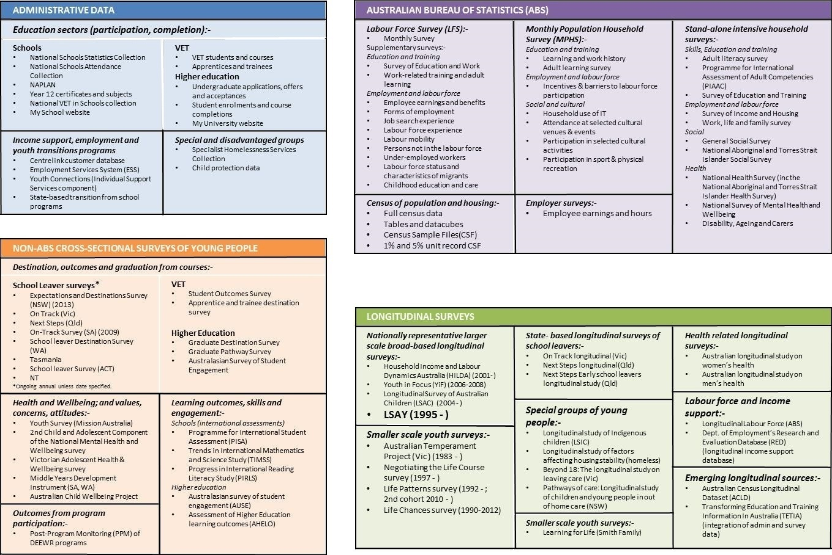

**Administrative data**

* Schools
  + National Schools Statistics Collection
  + National Schools Attendance Collection
  + NAPLAN
  + Year 12 certificates and subjects
  + National VET in Schools collection
  + My School website
* VET
  + VET students and courses
  + Apprentices and trainees
* Higher education
  + Undergraduate applications, offers and acceptances
  + Student enrolments and course completions
  + My University website
* Income support, employment and youth transitions programs
  + Centrelink customer database
  + Employment Service System (ESS)
  + Youth Connections (Individual Support Services component)
  + State-based transition from school programs
* Special and disadvantaged groups
  + Specialist Homelessness Services collection
  + Child protection data

**Australian Bureau of Statistics (ABS)**

* Labour Force Survey (LFS)
  + Monthly Survey
* Supplementary surveys
  + Education and training
    - Survey of Education and Work
    - Work-related training and adult learning
  + Employment and labour force
    - Employee earnings and benefits
    - Forms of employment
    - Job search experience
    - Labour Force experience
    - Labour mobility
    - Persons not in the labour force
    - Under-employed workers
    - Labour force status and characteristics of migrants
    - Childhood education and care
* Census of Population and Housing
  + Full census data
  + Tables and datacubes
  + Census sample files (CSF)
  + 1% and 5% unit record CSF
* Monthly Population Household Survey (MPHS)
  + Education and training
    - Learning and work history
    - Adult learning survey
  + Employment and labour force
    - Incentives and barriers to labour force participation
  + Social and cultural
    - Household use of IT
    - Attendance at selected cultural venues and events
    - Participation in selected cultural activities
    - Participation in sport and physical recreation
* Employer surveys
  + Employee earnings and hours
* Stand-alone intensive household surveys
  + Skills, education and training
    - Adult literacy survey
    - Programme for International Assessment of Adult Competencies (PIAAC)
    - Survey of education and training
  + Employment and labour force
    - Survey of Income and Housing
    - Work, life and family survey
  + Social
    - General social survey
    - National Aboriginal and Torres Strait Islander Social Survey
  + Health
    - National Health Survey (including the National Aboriginal and Torres Strait Islander Health Survey)
    - National Survey of Mental Health and Wellbeing
    - Disability, Ageing and Carers

**Non-ABS cross-sectional surveys of young people**

* Destination, outcomes and graduation from courses
  + School leaver surveys (ongoing annual unless date specified)
    - Expectations and Destinations Survey (NSW) (2013)
    - On Track (Vic)
    - Next Steps (Qld)
    - On-Track Survey (SA) (2009)
    - School Leaver Destination Survey (WA)
    - Tasmania
    - School Leaver Survey (ACT)
    - NT
  + VET
    - Student Outcomes Survey
    - Apprentice and trainee destination survey
  + Higher Education
    - Graduate Destination Survey
    - Graduate Pathway Survey
    - Australasian Survey of Student Engagement
* Health and wellbeing; and values, concerns, attitudes
  + Youth Survey (Mission Australia)
  + 2nd Child and Adolescent Component of the National Mental Health and Wellbeing Survey
  + Victorian Adolescent Health and Wellbeing Survey
  + Middle years Development Instrument (SA, WA)
  + Australian Child Wellbeing Project
* Outcomes from program participation
  + Post-Program Monitoring (PPM) of DEEWR programs
* Learning outcomes, skills and engagement
  + Schools (international assessments)
    - Programme for International Student Assessment (PISA)
    - Trends in International Mathematics and Science Study (TiMSS)
    - Progress in International Reading Literacy Study (PiRLS)
  + Higher education
    - Australasian Survey of Student Engagement (AUSE)
    - Assessment of Higher Education Learning Outcomes (AHELO)

**Longitudinal surveys**

* Nationally representative larger scale broad-based longitudinal surveys
  + Household Income and Labour Dynamics in Australia (HILDA) (2001-)
  + Youth in Focus (YIF) (2006-2008)
  + Longitudinal Study of Australian Children (LSAC) (2004-)
  + LSAY (1995-)
* Smaller scale youth surveys
  + Australian Temperament Project (Vic) (1983-)
  + Negotiating the Life Course survey (1997-)
  + Life Patterns survey (1992-; 2nd cohort 2010-)
  + Life Chances survey (1990-2012)
  + Learning for Life (Smith Family)
* State-based longitudinal surveys of school leavers
  + On Track longitudinal (Vic)
  + Next Steps longitudinal (Qld)
  + Next Steps Early School Leavers longitudinal study (Qld)
* Special groups of young people
  + Longitudinal Study of Indigenous Children (LSIC)
  + Longitudinal study of factors affecting housing stability (homeless)
  + Beyond 18: The longitudinal study on leaving care (Vic)
  + Pathways of care: Longitudinal study of children and young people in out-of-home care (NSW)
* Health related longitudinal surveys
  + Australian longitudinal study on women’s health
  + Australian longitudinal study on men’s health
* Labour force and income support
  + Longitudinal Labour Force (ABS)
  + Department of Employment’s Research and Evaluation Database (RED) (longitudinal income support database)
* Emerging longitudinal sources
  + Australian Census Longitudinal Dataset (ACLD)
  + Transforming Education and Training Information in Australia (TETIA) (integration of admin and survey data)

during the period that individuals stay with the provider. Administrative data from education providers is an important annual source of information for enrolments and graduates/course completers in the schools, VET and higher education sectors. In the VET sector completions data provides data on both module completers and course graduates and in the school sector completions data commonly refers to information for Year 12 certificate recipients from the secondary boards of studies. These data are an important component of the data in the *My School*, *My Skills* and *My University* websites that provide valuable information about education institutions that young people attend.

Other sources of administrative data are:

* Australian Government labour market and education and training programs, such as assistance provided through Job Services Australia (JSA), Disability Employment Services (DES) and Youth Connections, and in similar state and territory programs;
* Income support programs such as Youth Allowance, Austudy and ABSTUDY;
* Government programs targeting disadvantaged groups, such as the homeless and in out-of-home care.

The type of information collected for administrative purposes tends to reflect the unique nature of the program or institution, its activities and eligibility rules:

* Employment assistance programs include information on the labour market characteristics of participants, the duration of unemployment and assistance received at various stages.
* In the higher education and VET sectors course information includes qualification level and field of study.
* In the school sector information about studies undertaken includes performance in the key areas of literacy and numeracy in Years 3, 5, 7 and 9 from NAPLAN; subjects studied (in the senior secondary years); and participation in School-Based apprenticeships and other VET in Schools programs (which are also reported by qualification level and field of study, in line with other VET courses).

Because data is specific to each program, institution or activity, data concepts and definitions differ widely as does the type and scope of data collected. Administrative data are highly detailed and specific and are not generally designed to connect with datasets for other aspects of youth transitions, sectors or jurisdictions. Although data matching and individual identifiers are now more common, the ability to link across administrative systems and/or administrative systems and surveys is limited by privacy and feasibility concerns. Administrative data is generally released to the broader research community in restricted and aggregated form.

#### ABS surveys and the census

The ABS provides a major source of point in time information on youth and their activities, and how these may compare with other age groups through the Labour Force Survey (LFS) and a range of associated household surveys, some employer-based surveys as well as the Census of Population and Housing.

The LFS provides monthly estimates of employment, unemployment, labour force participation, job search and, for 15-24 year olds only, full-time education participation. Participants (aged 15 years and over) stay in the survey for eight months. In any one month about 8,000 participants are aged 15-24 years.

In several months of the year participants in the LFS are asked additional questions as part of a Labour Supplementary Survey (LSS). All those who are in their final month in the LFS are eligible to be selected for the Multi-Purpose Household Survey (MPHS), which collects information on up to 5 or 6 topics from the month’s outgoing group over a 12 months period. LSS topics are labour-related while those for the MPHS are more varied and based on consultation with the stakeholder community.

In both cases certain important topics are repeated on a regular basis (around annually or biennially). Regular topics in the LSS of relevance to youth transitions include education and work, job search experience, labour mobility, forms of employment, employee earnings, under-employed workers, and people not in the labour force. Two of the relevant regular topics in the MPHS are incentives and barriers to labour force participation, and participation in sport and recreation. The length of interview for the LSS and for each of the MPHS topics is relatively short (5 minutes or so). The interview is generally conducted under the Any Responsible Adult arrangements, under which one adult provides information for the whole household.

Among the LSS and MPHS surveys the supplementary Survey of Education and Work (SEW) is the most significant for youth transitions. The survey comprises around 7,000 young people aged 15-24 years and is undertaken in May of each year. Among other indicators, this information enables the assessment of the degree of engagement of young people in work or study, the destination of school leavers some six months after leaving school (by school Year completed), educational attainment by age, labour force outcomes by highest educational attainment, apprenticeship and traineeship commencements, and unmet demand for education courses and programs. These can be reported for the same socio-economic and demographic characteristics as are available in the LFS and to other LSS and MPHS surveys, namely sex, age, Indigenous status, marital status, household relationship, birthplace and year of arrival in Australia, and geographic location (state/territory and region of usual residence).

ABS also conducts a program of stand-alone household surveys on important and enduring themes which are broad ranging in scope and delve into issues at greater depth than is possible for the surveys associated with the LFS. These are conducted using personal interviews (most often by telephone) which last around 20 minutes on average. Those of significance to youth transitions may be grouped into four categories: skills, education and training; labour force and earnings; income from all sources; social matters; and health. The survey samples vary in the number of young people included. For example, the General Social Survey has included around 2,000 young people aged 18-24 years and the Survey of Education and Training around 4,000 15-24 year olds. These surveys tend to be repeated every 3 to 5 years. The information collected is considerable, covering a range of aspects of the survey theme in generally good detail.

Both these stand-alone surveys, the LLS and the MPHS, are generally released in unit record data files, enhancing their value for multivariate analyses.

The population census, conducted every five years, collects a relatively limited but important set of data for all individuals and households in Australia. The data includes demographic information, educational attainment and participation, labour force status, employment, income and place of residence. Census data is especially important as a source of information for small areas, or small populations that are dispersed geographically or hard to contact.

In addition to aggregate data, unit records are available for each of the censuses since 1981 containing a random 1% of the census population. From the 2006 census a 5% dataset is also available which provides greater detail for variables, but this can only be analysed in an ABS secure environment. The Australian Census Longitudinal Dataset (ACLD) brings together data from the 2006 and 2011 Censuses brings together a 5% random sample from the 2006 Census with corresponding records from the 2011 Census using data linkage techniques without name and address.

#### Non ABS cross-sectional surveys

Cross-sectional surveys other than those conducted by ABS fall into four groupings:

* Regular international student assessments, including the OECD’s PISA and the proposed Assessment of Higher Education Learning Outcomes (AHELO) as well as TIMSS (Trends in International Mathematics and Science) and PIRLS (Progress in International Reading Literacy Study). These collect data using internationally comparable measure of achievement in various domains of learning at different stages of education. In the higher education sector in Australia there is also a survey of student engagement with their university studies;
* Destination surveys for those leaving each sector of education:
* In the school sector, most states currently collect data annually on school leaver outcomes. Western Australia has conducted destination surveys since 1999, Victoria since 2003 and Queensland since 2005. Generally these surveys are conducted some six months after the end of the school year and cover all who left school in the previous year that also enable school level statistics to assist in future planning. Information collected differs across jurisdictions reflecting the range of purposes in conducting them e.g. some require data to enable jurisdictions to identify school leavers at risk (see Appendix 7 in the *Support Document*). They generally have a larger sample size than either the LSAY or the ABS Survey of Education and Work sample for that state/territory.
* In the VET sector, NCVER conducts an annual Student Outcomes Survey, which focuses on graduates’ and module-only completers’ employment outcomes and satisfaction with VET, further study patterns and reasons for not continuing with the training. The NCVER has also conducted a similar survey tailored specifically for apprentices and trainees.
* In the higher education sector, Graduate Careers Australia conducts annually a suite of surveys (under the name of the Australian Graduate Survey) that examine new graduates’ activities four months after completing their higher education degree and their higher education experience.
* Post program monitoring surveys of employment and training outcomes for those receiving employment assistance through Job Services Australia (JSA), Disability Employment Services (DES) and Indigenous Employment Policy (IEP). Information is collected on job seekers’ labour market and educational status and their perceptions of the assistance they received.
* A group of surveys about youth health, behaviours, wellbeing, concerns and values. Surveys of health and wellbeing are conducted relatively infrequently, roughly every 4 to 5 years. During 2013 four important health and wellbeing surveys for young people were being developed or were in the field. These covered:
* the health and well-being of over 6,000 Australian children and adolescents aged 4-17 years (*Young Minds Matter*) was in the field in 2013-14.
* adolescent health and wellbeing among children in Years 7 to 11 in Victoria (previously conducted in 2009).
* health, wellbeing and development in the middle years (ages 8 to 14). Two new surveys were being developed, one in SA and WA (piloted in 2013) with a separate national survey (due to be conducted in 2014).

#### Longitudinal surveys

Excluding LSAY, in 2013 there were twenty one other significant longitudinal surveys in Australia that in part or whole involved young people aged 15-25 and that explored youth transitions or aspects of it. Four of these had recently reached the end of their data collection. On the other hand, five commenced since 2012.

The vast majority of these surveys have or are being conducted for the Commonwealth and state and territory governments. Of the remainder, three surveys are conducted by universities and research institutions on their own behalf with funding mainly from the Australian Research council (ARC) and one survey has been conducted by a not-for-profit organisation (Brotherhood of St Laurence) with financial support from a broad range of sources over time.

The surveys differ significantly in a number of ways, such as study focus, participants, sample size, length of follow-up, geographic representation, and data collected. Those most like LSAY are three other nationally representative larger scale longitudinal surveys:

* The Youth in Focus (YiF) survey was undertaken to help understand the ways in which economic and social disadvantage are transferred across generations. It collected data for two waves only (2006 and 2008) with a sample of 18 year olds drawn from Centrelink records.
* The Longitudinal Survey of Australian Children (LSAC) is providing a comprehensive national picture of the current generation of Australian children as they grow up. It commenced in 2004 with two cohorts: one of 4-5 year olds and another of 0-1 year olds and plans to follow them through life.
* The Household, Income and Labour Dynamics in Australia (HILDA) survey is supporting research in the areas of family and household dynamics, income and welfare dynamics and labour market dynamics. Unlike the previous two surveys, HILDA is a general purpose, ongoing household survey covering those aged 15 and over.

These surveys differ in many details including survey design and purpose, sample sizes and selection, frequency of data collection and of commencement of new cohorts (see Appendix 2 in the *Support Document* for a fuller comparison).

The remaining longitudinal surveys can usefully be grouped into the following categories:

* Smaller scale youth longitudinal studies, similar in many respects to the nationally representative surveys except that they are smaller in size and/or scope and/or geographic coverage or are more qualitative in the type of data they collect.
* State-based longitudinal surveys of school leavers in Victoria and Queensland, which collect information about young people’s activities over a longer time period than the first post school year (5 years for Victoria and to age 24 for Queensland). The size of cohorts varies as does the specific data which is collected (see Appendix 8 in the *Support Document*).
* Longitudinal surveys of specific groups of young people or children, such as Indigenous children, the homeless or those who are in the child protection system. All of these collect information on schooling, education and labour market engagement where appropriate, in addition to information relevant to the circumstances of the young people who are the survey’s focus.
* Related longitudinal studies of the health of men and women and the factors that affect it. The information may also be able to be used to explore the impact of health on other aspects of life, such as education and employment.
* Two longitudinal data sources cover labour force and income support of the population, including young people. The ABS Labour Force Longitudinal survey follows LFS participants for 8 consecutive months and includes data collected through the LFS on some 1,500 young people. The Department of Employment’s Research and Evaluation Database (RED) is based on data from Centrelink and the Australian Government’s Employment Services system. It contains the income support history of all income support recipients for at least one day since 1 July 1998. Young people are captured mainly as a result of receiving Youth Allowance and NewStart.

Two further significant developments in the field of longitudinal data are:

* The Commonwealth and states and territories are developing a strategy for integrating administrative and survey data on early childhood, schooling, VET and higher education so as to enable longitudinal and outcome focused analysis of education. This strategy has a timeframe of five to 10 years. The project, Transforming Education and Training Information in Australia (TETIA), is focused on agencies, education jurisdictions and other relevant institutions working together to develop better cross-sectoral education and training data. A number of related studies are already in train and the strategy is due to be completed in 2014. This project has evolved from the previous work by the ABS on the Australian Longitudinal Learning Database (ALLD).
* The ABS has been developing the Australian Census Longitudinal Database (ACLD), which links a 5% sample of the 2006 census with their counterparts in the 2011 and subsequent Censuses, by using probabilistic techniques. The first version of this has been released. This will make the ACLD a longitudinal dataset, with new records added every five years. The ACLD will be available in unit record format for detailed analysis.

Both of these initiatives have considerable potential for adding to the information about young people’s transition experience. However, TETIA will be limited to people’s education experience while the ACLD will only provide information five years apart.

### Strengths and weaknesses of different data types

The different types of data discussed above - administrative data, cross-sectional surveys and longitudinal surveys – differ in the kind of information and insights they can provide for monitoring and describing youth transitions and for gaining a comprehensive and deep understanding of the transition process and its outcomes (see Table 3).

Administrative sources of data are an important source of information on youth transitions. They contribute to descriptions of young people’s activities and engagement at a point in time (i.e. snapshot) and changes over time in these snapshots. Their particular advantages lie in the depth and quality of data as they cover all participants or recipients. But this is also a source of disadvantage in that the scope of data is generally limited to the purpose for which the data is collected, meaning that they provide a picture of only one part of the transition process.

Cross-sectional surveys such as those conducted by ABS (including the population census) provide an impressive body of data for the analysis of youth circumstances, how these change over time, how they compare across different groups of young people and how young people compare with other age groups. These data are often the first source used by researchers and policy makers for describing the ‘state of youth’ and ‘how young people are faring’. Data can be collected and released relatively quickly and covers a broad range of topics relevant to youth outcomes. However, cross-sectional data are generally limited in their capacity to support more sophisticated analysis of pathways over time and the influence of background characteristics and experiences in this.

In comparison to the non-longitudinal data sources that are especially good at providing snapshots of groups of young people, longitudinal surveys have comparative advantages in other areas. In particular, by capturing detailed and precise data on individuals’ histories (including of their attitudes and perceptions), longitudinal data makes possible more sophisticated analysis of pathways over time as well as of the factors that shape youth outcomes:

* Unlike cross-sectional surveys, longitudinal surveys can capture accurate data on persistence and change in the circumstances of individuals and some phenomena can only be understood longitudinally, e.g. whether career expectations are realised, whether low skill or paid jobs are a springboard to future more established employment, the effects of school achievement on labour market earnings.
* Longitudinal data enable a clearer separation between the impact on youth transitions of ageing (e.g. adolescent development), time period specific events (e.g. an economic downturn) and cohort characteristics (e.g. school completion rates).
* Longitudinal data can help to understand the size and direction of the different causal influences that contribute to a particular pathway or outcome. While randomised control trials are often regarded as the ‘gold standard’ for demonstrating causal relationships in social science research, these are usually impractical or unethical to run. While longitudinal data cannot provide conclusive evidence of causality, they can satisfy the requirements for establishing causality better than cross-sectional data (Free 2004, p 11).
* Longitudinal data, which have cross-sectional information across time, hold significant technical advantages over cross-sectional data with less detailed and/or less reliable historical information. By building on rich background and individual data, a variety of sophisticated statistical modelling techniques have been developed to deal with omitted variables (e.g. the innate ability of students) which cannot be measured directly (Schneider et al 2007; Schlotter et al 2010).

1. Pros and cons of different data types in understanding youth transitions

| Data type | Advantages | Disadvantages |
| --- | --- | --- |
| Administrative data sources | * Full enumeration of participants (which enables reliable disaggregation by characteristics). * High quality course or program information since sourced from provider records. * Continuous data collection enables monitoring of changes over time with minimal delay. | * Narrowness in scope, focusing only on particular aspects of transitions i.e. partial indicators of transitions only are possible (such as the proportion of young people completing Year 12). * A range of important characteristics of participants is often missing. * Confidentiality restrictions on access to unit record information (micro-data). |
| Cross-sectional surveys and the population censuses | * Covers a broad range of issues of relevance to youth transitions. * Available on a regular (and often frequent eg annual) basis that enables tracking of broad youth population trends. * ABS Survey of Education and Work is large enough to monitor annually the education and labour market status of the youth population as a whole and some subsets, e.g. school-leavers. * ABS surveys in particular have high response rates as they are essentially compulsory. * The ABS 5-yearly census is an important source of information about the size and key characteristics of some small populations (e.g. homeless); and for basic data at regional and small area level. * Most data relevant to youth transitions are available as unit record data (microdata), albeit with some restrictions. | * Limitations in the type of historical data that can be collected accurately retrospectively given respondent recall difficulties for events that occurred more than about one year earlier. This affects data about, eg, past activities, experiences, circumstances and attitudes which are crucial for pathway analysis. * Aside from this, it is not generally feasible to collect the range and depth of information necessary for more insightful pathways/ transition analysis in one (point-in-time) cross-sectional survey. Hence in practice cross-sectional surveys tend to cover a particular theme in detail or several topics more sparingly which are capable of providing partial and/or broad indicators only. * In terms of existing cross-sectional and census data, coverage of some groups of young people in the surveys is patchy (e.g. some disadvantaged groups and those aged under 15 in LFS based surveys) while in the census individuals from especially disadvantaged groups are most often not identified as such. * Demographic information for young people generally does not include parental background (education and employment in particular) and/or SES. A proxy available in some surveys is the household’s SEIFA index |
| Longitudinal surveys | * Enables better descriptions and understanding of pathways because data is available for the same individuals over time. * Supports more sophisticated analysis of the dynamics of youth transitions including: * analysis of whether the same individuals persist in particular states over time or whether different individuals are involved, e.g. the persistence of unemployment * identification of causality to the extent possible by analysing the time sequence of events for individuals and the influence of background and experiences in shaping this. * Can contribute information to snapshots of youth populations because it may collect information which is not available from administrative and cross-sectional surveys, e.g. parental and family background and earlier life experiences. | * Greater complexity and cost of data collection. * Longer time periods are required to collect data, process and analyse so that results are less timely than cross-sectional or administrative data sources. * Larger and more complex datasets can be difficult to analyse. * Susceptible to loss of sample size through attrition, which may bias results if attrition rates are higher among some groups than others and attrition is not addressed through sample maintenance and re-weighting strategies |

By its nature, however, longitudinal data is slower and more costly to collect and analyse and subject to the risk of significant sample attrition.

Compared to other Australian longitudinal surveys covering children and young people in whole or part, LSAY has several distinctive features which make it particularly useful as a source of data on youth transitions:

* Sample size in LSAY is relatively large and is designed to be nationally representative - Each new cohort in LSAY has comprised around 14,000 young people in Year 9 or 15 year olds (from 2003 onwards). This is much larger than the cohort size in YiF (around 4,000), LSAC (around 5,000 in each cohort) and HILDA (about 2,400 15-24 year olds which equates to about 250 in each single year of age). Larger cohort sizes allow greater disaggregation of transition experiences and improve the capacity to analyse more reliably the experiences of smaller groups of policy interest and/or to account for them with greater accuracy in regression analyses. These smaller groups include disadvantaged and at risk young people. Because of the importance of reporting on Indigenous young people, they have been oversampled in LSAY (by a factor of around three).
* Frequency of new cohorts - Since LSAY was linked with PISA in 2003, a new cohort has been introduced into LSAY every three years although there was no new cohort in 2012. By contrast, LSAC is still following the two cohorts that it began with 10 years ago and HILDA is tracking the same group of young people that commenced in 2001 but children from the households in the survey join HILDA as independent participants when they attain age 15 which helps to introduce new cohorts into the survey. There was also a top up of the original sample in Wave 11. YiF is no longer active after following the original cohort for two waves. New cohorts enable the exploration of changes in the transition experience in light of changes in the social, economic, educational and labour market landscape that young people face. A frequency of around three years between cohorts in LSAY has meant that LSAY in every calendar year had young people still at school, in tertiary education (university and VET) and in the post tertiary stage of their life, which provided opportunities for observing the impact of events and policies on young people in each of these key stages of transition.
* LSAY incorporates literacy and numeracy achievement data from PISA - LSAY has included data on literacy and numeracy achievement for each of its cohorts based on rigorous tests. These were designed and conducted by the ACER for cohorts up to the one introduced in 1998. Since 2003 LSAY has tracked the cohort of young people who undertook the PISA tests and the PISA-based literacy and numeracy achievements are incorporated into the information about individuals in the LSAY database. Neither YiF nor HILDA contain assessed literacy and numeracy achievement, although they asked participants to self-assess their general competencies in these areas. LSAC incorporates NAPLAN results for the participants in the study. PISA and NAPLAN assessments are different: NAPLAN is informed by the National Statements of Learning in English and mathematics that underpin the state and territory learning frameworks; while PISA assessments are based around internationally developed frameworks and measure the use and application of language and mathematics in people’s lives. Also, PISA assessments provide a wealth of contextual information about learning, such as the educational resources accessible by the students, the educational attainment of their parents, their attitudes towards and beliefs about schooling and themselves as learners (Thomson 2010). The availability of PISA in LSAY enables comparisons of transition results from LSAY with those from other countries which use PISA cohorts as the basis of longitudinal surveys of young people. LSAC also as incorporates a number of other achievement and cognitive ability tests most of which are used internationally and enable cross-country comparisons. It also has information about school resources, parents’ educational attainment and attitudes from MySchool data.
* Focus on the transition from school into further education or employment - LSAY has had a strong focus on these transitions in the data collected. LSAY was designed from the start to help better understand youth transitions, especially the progression from school to further education and training or work and settling into satisfactory ongoing employment and careers. For this reason LSAY has collected detailed education and labour force information each year to enable the construction of pathways and histories of experiences. In addition, LSAY has collected related contextual and explanatory information on aspirations and intentions, reasons for actions taken, and attitudes to education, work and careers. This strong focus on education and employment transitions differentiates to some extent LSAY from both YiF and HILDA, both of which also collect information on transition related matters. LSAC cannot be compared at this stage as, at the last wave, participants were still in the middle years of schooling, but it is intended to collect this data as the cohorts age.
* LSAY has available detailed information about school attended (at age 15) and about the participants’ peers - PISA 2009 participants have come from a stratified sample of about 350 schools, with about 50 students drawn from each school. By using information from students from the one school researchers have derived indicators of, for example, school SES, performance and aspirations and similarly for student peers indicators. Further, as part of the PISA survey, information is collected also from school principals about the school environment and its policies and practices. This provides data for analysing the impact of school and peer characteristics on individuals’ outcomes. HILDA and YiF have not collected school and peer information of this type. Indeed, because their sample of participants is not based on schools and group of students within schools, collecting this type of information would have been onerous and impractical. LSAC collects school information through a teacher questionnaire in each wave, which covers, among other things, student personality and behaviour, school characteristics and parental engagement. As well linkage to NAPLAN/MySchool data makes available a wide range of contextual data on the school.
* The first and the most recent cohorts of LSAY are separated by 31 years, which provides LSAY with information about young people’s transition experiences over a period of more than three decades. The first LSAY cohort was for those aged 17 in 1978, and the most recent cohort is for those who were aged 15 years in 2009. In total, there have been 12 cohorts in LSAY since the start in 1978: eleven “standard” cohorts and one cohort of 16-19 year olds that commenced in 1989 and was augmented in each subsequent year up to 1994 by the addition of a sample of 16 year olds. The other three longitudinal surveys have had fewer cohorts and do not extend to periods before the 2000s. HILDA commenced in 2001 and this provides scope for analysis of cohorts of young people over the last 12 years, albeit with smallish single age cohorts. LSAC is tracking two cohorts separated by 4-5 years and YiF had only one cohort.

### Youth longitudinal surveys in other countries

Other countries have also invested in collecting and analysing longitudinal data about youth transitions over an extended period of time. Table 4 summarises a selection of large longitudinal surveys which cover in whole or part cohorts of young people of a similar age to those in LSAY.

These surveys differ widely in their scope and design. The group that is closest to LSAY includes the Canadian Youth in Transition Survey (YITS), the Swiss Transitions from Education to Employment survey (TREE) and the Longitudinal Survey of Young People in England (LSYPE). All feature a sample of young people that is drawn from schools and, for YITS and TREE, starts with PISA testing of 15 year olds. However, they differ in many other ways with LSAY generally featuring a smaller interval between cohorts and a smaller cohort (although this needs to be considered in relation to population size and available funding). More recently, the US has commenced a High School Longitudinal Study, which surveys a nationally representative sample of 23,000+ 9th graders from 944 schools in 2009. Students will be followed throughout secondary and postsecondary years with surveys gathering data from students, their parents, math and science teachers, school administrators and school counsellors. The focus of the study is students' trajectories from the beginning of high school into postsecondary education, the workforce, and beyond.

Another group of surveys cover both children and youth, either by following a single cohort through a lengthy period of time (55 years in the case of the British 1958 National Child Development Study) or by surveying a staggered cohort (e.g. the Canadian National Longitudinal Survey of Children and Youth and the Swiss Survey of Children and Youth). The latter group are more similar to LSAC in conception and design.

1. Youth longitudinal surveys in other countries

|  |  |  |  |  |
| --- | --- | --- | --- | --- |
| Country | Survey | Data scope | Age range/years | Other |
| Canada | **National Longitudinal Survey of Children and Youth (NLSCY)** | * Child health, physical development, learning and behaviour as well as social environment (family, friends, schools and communities). | * Began 1994 when sample aged 0 to 11. * Following until age 25. | * Sample 35,795 in Wave 9. * Biennial collection (last in 2009) |
| Canada | **Youth in Transition Survey (YITS)** | * Major transitions in young people's lives, particularly with respect to education, training and work. | * PISA students in 2000 followed to age 25. | * School based sample of 38,000 in Wave 1. * Biennial collection. * Not continuing. |
| Germany | **German National Educational Panel Study (NEPS)** | * Educational trajectories and outcomes, basic skills, non-cognitive competencies, academic self-concept, interests, educational and training goals, vocational training plans, social networks, and leisure activities. | * Began 2010 with six cohorts from newborns to adults. * Continuing to 2019. | * School based sample. * Starting sample of 16,000 in Grade 9 for school to work component. |
| Switzerland | **Transitions from Education to Employment (TREE)** | * Transitions through school & education to tertiary study and employment, social networks, critical life events, personal traits and health. | * PISA group in 2000 followed to age 30. | * Annual interview to age 23. * Starting sample 6,000. |
| Switzerland | **Swiss Survey of Children and Youth** | * Transition to labour market and education, socialization (incl. responsibility, achievement, bond with parents; delinquency and problem behaviours). | * Began 2006 with 2 groups aged 6 & 15 * Following to age 21. | * Total sample around 3,000. * Collected every 1-2 years. |
| UK | **British Cohort Study** | * 16-17 yrs age group (1986) – education, health, family, friends, activities, attitudes * 26-27 yrs age group (1996) – education, attitudes, employment, family, health | * Cohort born in 1970 followed to age 39. | * Sample about 17,000 at start. * Collected about every 5-10 years. |
| UK | **Longitudinal Survey of Young People in England (LSYPE)** | * Transitions from secondary and tertiary education or training to economic roles in early adulthood. Focus on ability to monitor and evaluate policy. | * Began 2004 with group aged 13/14 and followed to age 20. * New cohort 2013. | * Sample 16,000 in Wave 1. * School based sample, no PISA link. * Annual collection. |
| USA | **National Longitudinal Survey of Youth (NLSY)** | * Transition from school to work and adulthood, parental influence, family responsibilities, socioeconomic status, work-related attitudes and aspirations and health problems. | * 1st cohort aged 14 to 22 in 1979. * 2nd cohort aged 12-16 in 1997. | * Continuing – cohorts followed well into adulthood. |
| USA | **Panel Study on Income Dynamics (PSID) – Transition to adulthood** | * Cognitive and behavioural assessments, out of school activities, family processes, schooling, transitions to education and work, family formation. | * Follows children in PSID into adulthood. * Ongoing. | * Commenced 2005. |

Source: Princeton (2009)

A third group, which includes the USA Panel Study on Income Dynamics (PSID) is analogous to HILDA in that it is a general household longitudinal study that follows children in member households into their transition to adulthood, collecting comprehensive data on this sub-sample in the process.

This points to the wide range of designs and specifications for longitudinal surveys which are developed to address policy or research issues within each country’s context and circumstances, including available resources.

## 2.2 The use and impact of LSAY

The value of LSAY depends critically on the extent to which it is used by policy-makers and researchers and has an impact. Accordingly, assessing the actual use and impact of LSAY in recent years is a key part of the terms of reference for this review. This section considers this issue drawing on:

* in-depth interviews with a small number of key stakeholders across a broad range of users and stakeholder groups including Australian and State government departments, the OECD, researchers and non-government organisations;
* a survey of a range of different LSAY users examining the use and usefulness of data and research;
* an analysis of selected report downloads and citations in policy and research documents; and
* selected case studies of where LSAY has made a direct and significant contribution to policy and research on youth transitions.

### Stakeholder interviews

The overall view expressed by stakeholders was that the LSAY data was of national significance and should be preserved and continued in the future, but that its potential importance was not matched by the actual value derived from it at present. A variety of views were expressed about how more of this potential could be realised through changes to the design of the survey, the type of data collected, reducing attrition and ensuring that commissioned research serves the needs of a wide audience and is published in a timely way.

LSAY was seen as existing in an increasingly contested landscape of data bearing on the processes and outcomes of schooling, education and training and employment. In the schools area in particular it was seen as less essential with the emergence of new sources of data such as NAPLAN providing a more frequent and comprehensive source for analysis. The value of a longitudinal survey which enables analysis of youth pathways and outcomes across educational stages and the transition to employment and adulthood was widely acknowledged, albeit that for many stakeholders the highest priority is not these overall outcomes, but a sub-set that reflects their immediate responsibilities.

For Australian Government agencies the usefulness of LSAY depends largely on the extent of the overlap between agency’s policy responsibility and the areas in which LSAY collects data. Poor transitions to adulthood and their consequences, especially among disadvantaged youth, are seen as remaining an important policy issue in a changing economy. Keeping up with social changes and what decisions young people are making in light of these is seen as an important challenge for LSAY to retain and build its relevance. Australian Government agencies are major users of other data sources such as ABS surveys or HILDA as well as their own administrative databases. However, the complementary value of a longitudinal survey that is able to track individuals beyond their interactions with specific institutions or programs is recognised.

Among state government departments with responsibilities in different aspects of education, training and employment there were a range of views about the value of LSAY. Some agencies with the capability to do so were active users of the LSAY datasets, drawing on the results to help validate other research or data sources, suggest lines of research using their own data and provide a national benchmark for comparative purposes. Here there was support for the continuation of LSAY balanced by concerns about attrition and the frequency of adding new cohorts. In other cases state agencies made little use of LSAY reports or data as their policy interests lay in areas that LSAY did not cover in the depth required or because better data was available from their own administrative systems, school leaver surveys or national collections that was more frequent, accessible or better met their specific needs. In some cases this is because states had invested in their own innovative data systems. Here, support for LSAY was weak and the benefits of a longitudinal survey were seen as limited at present.

An interviewee from the OECD noted that LSAY provides a significant additional data source on youth that is not available in many other countries. It provides adequate sample sizes for detailed analysis of disadvantaged youth and includes a rich tapestry of data. LSAY was regarded as particularly valuable in filling in the gaps from broader cross-sectional surveys and in following the paths of cohorts of young people.

Among researchers there was a clear view that LSAY had significant value as a source of high quality longitudinal data focused on a policy driven research agenda. Other data sources, including new synthetic longitudinal datasets based on matched administrative data, were seen as limited in their ability to accurately reflect the breadth of experience across the full youth transition through education, training and employment. Support for LSAY over an extended period of years has meant that Australia knows more about its youth than just about any other country, despite the significant investment of countries such as the USA, UK, Canada and Germany in youth longitudinal data. Challenges for LSAY were seen in keeping abreast of the changing policy environment as well as new issues facing young Australians and the consequent need to broaden the scope and research focus of LSAY to make it more useful and relevant. The growing availability of other sources of school based achievement data was also acknowledged.

Other non-government stakeholders also recognised LSAY’s value as a long-term national research data source and a large investment, but shared the view that LSAY had experienced a decline in status and value with the growth of other data sources. These groups also varied in the use they made of LSAY, with some drawing on it heavily for their own advocacy and program work while for others LSAY provides useful information, but its outputs were of marginal value compared to other sources. LSAY’s value was seen in the breadth of destinations and life outcomes covered for young people and its capacity to analyse the influence of different background factors and interventions as part of this as well as its national coverage. Challenges were identified in placing greater emphasis in analysis on the value added at different stages of youth transitions, overcoming the “deficit model” approach to youth, reducing the slowness of report release, broadening the focus of outputs and reducing perceived closeness to government.

### User survey

A range of stakeholders thought to be familiar with LSAY from governments, research organisations, education and training providers, peak bodies and others were invited to participate in a short online survey to gather views and opinions about the survey’s current setup and possible future enhancements (see Appendix B for a summary of survey questions and respondent characteristics). In particular, the survey covered familiarity with and use of LSAY. Of 207 respondents in total, 140 had used LSAY research or data at some time and these were also asked about:

* the length and frequency of use
* whether and what other data sources were used in preference to LSAY
* the importance of LSAY when last used and whether other sources could have been used as effectively
* the frequency of use and usefulness of a variety of LSAY outputs
* the most useful aspect of LSAY overall and
* strengths and weaknesses of LSAY.

The 59 respondents who had never used LSAY were asked about the reasons for this. (There were also 8 nil responses to this question).

Responses were analysed by the type of organisation in which the respondent was employed (e.g. Australian or state governments, universities or other research organisations, peak bodies, etc). The different sub-groups are indicative of the broad range of interests of LSAY users, but the views identified may not be representative due to the voluntary nature of the survey and the small numbers involved.

Overall, the survey highlights a high level of awareness and use of LSAY across different stakeholder groups and the importance of LSAY to their work. Of all respondents, 86% were very familiar or somewhat familiar with LSAY or had at least a general knowledge of what it is about and 70% reported having ever used LSAY research or data in their work. Of those who had ever used LSAY:

* 66% had been using LSAY for two years or more and 74% used LSAY at least several times a year;
* on the occasion in the last two years when LSAY information was of the most help to their work, almost two thirds regarded it as critical or very important; and
* on those occasions when LSAY was used, 49% agreed that other sources could rarely or never have been used as effectively.

#### Familiarity and use

Twenty-eight per cent of all respondents were very familiar with LSAY and 38% were somewhat familiar (Figure 2). A further 20% reported having a general knowledge of LSAY. This pattern reflects the basis on which people were invited to participate in the user survey and the lower likelihood of response from those to whom LSAY is less familiar. Respondents employed in university or other academic research organisations were most familiar with LSAY, with 70% very familiar or somewhat familiar with LSAY. Familiarity was somewhat lower for those in government (56% of those in the Australian Government and 55% for those in state and territory governments). Familiarity was also high among schools, TAFEs and other VET providers (77%) and those in non-government not-for-profit service providers (61%).

1. Familiarity with LSAY

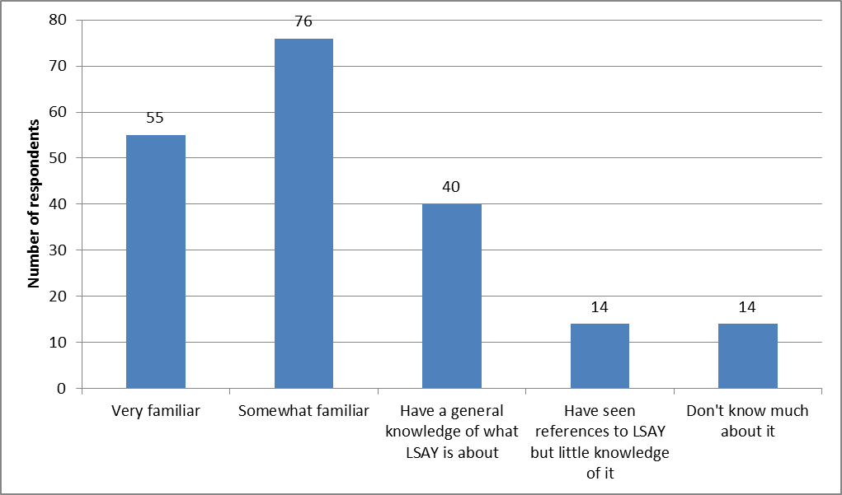

Source: LSAY User Survey 2013 Q8. Nil response = 8.

1. Ever and never used LSAY by respondent organisational type

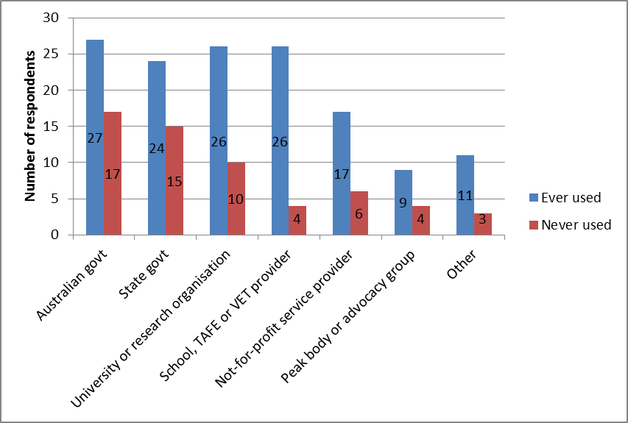

Source: LSAY User Survey 2013 Q9. Nil response = 8.

Seventy per cent of all respondents reported having used LSAY. Reported usage rates were highest among schools, TAFEs and other VET providers (80%), non-government not-for-profit service providers (74%) and university or other academic research organisations (70%). Usage rates among those in government were lower at 56% for Australian Government and 60% for state governments (Figure 3). Lower than average use among government employees may reflect the availability of administrative and other data sources that allow more specific and in depth analysis or, alternatively, a higher probability of responding to the survey even if they are not familiar with or using LSAY.

Of those who had used LSAY, the largest group had used it for more than 3 years (45%) with approximately equal proportions using it for 2-3 years (21%) and 1-2 years (19%). Only 15% had used it for less than one year. Of those who had ever used LSAY, 16% used it at least once a month and 58% used it several times a year. Frequency of use was highest among those from schools, TAFEs and other VET providers (89%) and non-government peak body or advocacy groups (78%). It was average among state governments (75%) and universities (73%) and below average among Australian Government employees (59%). For the 12 respondents who reported that they rarely used LSAY or did so less than once a year, a variety of reasons was given with the most frequent being “LSAY is limited in what it can help me with” (4 respondents).

To a significant extent familiarity with LSAY is associated with having used it as well as length and frequency of use. Of those who had used LSAY for more than a year, between 85% and 90% described themselves as very or somewhat familiar compared to 55% of those who had used LSAY for less than a year. Of those who used LSAY at least once a month, 95% were very familiar or somewhat familiar compared to 67% of those who used LSAY rarely or less than once a year. This suggests that a degree of familiarity with LSAY is a pre-condition for using it and that those who use it longer and more intensively become more familiar over time.

#### Importance of LSAY

Asked about the importance to their work of LSAY information on the occasion in the last two years when it was of most help, 18% rated LSAY as of critical importance, 46% as very important and 32% as moderately important (Figure 4). Ratings of importance were highest among those from university and other academic research organisations (77%) and from a school, TAFE or VET provider (67%) (Figure 5).

1. Importance of LSAY when of most help in last two years

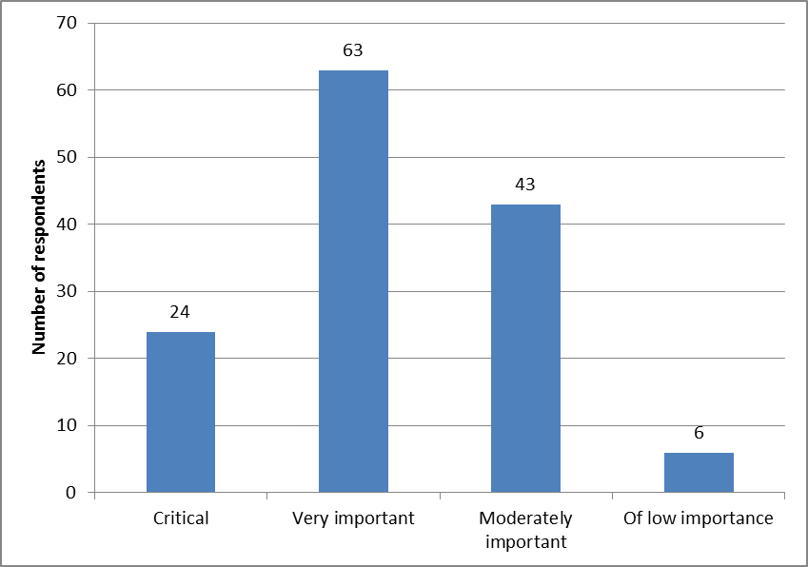

Source: LSAY User Survey 2013 Q15. Blank responses = 70.

1. Importance of LSAY by organisational type

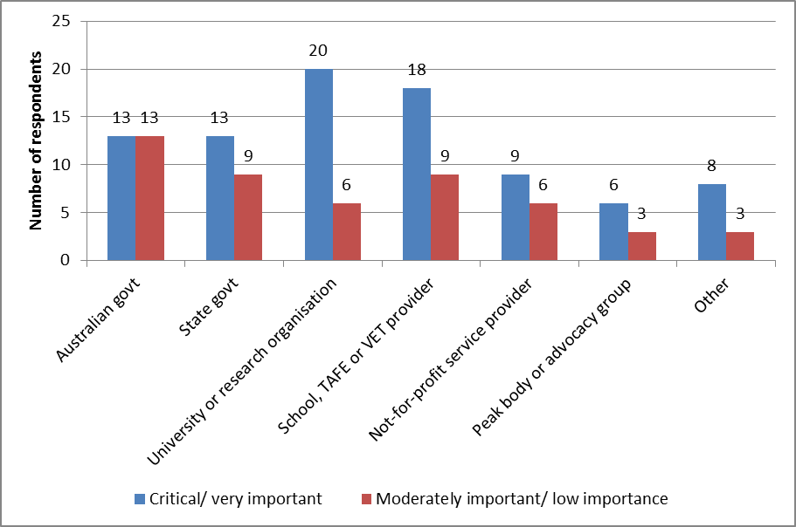

Source: LSAY User Survey 2013 Q15. Blank responses = 70.

1. Importance of LSAY for policy and research users

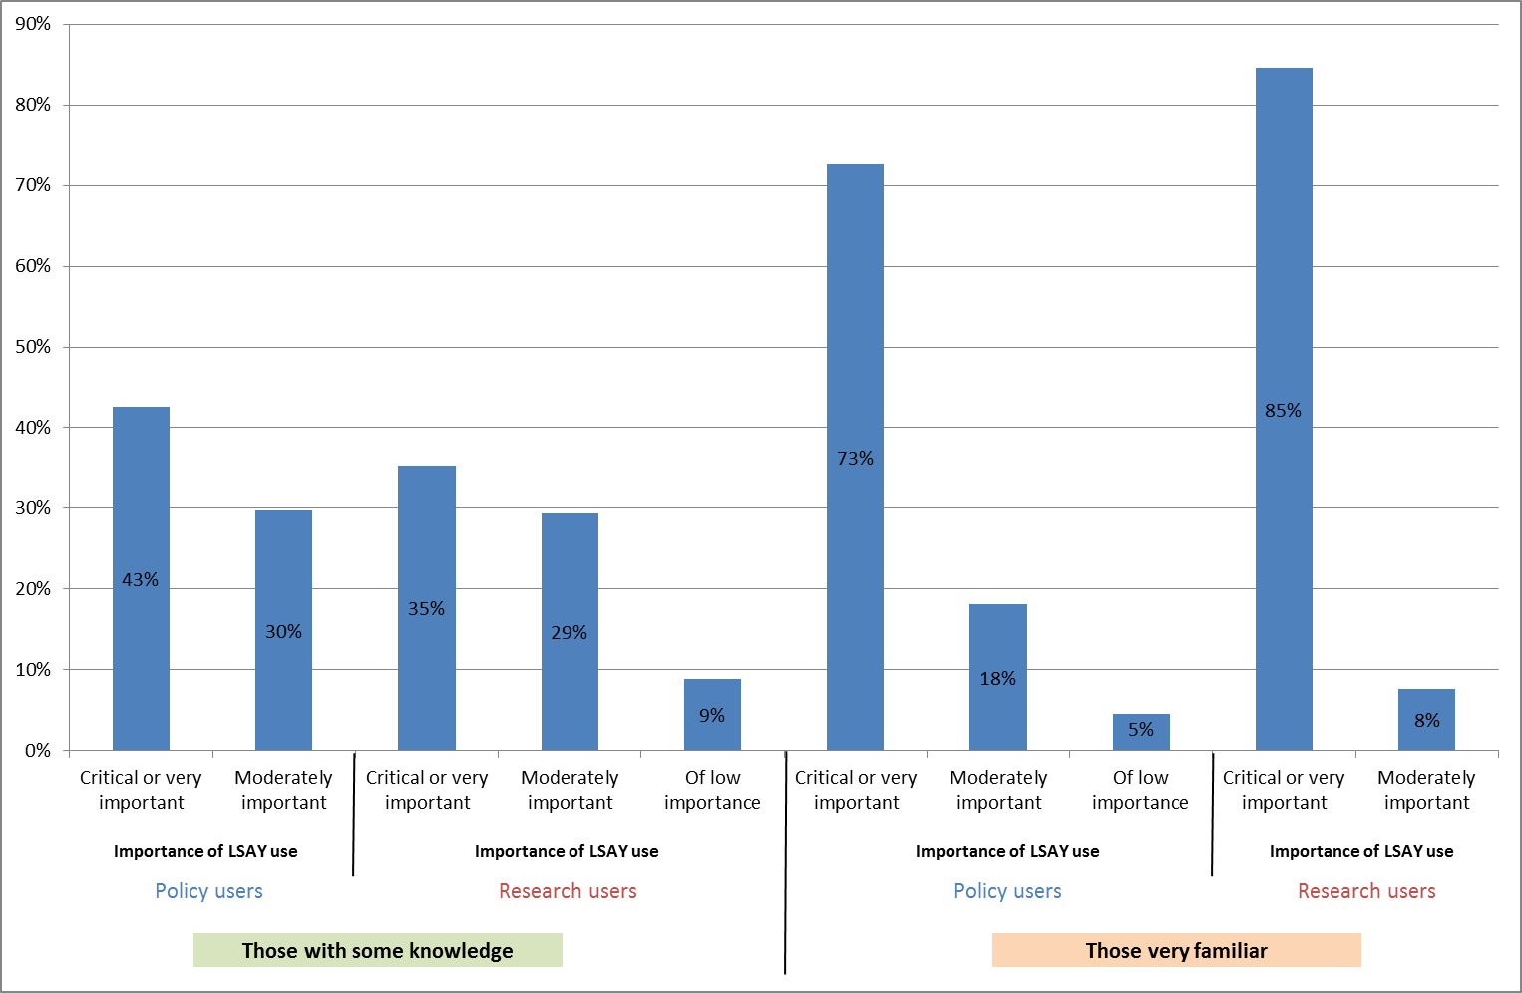

Source: LSAY User Survey 2013 Q5, Q8 and Q15. Policy users include those with policy development, executive or managerial roles. Those with some knowledge of LSAY includes those with a general knowledge or who are somewhat familiar.

LSAY was especially strongly rated as critical or very important among policy and research users who are very familiar with the survey. Figure 6 shows that 73% of users broadly classified as having a policy interest and being very familiar with LSAY rated it as critical or very important on the occasion in the last two years when LSAY information was of the most help to their work. By comparison, only 43% of policy users with some knowledge rated it as critical or very important. Among users broadly classified as having a research interest and being very familiar with LSAY, 85% regarded LSAY as critical or very important compared to 35% of those with only some knowledge.

#### LSAY and other data sources

Forty-seven per cent of those who had ever used LSAY indicated that they used other data sources in preference to LSAY (Figure 7). A preference for non-LSAY data sources was strongest among Australian Government (67%) and state government respondents (54%). The most commonly used other data sources were ABS surveys (77% of those answering yes), followed by own surveys (43%), administrative data (43%) and other longitudinal surveys (42%). Respondents from government were heavy users of ABS data (see Figure 7). Administrative data was used in preference to LSAY more by Australian Government than state government respondents, while a larger number of state government respondents reported using their own survey data. While the importance of LSAY data when last used was higher among those who reported not using other data sources in preference to it (74%), even among those who reported using other data sources in preference a majority still rated LSAY data or research as critical or very important when last used (53%).

1. Respondents using other data sources in preference to LSAY

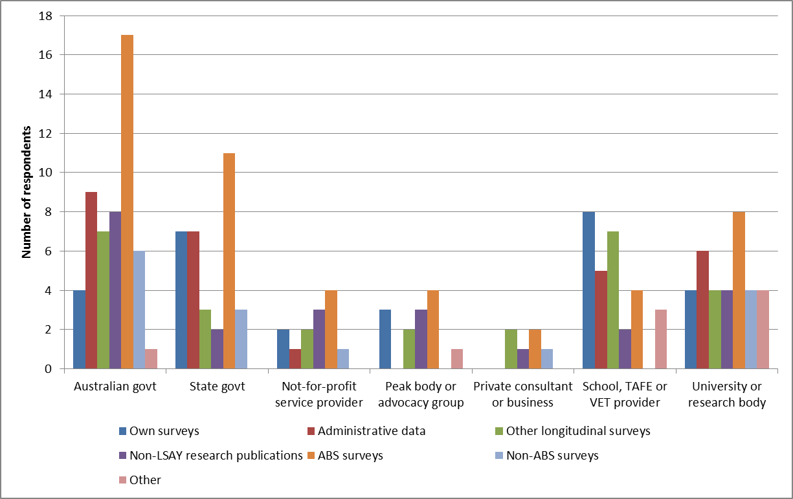

Source: LSAY User Survey 2013 Q13 and Q14. Only for those who have ever used LSAY.

1. Whether other sources than LSAY could have been used as effectively

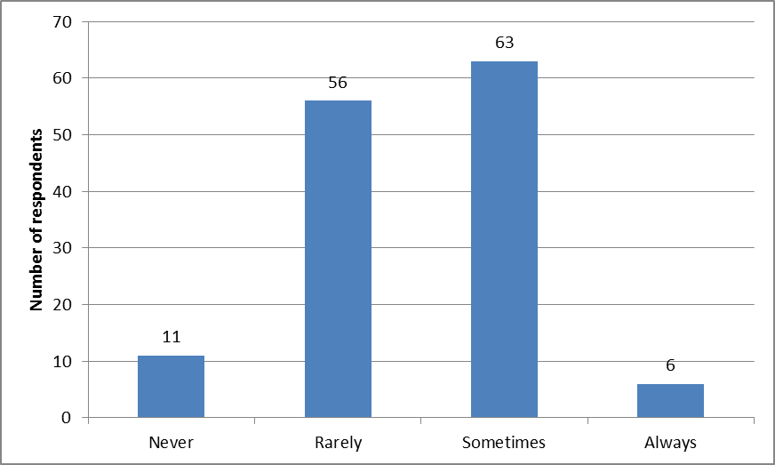

Source: LSAY User Survey 2013 Q16. Blank responses = 71.

Asked whether, on those occasions when it was used, other sources could have been used as effectively, 49% agreed that other data sources could never or rarely be used instead of LSAY and 46% agreed sometimes (Figure 8). The view that other sources could never or rarely be used as effectively was highest among university and other research organisations (65%) and non-government peak body or advocacy groups (67%). It was lowest among state governments (41%) and the Australian Government (35%).

#### Overall value of LSAY

A number of questions in the user survey addressed the overall value that a longitudinal survey such as LSAY contributes to understanding youth transitions and pathways.

When survey participants were asked which of three aspects of LSAY was most useful to them, 42% nominated the longitudinal experience of a cohort as it ages, but this was much stronger in university and other research organisations (Figure 9). Thirty-two per cent nominated comparing cohorts over time or in different circumstances, but this was a stronger interest for those from governments and of less interest to those from universities or from school, TAFE or VET providers. What young people at different ages are doing or thinking in a particular year was nominated by 23% overall but was of strongest interest to those from school, TAFE or VET providers and of less interest to those from governments or universities.

1. Most useful aspect of LSAY by organisational type

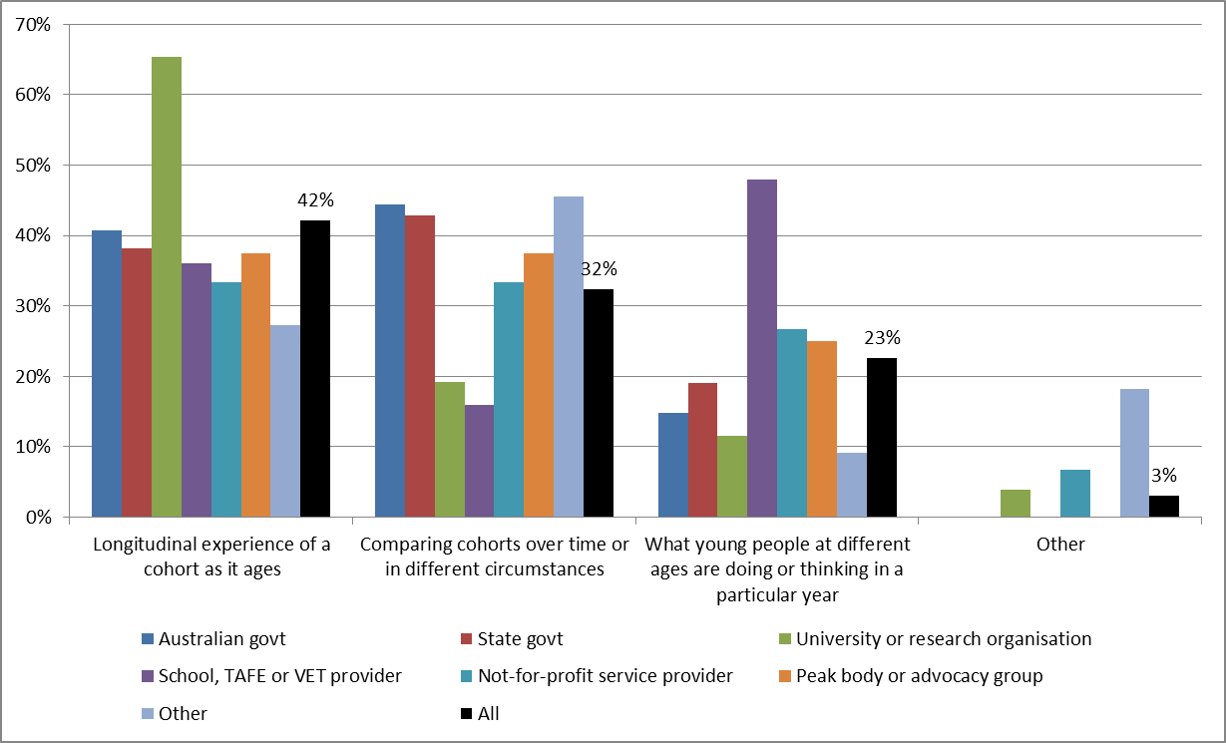

Source: LSAY User Survey 2013 Q21. Note there were 74 blank responses and 4 respondents nominated an “other” response.

1. Reasons for never using LSAY

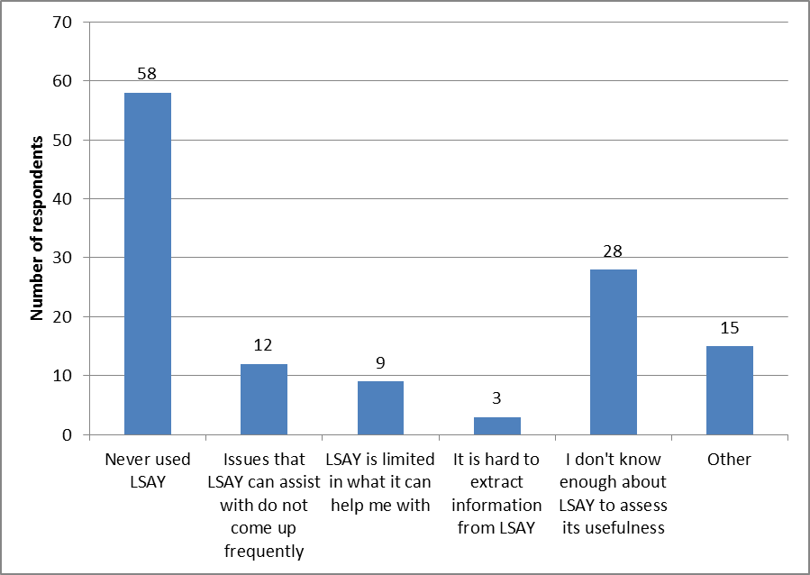

Source: LSAY User Survey 2013 Q27. There were 8 nil responses to this question.

A total of 58 respondents had never used LSAY and were asked the reasons for this (note multiple reasons could be given). Figure 10 shows that the major specific reasons given were not knowing enough about LSAY to assess its usefulness, followed by issues that LSAY can assist with do not come up frequently and LSAY is limited in what it can help with. Other reasons included some further elaborations of these as well as lack of time or relevance to job role, not knowing how to access the data, and lack of data on specific interests (e.g. carers, youth resilience and wellbeing, disability, particular industries).

Analysis of reasons for never using LSAY by organisational type (Figure 11) showed that the largest groups of non-users were in the Australian and state governments. The predominant reasons for non-use in the former were that issues that LSAY can assist with do not come up frequently, not knowing enough about LSAY to assess its usefulness and other. For those in state governments the main reason was not knowing enough about LSAY to assess its usefulness.

Respondents were also asked to nominate any strengths or weaknesses in LSAY (Figures 12 and 13 respectively). The major strengths were seen as the unique, longitudinal nature of the data and the breadth and depth of data covered along with its relevance and contribution to the evidence base for policy and practice.

1. Reasons for never using LSAY by organisational type

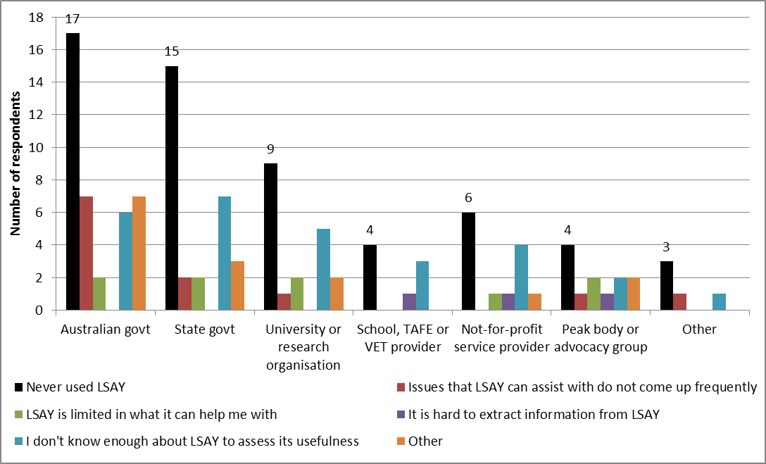

Source: LSAY User Survey 2013 Q27. There were 8 nil responses to this question.

1. Nominated strengths of LSAY

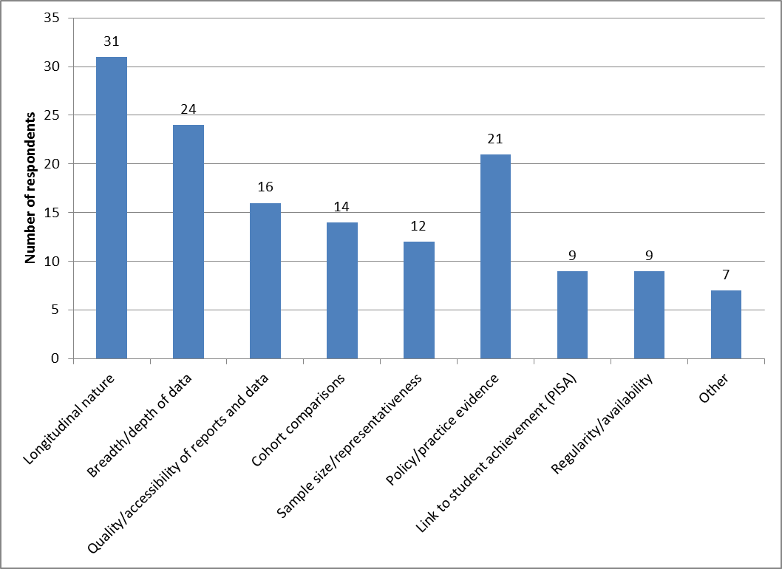

Source: LSAY User Survey 2013 Q22.

1. Nominated weaknesses of LSAY

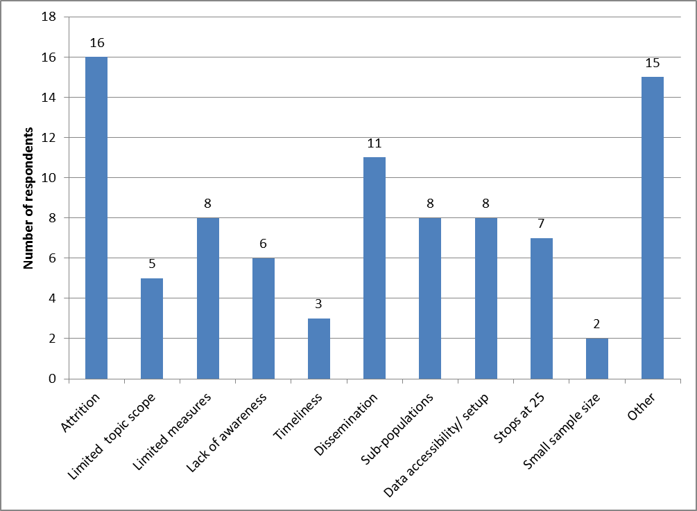

Source: LSAY User Survey 2013 Q23.

The major weakness nominated was attrition (Figure 13). Concern about this was strongest among those in universities and research organisations. Other weaknesses mentioned included:

* Dissemination in terms of the types of publications and dissemination activities available. This concern was strongest among those in governments or in education providers. Closely related were issues about difficulty of accessibility and set-up for users of datasets.
* Limited measures in the sense of a need for better performance measures (e.g. NAPLAN) or measures of SES background. Concern about this was strongest among those in universities and research organisations.
* Capacity to report on outcomes for small sub-populations, e.g. Indigenous.

The full list of strengths and weaknesses is in the *Support Document* at Appendix 1.

### Downloads and citations

NCVER collated statistics on citations and report usage to assess the use and impact of 16 selected LSAY research reports published between 2005 and 2013. The methodology was similar to that used in Hargreaves (2012) to analyse the impact of research funded under the LSAY Research Innovation and Expansion Fund (RIEF). Statistics proxy both use (as measured by website activity and, in particular, report downloads) and impact (as measured by citations).

The methodology involved extracting data for each LSAY publication on:

* The number of downloads and unique page views, based on Google Analytics data for 12 reports released since tracking of the LSAY website commenced in 2010.
* The number of media references, based on records held by NCVER for all reports published by NCVER.
* The number of research and other citations, based on a bibliometric analysis, undertaken by specialist NCVER information services staff using Google, Google Scholar, Publish or Perish, Scopus, VOCEDplus full text and parliamentary databases. The bibliometric analysis was supplemented by NCVER’s records of conference presentations and webinars.

The papers included in this analysis cover three time periods depending on the data used: four papers published up to 2008; six papers funded under the RIEF and published over 2010-11; and six papers published over 2011-13. A number of important caveats on the analysis should be noted (see text box). Detailed tables are in Appendix C.

|  |
| --- |
| **Caveats on downloads and citations analysis**   * As noted by Hargreaves (2012), it takes time for a research report to collect citations, and the ideal reference period for a citation analysis is three to five years following publication. For example, citations for Marks (2006) did not peak until 2009 and 2010 and did not decline significantly until 2013. For this reason, recently published reports are likely to have a lower number of citations compared with reports that have been in the public domain for three years or more. * Some of the selected reports were published on the ACER website and were made available on the NCVER and LSAY websites at a later date. Data on unique page views from the ACER website are not covered in this analysis. In addition, data on media citations are not available for reports published by ACER because these reports are not covered in NCVER’s media collection. * Google Analytics tracking of the NCVER website commenced in June 2009 and tracking of the LSAY website commenced in July 2010. Previous analyses by NCVER demonstrate that the main user activity occurs within the first one to two weeks of a report being published. For these reasons, the number of unique page views will be underestimated for all reports published prior to July 2010. * Google Analytics tracking of the LSAY website was implemented along with user registration on 22 July 2010. Data by user groups will be underreported for reports published prior to 22 July 2010 as information on user groups is only available from commencement of the user registration system. * Finally, as noted by Hargreaves (2012), the measurements adopted for this analysis of LSAY impact are proxies for impact; they are not ‘measures of impact’. |

Source: NCVER

#### Downloads

Website usage data for the 12 reports released since 2010 shows that the number of unique page views ranged from 815 up to 3,253 users (see Appendix C: Table C1). On average almost 2,050 users viewed the publication summary page for each report (including the research summary) (see Figure 14). An average of around 1,700 users downloaded each report, with the number of downloads peaking at 3,093 for the most recently released report included in the analysis (*The impact of schools on young people's transition to university*).

Google Analytics also provides some data on the types of users who download each report based on email logins. The largest single category are “guests”, i.e. users who have come to the website for the very first time, or whose previous visit(s) have not been remembered by the website, or they are yet to log in. Major identified users are research organisations or universities (averaging 207 downloads of reports) and governments (averaging 192 downloads of reports).[[2]](#footnote-2)

1. LSAY website activity – average views and downloads per report

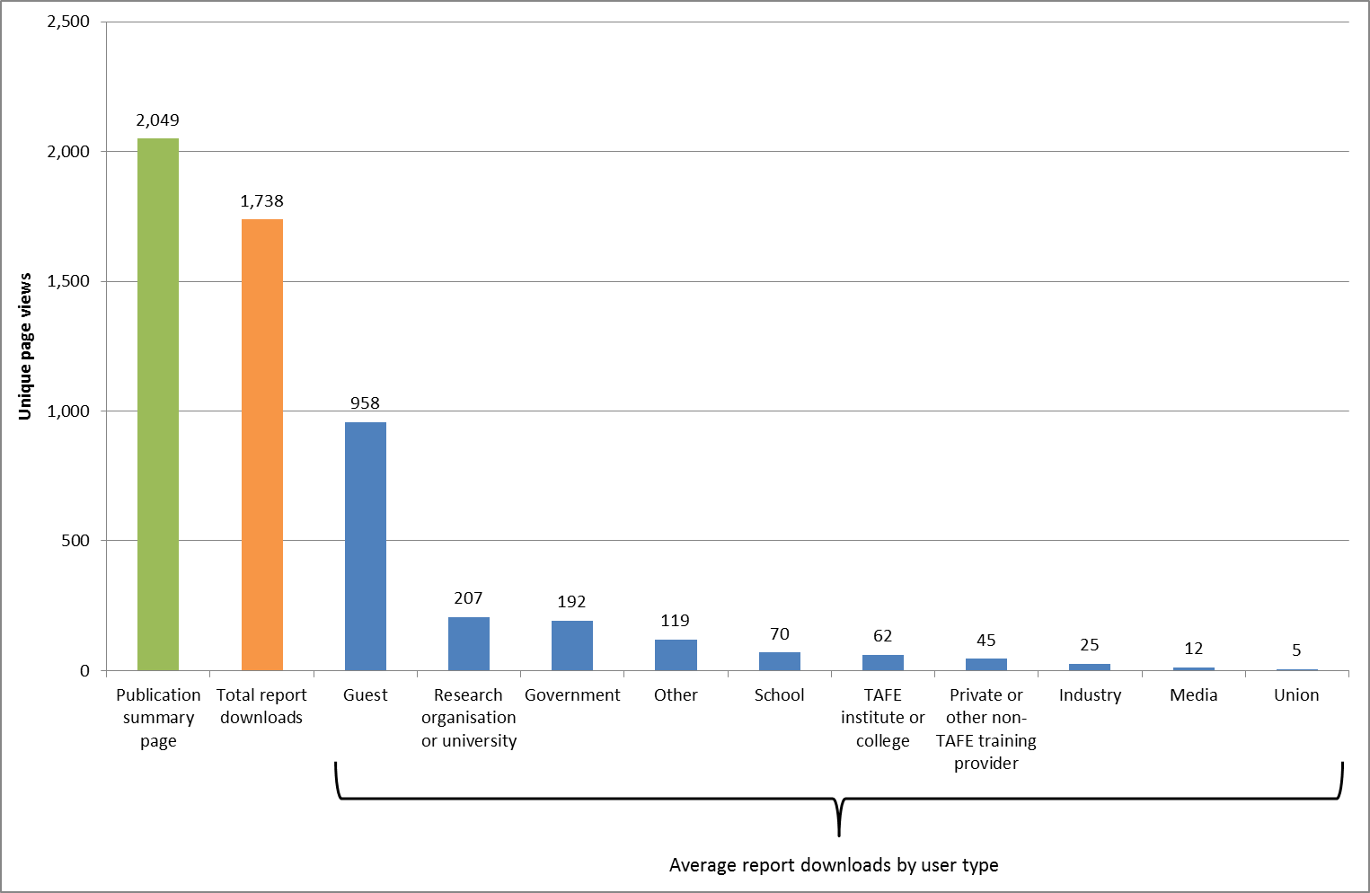

Source: NCVER

Covers 12 reports published since April 2010.

1. LSAY media references

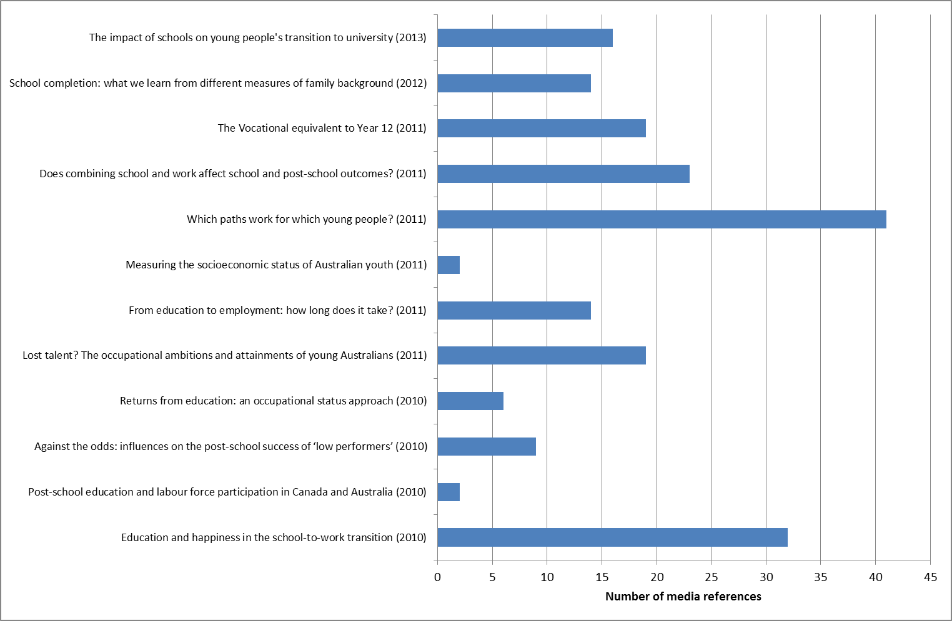

Source: NCVER

#### Media references

Figure 15 shows the number of media references for the 12 reports released by NCVER. The number of media citations differs considerably from report to report reflecting the topicality of each report’s subject matter. In general the number of media references is higher for more recently published reports.

#### Research citations

Academic citations are highest among the oldest reports (see Figure 16), reflecting the time taken for citations to build up over 3-4 years after publication. Research report and journal articles are the major types of publications citing LSAY, with additional citations in parliamentary sources (e.g. parliamentary debates or reports) and policy papers prepared by government departments and lobbying organisations.

In addition to the citations for the selected LSAY reports, a separate overarching search of the term ‘LSAY research report’ brought back a result of 20 items published over the past 16 years. These 20 items had a total of 1018 academic citations. It must be noted however that due to the inconsistencies of metadata assigned by website creators, which in turn affects web-crawling, this search did not bring back all LSAY reports and papers and thus serves only as a guide to the level of usage of LSAY publications.

1. LSAY research citations by publication

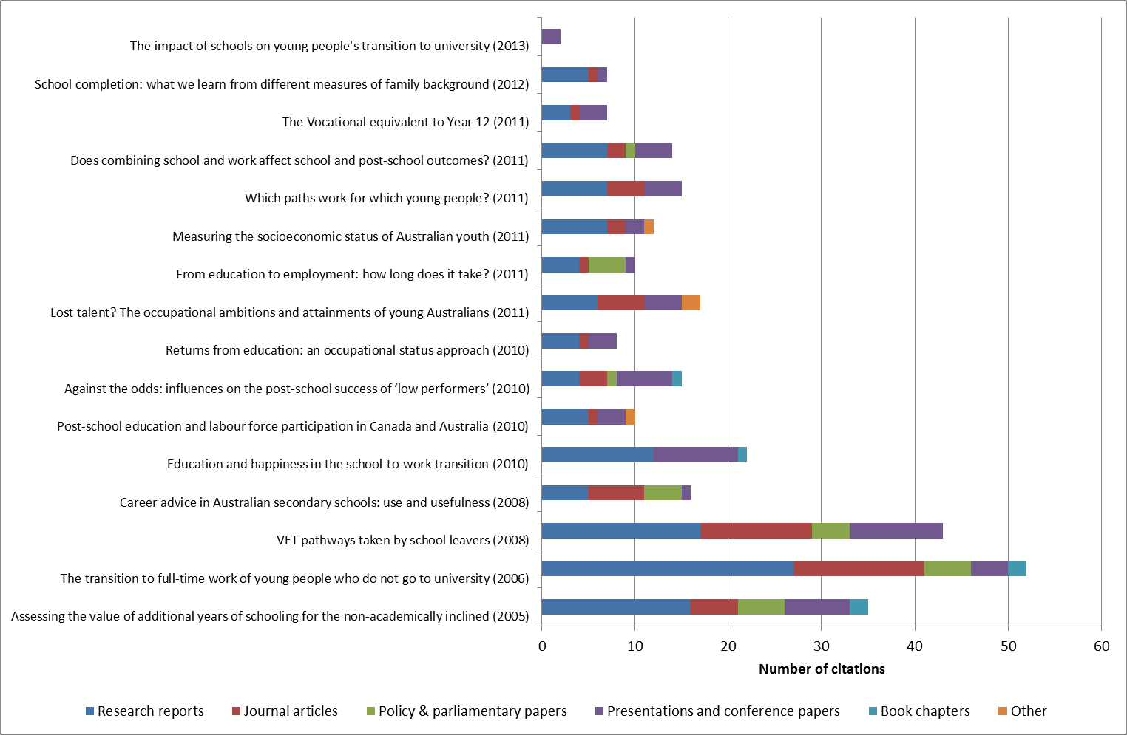

Source: NCVER

Covers 15 reports published since 2005. Bracketed date is year of release.

The analysis confirms that there are a substantial number of users of LSAY research reports and that LSAY findings are drawn on extensively in youth transitions research and policy analysis.

However, the citations analysis is limited in the ability to identify policy impact. There are known examples whereby LSAY findings have impacted policy indirectly through a secondary document, which cited the LSAY. For example, the Universities Australia submission to the Bradley Review refers to its Equity Action Plan, which is based on their Participation and Equity report (see following section on Case studies). That report made significant use of LSAY. There are other circumstances in which the policy impact is not known because the policy document is not publicly available or the citation to the LSAY report has not used terms that would be picked up in the search. For example, the report on combining school and part-time work by Anlezark and Lim (2011) was mentioned at a House of Representatives roundtable discussion but this policy impact was not picked up in the citations analysis as the research paper was not specifically mentioned in the Hansard transcript—it was instead referred to as ‘NCVER research’.

This difficulty in detecting policy impact from citations is supported by Hargreaves (2012) who found some examples of policy impact from citations of the RIEF reports in parliamentary legislation and additional examples of impact by supplementing the citations analysis with interviews with the researchers and selected end-users. Without the addition of qualitative methods, some impacts will never be captured via citations analyses. Even with this additional qualitative methodology, Hargreaves notes that there are difficulties in tracking the ways research directly or specifically influences policy and that the researchers need to be encouraged and better equipped to follow the impact of their research.

### Case studies

In the last five years or so there have been a number of instances when LSAY made significant contributions to policy development, review, evaluation or analysis. Eight examples from the period 2006 to 2013 are described in the form of case studies in Appendix D.

These examples were chosen because:

* the project/initiative was policy-related and of high importance to governments. The focus therefore was on major policy initiatives, reviews leading to policy initiatives, parliamentary inquiries and reports commissioned by government from organisations such as the Productivity Commission; and
* the contribution of LSAY research and data was critical or very important to one or more aspects of the initiative/project/report.

The eight case studies comprise:

* four policy reviews, each one commissioned by a different authority: the Minister for Education, the Department of Finance, COAG and the OECD the MCEETYA report to COAG on Transition Pathways (2006), the Career Transitions and Partnerships Strategic Review commissioned by the Australian Government Department of Finance (2007), the Review of Higher Education (Bradley Review) commissioned by the Minister for Education (2008) and the OECD Jobs for Youth Thematic Review (2008 to 2010)
* one Parliamentary inquiry – the House of Representatives inquiry into combining school and work (2008-2009)
* a policy initiative and its evaluation – the Youth Compact and National Partnership on Youth Attainment and Transitions (2009-2013)
* a project to identify good practice in youth transitions – the COAG Reform Council reporting on youth transitions (2009-2013 and ongoing) and
* a case study comprising three examples of where LSAY made a lesser contribution to the overall project than in the other seven case studies although the contribution was nonetheless noteworthy. This case study is representative of other similar instances where LSAY is called upon to provide particular information for a project. The three examples are the Review of Funding for Schooling (Gonski Review), the Vulnerable Youth report to Secretaries and Productivity Commission work on the impact of COAG reforms on VET and Youth Transitions.

The main elements of each of the eight case studies are encapsulated in Table 5. This table shows the type of document in which the LSAY information was used, the LSAY evidence utilised, and the LSAY reports referenced and/or the data bases analysed. It also shows the importance of the LSAY research and/or source data to the document.

It is useful to summarise the case studies against these headings.

1. Case studies of significant LSAY contributions to policy reviews and initiatives

| **Case study 1: MCEETYA report to COAG on Transition Pathways (2006)** | **Significance of LSAY contribution** |
| --- | --- |
| * Y98 and Y95 data files were used in commissioned research by Access Economics to examine the education and labour market experience in the first four post-school years and the experience in the first three post-school years of those who completed a post school qualification. * Provided information on proportions of school leavers in good, mixed and poor transition pathways and how those pathways were influenced by a range of individual characteristics. * Based on LSAY earnings data, also estimated the costs to the economy of mixed and poor transitions and of post-school completers not being employed at “potential”. * Four LSAY research publications by ACER were referred to in the report. | * Transition pathways information was central to the Committee’s report and provided the basis for the discussion on policy prescriptions. * Information from the Access Economics report on pathways and costs of poor transitions was used often by the then DEST in other contexts (briefings and policy documents). |

| **Case study 2:** **Career Transitions and Partnerships Strategic Review (Department of Finance, 2007)** | **Significance of LSAY contribution** |
| --- | --- |
| * LSAY research used in the review report dealt with destinations from school, transition patterns and influencing factors, the at-risk group, VET in Schools participation and post school outcomes, and Indigenous transitions. * LSAY sources were: * Access Economics report referred to above * a paper by DEST prepared for the review which made strong use of LSAY data and research * six LSAY research reports * a Productivity Commission report that used Y98 data for Indigenous youth pathways * Additional information, including from LSAY, not in report was provided to the Review team. | * LSAY was the only source for the information about transition patterns and its determinants, and on the number and characteristics of the at-risk group. |

| **Case study 3:** **Review of Higher Education (Bradley Review, 2008) and follow-up inquiries (2009 to 2011)** | **Significance of LSAY contribution** |
| --- | --- |
| * LSAY information used in: * review report, to provide baseline information on participation and completion, and on low SES students * Universities Australia (key stakeholder) submission to the review * DEEWR submission to Senate inquiry into access by regional youth following the Bradley report * DEEWR report on regional participation, used in the Review of Student Income Support Reforms. * The main LSAY sources were: * 3 LSAY reports in Bradley report * 11 LSAY reports in the Universities Australia report on Participation and Equity used in their submission * 8 LSAY reports referred in the DEEWR Senate submission * 8 LSAY reports in the DEEWR report on regional participation. | * LSAY information in the Bradley review was limited but of importance in the context of the study – and not available elsewhere. * Research from LSAY providing key information on low SES and regional participation and the factors influencing them were important to the Universities Australia position papers. * LSAY research on regional participation was important for the conclusion reached by the later Review of Student Income Support Reforms that low SES (rather than locational factors) was the major reason for lower participation in regional areas. * LSAY data was also used to analyse the relationship between increased rates of taking gap years and eligibility for Youth Allowance. |

| **Case study 4: OECD Jobs for Youth Thematic Review (2008 to 2010)** | **Significance of LSAY contribution** |
| --- | --- |
| * LSAY information used in: * responding to the extensive OECD questionnaire ahead of the visit to Australia by the OECD expert team * the OECD’s country report for Australia * LSAY information for the questionnaire provided background on the operation and performance of Australian education and training, transition and youth labour market * 10 LSAY reports and two sets of LSAY data extracted specifically for this purpose were used. * The OECD country report : * referenced 7 LSAY reports on transitions experience, benefits of part time work while at school, vocational education programs in schools, impact of VET for longer term young unemployed, participation in higher education by the low SES, at risk youth * analysed Y98 data to estimate time to first job after education. | * The OECD report used HILDA data as the standard data source in part because it covered the age range 15-29 which LSAY could not do. * Where LSAY information was used LSAY was the only source of information or the most robust source of information (because of the larger sample size and detailed information collected). * eg time to first job, impact of vocational programs at school and of VET on the unemployed. |

| **Case study 5: House of Representatives inquiry into Combining school and work (2008-2009)** | **Significance of LSAY contribution** |
| --- | --- |
| * LSAY information used in: * DEEWR submission to the inquiry * Inquiry report * NCVER report foreshadowed at the inquiry and published in 2011 after the inquiry. * LSAY evidence used: * extent of student working (across Year 9 to Year 12), characteristics, motivations and impacts * vocational education at school (including VET in Schools) and post school effects. * Sources of LSAY information used * in submission, 10 LSAY based publications * in inquiry report: 6 LSAY publications, 2 reports whose inquiry evidence was based on using LSAY, hearing evidence (sometime unreferenced) based on LSAY, sections of DEEWR submission (drawing on LSAY) | * LSAY was uniquely well placed to address key issues in the analytical component of the inquiry. * This was especially so in terms of impact of working while studying and of vocational education programs. * The inquiry report acknowledged the body of LSAY research on its topic and urged further research in this area. |

| **Case study 6: Youth Compact and National Partnership on Youth Attainment and Transitions (2009-2013)** | **Significance of LSAY contribution** |
| --- | --- |
| * LSAY information used in: * briefing and public information on website about the initiatives * evaluation of the National Partnership * Information from LSAY used: * evidence on benefits of Year 12 or its vocational equivalent and of good transitions in the years to the mid-twenties * nature of youth transitions in Australia, its importance and influences * Sources of LSAY evidence: * Briefing: several reports and other publications (difficult to enumerate and quantify) * Evaluation: 7 LSAY publications in the first Interim report. | * LSAY was the key source for describing the transition process and its determinants. * This also informed the choice of indicators (from ABS surveys and administrative data) for monitoring progress of reforms/policy interventions. * Interim evaluation report noted limitations of administrative and ABS survey data for transition analysis, especially because of lack of information to monitor sub-groups, and that LSAY could address these limitations. |

| **Case study 7:** **COAG Reform Council reporting on youth transitions (2009-2013 and ongoing)** | **Significance of LSAY contribution** |
| --- | --- |
| * LSAY information used in: * 3 papers commissioned by the CRC on youth transitions * at least 3 other papers at a youth transitions conference organised by the CRC (which attracted 11 speakers) * LSAY information used: * how youth transitions are influenced by individual, family, school and other factors * pathways from school * impact of work experience and vocational education while at school. * Sources of LSAY data - Varied across the six papers, reflecting different focuses, with 39 LSAY references in one and between 1 and 6 in the other papers. | * LSAY was the first and pre-eminent source of quantitative information on patterns of youth transitions consulted for these activities. * Some papers used partial indicators of youth transitions (eg Year 12 completions) to compare transitions across jurisdictions using other sources of data. * This is an ongoing activity by the CRC. |

| **Case study 8: Three smaller examples** | **Significance of LSAY contribution** |
| --- | --- |
| * LSAY information used in: * School Funding (Gonski) Review commissioned report by NOUS Group * Vulnerable Youth report: section on youth transitions * Productivity Commission (PC) report: analysis of successful transitions by age 25 * LSAY information and evidence used: * NOUS report analysed Y06 data for factors impacting on non-completion of Year 12 * Vulnerable Youth report used information on what assists successful transitions * Productivity Commission used Y98 data to calculate proportions of young people in successful transitions pathways and in other pathways | * LSAY was the only source of information for the NOUS report analysis because of the need for school achievement (PISA) information. * LSAY-based research was significant in identifying broad critical areas of intervention for good pathways. * The PC noted that LSAY was the best available data for their needs as it includes information on key transition activities. |

#### Type of documents and formats in which LSAY evidence was used

In the eight case studies LSAY evidence has been used in a range of documents and formats. The main one was review, inquiry and commissioned reports which were part of all of the case studies. Departmental submissions (and submissions by other major stakeholders) featured in two of the case studies and a Department paper prepared for a review on request from the reviewer was involved in another case study.

These documents aside, in one case study briefing and website information based on LSAY was an important aspect of the initiative. In another case study a conference with invited speakers, some of whom used LSAY evidence, was a key element.

#### Topics for which LSAY evidence was utilised

In the case studies LSAY research and data was called upon to address several issues/topics. In broad terms, these topics included the following:

* pathways from school into the workforce and independent adulthood
* good, mixed and poor transitions and factors that impact on them
* the size and characteristics of the at risk group
* participation at university by disadvantaged groups (especially low SES, Indigenous and regional students)
* impact of low SES on completing university for those who commenced it
* non-completion of Year 12 and the role of individual, school and other factors
* impact of VET in schools and working while at school on school and post school outcomes
* benefits of completing Year 12 or a vocational equivalent in the initial post school years and to around age 25
* time taken to a first job after leaving education
* unemployed young people and the benefits of further VET.

#### LSAY sources used

Reports published by the ACER and NCVER were the main sources of the information, although reports by other researchers using LSAY data were also referenced. In three of the eight cases studies (No 1, 4 and 8) LSAY data was used by the authors to extract specific information needed for the report.

Reports did not always refer to LSAY as the source of the evidence. For example, reports for Parliamentary inquiries often refer to particular submissions or hearings as the source of the evidence, although the submission themselves used and referenced LSAY reports and the speakers at the hearings may also have done so. In the case of the Bradley review, for instance, the Universities Australia submission was cited as the source of some facts which the submission obtained from one of their papers that had derived the information from LSAY based reports.

Second, the reference used in the report may not be an LSAY publication but rather a publication that had used an LSAY report or LSAY data to address the particular issue. For example, the FYA How Young People Are Faring reports are widely known and used, and referenced for information that the authors have extracted from LSAY.

#### Significance of LSAY evidence used in the case studies

As Table 5 (last column) shows, in each of the case studies LSAY contributed some key information or data and for that information/data LSAY was either the only or the best, most robust source. This was especially the case in relation to the use of LSAY for transition or pathway information, where LSAY is the pre-eminent source of information. Without such LSAY information the report or other document would be significantly weaker.

Of course not all of the references to LSAY research in these case studies were key contributions. In some cases LSAY was used to provide supporting evidence from another source or to give a more rounded appreciation of the issues. These were important contributions but of a slightly lesser significance than those where LSAY information was critical or key. For example, in the Jobs for Youth case study the reference to the Access Economics report finding that part time working while at school generally improves transitions is important and LSAY is the best source for demonstrating that findings. On the other hand the reference to the LSAY report showing that at age 25 women were less likely to be in full-time employment than males (in part because of child rearing responsibilities) is important but not key as the information could also have been obtained from other sources, such as the ABS or HILDA.

Across these eight case studies LSAY was key across a large part of the report in 4 case studies. In the rest it was critical for parts of the reports and supportive in other parts.

## 2.3 Recent findings

The analysis of LSAY data, as part of the funded research program and otherwise, has led to a growing body of reports and papers that describe and seek to explain contemporary Australian youth transitions to adulthood. In recent years substantial research has been undertaken that has contributed to new and revised findings based on this rich data source. There is now an extensive body of research based on LSAY as reflected in the updated research compendium (NCVER forthcoming) going back directly to the start of LSAY in the mid-1990s, but also encompassing its predecessors back to the 1970s.

This section identifies the key findings from research based on the LSAY dataset over the last five years in order to distil what has been learnt that is new or different from the results of previous research. This is not to say that the case for the value of LSAY rests solely on the novelty of its findings over time. There is much within recent research that represents continuity and evolution rather than new results. However, being able to point towards the contribution that LSAY makes in terms of new knowledge and fresh insights is an important part of demonstrating the survey’s ongoing value and relevance to policy makers, researchers and other data users.

For this purpose 66 papers and reports making substantial use of LSAY data were identified using the VOCED database of published papers as well as forthcoming LSAY research reports where a draft is available. Papers and reports published since 2008 have been included. This includes some reports published by ACER during the period of its responsibility, but mostly covers the period since NCVER became responsible for the analytical program. All LSAY reports and papers that arise from the DEEWR funded analytical program are included, as well as others that make substantial use of the data. However, some reports that are synthesis of existing data with no new analysis have been excluded (e.g. Circelli & Oliver 2012). The novelty of findings was assessed based on each report’s statements about earlier research and taking into account also the summary of existing research in the draft LSAY compendium.

A high level summary of new findings is contained in Table 6. A short outline of new findings from each report is at Appendix F.

Over the last five years, findings from analysis of LSAY have contributed to a better understanding of contemporary Australian youth transitions in three ways:

* More recent cohorts have different experiences from earlier ones in some important respects and LSAY has helped to map and understand these changes.
* Better use has been made of previously unutilised or underused data that has now been analysed, including by applying improved or different analytical techniques to the LSAY data.
* The focus of analysis of LSAY has shifted in some areas yielding additional insights on issues that have been examined previously.

1. LSAY findings since 2008

| **Topic** | **Key points** |
| --- | --- |
| **Literacy and numeracy at school** | * Low performance in numeracy as a 15-year-old does not necessarily mean poor employment and education outcomes post-school. Motivation to learn, a positive school experience and a career plan are important for these students in making a successful transition through education and work (Thomson & Hillman 2010). |
| **Subject choices in Years 11 and 12** | * Single sex schooling has only a limited effect on young people’s school choices in science subjects and their vocational plans for science careers (Sikora 2013). * VET in schools does not necessarily increase Year 12 completion, but can have positive effects through contributing to later training and employment choices (Nguyen 2010b). * Participation in workplace learning can benefit senior school students, especially lower-achieving students and those taking VETiS courses (Gemici & Curtis 2012; Black, Polidano & Tabasso 2012). |
| **Working during school years** | * The negative effects of combining school and work on school retention are stronger for those who work in Year 10 than those who work in Year 11 (Anlezark & Lim 2011). * Working too many hours while at school is likely to hinder a student’s likelihood of going to university, even if the intention to participate is unchanged (Gong, Cassells & Duncan 2012). |
| **Leaving before or completing Year 12** | * Indigenous students – the gap between Indigenous and non-Indigenous Year 12 completion rates has more than halved since 1999 (Nguyen 2010a). The remaining difference is only partly explained by background characteristics (Biddle & Cameron 2012) and aspirations to complete Year 12 also play an important role (Ainley, Holden & Rothman 2011). * Low SES students – grade repetition, participation in risky activities and low aspirations are the main predictors of Year 12 non-completion (Homel, Mavisakalyan, Nguyen & Ryan 2012). Academic school quality is especially important for students who come from the lowest socioeconomic stratum and are in the lowest academic achievement decile (Lim, Gemici & Karmel 2013). The influence of student background is mediated significantly by parental and peer expectations of Year 12 completion and academic achievement at age 15 (Gemici, Bednarz, Karmel & Lim 2014). * Low socioeconomic status exerts both a direct influence on education dropout rates at age 18 and an indirect influence via school achievement at age 15. However, the effect of being male or indigenous and school estimated value added is exerted indirectly but not directly (Mahuteau & Mavromaras 2013). * Certificate III should be considered an alternative rather than a literal equivalent to Year 12 in terms of its educational and labour market outcomes (Lim & Karmel 2011). * School factors have little influence on student engagement at age 15 suggesting the need to focus on improving engagement in earlier years (Gemici & Lu forthcoming). The effect of Catholic school attendance on high school completion and university commencement and completion independent of other factors may be smaller than previously thought (Cardak & Vecci 2013). * Personality matters in the successful completion of school, but not in shaping employment or education trajectories during the first year out of school (Hanel, Tabasso & Zakirova 2012). |
| **Going on to tertiary education and training** | * Strong school academic orientation along with non-government sector, single sex schooling and resourcing all contribute to higher TERs, including for students from low SES backgrounds (Gemici, Lim & Karmel 2013; Lim, Gemici & Karmel 2013). * The incidence of taking a gap year has increased significantly, especially among the less academically inclined and those from English speaking backgrounds. This has delayed course completion but had no significant effect on attrition (Curtis, Mlotkowski & Lumsden 2012a; Lumsden & Stanwick 2012). Previous Youth Allowance eligibility rules around independence also increased gap-year taking (Ryan 2013). * Receipt of student income support has a positive and substantial effect on course completion but not on participation (Ryan 2013). While financial needs are a common concern for tertiary students, they do not appear to be the main driver that affects completion rates and/or study decisions (Halliday, Wynes & Nguyen forthcoming). * For full-time tertiary students, working part-time reduces the course completion rate, but work in a job considered a ‘career’ job has a significant and positive impact on course completion (Polidano & Zakirova 2011). * Encouraging quick take-up post-school training, along with career planning, are effective strategies for assisting early school leavers (Polidano, Tabasso & Tseng 2012). * The increased probability of young males going to university has affected the quality of the apprentice in-take but this is moderated by an overall increase in both university attendance and the uptake of apprenticeships (Karmel, Roberts & Lim forthcoming). |
| **Pathways to the labour market** | * School students were positive about the career advice they received and individualised advice from a careers advisor was seen as most useful (Rothman & Hillman 2008). While young people’s ambitions are often unrealistic, there is a strong relationship between these plans and having a professional or managerial job by the age of 25 years (Sikora & Saha 2011). * There are different views of the value of completing Year 12 alone as a pathway to employment. Karmel & Liu (2011) found that the successful path is Year 12 plus further study; Year 12 alone is not sufficient. Fitzpatrick, Lester, Mavromaras, Richardson & Sun (2011) found that in terms of gaining a full-time permanent job quickly, as opposed to any job, having post-school qualifications is critical. On the other hand Ryan (2011), concentrating on marginal decision-makers found widespread, but modest, effects from the completion of Year 12 among those who do not proceed immediately from Year 12 to further studies. * For young women completion of Year 12 and then university is unambiguously the best path in terms of labour market outcomes (Karmel & Liu 2011). * A number of studies have confirmed that completing a bachelor degree has the largest impact on occupational status and earnings, with apprenticeships having a smaller but substantial effect on earnings (Marks 2008; Fok & Tseng 2009), while others argue that it is participation not completion that matters for earnings (Herault, Zakirova & Buddelmeyer 2011). * To overcome the limitations of following young people only until their mid-twenties, occupational status has been used as an alternative measure of returns to education, indicating that gaps in occupational prestige among young people with different educational attainment become larger as time passes (Lee 2011). |
| **Being unemployed or marginalised** | * Being ‘at risk’ is a transitory state for most young people who are not in full-time employment or study (Anlezark 2011a). * Prior unemployment is a strong predictor of subsequent unemployment, but the effects diminish as time since being unemployed passes and no ‘scarring’ effect occurs after a year in employment (Buddelmeyer & Marks 2010; Buddelmeyer & Herault 2010). * Completing a lower-level qualification (certificate I or II) or finding part-time or casual low-skill jobs can be a ‘stepping stone’, but primarily for males or those with high human capital (Oliver 2012; Karmel, Lu & Oliver 2013). * As with previous economic downturns, the recent one heightened job insecurity and made it harder for young people to find work, particularly an apprenticeship or traineeship (Anlezark 2011). While the effects on education participation are debated, evidence suggests that in the early 1990s recession school participation was more sensitive than post-school participation to increased unemployment (Vu, Gorgens & Bray 2012; Herault Kostenko, Marks & Zakirova 2009; Herault, Kostenko, Marks & Zakirova 2010). * Increased social capital (networks) can have a real effect on the educational outcomes of young people from disadvantaged backgrounds independent of the effect of student, family and school characteristics (Semo & Karmel 2011). * Programs which direct resources to individuals using an area-based measure of SES will mis-allocate resources because most individuals are, in fact, not low-SES (Lim & Gemici 2011). |
| **Making the transition to adulthood** | * Those undertaking vocational qualifications report increased happiness during the training period and afterwards, while for university graduates high initial levels of happiness decline upon completion of their qualification (Dockery 2011). * Life satisfaction increases from the late teens up to early 20s, but then decreases as the responsibilities and financial obligations of living independently grow (Nguyen 2011). |

### Changing youth experiences

Recent cohorts of young people have differed from their predecessors in some significant ways and LSAY research has helped both to highlight these developments and to understand the background to them:

* An important focus of LSAY has been the influence of student and school characteristics on the decision to leave school early rather than staying on to complete Year 12. Curtis & McMillan (2008) found that with the dramatic rise in Year 12 completion between the 1980s and the early 2000s, inequalities relating to gender and socioeconomic background declined, and the magnitude of differences between other socio-demographic groups fluctuated.
* The gap between Indigenous and non-Indigenous Year 12 completion rates in LSAY fell from 27 percentage points in 1999 (Y95 cohort) to 12 percentage points in 2007 (Y03 cohort) (Nguyen 2010a). Close to half of the 2007 gap was attributed to lower levels of literacy and numeracy among Indigenous youths, with other disadvantage accounting for the rest.
* The incidence of taking a gap year has increased from 10% in 1999–2000 to 24% in 2009–10. Those taking gap years are typically less academically inclined, more likely to live in regional locations when at school, have English speaking backgrounds, be employed when in Year 12 and are less likely to receive Youth Allowance at school (Curtis et al 2012a; Lumsden & Stanwick 2012). In contrast to other research, there seems to be no difference between the rates of course attrition or change between ‘gappers’ and ‘non-gappers’ when they do commence their post-school education. Ryan (2013) found evidence that taking a gap year was associated with receiving the Youth Allowance while in tertiary study (prior to eligibility changes in 2010).
* The proportion of young people in LSAY participating in VET in school programs increased from 28% in 1998 to 32% in 2005. Research using the LSAY data shows that VET in schools programs do not necessarily increase Year 12 completion, but have positive effects on attitudes to school (Nguyen 2010b). They also contribute to post-school employment choices, especially for those intent on getting a job straight after school. The effects of participation in workplace learning have also been analysed (Gemici & Curtis 2012; Black, Polidano & Tabasso 2012).
* The percentage of 17-year-old students (in Years 11 and 12) who held part-time jobs increased from 26.5% in 1978 to 57.4% in 2005, with more females than males working. While earlier research has established the negative association between longer working hours and school retention, Anlezark & Lim (2011) showed that this impact is stronger for those who work in Year 10 than those who work in Year 11, perhaps because the latter group tend to moderate their hours. Gong et al (2012) found that a student’s choice of working while at school and their chances of enrolling at university are not only driven by background characteristics, but also by the path they take with previous choices affecting subsequent school—work decisions and their educational outcomes.
* Combining work with full-time tertiary study has also become more common over time among those who have left school (Vickers, Lamb & Hinkley 2003). Polidano & Zakirova (2011) found that for those studying full-time, working affects completion, but finding work in a job considered a ‘career’ job while studying (especially in the final year) has a significant and positive impact on course completion for both VET and higher education students.
* That economic recessions have a disproportionate short term effect on youth unemployment has been well established. Anlezark (2011a) found that for the three LSAY cohorts in the 2009 data collection, work was harder to come by as a result of the GFC and there was an underlying threat of unemployment. It was particularly difficult to obtain an apprenticeship or traineeship. In the short-term some decided to undertake further study or changed courses to improve their employment prospects. However, there has been debate over how persistent these effects are likely to be, with a number of recent studies examining the effects on youth education participation rates of the early 1990s recession based on data for predecessors of LSAY (Herault, Kostenko, Marks & Zakirova 2009; Herault, Kostenko, Marks & Zakirova 2010; Vu, Gorgens & Bray 2012).

### Better use of data

Better use of LSAY data has come about through a number of studies looking at previously unexplored or underutilised data topics. For example:

* A couple of studies have examined the relationship between adolescent occupational plans and later attainments. Sikora & Saha (2011) found that having ambitious occupational plans is important, with a strong relationship between holding these plans and having a professional or managerial job by the age of 25 years. Gemici, Bednarz, Karmel & Lim (2014) find that young people’s aspirations are somewhat unrealistic, with the distribution of aspirations being quite skewed towards high status jobs.
* Lee (2010) used occupational status as a measure of potential returns from education and training and found that the gaps in occupational prestige among young people with different educational attainment become larger as time passes. The study also concluded that family background characteristics continue to influence young people’s occupational prestige above and beyond the influence of their educational attainment.
* Hanel, Tabasso & Zakirova (2012) analysed the impact of personality traits on dropping out of school and patterns of post-school education and employment, showing that personality characteristics do matter for the successful completion of school level education, but not in shaping employment or education trajectories during the first year out of school.
* Semo & Karmel (2011) made use of LSAY data to measure social capital and its impacts on youth transitions, finding that social capital networks and participation in a diverse range of activities including sport do influence educational participation and outcomes over and above the effects of background.
* Fok & Tseng (2009) sought to fill a gap in previous LSAY analysis of New Apprenticeships by looking at the wage gap between apprentices and their counterparts without training in terms of the positive incentive training provides for individuals to take up apprenticeships and stay in the trades sector. They found positive returns to apprenticeship and traineeship participation, not only in terms of weekly earnings, but also in terms of employment.
* The limited LSAY data on well-being and happiness has also been analysed with Nguyen (2011) finding that for the Y95 cohort life satisfaction peaked in their early 20s. Dockery (2011) found that, undertaking vocational qualifications has a lasting positive impact on happiness, but high levels of happiness among university graduates decline upon completing their study, perhaps due to the adjustment to subsequent work and life experiences.
* A small-scale supplementary qualitative survey of 51 LSAY Y06 respondents finding it ‘fairly difficult’ or ‘very difficult’ to manage financially collected additional data on areas not already covered in the LSAY finance topic including support from parents and others, the impact of financial stress on study decisions and the tertiary education experience, reasons for combining work and study, major expenses and impacts of financial stress on study grades and achievement. The analysis suggested that while some had considered changing their mode of study or withdrawing from study altogether due to financial stress, other factors were more significant, e.g. waning interest, pressures of work and study (Halliday Wynes & Nguyen forthcoming).

Better use of data has also come about through studies which draw on different data sources or utilise new or different statistical techniques. Homel, Mavisakalyan, Nguyen & Ryan (2012) linked data from the LSAY Y03 cohort with another cohort of young people born at the same time from the Youth in Focus (YIF) survey. This required the use of statistical matching techniques. The benefit was in the additional set of disadvantage measures, including family income and welfare receipt history, as well as information about the respondent’s earlier educational experiences and risky behaviour together with LSAY’s data about school achievement and completion. Based on this more multi-dimensional measure of disadvantage, the study concluded that poor school experiences, participation in risky activities and aspirations are the main predictors of Year 12 non-completion, while parental education and occupational status are less significant.

Several recent studies using LSAY have employed propensity score matching in their analysis to create comparison groups with the same background characteristics as the group of interest in the study, but which are not affected by a policy change of interest. This can allow the impact of a policy or intervention to be considered using LSAY data in some cases. For example:

* Two studies have used propensity score matching with LSAY data to create equivalent comparison groups to estimate the impact of participating in workplace learning on school and post-school outcomes. Gemici & Curtis (2012) found that there are benefits for senior school students, especially for lower-achieving students and those taking VET courses. Black, Polidano & Tabasso (2012) note that for some students there is a potential negative impact on higher education participation, particularly where workplace learning is intensive.
* Ryan (2013) used propensity score matching to analyse the effect of receipt of Youth Allowance on tertiary education participation when eligibility for Youth Allowance itself could not be directly observed. By creating a comparison group matched on student characteristics (other than family income), the study was able to show that Youth Allowance substantially improves course completion rates and that the eligibility rules in operation before 2010 did lead to more students undertaking a ‘gap’ year.
* Ryan (2011) also used propensity score matching to compare the effect of Year 12 completion on those for whom the decision to complete Year 12 is a real one with others whose achievement levels and social backgrounds meant they were always or never likely to complete Year 12. The study found widespread, but modest, effects from the completion of Year 12 among those who do not proceed immediately from Year 12 to further studies. In contrast to previous LSAY research, it found that there were substantial benefits from completion of an apprenticeship for males and a traineeship for females.

### Shifting focus of analysis

While research often confirms the results of previous research, some recent work using LSAY data has yielded additional insights through more sophisticated analysis that has shifted with the changing focus of educational policy. In particular, there has been renewed attention to the role of school level effects on education and training outcomes. Curtis & McMillan (2008) found that a range of school-related factors are significant, including peer group effects such as the behaviour of students in the school, the quality of student–teacher relations and, to a lesser extent, teacher morale. School sector itself was not a key explanatory variable.

Other studies using LSAY have contributed to a more nuanced understanding of the impact of disadvantage on educational outcomes and how this interacts with school-related factors in complex ways with student and family background having both direct and indirect effects of outcomes that are mediated by other factors, e.g. school achievement, intentions, career aspirations and peer attitudes. For example Lim, Gemici & Karmel (2013) stressed the role of academic school quality – as measured by school average predicted TERs and university enrolment probabilities – in mediating the effects of background on school completion for students who come from the lowest socioeconomic stratum and who are in the lowest academic achievement decile. Gemici, Bednarz, Karmel & Lim (2014) find that factors such as improved teacher quality can directly affect academic performance, parental and peer expectations, or perception of school. In terms of a student’s university intentions, they also find that peer plans have a far stronger influence than academic performance and perceptions of school. However, other work suggests that school factors have little impact on student engagement among 15 year olds (especially those most at risk of leaving school early), pointing to the need to improve the school experience at earlier ages (Gemici & Lu forthcoming).

Similarly, LSAY has helped with teasing out how Indigenous outcomes are affected by the interactions between school effects and disadvantage. Analysis of lower Year 12 completion rates for Indigenous students has pointed to the complexity and uncertainty of the relationship between background characteristics, achievement and intentions. Based on a review of the literature and their own analysis of LSAY, Ainley et al (2011) concluded that there is some consensus about the importance of four factors – the student, their family, their school and their community – but their relative importance and the extent to which this varies according to the setting of the students is unclear or contested. Biddle & Cameron (2012) found that 15 year old Indigenous students in the Y06 cohort are on average happier at school than their non-Indigenous counterparts and that differences in expectations of completing Year 12 disappeared once statistical controls were made for a variety of background characteristics.

The effect of schools on tertiary participation has been the subject of several previous studies using LSAY data. Most recently, Gemici, Lim & Karmel (2013) examined a broader range of school-level characteristics and use a refined measure of socioeconomic status to paint a more comprehensive picture of how school attributes influence the transition to higher education. The most influential factors to emerge from the analysis are the role of sector, academic orientation, differentiation from the norm (e.g. single sex schools) and resourcing. A related study, Lim et al (2013) found that students from a low socioeconomic background benefit more from attending a high academic quality school than their high socioeconomic background counterparts. Cardak & Vecci (2013) estimated the independent effect of Catholic school enrolment on school completion and university commencement and completion, finding that the effect is smaller than previously estimated once education aspiration and expectation variables were included.

Longitudinal data such as LSAY is ideally suited to analysis of pathways and transitions between different states over time and over the years many studies have taken advantage of this. A number of recent studies have made novel use of this capacity to explore a range of current issues and extend previous research findings:

* While previous research has established that the level of literacy and numeracy achieved at school is a major factor in a successful transition from school to later education and work, pathway analysis using LSAY Y03 data has shown that almost three-quarters of those who were ‘low achievers’ at age 15 in 2003 went on to successfully make the transition into full-time work or study (or a combination of these) by age 19 (Thomson & Hillman 2010). Motivation to learn, a positive school experience and some sort of career plan are especially important for these students.
* Following the pathways from subject selection related to science, technology, engineering and mathematics (STEM) in secondary school, through to post-school study and career choices shows that despite over half of all school students studying two or more STEM subjects in Year 12, less than a third of these then go on to post-school STEM study (Anlezark et al 2008; Lim et al 2009). The greatest leakage is the pathway from commencing post-school STEM study into a STEM occupation.
* Looking at the educational pathways chosen by young people as opposed to the educational level attained, Karmel & Liu (2011) found that for males, Year 12 completion is a key component of the more successful paths, including those that involve an apprenticeship. For females, the most successful pathway is going from Year 12 to university.
* Anlezark (2011a) showed that being ‘at risk’ is a transitory state for most young people who are not in full-time employment or study. She argued for a reconsideration of the definition of ‘disengaged youth’ to avoid including those with only short periods out of work or away from study and to concentrate on those most at risk of persistent disengagement over an extended period of time.
* Related to this, a number of studies using LSAY data have explored the dynamics of young people’s labour market status over time with a focus on the extent to which unemployment or low-skilled employment persist or change. Karmel, Lu & Oliver (2013) find that young people starting out in low-skill jobs do experience higher wages and higher occupational status and a shift from part-time to full-time from casual to permanent jobs five years after leaving full-time education. Buddelmeyer & Marks (2010) found that previous period labour market states trump all other factors in predicting current labour market states but having at least a certificate IV for women or a bachelor degree or higher for men, provided a buffer against these undesirable labour market states becoming persistent. Buddelmeyer & Herault (2010) found that prior unemployment has a ‘scarring effect’ on future unemployment, but the effects diminish as time since being unemployed passes, and no scarring occurs after a year in employment. In general, having a post-school qualification, at any level, lessened the scarring effect. Oliver (2012) found lower-level qualifications (certificate I or II) had limited value as permanent ‘stepping stones’ to further study or into the labour market, with the benefits by age 26 apparent for males but not for females.

In summary, analysis of LSAY data as part of the analytical program and more broadly has generated new and valuable insights over the last five years into the features of contemporary Australian youth transitions. This enables the research and knowledge base to be updated as the experiences of more recent cohorts differ from those of earlier ones. This has been made possible by analysis of previously unutilised or underused data and by applying improved or different analytical techniques and data sources. The focus of analysis of LSAY has also shifted in some areas as policy priorities have evolved, with a general purpose youth longitudinal survey such as LSAY well-placed to keep pace with emerging issues.

## 2.4 Future research priorities

While recent research findings based on LSAY have added incrementally to our knowledge of youth transitions, a greater challenge lies in positioning LSAY to meet future policy and research needs. This challenge arises in part from the extensive lead time needed in a longitudinal survey to develop, collect and analyse data as well as the changing nature of youth transitions and trajectories. It also reflects the difficulty of anticipating issues in advance of or early in their policy currency and adapting LSAY to meet them. Yet stakeholder feedback suggests that LSAY needs to become more agile and responsive if it is to regain interest and support especially from policy makers. This section discusses what this might involve and some areas of future research that LSAY could address.

### Stakeholder and user views

In interviews with key stakeholders for this review there was support from a range of quarters for some broadening of LSAY’s data scope to support greater breadth of research and to improve LSAY’s relevance to contemporary youth policy concerns.

Among some stakeholders there was interest in measures of outcomes broader than the narrowly economic and educational, including civic participation and youth wellbeing. There was also interest in better understanding the influences and causes of eventual outcomes for young people, including emerging concerns like the effect of school environments, adolescent risk taking behaviour and health and their role in shaping outcomes in adulthood. For some, LSAY was seen as having too great a focus on youth making poor transitions and not enough on those who are successful, especially where this occurs in spite of their circumstances or background.

For others, the model of transitions centred on education and employment outcomes on which LSAY has been based was seen as outdated and restrictive with social dimensions and impacts becoming just as important. This sense of LSAY being narrow in scope contrasted with the breadth of topics covered in other longitudinal surveys such as HILDA and LSAC.

Alongside these issues, there was an understanding that LSAY faces challenges in keeping pace with emerging policy issues within its existing education and employment focus such as the increasingly non-linear journey from school to employment, the casualisation of the youth workforce, the outlook for employment in lower skill jobs and the growing importance of enterprising skills and the return on education investment.

There was a recognition that the depth and scope of LSAY meant that it often goes to the “what” and “how” but rarely to the “why” of youth transitions. However, this was balanced with concerns that broadening the scope of data would lead to greater respondent burden, which could affect participation and attrition or require trade-offs in other regards given limited resources, e.g. fewer new cohorts. Some believed that other enhancements might be of greater value. For example, extending the age to which cohorts are followed to thirty years could give better information about returns from higher education.

These views are complemented by the results of the LSAY User Survey conducted for this review. This survey sought views about the level of interest in existing LSAY topic areas as well as enhancements to scope that would be of most interest to users.

Figure 17 shows the proportion of respondents who expressed a strong interest in each of the existing 14 policy and research areas to which LSAY findings relate. “Transition from school” attracted the strongest support with 72% of respondents saying that, as part of their work, it is an area affecting youth in which they had a strong interest. “Post-school pathways in education, training and employment” was the second most nominated area of strong interest.

The User Survey also sought views about interest in changes to the scope of the LSAY data collection. Asked if LSAY were to generate a wider range of information, which of a specified list of areas would be of most benefit to respondents, support for information through to age 30 and richer information on attitudes, opinions and beliefs was strongest among researchers (Figure 18). State governments expressed strong support for more robust information by states and territories and better information on small populations such as Indigenous young people. The last of these also attracted the greatest level of interest from those in the Australian Government. The survey did not specifically ask about enhancing the scope of LSAY to capture data about earlier childhood experiences although a few comments on this arose in answers to a separate question about weak points of LSAY.

1. Respondents expressing a strong interest in particular policy areas in LSAY

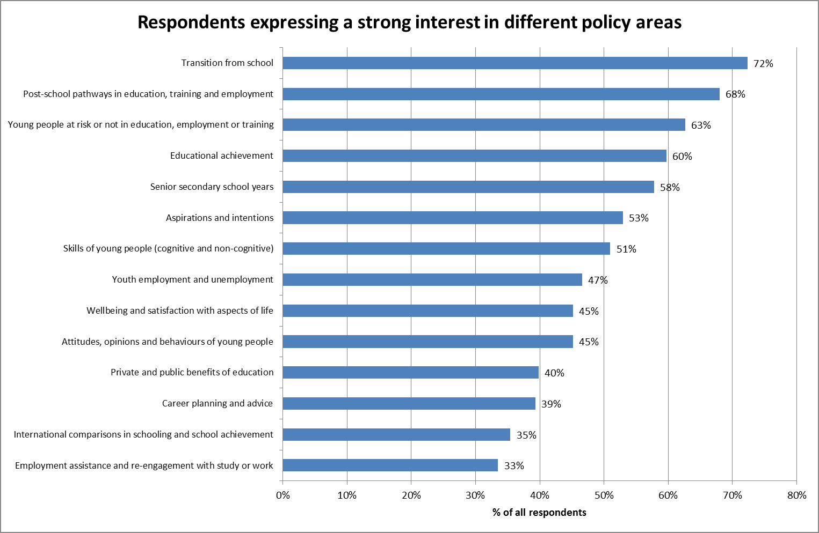

Source: LSAY user survey 2013 Q7

1. Enhancements to LSAY’s scope of most benefit

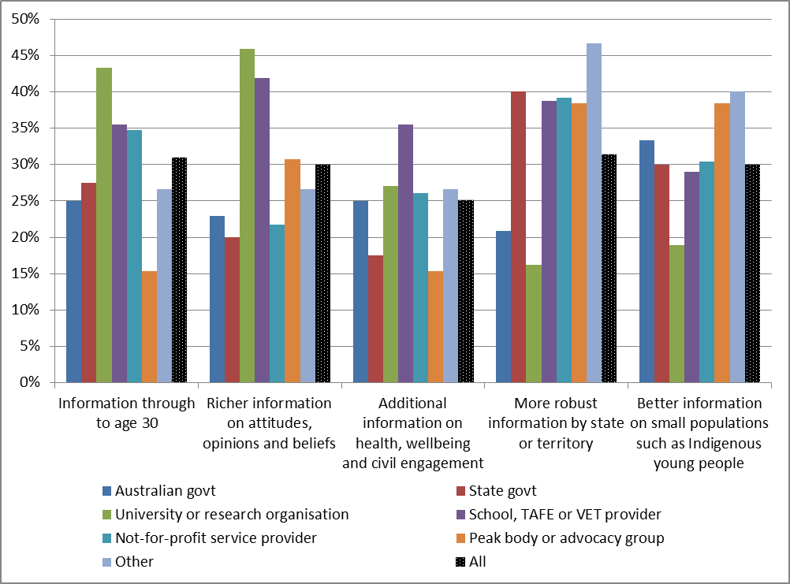

Source: LSAY user survey 2013 Q24

### Changing youth transitions

If LSAY is to be seen as more relevant it will need to capture key aspects of the changes that are underway in the experience of young people, particularly as they forge pathways through education and employment and other related aspects of adult life. In general terms over the last few decades youth transitions have become longer, less linear, more complex and less predictable in their outcomes. A variety of factors play a part in this including changes in: the economy and the nature of work; social structures such as the family, gender roles and personal relationships; and increasing budgetary pressures on the capacity of governments to meet societal expectations.

In terms of education and employment, it is reasonable to anticipate that some trends evident over the last decade or two will continue.

* The structure of the economy is changing in response to longer-term globalisation pressures and the opportunities associated with China’s growth, as well as short-term factors such as the recent global downturn. There is considerable uncertainty about how this will play out for the Australian economy over the coming decade (Gruen 2011; Parkinson 2011).
* The continuing growth of service industries is likely to affect demand for skills as well as employment choices and opportunities available to young people. Service industries have become the dominant employers, manufacturing continues to decline and the centres of employment have shifted geographically. Unskilled work is relatively rare and highly casualised (AWPA 2013). Some highly skilled work attracts a large income premium, but high qualifications and skills are not always a path to stable employment. Long term careers with one employer are no longer the norm.
* The average duration of post school education and training has lengthened as more young people complete school and enter tertiary education and training to establish their credentials in a competitive labour market (DAE 2012). Government policies have sought to expand the supply of post school education and training while encouraging young people to participate in order to meet labour market demand for skills and to spread the protective effect of education and training to a wider cross-section of young people.
* At the same time a small but significant proportion of young people continue to struggle to establish a secure educational and employment foundation for adult life. While around 81% of 15-19 year olds are in some form of education or training, those not in employment or education or training (NEET) comprise about 7% of 15-19 year olds and 14% of 20-24 year olds (ABS 2013a). The unemployment rate for 15-24 year olds is also around 11%. Their futures will be affected by the ongoing effects of the GFC as well as the structural changes in the economy. Long-term unemployment remains a particular concern.

As this sort of information has been LSAY’s core business for a long period it is arguably covered well. Covered to a lesser extent are other domains of life and how they are affected by these economic and educational changes:

* Young people are staying in the family home – or returning to it – to a far greater degree and family formation has been delayed. LSAY has collected basic data in these areas including living arrangements, finance, housing payments, children and marriage, but slower transitions to independence mean that for many youth these processes are only partly complete by age 25. Extending the age of follow-up to 30 could help here (see Section 3.4).
* Social attitudes on many matters, including diversity and multiculturalism, have evolved rapidly, but broader information in LSAY on the health and wellbeing of young people, their civic participation, risk behaviours and social capital is limited. Strengthening LSAY in this regard would provide measures of successful transitions beyond economic and educational outcomes and also assist in understanding the factors that contribute to a successful transition in the broadest sense (see Section 3.1).

Of a more contextual nature are rapidly changing modes of social engagement as a result of emerging communication technologies. Changing technology, social media and their adoption and penetration through the youth population are also changing the capacity to access education and training through non-traditional means such as distance education and online courses that allow considerable geographic mobility (Walsh et al 2011). It may also open up possibilities for improved collection of data in ways that maximise the familiarity of young people with mobile and online communications.

### Policy priorities

There are elements of continuity and change in the priorities and focuses raised in this review by policy makers and others seeking to better understand and support youth transitions in an environment of change.

The core purpose of LSAY to describe and explain the educational, training and employment dimensions of youth transitions and the pathways young people take through them remains important, albeit with some changes of emphasis picking up the changing nature of transitions and the data sources available to understand them. Outcomes and pathways for disadvantaged youth or those “at risk” (however this is defined) or “non-engaged” continue to be a central concern. Alongside these, there was an understanding that LSAY faces challenges in keeping pace with emerging policy issues within its existing focus such as the increasingly non-linear journey from school to employment, the casualisation of the youth workforce, the outlook for employment in lower skill jobs and the growing importance of enterprising skills and the return on education investment.

Emerging areas of policy interest include:

* Building on the greater focus on school effects in recent research (Section 2.3), there is also interest in having greater capacity to assess the holistic “value add” of cumulative school experiences to outcomes in a broader sense if such outcomes can be measured through LSAY.
* The problems faced by young people during the transitional period along with finer grained analysis that can throw light on what enables some young people to break out of expected patterns.
* The effect of various changes in education and training on youth transitions such as:
* New demand driven funding arrangements in the higher education sector on the “success factors” for entry into tertiary education and training.
* The growth of university vocational qualifications offered as 5-year rather than 3-year qualification pathways.
* VET qualifications offered as a post-Year 12 qualification.
* The increased costs of obtaining post-school qualifications and the role of income contingent loans in moderating these.
* The effects of evolving forms of educational delivery (on-line, distance, social media, etc) on participation and attainment.
* Labour market issues including:
* The risk of increased skilled unemployment for youth, which is becoming an issue in Japan and some other countries.
* Increased expectations of Year 12 as the base qualification for employment, effectively making it the entry requirement for the unskilled level.
* Changing demand for skills and how young people are able to adapt to these in a flexible and resilient way.
* The role of “enterprising” or “self-confidence” skills and attributes as well as measures of “readiness for work”. Linking these to possible contributing intervention factors and experiences would be powerful, and enable establishing a young person’s perspective on thriving in a changing (and declining) labour market on the way to adulthood.
* Wider policy concerns, particularly in the health and welfare area, including the effect of earlier childhood experiences and learning on later outcomes, delayed family formation and the changing gaps over time between outcomes for advantaged and disadvantaged youth.

At the same time it is clear that LSAY competes with a wider range of longitudinal and other data sources than previously. As cross sectional point in time data becomes more extensive and detailed policy makers and researchers have become increasingly interested in drilling down into the drivers of the circumstances, behaviours and performance of sub populations defined in various ways, whether by industry, level of qualification, geographic region or forms of barrier to opportunity. ‘Drill down’ is matched by ‘joined up’ as policy makers and researchers seek to understand the relationships between characteristics and behaviours in different aspects of social policy.

The capacity of any longitudinal survey to meet such expectations is ultimately constrained by many factors, not least of which are the feasibility of what data can be collected and the available resources. The challenge for LSAY is not to meet all expectations, but to lift its capacity to contribute more to understanding youth pathways to realise its potential and for it to attract greater support and use by policy makers.

### Conclusions

By and large these kinds of changes in the focus of policy makers and researchers and in the influences on the youth population do not require different research methods in LSAY, but they do require more extensive and richer information about respondents, including some sub-groups. These issues are taken up in Part 3 of this report looking at the scope of data collection, sample size and attrition.

While it is not possible for a longitudinal survey such as LSAY to be able to anticipate all policy issues that will emerge, it is imperative that it become more responsive and better at adapting to new concerns. This raises issues about governance and funding, which are also discussed in Part 3. Since future policy and research issues are hard to predict with any certainty, it is also important that LSAY retain a strong core of data that is collected consistently over time to enable it to serve as a general purpose vehicle for monitoring patterns of youth transitions.

## 2.5 Value for money

Assessment of value for money in public spending typically incorporates a number of aspects:

* economy in the sense of minimising the cost of resources used or required in an activity;
* efficiency in the relationship between the outputs of the activity and the resources required to produce them; and
* effectiveness in that the actual results of public spending achieve the intended outcomes of the activity.

In practice, assessments of efficiency and effectiveness in particular can be challenging where the relationships between activities, outputs and outcomes are complex, such as where the connections are separated over time or are mediated by a range of other factors. This is the case for LSAY, which as shown earlier in this report, exists within an increasingly competitive array of data available to policy makers and researchers. Accordingly, assessing the value of continuing LSAY to policy makers, researchers and the wider community is largely a qualitative task drawing together analysis presented elsewhere in this report.

### Cost

The cost of LSAY averages about $1.7m a year including data collection, sample design and maintenance, user support and overheads but excluding the research and analysis component ($0.4m) for comparability with other longitudinal surveys. For its design and implementation LSAY costs would appear to be on or a little lower than market rates. This equates to around $115 per respondent (based on a total of 15,156 respondents in the remaining sample for Y03, Y06 and Y09 in 2012).

Comparisons with other longitudinal surveys are hampered by differences in scale, data collection methods, the scope of work undertaken and the general lack of directly comparable data on costs. However, by way of illustration, the cost of HILDA is reported to be around $7m pa at present increasing to around $10m pa over the next four years (Crawford & Maré 2013). Based on around 17,600 individual interviews in Wave 11, this equates to between $398 and $568 per respondent.

The difference in cost is attributable to several factors:

* interview methods – HILDA and LSAC primarily use face to face whereas LSAY is telephone and online;
* range of data items and average interview length – HILDA and LSAC are both very extensive in range and depth of information collected, whereas LSAY is very focused on its core purpose. The average length of HILDA interviews is around 1¼ hours for a two adult household (plus a self-completed questionnaire); and
* extent of data preparation – HILDA and LSAC put a good deal more effort into making datasets easy for researchers to use.

### Value

The findings under Part 2 show that LSAY is of high value to its major stakeholders and that is has a potentially higher value if certain practical limitations, particularly on topicality, attrition, accessibility and ease of use and design limitations, particularly on the range of data items collected, can be overcome.

Despite the emergence of other data sources that can be utilised to analyse aspects of youth transitions, LSAY still occupies a unique place in the available Australian data because of its capacity to support holistic analysis of the pathways young people can take and the impact of their background and experiences across their schooling, post-school education and training and employment outcomes. While other data sources can provide greater detail on aspects of this transition, there is no other readily available, nationally representative data source that provides access to this breadth of data about experiences and outcomes at this point. Joining up administrative or census data by matching individuals synthetically to similar individuals or to the same individuals based on identifiers is promising, but at an early stage of development and needs to overcome significant privacy, consent, access and other logistical issues to realise its potential. Other longitudinal surveys offer greater depth and range of data (at higher unit cost), but have smaller samples and are not designed to address questions about school effects.

LSAY also contributes value through the relatively frequent addition of new cohorts, the incorporation of rich literacy and numeracy achievement data from PISA and its detailed histories of education and employment activities for the same individuals over time. Other features of value are the design of the sample that makes it possible to make inferences about the impact of school and peer characteristics on individuals’ outcomes and the long time span over which LSAY and its predecessors have extended.

As evidenced by the user survey, analysis of downloads and citations and policy case studies, LSAY is used in a number of policy and research contexts and is irreplaceable in a few. There is also a high level of awareness and use of LSAY across policy, research and general users. The value of a longitudinal survey which enables analysis of youth pathways and outcomes across educational stages and the transition to employment and adulthood was widely acknowledged.

However, the intensive use of LSAY is restricted to a relatively small group of policy makers and researchers and there are contrary views about its usefulness and the value currently derived from it. For many stakeholders policy priorities are framed by issues within particular sectors or are able to be adequately analysed by other data sources, in particular, administrative data, cross-sectional surveys by ABS and others or other longitudinal surveys such as HILDA that partly cover youth. For these users LSAY is of lesser interest because it is not able to drill down into the experience of specific groups of young people (e.g. those in a particular state or from an Indigenous background) in the required level of detail. Concerns about attrition and the six year gap between the 2009 and 2015 cohorts also limit the usefulness of LSAY as does the relative difficulty of using LSAY datasets. The slowness of completing and publishing reports, the focus on education and employment and perceived closeness to government were also seen as constraining the value that can be extracted from LSAY.

Over the past five years there has been a growing body of research based on the LSAY data, including publications from the funded research and analysis program and other researchers. Although results of the funded program have a reasonably wide dissemination through NCVER, the visibility of other research has been minimal. Overall, this body of research shows both continuity and evolution in the experiences of and influences on young people. It has also shown that LSAY can provide new knowledge in areas such as mapping and understanding changing youth experiences across cohorts and over time, a more nuanced understanding of the relationship between outcomes and the factors that shape them as well as better understanding of how complex transitions and pathways are becoming.

Looking to the future, youth transitions are continuing to change and policy interest in this area is only likely to strengthen given public debates over the outcomes of education and training, the effectiveness of government employment and income support policies as well as structural economic change and the consequences of the GFC and its implications for youth, especially those most at risk. Interest in a sound evidence base for public policy continues to grow. More broadly, young people are at the forefront of adopting new communications technologies which will have powerful impacts in coming years on education and employment and how young people live their lives. For LSAY to keep pace with these developments, it will need to evolve and collect more extensive and richer information about respondents including, for example, greater differentiation of their skills, aptitudes and non-cognitive skills.

In summary, stakeholders in general felt that, although the LSAY was of national significance and should be preserved and continued in the future, its potential importance was not matched by the actual value derived from it at present. LSAY is currently of high value to a restricted stakeholder group, while a larger group regards it as informative and useful, but of less direct relevance to the aspects of youth transitions of most concern to them. Balanced against this, LSAY has collected data at relatively low cost, which indicates that it has been good value for money thus far. However, the increasing availability of data on youth from other sources, including HILDA and LSAC, together with the limitations of LSAY, indicate that in its current form its value for money has been declining and will continue to decline unless the survey is revamped and rejuvenated. Part 3 of this report considers a range of ways in which this could occur.

# PART 3 – OPERATIONAL ISSUES

## 3.1 Scope of data

One of the terms of reference for the review is to identify the feasibility, implications and cost of proposed enhancements to LSAY, including the scope of survey questions. This includes the potential to rationalise questions in some areas and expand the scope of LSAY in others to improve its relevance to policy and research, in particular, to collect better information on health and wellbeing, building resilience, and earlier influences and experiences. Stakeholder and user views about data scope and research focus were outlined in Section 2.4.

### Current scope

LSAY was established with the primary aim of gaining a better understanding of the education and training pathways of young people as they move from school to work, and their experiences in the Australian labour market (ACER 1996). The context for this was the end of the relatively benign labour market for young people in the 1960s, when the majority of young people did not complete Year 12 and jobs for school leavers were easy to obtain (Karmel 2013). The oil price shocks of the 1970s, followed by recessions and higher rates of youth unemployment in the early 1980s and again in the early 1990s made entry into the labour market more difficult and brought these issues to the fore in government policy.

Over time LSAY and its predecessors developed into a more general purpose data set for the study of school experiences, school completion, post-school education and training as well as employment and unemployment. As summed up in the previous evaluation, the objective of LSAY had become ”to increase understanding of the key transitions and pathways in the lives of young people up to their mid-twenties, particularly the transitions from compulsory schooling to further education, training and work” (Markiewicz & Associates 2010, p 3).

The data collected by LSAY has not remained static since its inception, but questionnaire changes from year to year have been incremental, reflecting the need for continuity in core data items in a longitudinal survey. Modifications have occurred to meet societal, statistical and policy change in areas such as subjects offered at school, the structure of VET, changes to government assistance, the growth of the internet, increases in compulsory school ages and changes to statistical classification structures.

Data collected at present as part of the LSAY program covers a wide range of school and post-school topics, including: student achievement, student aspirations, school retention, social background, attitudes to school, work experiences and what students do when they leave school. The scope of this coverage for the Y09 cohort is depicted in Figure 19, which groups data into common themes called ‘topic areas’. The four major topic areas – Demographics, Education, Employment and Social – comprise the broadest subject matter at the top of this hierarchy. Underneath this are 11 sub-major topic areas and close to 80 minor topic areas. Appendix G maps the coverage of minor topic areas in each wave of the Y03 cohort. Not shown in Figure 19 or Appendix G is the lowest level in this hierarchy – some 800 individual data elements based on individual questions. Minor topic areas and individual data elements vary somewhat between cohorts, e.g. due to the evolution of questions as cohorts age, the cyclic change in the major PISA domain, the variation in minor domains over cycles and annual review and adaptation of the questionnaire.

1. LSAY topic areas Y09 cohort

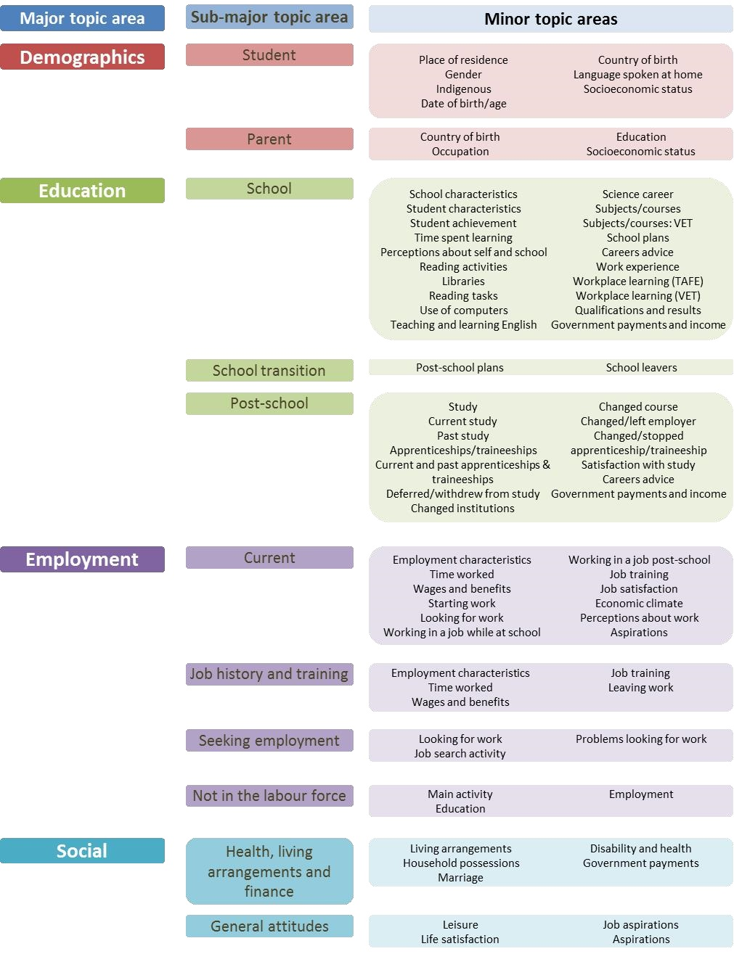

|  |  |  |
| --- | --- | --- |
| Demographics | Student | Place of residence  Gender  Indigenous  Date of birth/age  Country of birth  Language spoken at home  Socioeconomic status |
| Demographics | Parent | Country of birth  Occupation  Education  Socioeconomic status |
| Education | School | School characteristics  Student achievement  Perceptions about self and school  Libraries  Use of computers  Science career  VET subjects/courses  Careers advice  Workplace learning (TAFE)  Qualifications and results  Student characteristics  Time spent learning  Reading activities  Reading tasks  Teaching and learning English  Subjects/courses  School plans  Work experience  Workplace learning (VET)  Government payments and income |
| Education | School transition | Post-school plans  School leavers |
| Education | Post-school | Study  Current study  Past study  Apprenticeships/Traineeships  Current and past apprenticeships and traineeships  Deferred/withdrew from study  Changed institutions  Changed course  Changed/left employer  Changed/stopped apprenticeship/traineeship  Satisfaction with study  Careers advice  Government payments and income |
| Employment | Current | Employment characteristics  Time worked  Wages and benefits  Starting work  Looking for work  Working in a job while at school  Working in a job post-school  Job training  Job satisfaction  Economic climate  Perceptions about work  Aspirations |
| Employment | Job history and training | Employment characteristics  Time worked  Wages and benefits  Job training  Leaving work |
| Employment | Seeking employment | Looking for work  Job search activity  Problems looking for work |
| Employment | Not in the labour force | Main activity  Education  Employment |
| Social | Health, living arrangements and finance | Living arrangements  Household possessions  Marriage  Disability and health  Government payments |
| Social | General attitudes | Leisure  Life satisfaction  Job aspirations  Aspirations |

Source: NCVER (2012)

### Possible areas of change

At issue is the broad scope of LSAY and whether this needs to change to reflect emerging policy directions and research findings related to youth transitions. This issue has been under consideration for some years. The previous review of LSAY noted stakeholder interest in a broader scope of data in relation to young people’s early childhood and background experiences as well as a better indicator of SES status and youth health and well-being (Markiewicz & Associates 2010).

Following this, NCVER undertook a stocktake of the LSAY data comparing them against other relevant longitudinal studies, assessing their relevance to youth policy directions at national and state/territory levels and the national and international research literature on youth transitions. This study (Nguyen, Cully, Anlezark & Dockery 2010) concluded that the LSAY surveys provide a reasonable and consistent array of information for understanding the school-to-work transition, but that data collection needs to be extended given changes in policy context, other comparable surveys and research. It recommended that the scope of LSAY data collection be expanded in three areas:

* data on earlier circumstances are required to better understand the effects of early childhood learning on school-to-work transitions;
* richer information on the socioeconomic background of young people is needed to better understand the processes whereby background influences youth outcomes; and
* broader information on the health and wellbeing of young people would provide measures of successful transitions beyond economic and educational outcomes.

Follow on work has included a review of the well-being and life satisfaction questions in LSAY (Stanwick & Liu 2012) and an exploration of the usefulness of existing data items in applying a social capital perspective to understanding how socioeconomic background impacts on educational outcomes and transitions (Semo & Karmel 2011).

This section considers the potential policy and research value of expanding the scope of LSAY in four areas:

* school achievement before age 15
* family and parental socio-economic background
* child and adolescent learning and development and
* broader youth outcomes.

The scope to rationalise the existing questionnaire is also discussed in this section. The implications of any expansion in scope for data collection are discussed in greater depth in Section 3.2, in particular the feasibility and costs aspects. Overall assessments of priority are considered as part of the discussion of options in the dealt with in the Executive Summary.

### School achievement before age 15

The fact that LSAY commences when students are already 15 years of age limits its capacity to disentangle the relative impact of different influences on education, training and employment outcomes because LSAY’s earliest achievement measures (PISA) already embody the outcomes of earlier life and school experiences and opportunities. A consistent finding from LSAY research has been that the level of literacy and numeracy achieved by 15-year-olds is a major factor contributing to later patterns of education and work, including their chances of completing school, entering higher education, earnings and being unemployed (NCVER forthcoming, pp 11-13). However, this result is influenced significantly by the proximity of the age at which achievement is first measured to the subsequent outcomes. This tends to overstate the influence of achievement relative to other factors, e.g. family and community environments and individual capabilities.

The potential value of earlier achievement data is illustrated by a British study of the determinants of higher education participation decisions. This used an individual-level administrative dataset with information on a particular cohort of state school pupils as they progressed through the education system reaching Year 11 in 2001–02. The data included detailed information on pupils’ educational achievement in primary and secondary school, which enabled the study to examine when gaps in educational achievement emerged for different types of student. The study concluded that the major factor in different rates of higher education (HE) participation by social background is due to a gap in academic performance in secondary school and that interventions to counter this would be more likely to improve subsequent HE participation than concentrating on pathways from the end of schooling to higher education (Chowdry, Crawford, Dearden, Goodman & Vignoles 2008).

The most direct way of introducing earlier achievement into LSAY would be to match respondents with their NAPLAN records of literacy and numeracy in Years 3, 5, 7 and 9. This has already been agreed and implemented for the Longitudinal Survey of Australian Children (LSAC) (Daraganova, Edwards & Sipthorp 2013). An illustration of the benefit of this linkage is a recent study using LSAC, which showed a significant positive association between pre-school attendance, the qualifications of the pre-school teacher and Year 3 NAPLAN scores (Warren & Haisken-DeNew 2013). A recent investigation into the feasibility of linking LSAY to NAPLAN concluded that it would be feasible, subject to the agreement of states and territories and procedures for obtaining consent from survey participants (Gemici and Nguyen 2013). These issues are canvassed in more detail in Section 3.2.

There would be clear value added in LSAY including earlier measures of school achievement before age 15 by matching to NAPLAN records, subject to developing detailed protocols and obtaining agreement from data owners and consent from individual LSAY respondents.

### Family background and parental engagement

At present LSAY measures family background based on data collected from students at age 15 as part of the PISA testing. The PISA student survey asks questions about indigenous status, country of birth, immigration status/age of arrival and language spoken at home. Data about family socioeconomic status (SES) is also collected in the form of the student’s mother’s/father’s occupation, highest level of schooling, educational qualifications and main activities (working full-time, part-time, looking for a job or home duties). In addition, data is collected on items in the home that are indicative of family background and SES such as a desk to study at, a quiet place to study, a computer for school work, literature, books, a dishwasher and a DVD player, TVs, cars and rooms with a bath or shower. Related data that is not part of the SES measure include parental and peer post-school expectations and their influence on aspirations as reported by students.

There are two issues about this data. One is that for a significant number of students these data are missing due to non-completion of the relevant part of the student questionnaire, particularly for information collected about their parents. In the Y95 cohort, for example, up to 25% of information relating to parents’ occupation is missing (Nguyen et al 2010). This was around 6% to 7% for the Y09 cohort, but between 17% and 28% of responses were missing on the mother’s and father’s post-school qualifications (NCVER 2012b). The parental post-school plans variable has over 40% of data values missing, while the peers’ post-school plans variable has over 50% of values missing (Gemici, Bednarz, Karmel & Lim 2014).

The second issue is the lack of some data that would contribute to a better understanding of the effect of family background on youth transitions. At present LSAY’s family background data is focussed on socio-economic measures using parental education, occupation and home possessions. However, there is evidence that parental engagement and a variety of non-material factors also play an important role in outcomes. These include parental aspirations and ambitions for children, general attitudes to education and career, support for and involvement in career planning and role model effects on self-efficacy and career aspirations, especially for young people from otherwise disadvantaged backgrounds (Nguyen et al 2010). This echoes concerns with young people growing up in households in which there is no working adult as a role model and the effects on the inter-generational transmission of poverty. While SES as measured by parental education and occupation is still important, it may well be less significant than previously thought (e.g. Homel et al 2012; Lim et al 2013; NCVER forthcoming). More generally, there are arguments that across western industrialised countries socioeconomic background is becoming less significant in shaping education and later occupational outcomes after taking into account differences in cognitive ability (Marks 2013).

Richer measures of family background and parental engagement would need to be collected through a survey of parents, possibly at the commencement of a new LSAY cohort in 2015 (discussed in more depth in Section 3.2). A parental survey would also be an opportunity to reduce missing data about parental education and occupation and improve the quality of these data generally as parents are more likely than the children to provide accurate responses to questions about events in the past (e.g. highest level of school or educational attainment) as distinct from the present (e.g. current occupation).

Better quality data on parental education and occupation, along with data on parental attitudes and aspirations for education and careers would contribute to a more nuanced analysis of these issues. Table 7 compares family background data topics covered in PISA/LSAY, PIRLS and a number of youth longitudinal surveys. Y indicates that at least some data relevant to a particular topic is collected, although detailed measures and their depth vary extensively across surveys. Note that all of these include a parental survey (see *Support Document* Appendix 6 for a comparison of key features), but in PISA the parental survey is an international option, which Australia has not participated in to date. (For PISA/LSAY in Table 7, Y indicates data is collected through the student questionnaire and P indicates data is collected though the PISA parent questionnaire only.)

1. Family background data collected in selected surveys

|  | **PISA/LSAY\*** | **PIRLS** | **YiF** | **YIT** | **LSYPE** | **NLSY** |
| --- | --- | --- | --- | --- | --- | --- |
| Country | OECD | 49 incl. Australia | Australia | Canada | England | USA |
| Year | 2012 | 2011 | 2006 | 2000 | 2007 | 1997 |

| **Household structure** | **PISA/LSAY\*** | **PIRLS** | **YiF** | **YIT** | **LSYPE** | **NLSY** |
| --- | --- | --- | --- | --- | --- | --- |
| Household composition | Y |  | Y | Y |  | Y |
| Marital status/family type |  |  | Y | Y |  | Y |

| **Immigration & language** | **PISA/LSAY\*** | **PIRLS** | **YiF** | **YIT** | **LSYPE** | **NLSY** |
| --- | --- | --- | --- | --- | --- | --- |
| Country of birth/when arrived | Y |  | Y | Y |  | Y |
| Language spoken at home | Y | Y | Y | Y | Y | Y |
| Indigeneity | Y |  | Y | Y |  | Y |
| Cultural or ethnic background |  |  |  | Y | Y | Y |

| **Parental personal information** | **PISA/LSAY\*** | **PIRLS** | **YiF** | **YIT** | **LSYPE** | **NLSY** |
| --- | --- | --- | --- | --- | --- | --- |
| Marital/relationship history |  |  | Y | Y |  | Y |
| Religion |  |  |  |  | Y | Y |
| Self-rated health |  |  |  | Y | Y | Y |
| Smoking & drinking |  |  |  | Y |  |  |

| **Parental education/employment** | **PISA/LSAY\*** | **PIRLS** | **YiF** | **YIT** | **LSYPE** | **NLSY** |
| --- | --- | --- | --- | --- | --- | --- |
| Completed schooling | Y |  | Y | Y | Y | Y |
| Highest educational qualifications | Y | Y | Y | Y | Y |  |
| Employment status | Y | Y | Y | Y | Y | Y |
| Occupation | Y |  | Y | Y | Y | Y |
| Hours and earnings |  |  | Y |  | Y |  |

| **Resources** | **PISA/LSAY\*** | **PIRLS** | **YiF** | **YIT** | **LSYPE** | **NLSY** |
| --- | --- | --- | --- | --- | --- | --- |
| Education expenditure | P |  |  |  |  |  |
| Household income | P |  | Y | Y |  | Y |
| Financial assets and liabilities |  |  |  |  |  | Y |
| Home possessions | Y | Y |  |  | Y |  |

| **Parental aspirations and support** | **PISA/LSAY\*** | **PIRLS** | **YiF** | **YIT** | **LSYPE** | **NLSY** |
| --- | --- | --- | --- | --- | --- | --- |
| Engagement with reading |  | Y |  |  |  |  |
| Parental involvement in school | P | Y | Y | Y | Y |  |
| Support for learning in the home | P | Y |  | Y | Y |  |
| Attitudes to education |  |  | Y | Y |  |  |
| School choice | P |  |  | Y |  | Y |
| Aspirations for child | Y | Y |  | Y | Y | Y |
| Discussing school or future career |  |  |  | Y |  |  |

\* For PISA/LSAY, Y indicates data is collected through the student questionnaire and P indicates data is collected though the PISA parent questionnaire only. Data items are those collected for the year indicated but may vary across cohorts and waves. The 2009 PISA Parent Questionnaire was administered in eight OECD countries (Chile, Denmark, Germany, Hungary, Italy, Korea, New Zealand and Portugal) and in six partner countries and economies but not in Australia. The 2011 PIRLS Parent Questionnaire was administered in all countries participating in the study, including Australia.

In particular, a parental survey such as that conducted as part of PISA, would provide additional data on parental involvement in and attitudes towards their child’s school, support for learning in the home and school choice. As well, it would enable direct measurement of parental educational and occupational aspirations for their child as well as the parents’ educational qualifications, employment and occupation. Other surveys collect an even broader scope of data including the extent to which the parent discusses school or future career plans with the child and attitudes to education more generally.

As outlined in Section 2.4, a number of more recent LSAY research reports have pointed towards the complexity of the links between family background and youth outcomes, including in identifying the causal mechanisms through which they operate, the role of mediating factors and the direct and indirect effects. A parental questionnaire that provided better data on family background and parental engagement would improve LSAY’s capacity to be relevant to policy by supporting more sophisticated analysis of the relationship between social background and educational and other outcomes for youth.

### Child and adolescent learning and development

It is now well recognised that a child’s early years are fundamental to shaping their life chances and that a complex range of factors interact in this process, including the quality of family and community environment, personal capabilities, the broader economic and social environment and the availability of developmentally rich experiences (McLachlan, Gilfillan & Gordon 2013). Developmental trajectories and life events outside education and employment during a child’s earlier school years leading up to age 15 (and indeed before they commence school) as well as those during adolescence all ultimately bear on whether youth transitions are successful or unsuccessful.

Table 8 compares coverage of various aspects of child and adolescent learning and development topics in PISA/LSAY, PIRLS and in a number of youth longitudinal surveys. PISA/LSAY has strong coverage of formal learning through school, the quality of the school experience at age 15 and above and learning behaviours associated with this.

There are a number of aspects of earlier and adolescent development that could improve the explanatory power of LSAY. Nguyen et al (2010) refer in particular to the possibility of collecting data concerning early learning difficulties, parental behaviour and style, the quantity and quality of time parents spend with children, birth weight, and time spent in childcare and early childhood.

1. Child and adolescent learning and development data in selected surveys

|  | **PISA/LSAY\*** | **PIRLS** | **YiF** | **YIT** | **LSYPE** | **NLSY** |
| --- | --- | --- | --- | --- | --- | --- |
| Country | OECD | 49 incl. Australia | Australia | Canada | England | USA |
| Year | 2012 | 2011 | 2006 | 2000 | 2007 | 1997 |

| **Before school** | **PISA/LSAY\*** | **PIRLS** | **YiF** | **YIT** | **LSYPE** | **NLSY** |
| --- | --- | --- | --- | --- | --- | --- |
| Use of child care | P | Y |  |  |  | Y |
| Home learning activities | P | Y |  |  |  |  |

| **Learning behaviours** | **PISA/LSAY\*** | **PIRLS** | **YiF** | **YIT** | **LSYPE** | **NLSY** |
| --- | --- | --- | --- | --- | --- | --- |
| Absenteeism/expulsion | Y |  | Y |  | Y | Y |
| Enrichment/remedial courses | Y |  | Y | Y | Y | Y |
| Grade repetition | Y |  | Y | Y | Y | Y |
| Voluntary reading outside school | Y |  |  | Y | Y | Y |
| Study & reading strategies | Y |  |  |  |  |  |
| Visiting libraries | Y |  |  |  |  |  |
| ICT use at school and home | Y |  |  |  |  |  |
| Expected level of educational attainment | Y |  | Y | Y | Y | Y |

| **Home environment:-** | **PISA/LSAY\*** | **PIRLS** | **YiF** | **YIT** | **LSYPE** | **NLSY** |
| --- | --- | --- | --- | --- | --- | --- |
| Parenting style/rule making |  |  |  | Y | Y | Y |
| Parent’s personal control beliefs |  |  | Y |  |  |  |
| Quality of relationship with youth |  |  | Y |  | Y |  |

| **Child/youth development:-** | **PISA/LSAY\*** | **PIRLS** | **YiF** | **YIT** | **LSYPE** | **NLSY** |
| --- | --- | --- | --- | --- | --- | --- |
| Activities out of school | Y |  |  | Y |  |  |
| Part-time/casual employment | Y |  |  |  |  |  |
| Physical and mental health | (a) |  | Y |  |  | Y |
| Drug and alcohol use |  |  | Y |  |  | Y |
| Delinquency/ contact with authorities |  |  | Y | Y | Y |  |
| Time spent in child protection |  |  |  |  | Y | Y |
| Learning difficulties or disability | (b) |  |  | Y |  |  |

\* For PISA/LSAY, Y indicates data is collected through the student questionnaire and P indicates data is collected though the PISA parent questionnaire. Data items are those collected for the year indicated but may vary across cohorts and waves.

(a) Psychological distress questions were introduced in 2010 for the Y03 and Y06 cohorts (when the Y06 cohort was about 19).

(b) LSAY has limited data about any disability or health problem that has lasted for six months or more and has limited the amount or type of work participants can do. Health problems listed include depression/mental health as well as learning difficulties.

Some recent research using LSAY such as Homel et al (2012) has also highlighted the value of information about risk factors including aspects of the participant’s earlier educational experiences ( e.g. grade repetition) combined with risky behaviour in adolescence (e.g. smoking and alcohol consumption) in accounting for transition outcomes.

A similar study in Canada looked at academic and social outcomes for high‐risk youths in Manitoba, using longitudinal, population‐based data for a cohort of children born in 1984‐1985. The study focused in particular on students with one or more of three factors that place them at risk of not succeeding in high school: (a) being involved with the child welfare system, (b) living in poverty, and (c) having teen mothers. It found that for youths with one risk factor, 41 to 57 per cent failed to complete high school, and 84 per cent of those with all three risk factors did not complete high school, compared with only 18 per cent of youths with none of the risk factors. Similar poor outcomes were found for performance in grade 9, unemployment in early adulthood, and teen births (Brownell, Roos, MacWilliam, Leclair, Ekuma & Fransoo 2010).

Apart from earlier measures of school achievement as discussed above, other aspects of students’ earlier learning experiences can be relevant. Areas where LSAY offers less coverage than these other surveys include the use of child care before commencing school and home learning activities for the young child. Since these are covered in the PISA parent questionnaire taking up that international option would make this data available to LSAY.

Other areas where PISA/LSAY is relatively limited in coverage are the home environment and broader aspects of child and youth development that would help to identify at risk youth. Other longitudinal youth surveys collect data about the influence of home environment in terms of:

* parenting style including the extent to which parents set and observe rules for behaviour by themselves and their children;
* parent’s own attitudes and beliefs about the extent of control they have over their life; and
* the quality of the parent’s relationship with the youth including the extent of difficulties and arguments.

Broader aspects of child and youth development that are also potentially useful in explaining youth transitions include physical and mental health issues, drug and alcohol use, occurrence of delinquency or contact with authorities such as the police, involvement in the child protection system and learning difficulties or disabilities that affect the child or youth’s education or development.

There are a number of issues to consider in whether LSAY’s coverage should be expanded in relation to home environment and broader aspects of child and youth development. First, doing so is beyond the scope of the PISA parental survey and so would require a separate survey of parents either following a PISA parental survey or instead of it (e.g. in Wave 2). Second, this type of data is more sensitive and difficult to collect than existing PISA/LSAY core data and this would have implications for acceptability to key stakeholders, collection timing, mode and cost.

Thirdly, it could be argued that broadening LSAY to include these is unnecessary since LSAC is already collecting rich data on child physical, mental and intellectual development and emotional wellbeing along with family demographics, the home education environment, parenting style and child care. It is also sourcing data on literacy and numeracy achievement from NAPLAN and, as it follows its subjects through to their mid-twenties, will collect similar data to LSAY on education and employment pathways and outcomes. Consequently, LSAC will enable policy and research questions about the relationship between earlier learning and child and adolescent development and transition outcomes to be addressed once its cohorts are older (the older LSAC cohort reaches 20-21 years of age in 2020). However, since the LSAC cohort size is approximately half that of LSAY, the extent to which it can do this analysis may be more limited than if some measures were collected through LSAY. Also, since the LSAC sample is not drawn from within schools as the PISA/LSAY sample is, it would not be possible to look at the effect of school-level factors using LSAC.

While there would be potential value in collecting measures of home environment and broader aspects of child and youth development in LSAY, doing so would be a complex and challenging task in relation to planning for a new cohort in 2015. The option of a parental survey in PISA 2015 to derive more accurate and richer measures of family background and instituting data linkages to NAPLAN for this cohort present significant opportunities to enhance the value of LSAY in the short term. The value of broadening the scope of LSAY further to include child and youth development, in particular to better identify youth at risk, could be considered for new cohorts beyond 2015 depending on LSAY’s capacity to augment LSAC for this purpose.

### Broader youth outcomes

Australian governments have committed to broad goals for schooling that include not only promoting equity and excellence in formal learning, but also that young Australians become confident and creative individuals as well as active and informed citizens with strong personal values, optimism about the future, self-awareness and the ability to manage their emotional, mental, spiritual and physical wellbeing (Melbourne Declaration).

While the focus of LSAY is on education and employment outcomes for youth transitioning to adulthood, some data is collected for all the active cohorts on disability, physical and mental health, living arrangements, general attitudes and volunteering. Nguyen et al (2010) argued that both policy and research interest in non-economic outcomes is growing, and LSAY may need to adapt to this for it to remain at the forefront of youth transition research. Coverage of broader outcomes in LSAY and other longitudinal surveys is summarised in Table 9 under the headings of physical health, mental health and well-being, risk behaviours, attitudes and social capital.

#### Social capital

LSAY has collected some data about the effects of social capital networks on youth transitions, primarily in relation to the Y03 cohort. Semo & Karmel (2011) analysed this and found that social capital does influence educational participation over and above the effects of background characteristics such as parents’ education levels, parental occupation, geographic location, cultural background, school sector and academic achievement. However, not all of this data is collected for the newest cohort. Semo (2011) argued that LSAY has the potential to provide a platform for testing social capital theories that relate to young people and youth transitions, but its role rests on having a consistent and reliable set of questions asked from early waves of each cohort.

1. Broader outcomes in selected youth and household surveys

|  | **LSAY** | **HILDA** | **YiF** | **YIT** | **LSYPE** | **NLSY** |
| --- | --- | --- | --- | --- | --- | --- |
| Country | Australia | Australia | Australia | Canada | England | USA |
| Year | 2012 | 2011 | 2006 | 2000 | 2007 | 1997 |

| **Physical health:-** | **LSAY** | **HILDA** | **YiF** | **YIT** | **LSYPE** | **NLSY** |
| --- | --- | --- | --- | --- | --- | --- |
| Self-rated general health | Y | Y | Y |  | Y | Y |
| Physical health and disabilities | Y | Y | Y | (a) | Y | Y |

| **Mental health and well-being:-** | **LSAY** | **HILDA** | **YiF** | **YIT** | **LSYPE** | **NLSY** |
| --- | --- | --- | --- | --- | --- | --- |
| Mental health and well-being | Y | Y | Y | Y | Y | Y |
| Life satisfaction | Y | Y |  |  | Y |  |

| **Risk behaviours and attitudes** | **LSAY** | **HILDA** | **YiF** | **YIT** | **LSYPE** | **NLSY** |
| --- | --- | --- | --- | --- | --- | --- |
| Drinking/smoking/exercise |  | Y | Y |  | Y | Y |
| Personality traits |  | Y |  |  |  | Y |
| Occurrence of major life events |  | Y | Y |  |  | Y |
| Illegal/risky behaviour |  |  | Y | (b) | Y | Y |
| General attitudes | Y | Y | Y |  |  | Y |
| Locus of control |  | Y | Y |  | Y | Y |

| **Social capital:-** | **LSAY** | **HILDA** | **YiF** | **YIT** | **LSYPE** | **NLSY** |
| --- | --- | --- | --- | --- | --- | --- |
| Perceptions of school | Y |  |  |  |  | Y |
| Perceptions of teachers | Y |  |  |  | Y | Y |
| School organised activities | Y |  |  |  |  |  |
| Community activities | Y |  |  | Y | Y | Y |
| Networks and support | Y | Y |  | Y |  | Y |

(a) Asked in relation to whether it affects activities, but data on nature of disability or condition not collected.

(b) Collected through parent questionnaire for age 15 only.

Data items are those collected for the year indicated but may vary across cohorts and waves.

A constraint on doing so has been the length of the PISA student questionnaire that has been used in the past as the vehicle for collecting this data. An alternative may be to collect such data in future as part of LSAY in Wave 2, subject to other demands on average interview times and further work to establish the most appropriate measures to use. As well, collecting social capital data only at the beginning of LSAY means that analysis focuses on how social capital at age 15 influences later outcomes, when social capital networks are also an outcome of the transition to adulthood and are influenced by transition pathways. A broader focus on social capital as both an influence and an outcome would require data to be collected a number of times over the life of an LSAY cohort.

#### Physical health

LSAY currently collects data on self-rated general health (excellent to poor) and whether participants have any disability or health problem that has lasted for six months or more and has limited the amount or type of work they can do. This includes details of some common chronic conditions (e.g. limb/back/neck problems and diabetes). The reported incidence of disability or health problems in LSAY is slightly lower than that in the general population of young people (e.g., just over 6% of the Y03 cohort in 2012 compared with 7% among all 15-24 year olds in 2009 (AIHW 2011)). Other surveys point to between 20% and 30% of 35 year olds being concerned about their physical and mental health (Cuervo & Wyn 2011).

In order to make a case for gathering any additional health status data, a relationship between them and the success of youth transitions would need to be demonstrated. Potentially health is of interest as both an outcome in its own right as well as an influence on young peoples’ education, training and employment outcomes. There is evidence of a strong correlation between educational attainment and health with education influencing health outcomes through a range of complex mechanisms including: the effect of employment and income on access to health care; the effect of knowledge and cognitive development on behaviours such as smoking and diet; and through the effect of social networks on access to information and services (DAE 2012a). Health can also affect education. For example, a small qualitative survey of 27 young people who left school early found that a third reported serious health conditions that drastically inhibited their ability to attend school (AYAC 2012). More generally there are arguments that health outcomes for young people are increasingly affected by the changing nature of youth transitions in Australia such that the task of balancing life’s responsibilities including study, work and social relationships has become more challenging for recent cohorts (Cuervo & Wyn 2011).

LSAY is not an appropriate vehicle for collecting detailed and sensitive health data which is collected through other specialist vehicles (NCVER 2013). Moreover, there are difficulties in the extent to which a general survey such as LSAY can collect information on health and wellbeing issues that may only affect a small proportion of the youth population. Nevertheless, there is a case for LSAY to collect some additional data on physical health in order to contribute to a better understanding of its role in influencing education and employment outcomes, as well as the impact in turn of education and employment on health outcomes as young people reach adulthood. This might be achieved by adding a limited number of questions about the use of common medications, the frequency of access to health services and other relevant variables that could usefully contribute to explaining transition pathways and outcomes.

#### Mental health and well-being

The LSAY dataset already has a range of items in this area including subjective measures of life satisfaction with various aspects of life, such as work, getting on with others, social life, life at home and life as a whole. PISA includes some questions about coping with school and later waves have included questions about financial stress (annually from wave 6 for Y03 and from wave 5 for Y06) and psychological distress[[3]](#footnote-3) (in 2010 for both the Y03 and Y06 cohorts).

It is clear that policy interest in this area has increased in recent years (Nguyen 2011). MCEETYA commissioned work on conceptualising and measuring student well-being specifically in the school context (Fraillon 2004). A study exploring the value of a more holistic and comprehensive approach to student wellbeing as a first step towards embedding this in the school curriculum (Noble et al 2008) led to the adoption by MCEECDYA of the National Safe Schools Framework in 2010. Surveys of school students have provided base level data about their social and emotional well-being (Bernard et al 2007). Other regular reporting also focuses policy attention on health and wellbeing (AIHW 2007; ARACY 2013). A number of individual schools have implemented programs to improve student well-being and thereby improve outcomes.

Collecting data on mental health and well-being is challenging given the sensitive nature of any survey questions as well as the complexity of a notion encompassing several different dimensions, such as physical, emotional and mental health and the social aspects of life. There is no consistent definition or single framework of indicators that best measure wellbeing, with different measures appropriate at different stages of life. The emotional and social aspects of wellbeing in particular are more difficult constructs to measure, especially in a telephone interview such as is currently used for LSAY. There are also differences between measuring well-being as a positive state as distinct from the absence of harm. While there are existing instruments able to measure the positive components of well-being among adolescents, they are designed as self-completed questionnaires and would likely require extensive adaptation and validation to be used in LSAY. On the other hand, longitudinal surveys have a significant potential contribution to make in this area compared to available cross-sectional data since they can help to disentangle the effects of adolescent mental health and well-being on young people’s transitions from the effects of poor transitions on mental health and well-being in adulthood.

As with physical health, the case for gathering additional data on mental health and well-being in LSAY rests on the role it can be shown to play in the process of youth transitions rather than in attempting to measure its overall status among young people. To date the data collected on psychological distress from the Y03 and Y06 cohorts has not been analysed. A first step would be for the existing question about psychological distress to be repeated for the Y06 cohort nearer to their mid-twenties and for it to be collected from the Y09 cohort at suitable intervals. The added value of this data could then be considered along with whether the absence of distress is an adequate measure of well-being or whether other measures of mental health and well-being capturing resilience and adaptability should be included and how that might be done. Within the constraints of a broad telephone survey conducted by non-health professionals, and given current knowledge, a measure of psychological distress such as the Kessler-6 is probably about as much as could be included.

#### Risk behaviours and attitudes

LSAY currently collects some data on attitudes and aspirations, including attitudes towards schooling and aspirations for education and employment. However, it does not currently collect data about behaviours which can signal risk for youth transitions.

Some recent studies point towards the value of a more nuanced understanding of the effects of risk behaviours over and above the role of social background and aspirations in shaping youth transitions. Homel et al (2012) used synthetic data matching between LSAY and YiF to create a more multi-dimensional measure of disadvantage covering both its cultural and material aspects. They found that poor school experiences, participation in risky activities (e.g. smoking and drinking alcohol) and aspirations are the main predictors of Year 12 non-completion, while parental education and occupational status are less significant. Cobb-Clark et al (2013) using the YiF data found that educational penalties associated with early marijuana use are compounded by high-intensity use and for those living in families with a history of welfare receipt.

This is consistent with the findings from a number of British studies using the LSYPE well-being data which find that the socio-economic gap in most outcomes is significantly reduced once differences in beliefs about future higher education, together with a range of other attitudes and behaviours of the young person, are taken in to account (Chowdry, Crawford & Goodman 2009). Analysis of the LSYPE also suggests that the impact of risky behaviours on educational outcomes can be significant, lowering General Certificate of Secondary Education (GCSE) scores by 20% after controlling for other background characteristics (Cebulla & Tomaszewski 2009), with attitudes and aspirations to education playing a significant role in shaping the propensity to become involved in risky behaviours while at school (Green & Ross 2010).

HILDA, YiF and the NLSY97 collect a broader range of data in this area. These include a number of scales to measure attitudes and personality traits and the individual’s feelings of control over their life. Particularly relevant to youth at risk are measures of illegal or risky behaviour including delinquency, drug and alcohol use, contact with authorities, truancy, criminal activity and sexual behaviour. Given the sensitivity of these issues they are usually collected using self-completed questionnaires, enabling respondents to directly enter their responses without an interviewer knowing their answer (Nguyen et al 2010, p 23).

While there is potential value from collecting such data in LSAY, there are also significant challenges to overcome in terms of sensitivity, data collection methods, ethics, cost, respondent burden and attrition. For these reasons it would be important to proceed carefully. A starting point would be to review in greater depth the data collected in this area through other surveys mentioned above to establish priorities that could then be considered for collection over the life of a new cohort commencing in 2015.

### Possible rationalisation of some data

If the scope of LSAY data to be collected is increased, it is important to consider whether there is also scope to reduce data collection in some areas. This could be achieved by reducing the level of detail on some topics, including them less frequently or dropping them altogether.

The 2010 stocktake of LSAY data suggested that the current LSAY survey instruments collect a high level of detail on school subject choices, especially in Years 11 and 12. However, this data has been used in analyses of STEM study and career choices as well as the impact of VET in schools. Moreover, LSAY has offered the only existing source of national information on Year 12 school subject choice (Nguyen et al 2010). An earlier review of the LSAY questionnaire (McMillan, Redway & Rothman 2002) recommended the continued collection of Year 11 subject choice information as VET subjects tend to be taken in Year 11 more than in Year 12 and the ability to analyse and report on VET in schools would be reduced if Year 11 subject choice data are not collected. The report did suggest that consideration should be given to dropping a number of data items that applied only to very small subsamples of respondents (studying for the International Baccalaureate; reasons for returning to school) or had been little used in analysis.

There are good reasons for caution in changing or dropping data items in LSAY given the importance of comparability of data over extended time periods in a longitudinal survey. However, the temptation to avoid change can over time lead to the accretion of less essential data in the collection. Given that the last thorough review of the questionnaires was in 2002, it would be appropriate for there to be an in-depth re-examination of the questionnaires and the coverage and depth of data topics over the life of cohorts with a view to identifying scope to reduce the length of interviews. The results of this review should be available for consideration alongside any proposed expansion in scope as discussed earlier in this section. Consultations with a variety of LSAY stakeholders should be undertaken as part of this to test the broad acceptability of any proposed changes.

### Conclusions

Since its inception LSAY has had a core focus on the educational, training and employment dimensions of youth transitions. The 2010 review of LSAY stressed that the survey “cannot be 'all things to all people' and thus greater clarity and communication about the core purpose of LSAY, what it can and what it cannot do, may assist in narrowing and thereby prioritising the range of improvements” (Markiewicz & Associates 2010, p ii). The expansion in the scope of LSAY canvassed here need not alter the core purpose of describing and explaining the educational, training and employment dimensions of youth transitions. The case for gathering additional data rests on the role other factors can be shown to play in these transitions and/or in their association with the outcomes that LSAY has measured in the past. The goal of broadening LSAY’s scope would be to rejuvenate its relevance to contemporary policy and research concerns and improve its capacity to describe and explain patterns, rather than to make LSAY comprehensive in scope.

This approach reflects the significant practical constraints on what and how data is collected through LSAY discussed in following sections of this report (e.g. budget, survey design, data collection methods) as well as the need to be selective about what and how additional data might be included to complement LSAY’s core purpose. The clearest case for the potential value of some broadening of the scope of data relates to:

* Matching to NAPLAN records to obtain earlier measures of school achievement before age 15, subject to developing detailed protocols and obtaining agreement from data owners and consent from individual LSAY respondents. This would improve LSAY’s capacity to separate the effects on youth outcomes of school achievement relative to other factors, e.g. family and community environments and individual capabilities.
* Participating in the PISA parental survey to obtain more accurate and wider data on family and parental background and engagement. This would allow LSAY to better explore the complexity of the links between family background and youth outcomes, including in identifying the causal mechanisms through which they operate and the role of mediating factors as well as those that can build resilience.
* Introducing some selected broader measures of youth outcomes in LSAY including social capital, physical and mental health and risk behaviours and attitudes to capture their role in youth transitions. There are differences between each of these dimensions in the extent to which LSAY has already collected data and could do so in future and the challenges and sensitivities in doing so, but these should be considered for collection in future.

While there is considerable policy and research interest in child and adolescent learning and development beyond formal school achievement, it would be very difficult to collect such data from young people and their parents for a new LSAY cohort in 2015. The availability of such data from LSAC as its cohorts reach adolescence also reduces the case for LSAY to pursue this issue. However, this could be reconsidered for new LSAY cohorts beyond 2015 depending on LSAY’s capacity to augment LSAC.

## 3.2 Data collection methods

This section outlines existing LSAY data collection methods and compares them with those in other longitudinal and youth surveys both in Australia and overseas. It also discusses a number of options for future data collection including the addition of a parent survey or some element of face to face interviewing, expanding the scope of data collected through LSAY, making greater use of supplementary topics on an occasional basis, linking with administrative data collections such as NAPLAN, better aligning data LSAY and LSAC and promoting online survey completion.

### Current arrangements

At present the data available in LSAY is collected through several different mechanisms. As part of the PISA testing in 2012 school principals and/or administrators completed a questionnaire about their school that included demographic characteristics and an assessment of the quality of the learning environment at school. Students underwent 2 hours of testing in reading, mathematics and science plus a 40 minute computer-based assessment that assessed one or more of problem solving, mathematical and reading literacy. In addition there was a student background questionnaire, which comprised a set of core items in all participating countries about the student and their family background plus a series of international options, of which Australia participated in one on ICT familiarity and another on interruptions to schooling and preparation for future careers. A total of 40 minutes was allowed for this background questionnaire (Thomson, De Bortoli & Buckley 2013).

In the past LSAY has involved some additional data being collected through PISA as a national option including, most critically, contact details for follow-up in subsequent years. However, in 2012 an increase in the length of the student questionnaire due to the addition of new questions that collect information on factors impacting on student performance prevented the LSAY questions from being included and so commencement of a new cohort was not possible.

From the commencement of LSAY proper in the following year, those who participate in the PISA testing and provide their contact details are followed up annually with data collected via a computer assisted telephone interview (CATI). In 2012 these interviews averaged approximately 20 minutes in length for the Y09 cohort and 15 minutes for the Y03 and Y06 cohorts. Depending on the stage at which cohorts are, interview length has been up to 25 minutes in earlier years.

In 2012 an online option for survey completion was made available for the first time in response to requests from participants. Respondents had a choice between completing the LSAY survey online, in their own time and from a location of their choosing, or completing the usual telephone interview. By offering two methods to complete the survey, it was hoped to maintain response rates in an increasingly difficult survey environment and to increase the number of LSAY participants in each subsequent year. A significant number of completed interviews were conducted online: 29.9% for the Y09 cohort, 27.2% for the Y06 cohort and 32.6% for the Y03 cohort.

### Comparison with other youth and longitudinal surveys

Comparison of LSAY with other relevant Australian and overseas longitudinal surveys can potentially highlight LSAY’s strengths or suggest better ways of collecting data. A detailed comparison of LSAY with four other Australian longitudinal surveys and three overseas youth longitudinal surveys is contained in Appendices 2 and 3 of the Support Document. The key points of this on data collection are summarised in Table 10.

The four Australian longitudinal surveys are: Youth in Focus (YiF), a longitudinal survey of a national sample of young people and their parents conducted over 2006-08; the Longitudinal Survey of Australian Children (LSAC); the Longitudinal Study of Indigenous Children (LSIC); and the Household, Income and Labour Dynamics in Australia (HILDA) survey of households. The three overseas youth longitudinal surveys are: the Youth in Transition Survey (YITS, Canada); the Longitudinal Survey of Young People in England survey (LSYPE); and the National Longitudinal Survey of Youth (NLSY, USA).

The design of surveys is always a trade-off between competing considerations of purpose, budget and feasibility and each survey reflects the particular combination of these circumstances as they apply in each country at a given point in time. In broad terms, however, this comparison shows that LSAY is relatively quick and efficient as a data collection mechanism, with the shortest average interview length but is also limited in some of the types of data it is able to collect and from whom, e.g. from and about parents and the earlier experiences of the young people being surveyed.

#### Coverage

Coverage of a survey refers to the types of individuals from whom data is collected, with young people themselves being the key source of data in longitudinal youth surveys. In childhood surveys such as LSAC and LSIC the principal informant at the start is the parents, but the child becomes increasingly important in this regard as they grow older. In the three overseas longitudinal youth surveys and in the Australian YiF survey, parents are also interviewed to obtain data about family background and the earlier life experiences of the young person.

Surveys differ in how often and which parents are interviewed:

* In YiF, YITS and NLSY the parental interview was in the first wave only, but in LSYPE parents were interviewed annually for the first 4 waves in part due to the younger starting age of the youth cohort in that study and the need to obtain parental consent and for the value of this data in investigating some issues, e.g. the effects of bullying in schools. However, a review of the LSYPE recommended that in a second cohort parents be interviewed over the first 3 waves only (UK DfE 2010).
* In YiF, YITS and NLSY only one parent was interviewed, while in LSYPE data were collected from both a main and second parent where possible. The review of the LSYPE recommended that both parents be interviewed over the first 3 waves of a new cohort, but that second parent interviews could be conducted using web-based or postal questionnaire to reduce costs (UK DfE 2010).

1. Aspects of data collection in selected longitudinal surveys

| **Feature** | **LSAY** | **YiF**  **(Australia)** | **LSAC**  **(Australia)** | **LSIC**  **(Australia)** | **HILDA**  **(Australia)** | **YIT**  **(Canada)** | **LSYPE**  **(England)** | **NLSY**  **(USA)** |
| --- | --- | --- | --- | --- | --- | --- | --- | --- |
| **Young person / child coverage** | Yes | Yes | Yes – 2 age cohorts | Yes | Yes (1) | Yes | Yes | Yes |
| **Parent coverage** | No | Yes | Yes | Yes | Yes | Yes | Yes | Yes |
| **Collection methods** | Mixed – Self-completion (paper) in PISA then CATI & online other waves | CATI and self-completed questionnaires (paper or online). | CAPI with CATI in remote areas plus a self—complete questionnaire. | CAPI with CATI in remote areas. | Mostly face to face plus a self-completed questionnaire. | CATI | CAPI in early waves with mixed CATI/ online/ CAPI in later waves. | Mix of CAPI and CATI depending on cohort and wave. |
| **Average interview length** | 15-25 minutes | 30 mins plus 10 mins for self-completed questionnaire. | Ranges from just over 1 hour to 2½ hours depending on cohort and wave. | Ranged from about 1 to 1½ hours in wave 4. | Around 75 minutes in wave 11. | 69 minutes in cycle 6 (incl. tracing & call-backs) | 1½ hours in wave 1 down to 25 minutes in Wave 5. | Approx 1 hour. |
| **Collection frequency** | Annual | Twice only | Biennial with self-complete questionnaires between waves | Annual | Annual | Biennial | Annual | Annual then biennial |
| **Follow-up period** | 10 years | 2006 to 2008 | 15 years minimum | 8 years minimum | Ongoing |  |  |  |
| **Data linkage** | Under consideration - NAPLAN | Yes – Centrelink admin data | Yes - Medicare, NAPLAN, AEDI, childcare, ABS census | Yes - AEDI | No | Potential to match with university/ college data. | Yes – pupil attainment and characteristics plus school level data. | No |

Notes:

(1) While all members of selected households are included in the HILDA sample, individual interviews are only conducted with those aged 15 years and over.

#### Collection methods

Methods of collecting data have evolved considerably over time with the availability of increasingly sophisticated technology. LSAY uses a mixed mode of collection with both CATI and online collection. In contrast, most other longitudinal surveys employ to a greater extent face to face computer assisted personal interviewing (CAPI), with CATI or online collection used as a back-up where face to face collection is not feasible. The extent of reliance on face to face over other forms of data collection reflects budget constraints as well as the stage of a study, with CAPI more likely to be used as the primary data collection in the early waves of a cohort, shifting to CATI or online in later years. In the case of the LSYPE a face to face interview was felt to be more appropriate for the first interviews with younger people likely to be more comfortable with that format and other modes more appropriate for young adults (UK DfE 2010). Within either approach, a separate questionnaire is employed to collect more sensitive data (e.g. about risky or illegal behaviours). This can be directly entered by the respondent into a laptop in a face to face interview (LSYPE) or a separate self-completed paper or online questionnaire (YiF).

#### Interview length

At present the average LSAY interview length at 15-25 minutes is significantly lower than other longitudinal surveys where the average length is often an hour or more. Interview length tends to be shorter in later years of a cohort or where data collection occurs via the telephone. For example, in both HILDA (average interview of around 75 minutes across all questionnaires) and LSAC (up to 2½ hours depending on cohort and wave), the interview length reflects the scope and type of the data collected and the need for this to occur face to face. The YiF survey, which averaged 30 minutes, probably represents the maximum length that is feasible over the telephone.

#### Collection frequency

The longitudinal surveys in Table 10 are split relatively evenly between those where data collection on active cohorts occurs annually (LSAY, LSIC, HILDA and LSYPE) and those where it occurs every second year (YiF, LSAC and YIT). The US NLSY has used annual collection over the first 15 years or so of each cohort before then becoming biennial. Where collection occurs every second year, additional strategies may be employed to maintain contact in between, e.g. for LSAC this involved an additional postal questionnaire.

Collection frequency can reflect a range of considerations including the rate at which outcomes of interest change (arguably more quickly for youth than for small children), cost, achieved levels of response and attrition and the length of time over which a cohort is to be followed.

#### Data linkage

Increasingly linkage to administrative or other data is seen as an avenue for enhancing the richness and value of longitudinal surveys or for verifying the accuracy of data collected in surveys. With the exception of the NLSY, most other longitudinal studies have sought to make use of this, with the recent review of the LSYPE recommending that data linkage be expanded to include National Health Service data on health episodes, a longitudinal study on work and pensions and higher education data and, possibly, criminal records (UK DfE 2010).

A key issue here is how to obtain any necessary written consent from young people or their parents. As noted, this is more easily achieved in a personal than in a telephone interview. In the YiF and YIT surveys, both of which used CATI, respondents were asked during the telephone interview to give their verbal consent to linking to administrative data and written consent was not sought.

The precise requirements for obtaining consent vary with legislation and codes of ethics in different countries and, to the extent that they are becoming more stringent over time, practices in earlier cohorts or in other countries do not necessarily provide guidance for future LSAY cohorts.

### Data collection options

#### Linking to administrative data including NAPLAN

A recent study of the potential uses of linkage between LSAY and administrative and other data sources concluded that it would greatly enhance the ability to explore key drivers of young people’s transition outcomes without increasing respondent burden (Gemici & Nguyen 2013). Data linkage is increasingly used in longitudinal surveys in other countries and has contributed valuable findings. For example, using linked data from the Manitoba Population Health Research Data Repository, Canadian researchers have established important causal relationships between early life risk factors and long-term health, education and labour market outcomes (NCVER 2013).

Gemici and Nguyen (2013) identify several potential benefits in linking LSAY to other collections:

* Linking to NAPLAN would give access to data on literacy and numeracy development from grades 3 to 9, allowing researchers to better control for academic achievement at earlier ages. Conversely, the lack of contextual information in NAPLAN data can be broadened with individual background and transition data collected from LSAY.
* Linked administrative data from the education, training, and health sectors would allow researchers to explore the key drivers of young people’s transition outcomes over a much longer time span and wider range of outcomes than is currently possible through LSAY alone. In particular, it could mean extending LSAY with information on outcomes prior to age 15 (when LSAY starts) and beyond age 25 (when LSAY ends).
* Data linkage can significantly broaden the informational value of LSAY without adding to respondent burden. The benefits are particularly strong in topic areas that are currently limited in LSAY, such as health information and early educational performance. Medicare data on pharmaceuticals and out-of hospital service could provide a more accurate and extensive picture of any medical conditions or health issues that may impact on respondents’ outcomes.
* Data linkage can improve the accuracy of LSAY data because currently data are mostly self-reported and thus dependent on respondent recall.
* By reducing existing respondent burden, data linkage would allow scope for adding new questions to LSAY that could cover complex areas, such as social capital, wellbeing, and other measures of personal characteristics such as personality traits and risky behaviours associated with young people’s decision-making and impacts on later outcomes.
* Data linkage could be a relatively inexpensive way of broadening the informational value of LSAY within tight resource constraints.

The principal challenges to overcome are obtaining consent from respondents, developing processes that protect privacy and confidentiality and implementing effective linking algorithms that match individuals with a high probability. Of these, obtaining consent and protecting privacy present the greatest challenges.

* While there is no statutory minimum age at which a young person can consent to data linkage, parental consent is usually expected up to age 18. It is generally thought most appropriate to obtain written consent. In other surveys this is handled in a face to face interview, but different procedures would need to be followed in LSAY, possibly through sample maintenance activities during the year.
* Privacy would be addressed through the use of an independent data integration authority and arrangements for the storage of data similar to the model developed for linking LSAC and NAPLAN (Gemici & Nguyen 2013).

The possibility of consent bias – different population sub-groups consenting to data linkage at different rates – is a further issue on top of obtaining consent. Gemici & Nguyen (2013) suggest that this can be addressed by developing appropriate statistical weights based on consent probabilities and obtaining consent at the earliest possible stage to avoid compounding consent bias with attrition.

The recent implementation of data linkage between LSAC and NAPLAN, following agreement of state/territory governments and consent from a high proportion of parents, shows that these challenges can be overcome. The potential benefits of implementing data linkages are significant in terms of broadening the scope of data available for analysis and containing the burden of data provision on respondents. Further work on these processes and protocols should be pursued so that that they can be implemented for any new LSAY cohort.

The cost of linking NAPLAN data with LSAY would depend on the nature of the precise arrangements that were implemented. In 2013-14 NCVER is undertaking a pilot project at a cost of less than $50 000 to examine the feasibility of data linkage with NAPLAN. Once completed, the operational steps required for participant consent and matching data will be better understood and costs can be estimated.

#### Introducing a parental survey

Where they are used, parent questionnaires differ in the scope of data they collect. In the case of PISA 2009, the Parent Questionnaire was designed to provide efficient, reliable and valid data about home, school, and community factors influencing reading literacy against limited (international) costs and efforts. The questionnaire takes about 20 minutes to complete and covers:

* basic parent and family characteristics (father’s education, mother’s education, and number of children in the household);
* child’s past reading engagement, home reading resources and support and parents’ own reading engagement;
* annual household income and annual spending on children’s education;
* parents’ perception of and involvement in school; and
* school choice (i.e. options and reasons) (OECD 2012).

If Australia were to participate in the PISA Parental Questionnaire the benefits would be:

* Additional measures of parental engagement with learning and education, that would broaden out the effects of family background as well as the child’s engagement with learning.
* Missing data about parental education and occupation could be reduced (currently this is missing for up to 25% of students who participate in PISA)
* The quality of data could be improved as parents are more likely to provide accurate responses to questions about events in the past (e.g. highest level of school or educational attainment) as distinct from their current status (e.g. occupation). In countries where the PISA 2009 parent questionnaire was completed, the comparison of students’ and parents’ responses shows that agreement is over 80% for parents with university degrees but below 50% for parents with a tertiary VET qualification (NCVER 2013).
* Student response rates could be improved by influencing parents to support the survey and encourage their children to participate (especially in the first year after PISA where attrition is highest) by giving another point of contact with the youth to enable them to be located and followed-up for interview.

Participating in the PISA Parental Questionnaire would be low cost, e.g. around $30,000 for PISA 2015. The greatest risk is likely to be a modest response rate – this was one of the concerns that led to Australia not participating in the PISA 2009 parental survey. Although return rates of questionnaires vary considerably by country, those countries most like Australia had rather modest return rates to the PIRLS parental survey in 2006. There would also be concerns about additional administrative burden on participating PISA schools in supplying parental contact details. Australia has already decided not to participate in the PISA 2015 Parental Questionnaire (the OECD required a decision by early 2013) and the states/territories (other than NSW and Victoria) did not support participation. The issue could be revisited for PISA 2018, if a new LSAY cohort was delayed until that year.

Another option would be to develop a separate LSAY parent survey and deliver it:

* Alongside PISA using an online platform recently developed by ACARA and Education Services Australia to administer school parent surveys (noting that funding for this beyond June 2014 is currently uncertain); or
* As part of Wave 2 or 3 of a 2015 LSAY cohort using the data collection contractor and the same options of a telephone or online survey as apply to young people.

The feasibility of either option would need to be tested further. In either case access to parental contact details would be needed, either gathered from students in PISA or from schools. For example, the LSYPE gathers home contact information for students directly from schools.

The primary advantage of a parents’ survey separate to PISA is that it would allow a wider scope of data to be collected from parents that might inform youth transition policy development in a specifically Australian context. This might include data about:

* early childhood learning, e.g. use of child care before school, home learning;
* parental perceptions of and involvement in school;
* the student’s history of absenteeism, remedial courses, grade repetition and expulsion;
* parenting style and quality of relationship with the youth;
* the child’s/youth’s physical and mental health, delinquency/ contact with authorities;
* parental attitudes to education and careers and aspirations for their children; and
* other measures of SES e.g. receipt of family benefits or income support etc.

LSAY has some measures of these at present from students, but a richer set of data in these areas would enable a deeper analysis of the factors that affect youth transitions and support conclusions that are more nuanced.

The costs of a parent survey separate to PISA is likely to vary depending on the option pursued. A parental survey as part of telephone interviewing in an early wave of a Y15 cohort (say in 2016) could cost approximately $0.5m, similar to the cost of a new cohort of young people in the first year. A survey using the ACARA platform is likely to cost significantly less, but a purely online survey may suffer from low response rates. In either case, the greatest risks are likely to be around obtaining contact details for parents and response rates from them.

On balance, there is strong merit in a parental survey as part of any new LSAY cohort to collect data on early learning and circumstances and more accurate SES data. The most efficient and direct way to achieve this would have been to participate in the PISA parental survey in 2015. As this is no longer feasible due to the PISA timetable, consideration should be given to a separate parental survey within LSAY in a subsequent early wave of the 2015 cohort, e.g. 2016 or 2017.

#### Introducing some face to face interviewing

While LSAY has always collected data through telephone interviews, its predecessors used a variety of mechanisms. The Youth in Transition Survey (YITS), which operated from 1978 to 1996, collected data exclusively by mail survey as alternative and more expensive methods were not feasible within the limits of the resources available (ACER 1996). Following this the youth sample of the Australian Longitudinal Survey, which operated from 1985 to the mid-1990s, were first interviewed face-to-face and from 1989 by telephone. Similarly, the subsequent Australian Youth Survey, which operated from 1989 to the late 1990s, at first interviewed participants face-to-face and from 1995 by telephone.

The general advantages and disadvantages of the four main collection methods are set out in Table 11. An element of face to face interviewing in the early stages of a longitudinal survey would offer a number of potential advantages:

* Establishing face to face contact with interviewees (especially in the early phases) can help to build rapport and commitment to a survey, thereby increasing response rates and reducing attrition across subsequent waves. For example, the experience with HILDA suggests that the use of the same individual interviewer wherever possible for each household assists in nurturing relationships with and engagement of sample members (Watson & Wooden 2012).
* A face to face interview provides a ready mechanism to obtain signed consent, where this is required from young people for data matching or from parents for participation of the child/youth in the survey.
* Face to face interviews are best for long or complicated questionnaires and some questions asked in LSAY would probably be better received in a face to face interview, aided by show cards etc. Some questions do not work well in the CATI environment, e.g. those with long lists.
* Face-to-face interviewing also enables further mixed modes to be employed. For example, for sensitive topics, the interviewer can hand over their computer for self-completion (hence there is no chance that a parent or care-giver will overhear).

There are, however, some significant disadvantages to face to face interviews:

* There is a significant cost premium on face to face interviews and the same survey may cost from twice to up to five times as much to administer face to face as over the telephone, depending on the length and scope of the interview and nature of the survey. The LSYPE review recommended that a sequential mixed mode approach be used in future with the cheapest mode used first and then more expensive modes worked through for non-responders (UK DfE 2010).
* The logistics of organising face to face interviews could be more challenging in a survey targeting young people who are time poor, mobile and native users of mobile technologies with a preference for quick and convenient interviews. From this angle, there is a risk that greater use of face to face interviewing could increase attrition. However, face-to-face interviews would really distinguish LSAY from other surveys and marketing that young people face.

1. Pros and cons of different data collection methods

|  |  |  |  |  |
| --- | --- | --- | --- | --- |
| 1. **Design parameter** | 1. **Face to face** | 1. **Telephone** | 1. **Postal** | 1. **Web** |
| 1. **Cost of data collection** | 1. Usually most expensive method. | 1. Usually around 50%-70% of face to face cost for same interview. | 1. Relatively cheap (but questionnaires need to be kept short and simple). | 1. Cheap (no print, interviewer or data input costs). |
| 1. **Amount and type of resources required** | 1. Specialised fieldworker skills and field force management resources needed. | Specialised interviewer skills and management resources needed. | Operational resources for managing mail outs returned questionnaires. | 1. Programming and web hosting resources needed. |
| 1. **Timetable considerations** | 1. May require several months unless respondents are easily accessible or ‘captive’. | A potentially fast mode of data collection, but depends on respondent availability. | With response reminders, may require several months. | 1. Usually the fastest mode of data collection, but likely to require postal/email reminders to achieve acceptable response. |
| 1. **Operational control** | 1. Best for control of field sampling and data collection. | Good for interviewer supervision, but respondent tolerance may be limited. | Few means of controlling how questionnaires are completed. | 1. Question routing and ordering can be controlled by programming. |
| 1. **Amount/complexity of data to be collected** | 1. Best/mandatory for long and complicated questionnaires. | Limitations on length and data collection complexity compared with face to face. | Weaker for groups with poor literacy or motivation, but can be good for experts. | 1. Requires computer and language literacy. Complex routing can be programmed into web questionnaires. |
| 1. **Data quality** | 1. Best for complex topics and issues. Computer assistance improves quality. May incur interviewer effects. | Good for simple factual and attitudinal questions. Computer assistance improves quality. Interviewer effects less likely. | Worst for missing data, routing errors, misunderstandings. | 1. May include prompts if questions are missed and data validation can be programmed into web questionnaires. |
| 1. **Statistical efficiency** | 1. To reduce fieldwork less efficient clustered samples needed for national surveys. | Does not require clustered samples. | Does not require clustered samples. | 1. Does not require clustered samples, but may have sampling problems (ie coverage). |
| 1. **Expected response rate** | 1. Usually gets highest rate. | Likely to be 10%-30% lower than face to face. | Can be well below 50%. | 1. Limited evidence but generally likely to be a low response rate: may be higher among computer literate and young respondents. |

*Adapted from the Magenta Book: Guidance notes on policy evaluation*

Source: UK DfE (2010, p 67)

There are also risks in introducing more variety in data collection modes over the life of any cohort. Using different interview modes risks unintentionally producing errors in the measurement of outcomes of interest since the mode of collection is known to affect responses (Dillman 2009). For example, the review of the LSYPE recommended that for a second cohort the survey questionnaires should be designed from the outset to be mixed mode, with questions that pose the greatest risk of measurement error between modes not asked in mixed mode waves if possible (UK DfE 2010).

Taking all of these factors into account and other priorities such as a parent survey and a broader scope of data suggests that an element of face to face interviewing in the early stages of LSAY would not be feasible at this stage.

#### Collecting sensitive data

Section 3.1 considered the arguments for LSAY to collect a broader scope of data to improve the relevance of the survey for policy-makers and researchers. It concluded that there are good arguments for doing this in a number of areas, including some which may involve more sensitive questions, e.g. about mental health and well-being and risk behaviours and attitudes.

A number of these have been a part of the CATI questionnaire in the past (e.g. psychological distress) or could be included in it. A greater data collection challenge arises in connection with variables that are more sensitive or where responses are likely to be affected by the mode of data collection, concerns about the confidentiality of any data provided and interviewee perceptions of the trustworthiness of the data collection body. A particular risk is that more sensitive questions – such as any about drinking alcohol or use of illegal drugs – will increase non-response rates (to those items or to the survey as whole) or increase attrition or affect consent to participate.

Other longitudinal surveys do not include sensitive questions in the main interview, but rather in a supplementary questionnaire that is paper based (e.g. HILDA, YiF) or, where the main interview occurs face to face, directly onto a computer by the interviewee (e.g. LSYPE, NLSY). Another alternative would be as part of online data collection. Research suggests that the latter can be an effective way of collecting data on sensitive questions (e.g. Kays et al 2012), but further risks arise for those even among the youth population who have poor internet access or familiarity. In whatever mode a respondent is asked to complete a supplementary questionnaire separate to the main interview, there is a risk of non-response.

Experience with other surveys suggests that much depends on the strategies adopted to follow up and remind respondents or to encourage compliance, e.g. how any financial incentives are structured (Bruenig et al 2009). The inclusion of a broader range of questions in other longitudinal surveys – including those such as YiF and YITS where the main interview is a CATI one – suggests that it is feasible to collect data about broader health and well-being outcomes for youth in the transition to adulthood via a supplementary online or paper questionnaire. A next step would be to develop a shortlist of data topics and items that would be most valuable to collect in this way and to map out how it would be implemented, i.e. when it should be administered and what strategies could be adopted to maximise response and data quality.

#### Supplementary studies

One option would be to add interview questions or modules for all participants from time to time to address topical issues. This is an ambitious task as suitable questions need to be developed and tested rigorously, in what may be a short timeframe. Constraints on this are the need to gather data on a core set of variables over an extended period of time and expectations of a reasonable telephone interview time. LSAY is an attractive vehicle for such a purpose as there is a low marginal cost in adding policy targeted topical questions in response to specific needs. Given the extensive other data collected about transition outcomes, there is also the potential to relate any new data to a rich set of outcomes measures and background factors.

Another approach is supplementary qualitative studies involving in-depth interviews or focus groups to complement statistical analysis by presenting the human story in a more engaging way. Another survey which uses in-depth interviews is the Brotherhood of St Laurence’s Life Chances study which has followed a small cohort of young people born in Melbourne in 1990. In 2012, 25 of the 123 survey participants also took part in semi-structured interviews covering experiences and decision-making about pathways since leaving school, as well as reflections on their childhood and their future. Sections of the interviews were used to illustrate points in the report on the cohort’s progress (Taylor, Borlagdan & Allan 2012). Similarly, the Life Patterns study involves in-depth interviews with a sub-sample of 100 young people as part of an annual survey of a cohort of around 2,000 (Cuervo & Wyn 2011).

An example of this in LSAY is an open ended question about the effect of economic climate on work and study decisions that was added to the 2009 round of interviewing for the Y98, Y03 and Y06 cohorts. Verbatim responses were collected from a 10% pilot sample of each cohort. Analysis showed that, as with previous economic downturns, the recent one heightened job insecurity and made it harder for young people to find work, particularly an apprenticeship or traineeship (Anlezark 2011). An upcoming LSAY report (Nguyen & Halliday Wynes, forthcoming) uses focus groups from within the 2006 LSAY cohort in order to examine the impact of financial stress on young people undertaking tertiary study. Having full control of sampling and data collection would greatly facilitate conducting more supplementary surveys and focus groups (NCVER 2013).

Compared with adding modules to the questionnaire, supplementary surveys or focus groups can provide more timely data and broaden the informational value of LSAY without increasing questionnaire length. Focus groups may be less effective than in-depth personal interviews where the subject matter is sensitive, e.g. health or well-being. Costs can be low, for example, the additional cost of the focus groups used for Nguyen & Halliday Wynes (forthcoming) was under $30,000. However, costs may be higher if coding of verbatim responses to in-depth interview questions is required. The primary value of qualitative studies would be to provide colour and illustrate the LSAY data since they would not be able to directly harness the explanatory power of the LSAY dataset.

Supplementary qualitative studies can be a relatively quick and effective way to address emerging issues relating to youth transitions that would be useful to policy-makers. They could also be used to test and assist in shaping the main questionnaire for use in later years.

#### Promoting online data collection

Apart from convenience for respondents, greater take-up of online survey completion is potentially cheaper in that it reduces the need for interviewers. However, experience to date with LSAY suggests that there has been little if any reduction in the overall amount of phone calls required to achieve an interview. Some respondents used the online option as an avoidance tactic (Wallis Consulting Group 2013a). Of those in the Y09 cohort in 2012 who completed the survey online, around one third did so without requiring follow-up while the remainder required an average of 5.9 calls before they completed the online questionnaire (the maximum was 54 calls). For 2013, procedures have been amended to close off the online option before the end of the interviewing period so that there is not the same opportunity for reluctant respondents to delay.

The potential maximum take-up of the option of completing LSAY online may take some years to become clear. The LSYPE commenced offering an online completion option at wave 5 in 2008 in order to reduce the costs of face to face interviewing that had been used until then and in preference to reducing the frequency of data collection. In wave 5, 32% of young people completed the survey online and over the two subsequent waves this proportion rose to 39% and then 40% (UKDfE 2011). The review of the LSYPE recommended that for a future cohort a sequential mixed mode design be adopted with the cheapest mode used first and then more expensive modes worked through for non-responders. Offering the different modes in sequence was preferred to offering them concurrently and allowing the respondent to select up front because of the potential to bias non-respondents and the lack of evidence to suggest that offering a choice improves response rates (UK DfE 2010).

Online data collection will become increasingly important as technology changes, but there would be risks in terms of attrition and response bias if it were relied upon exclusively. Its viability is also critically dependent on the quality of email contact information collected. The extent to which it is taken up should be monitored over the next couple of years with a view to making incremental improvements to data collection procedures as required.

### Conclusions

LSAY is comparatively a very lean and efficient survey due to the mode of data collection via telephone and online and the concentrated focus on employment and education outcomes. In comparison to other longitudinal surveys there is scope to broaden the data LSAY collects to make it more relevant to policy and research, without imposing a disproportionate burden on participants. The most valuable enhancements to data collection for any future LSAY cohort would involve obtaining consent to link to earlier NAPLAN results, a parental survey, further qualitative supplementary studies and the capability to gather more sensitive data about a broader range of youth outcomes.

## 3.3 Adding new cohorts

So far the interval between LSAY cohorts has varied over time between three and five years with cohorts commencing in 1995, 1998, 2003, 2006 and 2009. Follow-up of the two earliest cohorts has finished and follow-up of the 2003 cohort was completed in 2013. Data collection on the 2006 and 2009 cohorts will finish in 2016 and 2019 respectively. An age cohort based longitudinal survey such as LSAY will wind down unless new age cohorts are added at some point. Adding a new cohort as part of PISA 2012 was considered, but it was decided not to commence a new cohort at that time due to the addition to the PISA student questionnaire of additional items that collect information on factors impacting on student performance as well as the expectation that LSAY would be reviewed again in the near future.

This section examines the issue of the frequency of new cohorts in terms of the fundamental policy and research needs that LSAY supports as well as practical constraints around impacts on schools, cost and implications for PISA. The purpose and value of cohort comparisons in meeting policy and research needs is considered first and then the advantages and disadvantages are considered of linking to PISA or NAPLAN.

### Stakeholder and user views

In stakeholder interviews the link between LSAY and PISA was seen by researchers as a strength, in that it gave a robust measure of achievement and depth of education experience and attitudinal data at the outset of a cohort. Researchers also considered that the frequency of new cohorts could be reduced if necessary, without a significant impact on LSAY’s explanatory power. Among those in state governments, there was a stronger concern that the three yearly spacing between cohorts had not been maintained in 2012. There was also a sense that, with their own school leaver destination surveys and advances in using their administrative data, the benefits of a longitudinal survey attached to PISA are now less than in past at least as it relates to the school experience. For non-government organisations, the link to PISA was seen as a source of credibility for LSAY and minimising the work for schools in participating in these surveys.

The LSAY user survey conducted for this review suggests that from the perspective of governments this capability to compare the experiences of different cohorts is regarded as the most important aspect of LSAY. 44% of Australian government respondents and 43% of state government respondents agreed that comparing cohorts over time or in different circumstances is the most useful aspect of LSAY. A slightly smaller proportion of government respondents nominated the experience of a single cohort as it ages (41% of those in the Australian Government and 38% of those in state governments). However, the frequency of new cohorts did not feature strongly in comments.

### Purpose of cohort comparisons

An important purpose of longitudinal surveys such as LSAY is that they allow the experiences of different cohorts over time to be compared and contrasted. A distinctive feature of LSAY compared to other longitudinal surveys has been the semi-regular addition of a new cohort. One of the strengths of longitudinal surveys in explaining social phenomena is that they provide a way of separating out the confounding influences of age, period and cohort:

* age effects are those that are similar for all respondents of a particular age, e.g. the developmental changes from childhood to adulthood;
* period effects are those that vary across time but are similar for any particular point in time, e.g. economic conditions that make it harder or easier for young people to enter the labour force; and
* cohort effects are those that are the same for individuals in the cohort, e.g. exposure to technological change.

Decomposing the influence of these different effects using cross-sectional data is difficult, but is more feasible with longitudinal data (Crawford & Maré 2013; Wijisekere 2009), especially when the subjects of the study are young people going through a stage of rapid development.

Longitudinal youth surveys in other countries have added new cohorts at much longer intervals than in LSAY (see Appendix 3 in the Support Document):

* The Youth in Transition (YIT) Survey (Canada) had a single cohort, although the sample comprised two sub-groups – 15 year olds in PISA in 2000 plus a sample of 18-20 year olds;
* The Longitudinal Study of Young People in England (LSYPE) commenced in 2004 with a second cohort commencing in 2013.
* The National Longitudinal Survey of Youth (NLSY) (USA) involves two cohorts that are 18 years in age apart (commencing 1979 and 1997).

Other studies have adopted a design involving multiple parallel cohorts. For example, the German National Educational Panel Study, which was launched in 2008, involves six contemporaneous cohorts: (1) newborns (2) kindergarten children (3) students at the beginning of upper secondary and (4) shortly before the end of lower secondary schooling (5) first-year college and university students and (6) adults aged 23 to 64 (Leuze et al 2011).

The recent review of the LSYPE focussed on the case for adding a second cohort after 9 years and concluded that a primary benefit of doing so would be the possibilities for comparative studies with the first LSYPE cohort and to gain a better understanding of the different pathways that young people follow. Alternatively, the report found that not commissioning a second cohort would lead to “considerable gaps in policy knowledge concerning young people’s experiences of school, their relationships with their peers and families, their experiences of transitions into adulthood and work, their aspirations for the future and how these relate to their family backgrounds and socio-economic circumstances” which could not be bridged by other longitudinal or cross-sectional studies (Collingwood et al 2010, p 23).

In recent years a number of reports using LSAY data have compared the experiences of different cohorts (Table 12). Issues explored have included choice of science, mathematics, engineering and technology (STEM) subjects and careers, outcomes for Indigenous youth, gap-year taking, receipt of Youth Allowance, the effect of completing Year 12 on outcomes and the value of VET in reducing joblessness. The cohorts used most typically have been Y95, Y98 and Y03, since these are the cohorts on which data over the longest time span has been available.

A separate group of studies have used data from multiple cohorts not to compare the experience of cohorts, but to pool data to create larger sample sizes to explore specific issues. For example, Lim & Karmel (2011) combined the Y95 and Y98 cohorts to ensure reasonable sample sizes in examining the equivalence of outcomes between Year 12 completers and non-completers (see also Polidano & Zakirova 2011; Polidano, Tabasso & Tseng 2012; Oliver 2012; Herault et al 2009; and Herault et al 2010). These studies combine cohorts up to eight years apart.

1. Summary of LSAY research comparing multiple cohorts

|  |  |  |
| --- | --- | --- |
| Study | Cohorts | Findings |
| Anlezark et al (2008) From STEM to leaf: where are Australia’s science, mathematics, engineering and technology (STEM) students heading? | Y95, Y98 and Y03 | * The proportion of students studying STEM subjects at school and post-school has decreased over time but the proportion of students working in a STEM career has changed little. * The results are similar for high achieving students as for others. |
| Nguyen (2010b) The impact of VET in Schools on the intentions and achievements of young people  (LSAY briefing paper no. 21) | Y95 and Y03 | * Undertaking school VET increases orientation towards post-school study through an apprenticeship or traineeship that combines training and employment. |
| Nguyen (2010) Early post-school outcomes of Indigenous youth:  the role of literacy and numeracy  (LSAY briefing paper no. 22) | Y95 and Y03 | * There have been significant increases in the proportion of Indigenous young people who have completed Year 12, are employed or are undertaking or have completed a VET qualification. The proportion undertaking or having completed a bachelor degree or higher is unchanged. |
| Austen & MacPhail (2010) Post-school education and labour force participation in Canada and Australia (LSAY Research report) | LSAY Y95 and Y98  Canadian YITS cohorts A and B | * In Australia the probability of full-time employment at age 25 is not improved by the completion of a VET qualification while in Canada there is a positive relationship between a college/other post-school education qualification and full-time employment chances at ages 24 to 26. |
| Lumsden & Stanwick (2012) Who takes a gap year and why?  (LSAY briefing paper no. 28) | Y95, Y98, Y03 and Y06 | * The incidence of taking a gap year has increased from 10% in the period 1999–2000 to 24% in 2009–10. |
| Ryan (2013) Student income support and education and training participation in Australia  (LSAY Research report no. 62) | Y95, Y98 and Y03 | * Between the Y95 and the Y98 cohorts there was a significant increase in the propensity of receiving Youth Allowance for those taking a gap year between the completion of school and further study. |
| Ryan (2011) Year 12 completion and youth transitions  (LSAY research report no. 56) | Y95 and Y98 | * There are widespread, but modest, effects from the completion of Year 12 among young Australians who do not proceed immediately from Year 12 to further studies. * The effects are more evident in data from the Y95 cohort than the Y98 cohort. |
| Buddelmeyer & Herault (2010) The role of VET in preventing the scarring effect of youth joblessness | Y95 and Y98 | * Scarring effects are more pronounced in the younger Y98 cohort. * For the older cohort, but not the younger cohort, completion of a recognised post-school VET qualification does appear to offer protection against scarring. |

Arguments for a longer gap between new LSAY cohorts include:

* The sorts of topics in Table 12 that LSAY has explored so far do not require cohorts with only three years between them.
* A five year gap between the LSAY Y98 and Y03 cohorts came about when LSAY was aligned to commence with the PISA cohort in that year and does not appear to have caused a significant issue for LSAY users. Likewise the six year gap due to missing the 2012 PISA cohort has not so far caused a significant issue for most LSAY users, although it did mean that the opportunity was missed to look at financial literacy and its impact on future outcomes in conjunction with maths being the major domain for PISA in 2012.

However, a longer interval between cohorts would mean fewer cohorts at any one time to provide a perspective about what young people are doing in a descriptive sense. While cross-sectional data is better suited to this purpose than longitudinal data, there could be an adverse effect on perceptions of LSAY’s timeliness or relevance to policy issues.

One way of considering this is by way of the occurrence of an event such as the Global Financial Crisis (GFC). Figure 20A shows how this might impact on cohorts occurring every three years while Figure 20B shows the impact on cohorts spaced six years apart. With a 3-year cohort interval, at any one point data would be available from three cohorts to assess the impact of a recession on education and labour force participation by young people at different stage of the transition to adulthood. The youngest cohort would mostly be in the latter stages of schooling, the middle cohort in post-school education and training and the oldest cohort would be mostly in the labour market.

1. Impact of cohort frequency on data availability

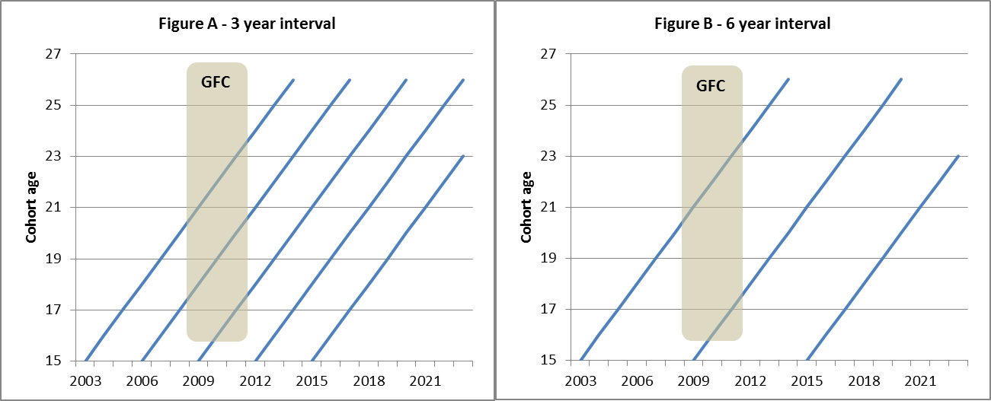

A 6-year interval between cohorts would still allow pathways to be compared between the youngest and the oldest cohorts, but the usefulness of the analysis would be much more dependent on the precise timing of impacts, the stage at which the two cohorts had reached and the policy issue being investigated. This would lead to a higher risk of an event occurring without suitable cohorts to compare. For example, if the subject related to a specific stage such as completing Year 12, then at any one time the most recent data available to analyse this would be between 1 and 6 years old rather than 1 and 3 years old with a 3-year interval between cohorts. Significant and unforeseen events that have a powerful impact on young people’s pathways are the ones most difficult to capture if the interval between cohorts is lengthened too much. The period of time before the longitudinal effects of the event can be analysed may also be longer if this requires both cohorts to have reached a similar age. Collecting data in 9 year cycles would mean that only one major PISA domain would ever be collected and linked with LSAY.

It also needs to be acknowledged that adding a new cohort every 3 years is resource intensive in the longer term and the overall value for money needs to be considered carefully in relation to other priorities. For example, if the 2012 cohort had commenced, there would now be four cohorts in the field. This would have added over $600,000 to data collection costs in 2013, with additional costs in data preparation and documentation. The number of cohorts in the field at any one time would be even greater if the age range for following LSAY cohorts were extended.

On the balance of risk, it would be desirable if possible to retain a three year interval between adding new LSAY cohorts. It may, however, be possible to retain some flexibility about this as PISA 2015 is the next opportunity to commence a new cohort in any event. A decision about when then to add another cohort would not be needed until before PISA 2018.

### Linking to PISA

The LSAY Y95 and Y98 cohorts commenced as surveys of selected Year 9 students within a nationally representative sample of schools. Academic achievement was measured using tests designed by ACER. When PISA commenced in 2000 the issue arose of whether LSAY should continue as a separate survey or link to PISA as the starting point. Since then the Y03, Y06 and Y09 LSAY cohorts have all started from the Australian PISA sample. Linking to PISA had a number of advantages:

* It minimised the survey burden on schools as PISA was occurring anyway and securing school consent to participate in external testing has become more challenging over time.
* While the ACER achievement measures were robust, those used for PISA were regarded as more so noting that NAPLAN did not commence until 2008.
* PISA offered the advantages of: an internationally comparable baseline of academic performance using well resourced, designed and tested questionnaires with rotating topics of interest (e.g. environment, financial literacy); student background data collected in a consistent way including comprehensive background information and useful indices for analysis (e.g. wealth, cultural possessions, economic social and cultural status); and the opportunity to link to PISA school data.

Because the major domain in PISA rotates in each round, missing starting an LSAY cohort in any PISA means that the opportunity to assess the long term impact of that domain on youth outcomes is foregone. In 2012 the major PISA domain was mathematical literacy and the major domain in 2015 will be scientific literacy.

Nevertheless, there were also a number of disadvantages in linking LSAY to PISA:

* Whereas before Y03 LSAY started students in Year 9 students, PISA samples 15 year old students, who are spread across Years 9 to 11. The survey design for an age-based sample is considerably more complex because it needs to allow for the highly varied circumstances of young people, especially while at school. This means some questions in LSAY are needed to clarifying respondents’ school year status and other individual circumstances each year.
* It restricts the level of flexibility in commencing new cohorts by making the interval between cohorts a multiple of 3 years.
* It creates a degree of lock-in to the PISA sampling methodology and international classifications. Although the PISA sample has been increased to allow for comparisons to be made between states and to better capture Indigenous students, it would be difficult to make further enhancements, for instance, to over sample other sub-groups of interest to LSAY users such as low SES.

An emerging issue is that the length of the PISA testing (around 2½ hours) limits the time available for LSAY specific questions to be added. In the PISA testing the principal data collected is about student academic performance and the student background questionnaire. Under the PISA procedures, a limited number of questions of national interest could be added as national options to the questionnaires such as that on student background subject to agreement between the National Program Manager (ACER for Australia) and the international contractor responsible for approving contextual questionnaires (a consortium of European universities and educational research institutions). This creates risks for LSAY, such as losing the capacity to add national option questions needed to start a new cohort in 2012. An additional telephone survey to collect national options information would have added around $300,000 to the cost of LSAY in 2012 and would also have added to the complexity of the survey program.

The key information collected at this stage is contact details to allow students to be contacted in the next wave. It has become increasingly difficult to collect quality contact information through PISA. This has resulted in a high level of attrition from wave 1 to wave 2 of LSAY (around 38 per cent in the 2009 cohort). The additional LSAY questions occur at the end of the PISA questionnaire, when respondents may be suffering test fatigue; either not answering or answering incorrectly. This may in part explain the high LSAY first year attrition rate and raises questions about the ability of an LSAY sample drawn in this way to sustain a longitudinal survey.

A further constraint of starting with PISA is that the current PISA arrangements do not contain provisions for gaining written consent for future data linkage, such as to NAPLAN (as discussed in section 3.2). Telephone based surveying in later years does not lend itself to obtaining written consent (in other surveys this occurs through personal interviewing in the first wave).

These issues make it worthwhile considering whether there are other ways of linking LSAY to PISA or whether an alternative starting point to PISA would be more appropriate. One alternative would be to run LSAY as a follow-up CATI survey within a few months of the PISA testing. This would still require contact details and student consent to participate through PISA. This would retain the benefits of the PISA link, without the pressures on PISA testing, but there may be a loss of sample with the delay. It would also depend on the capacity of the PISA data collector to supply cleaned contact details within a short period of the testing.

If this is not possible, another alternative would be a year based cohort that uses NAPLAN results as the measure of academic achievement. Such a cohort could commence when students are in Year 9 subject to agreement of school authorities to a process for drawing a sample of students, access to contact details and a process for students to consent to participate. This would offer a number of advantages and disadvantages as set out in Table 13.

1. Advantages and disadvantages of starting LSAY from NAPLAN

|  |
| --- |
| **Advantages** |
| * Subject to consent and agreement to data linkage between LSAY and NAPLAN, there would be no need to administer a separate achievement test to students. Access to NAPLAN scores for Years 3 to 9 would allow researchers to control for academic performance at earlier ages than at present. * Although PISA scores are widely accepted as a high-quality measure of academic performance at age 15, they assess literacy and numeracy in a very general sense. NAPLAN is a purely Australian measure of academic performance which is specifically designed to align with national education priorities. * Would increase control and flexibility over sampling design, recruitment and data collection, for example: * simplifying data collection and analysis * reducing starting sample size by up to one-third * still oversampling students from all equity groups to improve the scope for analysis of small sub-groups and help counteract attrition * starting new cohorts earlier than at present to catch students who leave school before Year 9 * more flexibility in the interval between new cohorts * enabling LSAY administrators to seek written consent for data linkage right from the outset of every new cohort and * providing flexibility around the design of any parental questionnaire. |

|  |
| --- |
| **Disadvantages** |
| * While achievement testing would not be duplicated, there would still be additional work for schools in compiling the student sample, administering a background questionnaire and completing a school questionnaire (if retained). * LSAY has been used by the OECD to test the predictive power of PISA test items, providing evidence on the types of items that are best in assessing skills needed in adult life. * PISA and NAPLAN measure achievement differently and NAPLAN Year 9 results may not be as robust as PISA measures of achievement for LSAY’s purposes. * If the school questionnaire is not retained the ability to jointly analyse student and schools data would be lost. This is a highly desirable feature of the current LSAY-PISA link because schools have an important independent effect on young people’s transition outcomes. * Sampling, recruitment, data collection and datafile production procedures would have to be re-developed and re-implemented with cost and resource implications. PISA processes are tried, proven and accepted. * Would introduce a series break in the measurement of academic achievement. * LSAY may be affected if NAPLAN arrangements change in future. * Would mean loss of internationally comparable achievement benchmarks at 15, but these have been used only infrequently in LSAY so far. |

Source: NCVER (2013)

Another alternative would be to forgo new LSAY cohorts altogether for the immediate future and build instead on the cohorts of children already participating in the LSAC. The older LSAC cohort turns 15 in 2014-15 and the younger in 2018-2019. Planning is underway for both cohorts to be followed through until their twenties and the scope of the survey will include education, training and employment outcomes as covered in LSAY.

This would offer a number of advantages including:

* data that covers the whole education journey from infancy through schooling to transition to work and adulthood;
* LSAC’s face-to-face interviews mean it can drill deeper in some areas; and
* potential resource economies.

However, there would be a significant loss of analytical power compared to LSAY in doing this:

* The LSAC sample size (about 4,000 in each cohort after attrition so far) is much smaller than in LSAY and involves no oversampling so would be of even less capacity to analyse outcomes for small sub-groups or jurisdictions.
* The LSAC sample is drawn from postcodes whereas the PISA/LSAY sample is drawn from schools meaning that, while PISA/LSAY can analyse school effects, LSAC could not.
* There are no follow-up LSAC cohorts at this stage. If any are added in future, then depending on the age from which they are followed, there could be potentially a significant time gap between cohorts.

Another possibility if LSAY is no longer linked to PISA would be to start LSAY at an earlier age or year level to capture a broader cross-section of students and to collect data on a wider span of years of schooling. For example, the LSYPE first interviews young people at age 13/14 when in Year 9. The principal benefits of an earlier commencement would be in:

* Helping to include more young people who are not enrolled in school even before the end of compulsory schooling, especially for Indigenous students.
* Enabling collection of a longer and richer span of data on individuals which would lead to deeper analysis and understanding of their transitions through and beyond schooling. The value of this would be greater the earlier the starting age.

On the other hand there would be a number of potential disadvantages including:

* The overall value for money of adding extra year(s) at the start of cohorts versus other enhancements such as following them for longer. The intention for LSAC to follow cohorts through to adulthood might sufficiently cover this aspect.
* Consent to be part of a survey becomes more problematic as the subjects become younger, with stronger expectations of parental consent, although parental involvement may in turn lead to greater participation by young people.

### Conclusions

The fundamental issue about cohort frequency should be determined by the policy and research needs that LSAY data and analysis helps to meet balanced against available resources and other priorities. A longer interval than three years between cohorts would still allow comparisons between young people at different ages and stage of transition to adulthood, but the longer the interval the greater the risk that LSAY will be less useful and its results less timely. This could reduce its capacity to capture the effects of significant and unforeseen events such as another economic downturn.

While adding a new cohort every 3 years is resource intensive, the link to PISA has provided an economical and effective starting point for LSAY with robust measures of school achievement and minimising the administrative overheads for schools. However, there are pressures on the available space within the PISA testing to accommodate LSAY, which led to not commencing a new cohort in 2012. A decision on whether to commence a new cohort in next PISA cycle in 2015 will need to be made later in 2014. To maintain the currency of LSAY, it is highly desirable that a new cohort is added to LSAY no later than 2015, preferably as part of PISA or in association with it. If this is not possible then the next best alternative would be a cohort starting from Year 9 NAPLAN testing. The frequency of adding new cohorts beyond 2015 would desirably revert to every three years, although this interval might be stretched to 4-5 years if the link with PISA is lost.

Relying instead on LSAC cohorts, which are now starting to enter the same age range as LSAY, would offer a number of advantages including richer data that covers the whole education journey from infancy onwards, but this would be at the cost of a significant loss of analytical power due to LSAC’s smaller sample size and the selection of the sample not being school based.

## 3.4 Age to which cohorts are followed

So far LSAY cohorts have been followed until their mid-twenties. Y95 and Y98 were slightly younger when sampled initially (averaging 14.5 years compared to 15.7 years for the later three cohorts selected as part of PISA) and were followed until they were 25.5 years old on average (compared to 25.7 years for the later cohorts). Earlier cohorts in the LSAY program were followed up to ages ranging from 20 years to 33 years.

In a youth longitudinal study such as LSAY the age to which cohorts are followed shapes the degree to which the study is able to cast light on the full span of issues associated with transitions to adulthood. It has been suggested in previous reviews of LSAY and elsewhere (Markiewicz & Associates 2010; Phillips Curran 2000; and Nguyen et al 2010) that follow-up to 30 years of age would provide a better marker for the completion of youth transitions than 25 years of age. However, there are implementation issues about attrition and resourcing that need to be considered in forming a view on this issue.

### Stakeholder and user views

A number of stakeholders across governments, researchers and non-government organisations supported extending the tracking of cohorts to older ages to better reflect emerging social norms of extended study patterns and later labour market entry. In particular, expanding the age of final collection to 30 years would provide better data on overall “return for investment” from higher education and training as many young people were seen to still not be fully established in the workforce in their mid-twenties. However, there was also awareness that this could involve trade-offs and require judgements about the relative value to be gained in better understanding later outcomes compared to those for early education leavers.

The LSAY user survey asked respondents if LSAY were to generate a wider range

of information, which of the several areas would be of most benefit to them (respondents could nominate more than one). Approximately equal numbers of respondents (between 62 and 65) selected: information through to age 30; richer information on attitudes, opinions and beliefs; more robust information by state or territory; and better information on small populations such as Indigenous young people. Fewer selected additional information on health, wellbeing and civil engagement (52 respondents). As shown in Figure 21, the proportion of respondents nominating information through to age 30 was highest among university or other research organisations.

### Overseas youth surveys

Overseas youth longitudinal surveys have followed cohorts to a wide variety of ages (see Table 14) ranging from 20 years (LSYPE) up to middle age (US NLSY79). The Swiss longitudinal survey, which also starts from PISA, has followed a cohort to age 30, with less frequent data collection in the last years of the cohort.

1. Importance of following cohorts to age 30 by organisational type

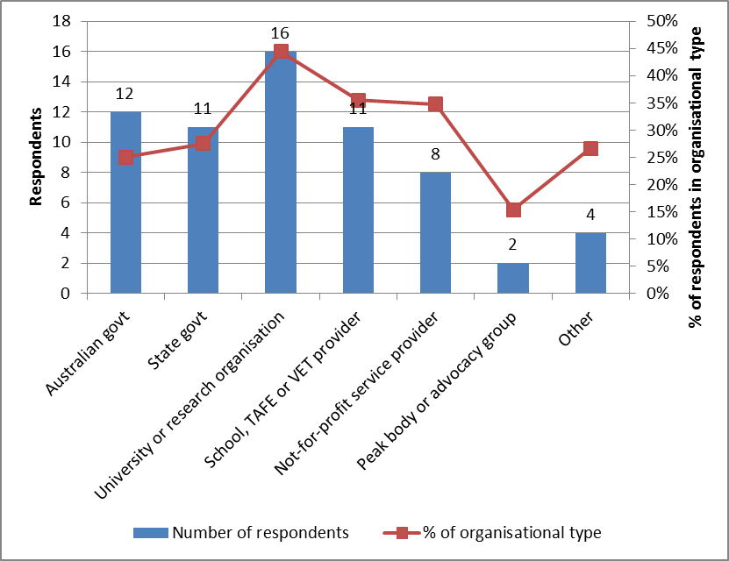

Source: LSAY user survey 2013 Q24

1. Overseas youth longitudinal surveys

|  |  |  |  |  |
| --- | --- | --- | --- | --- |
|  | Youth in Transition (YIT) Survey (Canada) | Longitudinal Study of Young People in England (LSYPE) | National Longitudinal Survey of Youth (NLSY) (USA) | Transitions from Education to Employment (TREE) (Switzerland) |
| Age to which cohorts are followed | Two cohorts:   * Cohort A – 15 year-olds reading cohort in PISA 2000 and born in 1984 – followed to cycle 6 (2010 at age 25) * Cohort B – 18-20 year-olds in 2000 – followed to cycle 5 (2008 at age 26-28) | Two cohorts:   * First cohort began in 2004 and was followed in 7 annual waves to 2010. * Second cohort commencing in 2013 and will be followed for the next 6 years to age 19/20. | Two cohorts followed well into adulthood – in 2010 NLSY79 were aged 45-53 years and NLSY97 in 2011 were aged 25-31 years. | * Single cohort commencing from PISA 2000 followed up to age 30 in 2014. |
| Frequency of data collection | Every 2nd year. | Annual | * NLSY79- Annual until cohort aged 29-37 then every 2nd year. * NLSY97 - Annual until cohort aged 26-30 then every 2nd year. | * Annual to age 23 then once at age 26 and again at age 30. |
| Data collection method | CATI | CAPI for first 4 waves then mixed mode (online, CATI or face to face). | * NLSY79 – CATI * NLSY97 – CAPI. | * Written questionnaires up to age 20 then mainly CATI. |

Note: CATI = computer assisted telephone interviewing; CAPI = computer assisted personal interviewing.

### Arguments for longer follow-up

The principle argument for a longer follow up period is that transitions for young people through education, training, work and household formation are now taking longer or are more complex or fluid than for previous cohorts. In part this is a result of government policies to encourage young people to stay on at school longer and to undertake post-school education and training. However, it also reflects changes in the economy and in the economy more broadly.

Karmel & Liu (2011) argue that whereas a generation ago “there were clearly defined markers of the transition from youth to adulthood: leaving home, finishing school, starting work, buying a house, getting married and starting a family”, changes in the structure of the labour market such as casualization, greater part-time employment (often combined with study) and social changes in the formation of relationships have all blurred these markers, making the definition of a successful youth transition more complex—and more difficult to determine. One element of this is the increased incidence of taking a gap year in Australia – up from 10% in 1999–2000 to 24% in 2009–10 (Lumsden & Stanwick 2012). Gap year takers are typically a year or two behind those who do not take a gap year and by the time they have completed tertiary education they are already in or near their mid-twenties, making it difficult to measure their longer-term labour market outcomes using LSAY data up to only age 25. Other work also paints a picture of increasingly uncompleted transitions by age 25, especially for disadvantaged young people (Productivity Commission 2013).

1. Percentage of LSAY cohorts in full-time study and full-time employment

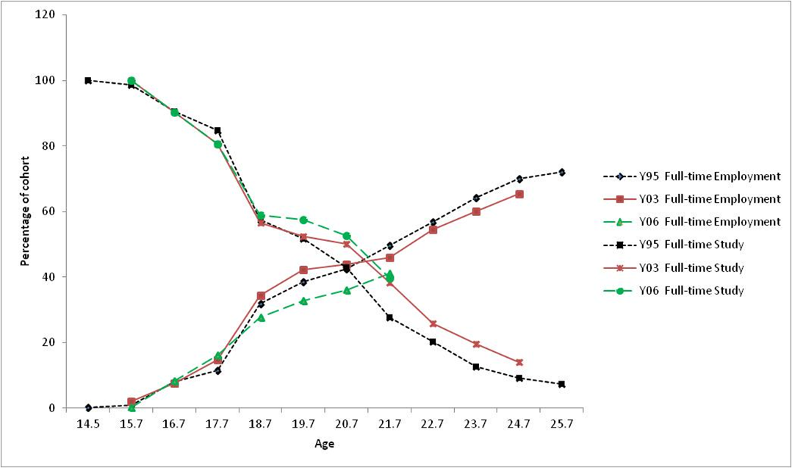

Source: NCVER (2013)

Lengthening transitions are evident in the LSAY data. Figure 22 presents the percentages of the Y95, Y03 and Y06 cohorts in full-time study and full-time employment over the ages from 14 to 25. This shows that there has been an increase in the age at which young people switch from mainly being in full-time study to mainly being in full-time employment. For the Y95 cohort, this crossover point was around the age of 21; for the Y03 and Y06 cohorts, this has increased to around 21.5 and 22 years respectively. The proportion of the Y03 cohort still in full-time education as they approach their mid-twenties is also higher than for the Y98 cohort.

Evidence for longer transitions can also be seen in social indicators of independence. By their mid-twenties fewer in the Y03 cohort were married or de facto (34.2% compared to 34.8%) or had dependent children (8.8% compared to 10.4%), consistent with later ages of first marriage and age at first birth of children. In newer LSAY cohorts significantly more young people are still living in the parental home in their mid-twenties. Figure 23 shows that the age at which the majority of young people are buying or renting their own home has increased from around 22.7 years for the Y95 cohort to around 23.7 years for the Y03 cohort.

1. Percentage of LSAY cohorts living or not living at home

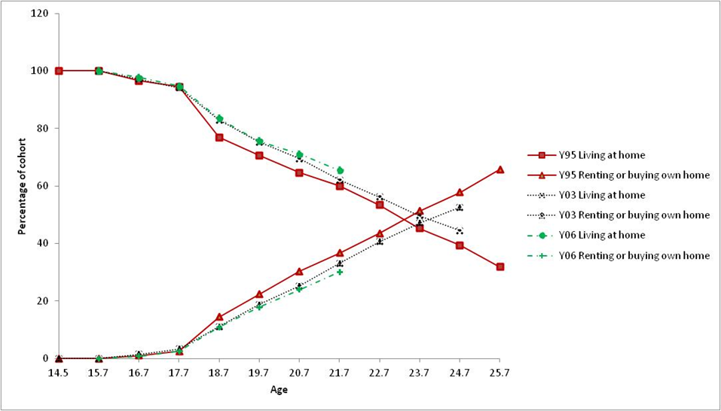

Source: NCVER (2013)

Apart from better encompassing the longer transition from youth to adulthood, the principal advantages of extending LSAY to beyond 25 years of age are that it would:

* Make the transition points and destinations of young people more visible, particularly for disadvantaged young people for whom the pathway to stable employment and living arrangements may be most difficult.
* Support better estimation of the returns from education and training, particularly for those young people who pursue advanced qualifications or who delay post-school study or entry to the workforce.
* Enable better measurement of social outcomes such as living arrangements where the shift to independence may take longer and not be as linear as in the past.

Offsetting this are the additional costs and the implications of response rates for biasing results.

Additional costs would relate primarily to conducting extra interviews and sample maintenance to maintain contact. Based on the existing data collection contract, continuing the Y03 cohort for an additional 5 years beyond 2013 would cost around $750,000 over five years assuming that data was collected each year, attrition was 10% pa and the length of the interview remained unchanged. These costs could be reduced by collecting data at a reduced frequency, either from age 25 or earlier. If after age 20 LSAY moved to a two-yearly interview cycle, interviewing could be extended to age 30 with only one additional interview. There would be some additional costs in doing so to minimise attrition over the longer break between interviews and manage any associated recall errors.

The impact on response rates and bias is harder to predict. Year-on-year attrition tends to improve as the cohorts get older and are more committed to the program. In 2013, both the Y09 and Y06 cohorts retained 88 and 90 per cent of respondents (respectively) from the previous wave, the highest retention rate recorded across all waves/years to that point. As noted in Section 3.6, attrition to age 25 is already concerning and appears to be increasing over time. However, most of this occurs between PISA and the first LSAY interview and further attrition beyond age 25 is likely to be at more stable levels. Nonetheless, it is probable that more advantaged young people are the most likely to remain in the survey for the full duration of time and the effect of this on bias would need to be dealt with through weightings.

### Conclusions

There is a good case for extending LSAY beyond 25 years to 30 years to more effectively capture lengthening youth transitions and allow for better explication of the pathways taken as well as to more accurately measure outcomes in early adulthood. These longer transitions result from a number of social and economic trends as well as government policies.

This extension would need to be implemented alongside strategies to reduce sample attrition so that there were sufficient subjects remaining in the sample to provide useful data. It would also need to be introduced with consideration to other areas of possible economy for LSAY such as biennial surveys conducted after the critical years of transition, for example after 21 or 25 years.

Given that 2013 is the final year of data collection for the Y03 cohort under the current arrangements, immediate consideration would need to be given to whether to extend this cohort. This would require at least additional sample maintenance and contact in 2014, as a prelude to additional interviews in 2015 (assuming a two-yearly interview cycle for that cohort after age 25). Alternatively, the Y06 cohort turns 25 in 2016 and an extension to age 30 could occur from then.

## 3.5 Sample size and design

The current link between LSAY and PISA means that the design and size of the sample is largely a result of the requirements of international comparisons, although there is some flexibility within this. This section sets out the design and size of the PISA sample, reviews several issues about this that have arisen through the user survey and stakeholder interviews. As discussed in the section on adding new LSAY cohorts, the link between LSAY and PISA constrains the LSAY sample in important ways, but even if this link were broken there would still be significant additional developmental work and operational and sampling issues to overcome in developing and implementing an alternative approach. In particular, to better reflect state/territory samples and smaller sub-populations of policy interest including Indigenous students and other disadvantaged students who are most likely to be affected by survey attrition. Finally, the focus of the section is on the appropriateness of the initial sample design/size, with attrition in subsequent waves the focus of the following section.

### Stakeholder and user views

Stakeholders in state governments, especially those which conducted their own school leaver destination surveys, felt that LSAY’s sample size and its jurisdictional breakdown limited its usefulness to being a benchmark for national trends. Nonetheless, they recognised it was of value for jurisdictions which do not run their own surveys. There was also a view that individual school samples in PISA/LSAY were too low for much school based analysis. Some researchers suggested that the PISA sample be re-designed to increase the number of schools included and reduce the number of students per school. Another suggestion, building on the increased capacity of school systems to track students while at school, was to commence a longitudinal study tracking individuals once they left school.

1. Importance of sample size related enhancements

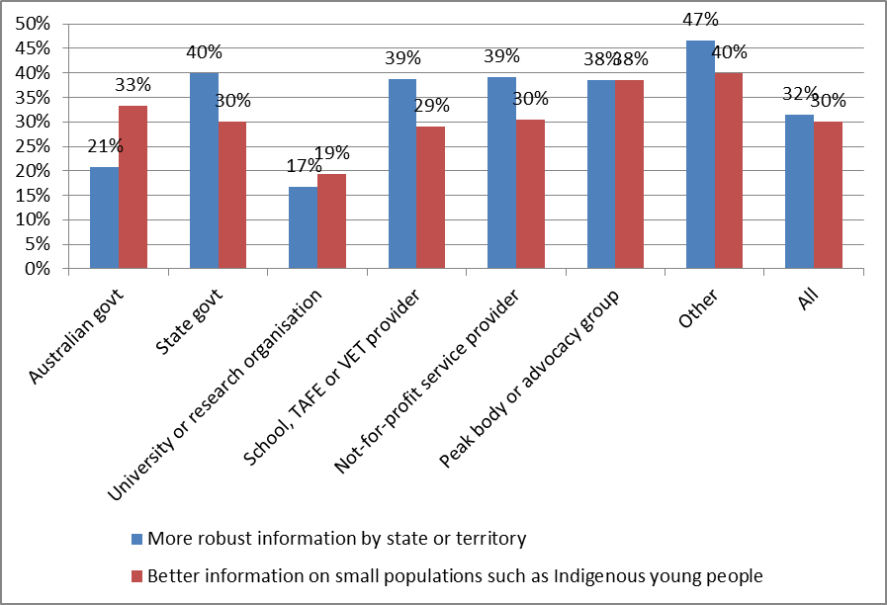

Source: LSAY user survey 2013 Q24

In the LSAY user survey, more robust information by state and territory and better information on small populations such as Indigenous young people were two of the top four suggested enhancements to LSAY. Unsurprisingly, this was the most commonly suggested enhancement by respondents from state governments (Figure 24). It was also rated highly by education and service providers as well as peak bodies. Better information on small populations was also rated highly by peak bodies.

### Characteristics of the PISA sample[[4]](#footnote-4)

PISA is a two-stage stratified sample. The first stage comprises the sampling of individual schools, while in the second stage individual 15-year-old students in each school are sampled. An age-based sample was chosen for PISA because of the complexities of defining an internationally comparable sample based on grade, which differs significantly across countries.

The PISA sampling frame contains details for all Australian schools. This is stratified by a number of variables including state/territory, school sector, school location, gender of students at the school and a socioeconomic background variable (based on the Australian Bureau of Statistic’s Socio-Economic Indexes for Areas (SEIFA) index). In the sampling process, schools are ordered by their size within their strata and individual schools are then selected using probability proportional to size within their strata group. The achieved sample of schools in 2009 by sector and state is shown in Table 15. A total of 353 schools participated (well above the international minimum of 150) to allow for over-sampling smaller states and Indigenous students and allow for LSAY attrition over time.

Once the schools have been selected, the second stage is to select individual 15-year-olds from each of the schools. The PISA target population is 15-year-old students in Year 7 or higher and enrolled at an educational institution, either full- or part-time, at the time of testing. Part-time students, students undertaking only VET and students attending foreign schools are excluded. Further exclusions include those who are schooled at home, in the workplace or out of the country and students with a severe intellectual or physical disability. The international age requirement is that an individual had to be 15 years old during the period March to August in the year of testing.

1. PISA 2009 achieved sample of schools and students by state and sector

**Schools by state and sector**

| **State** | **Catholic** | **Government** | **Independent** | **Total** |
| --- | --- | --- | --- | --- |
| ACT | 8 | 13 | 4 | 25 |
| NSW | 17 | 52 | 12 | 81 |
| VIC | 13 | 35 | 11 | 59 |
| QLD | 11 | 39 | 11 | 61 |
| SA | 7 | 26 | 8 | 41 |
| WA | 7 | 22 | 9 | 38 |
| TAS | 6 | 21 | 4 | 31 |
| NT | 4 | 9 | 4 | 17 |
| Total | 73 | 217 | 63 | 353 |

**Students by state and sector**

| **State** | **Catholic** | **Government** | **Independent** | **Total** |
| --- | --- | --- | --- | --- |
| ACT | 355 | 528 | 153 | 1036 |
| NSW | 676 | 2177 | 460 | 3313 |
| VIC | 542 | 1279 | 475 | 2296 |
| QLD | 456 | 1649 | 426 | 2531 |
| SA | 304 | 920 | 300 | 1524 |
| WA | 321 | 842 | 323 | 1486 |
| TAS | 272 | 867 | 138 | 1277 |
| NT | 172 | 453 | 163 | 788 |
| Total | 3098 | 8715 | 2438 | 14251 |

Source: Thomson et al (2010)

1. PISA achieved student sample as a percentage of the target population

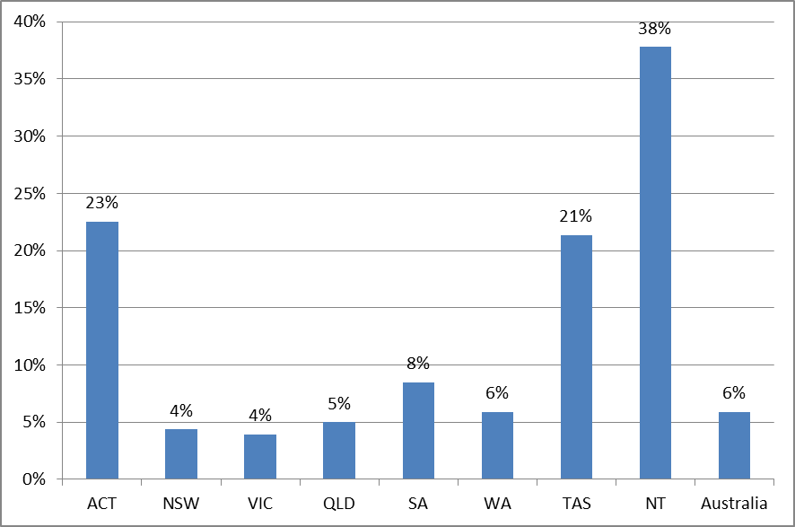

Source: Thomson et al (2010)

The international PISA sampling rules require that 35 individuals per school are selected. If a school has fewer than 35 15-year-old students, then all are selected. Where schools have more than 35 students aged 15, individuals are selected with equal probability. In Australia, over-sampling to ensure adequate representation of small jurisdictions and Indigenous students meant that the sample was increased to 48 students per school and all Indigenous 15-year-olds at each selected school were included (Thomson et al 2010). The achieved Australian PISA sample in 2009 was 14,251 students.

The 2009 achieved PISA student sample comprised approximately 6% of all 15 year old students. The over-sampling arrangements for smaller jurisdictions ensured that a much larger proportion of the target population in those states and territories were sampled, up to 38% in the case of the NT (Figure 25). Similar over-sampling occurred in relation to a range of other smaller sub-populations of students (Figure 26):

* The achieved Indigenous sample was 1,143 students or 15% of the target population of Indigenous students. Indigenous students comprised 8% of the total achieved PISA sample compared to 3% of the weighted sample.
* Similarly, the achieved remote sample was 453 students, or 14% of the target population of 15 year old students in remote areas. In PISA 2009, three-quarters of students attended schools located in metropolitan areas and almost one-quarter were from provincial areas. Remote students comprised 3% of the total achieved PISA sample and 1% of the weighted sample compared to 2.2% of students of all ages being in remote or very remote areas in 2012 based on ABS data. Note however that the proportion of 15 year olds is likely to be lower as some students move to other locations for secondary schooling.
* By socio-economic background (as measured by the PISA economic, social and cultural status index), the PISA student population was divided into four approximately equal quartiles with around 3,100 to 3,200 students in each.

1. PISA achieved Indigenous and remote samples as percentage of target

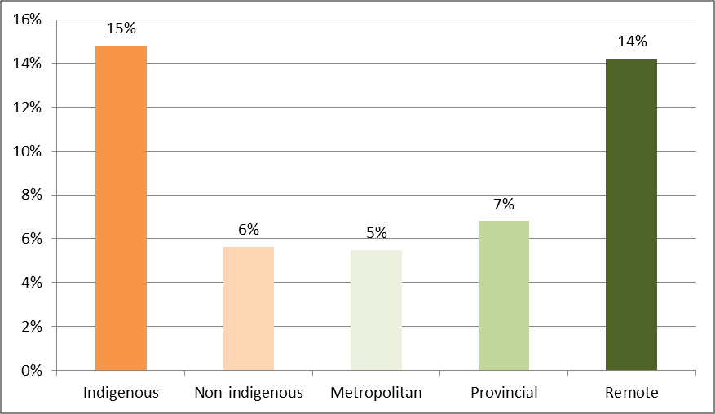

Source: Thomson et al (2010)

In terms of immigrant status, almost 60% of PISA 2009 students were Australian-born, 32% students were first-generation and 11% were foreign-born. 90% of participating students spoke English at home and 10% spoke a language other than English at home most of the time.

### Samples in other longitudinal studies

Table 16 summarises sampling arrangements in a range of other longitudinal surveys, both those focussed on youth and on other populations. Starting from an achieved PISA sample of just over 14,000 students in 2009, LSAY’s initial sample size is significantly smaller than that used in Canadian and English longitudinal youth surveys, but larger than that in the US. It is also larger than other longitudinal surveys such as LSAC and LSIC, but smaller than in HILDA (note that this is a broad household panel survey covering individuals of all ages aged 15 and over).[[5]](#footnote-5)

1. Sample size and structure in selected longitudinal surveys

| **Youth longitudinal surveys** | **Sample size at commencement** | **Sampling strategy** | **Sub-populations** |
| --- | --- | --- | --- |
| **Youth in Focus (Australia)** | * Wave 1 achieved about 4,000 young people and 3,900 parents or carers. | * Randomly selected from a cohort of all people born 1987-88 and in Centrelink records. | * Over-sampling for individuals with heavy exposure to the income‐support system. |
| **Youth in Transition (YIT) Survey (Canada)** | * PISA 2000 cohort – abt. 38,000 15 year-olds. * Around 23,000 18-20 year-olds in older cohort. | * Two-stage sampling of schools then students for 15 year old cohort. | * Stratification to ensure results representative for small provinces and two major language groups. |
| **Longitudinal Study of Young People in England (LSYPE)** | * Issued sample for Wave 1 approx. 21,000 young people in 647 schools. | * Two-stage sampling of schools then students | * Minority ethnic groups over-sampled to achieve issued sample numbers of 1,000 in each group. |
| **National Longitudinal Survey of Youth (NLSY) (USA)** | * NLSY79 - 12,686 young people interviewed. * NLSY97 - 8,984 respondents in 1997 | * Respondents identified through screening of sampled households. | * NLSY79 - oversample of civilian Hispanic/Latino, black, and economically disadvantaged. Separate military sub-sample. * NLSY97 - supplemental samples of black and Hispanic youths. |
| **Transitions from Education to Employment (TREE) (Switzerland)** | * 6,343 indicated willingness to participate and provided contact details (54% of PISA sample). | * Based on PISA sampling strategy. | * Representative for country as a whole, the three language regions and for selected cantons. |

| **Other Australian longitudinal surveys** | **Sample size at commencement** | **Sampling strategy** | **Sub-populations** |
| --- | --- | --- | --- |
| **Longitudinal Survey of Australian Children (LSAC)** | * Around 10,000 children and families were recruited for the study, with approx. 5,000 in each cohort. | * Families selected at random from Medicare database using a two-stage clustered design, first selecting postcodes then children. | * Stratification used to ensure proportional geographic representation, but no over-sampling of sub-populations. |
| **Longitudinal Study of Indigenous Children (LSIC)** | * Wave 1 sample about 1,650 children (5-10% of ATSI children of the appropriate ages). | Two-stage approach:   * 11 geographic sites chosen * Indigenous children selected within those areas using addresses provided by Centrelink and Medicare. | * No oversampling. * Not nationally representative, but sufficient to reflect the distribution of ATSI children aged 0-5 years in the states and across locations. |
| **Household, Income and Labour Dynamics in Australia (HILDA)** | * Wave 1 panel consisted of 7,682 households and 19,914 individuals. | * Began with a large national probability sample of Australian households occupying private dwellings with sample members selected from these. | * Sample stratified by State, and in five most populous States, by metropolitan and non-metropolitan regions. * Excludes people living in remote and sparsely populated areas. |

Source: See Appendices 2 and 3 in the Support Document.

The two stage sampling strategy used for PISA/LSAY that selects schools and then students within schools is also followed in the Canadian and English youth longitudinal surveys, although the latter is not linked to PISA. This is a valuable feature of LSAY because it enables school effects to be studied as one influence on youth transitions and outcomes. Further benefits of include that it is consistent with the earlier LSAY cohorts, that it is an efficient way of recruiting a cohort, can help to verify and clean student and parent information and gives access to school-level information collected through PISA.

The arrangements for improving the representativeness of the sample for sub-populations within the survey vary considerably depending on national context and the purpose of each study. The Canadian YITS, like PISA/LSAY sought to produce robust results for all sub-national jurisdictions. Longitudinal youth surveys in other countries commonly over-sample for a range of ethnic or other disadvantaged groups, but this is less strongly a feature of the other Australian longitudinal surveys included in this comparison.

### Sampling issues for LSAY

An important issue is whether the sampling and over-sampling arrangements for PISA produce a starting sample for LSAY that is adequate on those issues which it is intentionally designed to address, i.e. a reasonably robust result for smaller jurisdictions, Indigenous students and those from remote areas.

One way of assessing whether sample sizes are adequate is to consider the confidence limits associated with estimates of particular parameters based on the LSAY data. NCVER (2013) calculates the sample size required for a margin of error of 5% or less around a population estimate of 50%. The analysis shows that the margins of errors are below 5% for Australia across all sectors and for each of the school sectors separately. When considering each individual state and sector, most of the estimates have precision at or below the recommended 5% for all waves. However, in the later waves when the cumulative effects of attrition have been seen, the precision of the smaller jurisdictions (Northern Territory, Tasmania and the Australian Capital Territory) would be greater than 5%, particularly for the individual school sectors.

Overall, the current sample size works well in providing reliable population estimates at state level, although there is scope to potentially reduce PISA/LSAY sample sizes in some of the larger states without sacrificing precision. Alternatively, there is an argument for increasing the sample sizes of some of the smaller states to ensure that the impact of attrition on precision is reduced.

A similar analysis of the sample size required to keep the margin of error around Indigenous sub-population estimates at or below 5% found that this was achievable at the national level only and in the early waves of LSAY. These estimates became less accurate as the sample size decreases due to attrition in later waves.

There is evidence that the LSAY Indigenous population over-represents higher achieving students, in part because a higher proportion of ATSI 15 year olds are not enrolled in school full-time compared to non ATSI 15 year olds (see Figure 27). Lower achieving ATSI 15 year olds are therefore less likely to be sampled in PISA and LSAY, which points to the limits of using LSAY rather than cross-sectional population data to describe the experience of all ATSI 15 year olds. Where LSAY can be more useful is in describing transition pathways within populations and the factors that are associated with those pathways. The critical factor in the extent to which LSAY enables longitudinal analysis is the cumulative effect of attrition over time. Similar comments would apply to other small sub-populations, especially students from remote areas.

1. Full-time school enrolment as a percentage of year age groups 2011

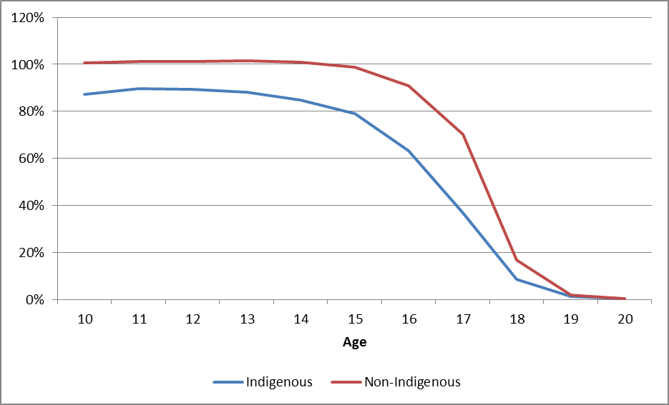

Source: ABS, NSSC Table 40a Full-time students - by States and Territories, Affiliation, Sex, Year, Age, Indigenous Status and Grade (1998 to 2012) and ABS 3238.0.55.001 - Estimates of Aboriginal and Torres Strait Islander Australians by single year of age, June 2011

There are a number of other limitations resulting not just from sampling, but also budget constraints, which mean that there are limits on the types of analysis able to be undertaken with LSAY including to:

* Compare the impact of different institutional structures, programs, legislation or policy across jurisdictions. However, there is limited information about specific programs in the LSAY surveys, the numbers participating in them are too small, or it is difficult for students to identify whether or not they have participated in them (NCVER 2011, pp 8-9). Nonetheless, where sufficient numbers of young people are affected and they can be identified some useful analysis has been carried out, e.g. in relation to the effect of receiving Youth Allowance on educational participation (Ryan 2013) and on the general effectiveness of career advice (Rothman & Hillman 2008) In the future, data linkage to administrative systems could provide reliable information in this area.
* Examine the circumstances of more specific groups of young people such as those:
* with a disability - In 2009 an estimated 7% of young Australians aged 15-24 reported having a disability and of these around one-quarter had profound or severe core activity limitations (27%) (AIHW 2011). The total number with disability is roughly equivalent to the share of South Australian students in the national total, while those with a severe limitation is roughly equivalent to those in the ACT. PISA excludes participants that have a disability that impacts on their ability to sit the PISA test. That is, if a respondent can’t sit the test they are excluded. Special schools are also excluded from the population. As a result, LSAY will not be representative of the population with a disability.
* with caring responsibilities - In 2003, among young people aged 15–24 years living with parents an estimated one-quarter (25%) lived with a parent with disability and 7% were caring for a family member with disability (AIHW 2011).
* from culturally and linguistically diverse backgrounds, including refugees. At June 2009, there were 56,200 young people aged 12–24 years living in Australia who had arrived under the Humanitarian Program for refugees and others in refugee-like situations since 1993-94, accounting for 1.4% of all young people aged 12–24 years in Australia (AIHW 2011).

Considerable caution is needed in designing over-sampling since boosting sample sizes in any one sub-population may improve the accuracy (reduce bias) and precision of the analysis of this group. However, it can lead to inefficiencies when performing an overall analysis, or in other sub-populations (NCVER 2013). It is also important to bear in mind the overall purpose of LSAY, that over-sampling can distract from this purpose and whether the only way to track some groups of interest given their size would be through separate surveys.

In statistical terms, increasing sample size to improve the robustness of results is subject to diminishing returns in that the error for a variable in a sampling frame is proportional to the inverse of the square root of the sample size. Consequently, the error is relatively insensitive to sample size and it would need to be increased significantly to have a significant impact in reducing the error. This may be cost prohibitive. Applying weights to deal with different levels of representation of sub-populations in the sample increases the standard errors associated with any estimates based on the data, particularly if the sub-populations are small. Ideally any sub-groups of interest should be part of the sampling frame, but this also adds to cost and complexity of sampling and also to the survey workload on schools if the same ones with high proportions of disadvantaged or Indigenous students have to be surveyed at regular intervals.

### Conclusions

The current LSAY sampling strategy and sample sizes are adequate for making robust population-based estimates over all waves at the national/sector level and at state/sector level for the larger jurisdictions. However, the margin of error increases to unacceptable levels for smaller jurisdictions over time with attrition. The use of cluster-based sampling is the most appropriate methodology and allows multi-level models to be used to investigate the impacts of school-level characteristics. The sample of Indigenous students is too small to make robust predictions other than at the national level, and this robustness rapidly decreases as the sample size is reduced by attrition.

In so far as there are issues about the initial sample size in LSAY, then the scope for change is limited if PISA remains the starting point for LSAY, unless a random sub-sample of PISA participants is selected. The Australian PISA sample is considerably larger than the minimum required by the international requirements and already over-samples smaller jurisdictions and Indigenous students. There are likely to be limits on the willingness of the international PISA consortium, the Australian and state and territory governments that fund PISA and on school authorities that facilitate the testing to further increase sample size, especially if the primary reason for this is unacceptably high attrition rates in subsequent waves of LSAY.

To the extent that the real issue with LSAY sample sizes is due to attrition (discussed in the following section), then addressing that issue is likely to be a more cost efficient and effective way of increasing the size of the LSAY cohorts as they age. Even with oversampling, the high level of attrition for disadvantaged students has a significant effect on the sample size for this population as cohorts age.

If the starting point for LSAY is not PISA, then there would be greater flexibility in sampling strategy and size to reflect the requirements of a longitudinal survey. This could allow for a re-prioritising of the different elements of LSAY. For example, NCVER estimates that the size of the initial sample could possibly be reduced by up to one-third compared to that used for PISA based on comparisons with other well-known national and international panel studies that use considerably smaller initial sample sizes. The resource saving from a smaller initial sample could then be invested in sample maintenance, thus reducing the attrition problem inherent in LSAY, or a range of other enhancements to LSAY that would improve its capacity to address policy and research questions.

## 3.6 Response rates and attrition

While longitudinal surveys offer the potential for rich data on pathways and transitions over time, respondent attrition can undermine the reliability of findings based on their data. Consequently, a major task in implementing any longitudinal survey is to track sample members who relocate, change their contact details or lose interest in being a part of the survey. A growing research literature on the methodology of conducting longitudinal surveys seeks to identify in a systematic and empirical way how to minimise attrition (Watson & Wooden 2009; Fumagallli et al 2009). In particular, response rates generally tend to be lower among youth.

This section considers first why attrition matters in a survey such as LSAY and then analyses patterns of attrition across different cohorts over time and across different sub-groups. These patterns are then compared with those in other longitudinal youth surveys. A number of aspects of good practice in managing attrition are discussed as a prelude to a discussion of a number of options to improve attrition in LSAY.

### Stakeholder and user views

In stakeholder interviews attrition was seen as one of the main limitations on LSAY, particularly the higher attrition rates among disadvantaged and Indigenous youth. For some, maintaining the composition of each cohort was a higher priority than broadening the data collected. Attrition was also a concern for those who supported tracking each cohort to a later age. Among those from governments, there were concerns that attrition meant some analysis is based on very small samples, limiting the depth of the questions that can be explored so that the focus is more on the “what” but rarely to the “why” of an individual’s transition.

In the LSAY user survey attrition rates was the single most commonly mentioned issue by respondents when asked to name any weaknesses of LSAY (see Figure 13) (note that multiple responses were possible).

### Why attrition matters

The gradual loss of sample members over successive waves of a longitudinal survey has a cumulative effect on the remaining sample and reduces the precision of the research based on it. Attrition can be either random or non-random. This distinction is important because with non-random attrition different groups of people drop out of the survey at different rates. Research suggests that attrition and non-response are generally higher among males, young people, non-English speakers, single people and single person households, those with lower levels of education or from low SES backgrounds, non-home owners or those living in urban locations (Watson & Wooden 2009).

Attrition, especially non-random attrition, leads to two problems in analysing longitudinal data:

* Bias so that the sample no longer represents the original sample.
* Small sample sizes for sub-groups of interest.

#### Bias

The impact of attrition on bias is dependent on the individual question being investigated and particular variables included in the analysis. Bias may not exist even if attrition rates are high, for example, when considering results based on the entire LSAY sample for Australia as a whole. Detecting bias in LSAY is not straight-forward as comparable whole sub-population data may not be readily available. For example, Ryan (2011) using LSAY data showed that attrition appeared to increase slightly the estimates of Year 12 completions; however there was no impact on the relationships or factors influencing Year 12 completion observed in his study (from NCVER 2013).

In any case, care is needed in comparing results for an LSAY cohort with those for a wider population group, for example, in comparing the Year 12 completion rate for an LSAY cohort with that for all school students derived from administrative or other survey data. An estimated completion rate for an LSAY cohort can be an unbiased estimate of the experience of that age cohort but differ from estimates for wider population groups derived from other sources. Generating population estimates beyond the first wave of LSAY requires benchmarking against other available data sources and careful management of the survey to ensure that it continues to match the populations of interest. This is not generally possible and thus the use of LSAY to provide age-based population estimates is therefore limited.

#### Small sample sizes for sub-groups

Attrition can lead to biased estimates when analysis is limited to smaller sub-samples of the whole population and those who drop out have poorer outcomes than those who remain in the survey (Ryan 2011). By definition, the outcomes of those who drop out can never be known. Even if the survey drop out is random (not linked to the characteristics of individuals dropping out), for certain sub-groups over a number of waves (years), the sample size may become too small to undertake robust statistical analysis. Often, it is these small sub-groups that lead to the more interesting results or comparisons (for example, regional, low-SES individuals). It is critical that the key sub-populations of interest have adequate and representative sample sizes in wave 1 and that subsequent attrition is minimised. A number of studies using LSAY data have commented on the limitations due to sample size and attrition in analysing sub-populations such as Indigenous youth. For example, the Y06 Indigenous sample dropped from 1,080 students in 2006 to 349 students in 2009 (Ainley et al 2011, p 26).

### Patterns of attrition in LSAY

Analysis of aggregate attrition rates in LSAY over time suggests that attrition is highest in the most recent 2009 cohort (see Figure 28). For the two completed cohorts (Y95 and Y98) the sample in the final Wave 12 was 28.8% and 25.5% of that in Wave 1. So far Y03 is tracking between Y95 and Y98. Attrition in the samples for Y06 and Y09 is concerning as each is showing a lower level of remaining sample than for the preceding cohorts at the same stage (noting that the Y95 and Y98 samples were rebuilt in Wave 3).

A review of attrition in LSAY concluded that there is no ‘magic number’ to indicate when a cohort becomes too small because of attrition bias, especially when appropriate weights are applied as is the case for LSAY (Rothman 2009). For the full LSAY cohort, however, standard errors remain reasonable even when the remaining sample is as low as 25% of the original sample, although errors are much larger when the sample size falls to 10% of the original. It concluded that for the full cohort, a sample size that is less than 25% should be used with extreme caution.

At the current rate of attrition, as little as 20% to 22% of the original Y06 and Y09 samples could be left by age 25. If the Y09 cohort was followed to age 30 and experienced the same attrition rates as earlier cohorts to age 25 and 10% pa thereafter, as little as 12% to 13% would remain in the final wave.

The largest sample loss appears to be from Wave 1 to Wave 2 rather than in subsequent waves (see Figure 29). The Y03 cohort only was contacted again in the same year as it undertook PISA (shown as Wave 1a in Figures 27 and 28). A telephone interview occurred late in 2003 covering school as well as the influences on young peoples’ decision making about why they may choose to stay at school or leave before year 12 and their plans for work or study after secondary school. This suggests that the survey arrangements including the speed or nature of LSAY follow-up may be a significant factor in attrition at this point.

Another factor is student non-response or invalid response to the question where they are asked to provide contact details. For example, the starting point for Wave 2 of Y09 was the 14,251 students who participated in PISA. Table 17 shows the breakdown of the loss to the achieved sample of 8,759 in Wave 2.

1. Remaining LSAY sample in each wave as a proportion of Wave 1

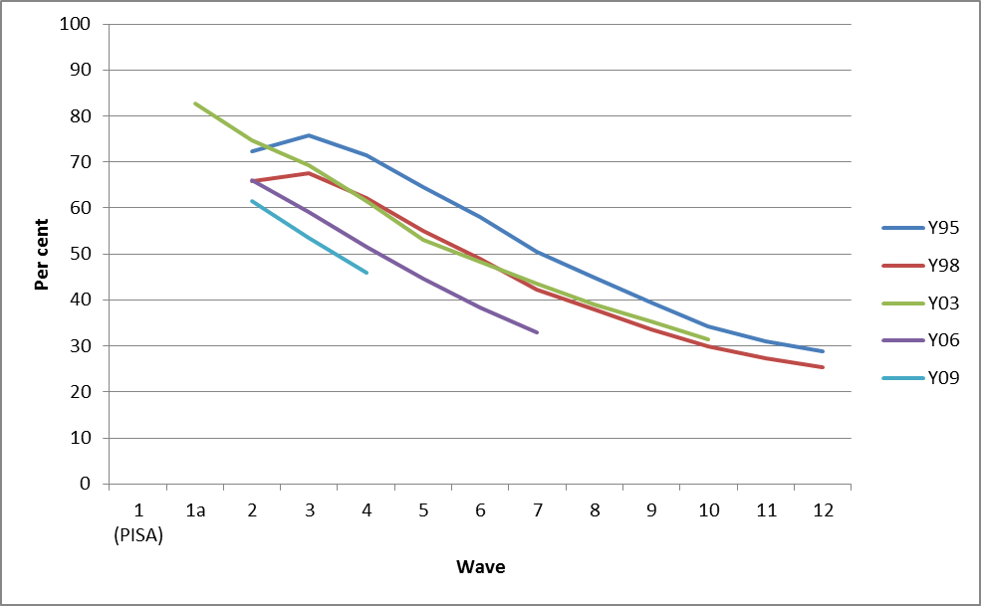

Source: LSAY cohort reports

Notes: For the Y95 and Y98 cohorts a paper-based questionnaire was used in Wave 2 and this resulted in a higher than expected drop-out. In subsequent waves of each cohort the survey was rebuilt using telephone interviewing, which resulted in an increase in sample from Wave 2 to 3.

1. Wave on wave retention rate for LSAY cohorts

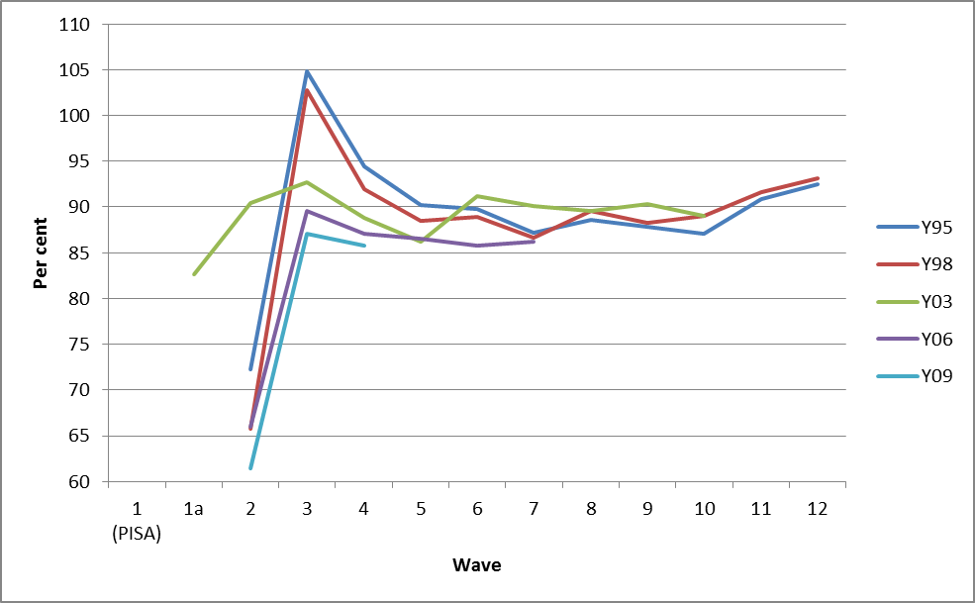

Source: LSAY cohort reports

Notes: For the Y95 and Y98 cohorts the shift to telephone interviewing in Wave 3 enabled some of the original sample to be re-included.

1. LSAY Y09 cohort – sample loss from Wave 1 to Wave 2

|  |  |
| --- | --- |
| Achieved PISA sample 2009 | 14,251 |

|  |  |
| --- | --- |
| Records provided by ACER to Wallis for Wave 2 | 14,157 |

|  |  |
| --- | --- |
| Removed records |  |
| Had no address or phone number | 2,495 |
| No phone number could be found | 557 |
| Refusal or Ineligible | 170 |
| Returned to Sender and had no phone number | 188 |
| Total removed records | 3,410 |

|  |  |
| --- | --- |
| Fielded records |  |
| Interviews (a) | 8,278 |
| Refused (a) | 656 |
| Non-contactable (a) | 1,093 |
| Total fielded records (a) | 10,147 |

|  |  |
| --- | --- |
| Achieved Y09 sample in Wave 2 (b) | 8,759 |

Source: Walllis Consulting (2011)

Notes: (a) Main sample only. (b) Combined pilot and main sample.

Out of the 14,157 records in the starting point for Wave 2, it was discovered that many were either missing an address and/or phone number or the information given was unusable, e.g. the given phone number was invalid or had one digit wrong. In these cases phone searches were not possible and the records could not be used. In total, 2,495 records (18% of the original sample) were excluded on this basis and a further 557 were excluded as no phone number could be found. A mail-out of a newsletter, calendar, and brochure in late 2009 and a pre-survey mail out at the end of June 2010 led to some further refusals and deletions from the sample due to incorrect contact details. Records where an interview could be attempted represented 75.4% of the original PISA sample and the achieved Y09 sample (pilot and main survey) in Wave 2 was 81.5% of the fielded records.

A factor in the 2009 experience was the use of optical character reading technology, which compromised the quality of the contact details. Possible solutions to this in future could include issuing certificates of participation to increase the incentive to provide correct contact details and, with the move to on-line completion in 2015, pre-populating contact details from school records (subject to necessary privacy approvals and student/parental consent).

In terms of differential attrition rates across parts of the LSAY sample, Figure 30 shows that:

* For smaller jurisdictions the oversampling in PISA has raised their share of the LSAY sample over time, but greater than average attrition (indicated by a decline in the share of the LSAY sample over time) does not appear to be a significant issue other than in the NT between Waves 1 and 2. The ACT’s share of the LSAY sample actually increased over time due to lower than average attrition.
* For males there has been some variability across cohorts in attrition levels, but attrition appears to be highest among males in the Y09 cohort.
* The representation of Indigenous students has increased considerably with over-sampling for PISA, but attrition (especially from Wave 1 to 2) appears to be higher in the more recent cohorts and is not confined to the early waves.
* While the representation of remote students has increased (perhaps as a result of selecting more Indigenous students), attrition is higher than average and continues beyond the early waves (Data for Y95 and Y98 is for the broader group rural and remote).
* The representation of those born outside Australia has reduced somewhat over time and the drop in sample share is mainly between Waves 1 and 2.
* For those in government schools, sample share declines over waves suggesting greater than average attrition.
* For those in the lowest quartile of achievement measured attrition is significantly higher across all waves than for those in the highest level of achievement.

1. Sub-populations as a proportion of the LSAY sample over time

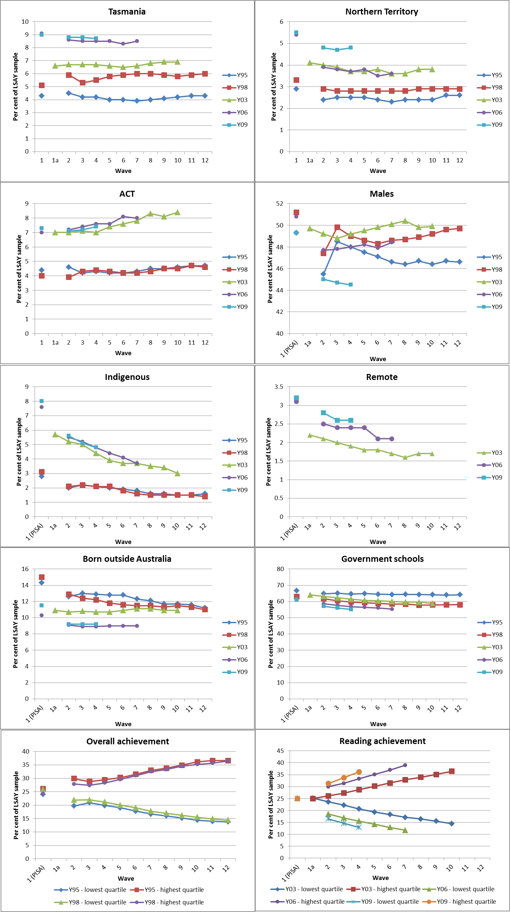

Source: LSAY cohort reports (unweighted data).

### Attrition in other longitudinal surveys

Figure 31 compares sample retention in LSAY with that in three other longitudinal youth surveys:

* the Longitudinal Survey of Young People in England (LSYPE)
* the Swiss Transitions from Education to Employment (TREE) and
* the US National Longitudinal Survey of Youth (NLSY).

All longitudinal youth surveys suffer from attrition, but some have slightly better year-on-year retention rates. LSAY has year-on-year retention rates somewhat lower than LSYPE while the Swiss TREE survey, which also uses PISA as its first wave, has suffered from significant attrition in the period following PISA and the first wave. However, TREE has higher year-on-year retention rates (greater than 90 percent after wave 2) and so has a better cumulative retention rate over the waves. Rothman (2009) notes that in other longitudinal surveys, such as those conducted in the United States by the National Centre for Education Statistics, lower attrition is due to their capacity to track participants through social security numbers, which are required information on university enrolment, student loan and income tax records. The use of financial incentives may also be a factor.

1. Remaining sample in selected longitudinal surveys compared to LSAY

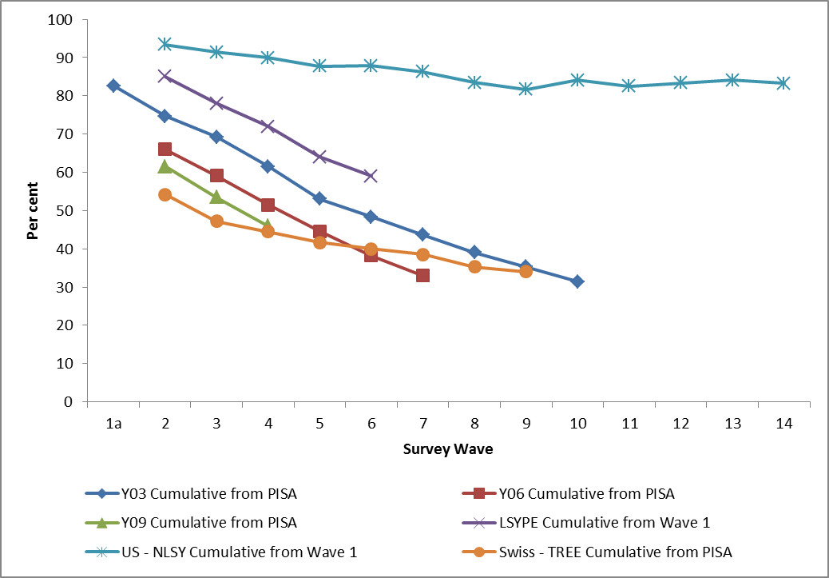

Source: NCVER (2013)

### Managing attrition

In general for surveys, non-response and attrition rates are increasing as people are reluctant to participate or more inclined to refuse. The ephemeral nature of mobile phone numbers and email addresses makes it increasingly difficult to maintain contact with respondents. Good practice in sample management is a critical part of keeping attrition in longitudinal surveys such as LSAY to a minimum as is the use of appropriate weights in data analysis.

#### Existing LSAY arrangements

Beyond Wave 2, the principal cause of attrition from LSAY is additional refusals to participate and those who are away or can no longer be contacted. For example, for the Y03 cohort in 2012, 543 of the main sample of 4,306 were not eventually interviewed (12.6%). Of these 222 refused, 48 were uncontactable and 273 were not interviewed for reasons such as being away or overseas (Wallis Consulting 2013).

The principal strategies used by the LSAY data contractor to minimise attrition are:

* Regular communication with respondents through the six monthly sample maintenance program that comprises a “newsletter” and a thank you letter/postcard in the interim periods between interviews and a reminder pre-survey mailout before interviews commence. These provide an opportunity to update contact details. The newsletter has evolved over time to be youth focussed and recently was in the form of a YouTube video clip.
* Intensive training and debriefing for interviewers. Training is designed to impart the required interviewing skills and to ensure that all those working on the project are fully conversant with its requirements. Most of the interviewers are in the same age group as survey participants so are more able to establish rapport, but interviewer skill and job experience are also critical in achieving good response rates.
* Well-developed email and calling procedures to make contact with as many participants as possible as part of the annual survey round. In 2012 for the Y03 and Y06 cohorts 17% of interviews were obtained after 15 or more phone calls. Attempts are made to track respondents who are initially uncontactable as well as to turn around those who initially refuse to participate.
* In 2012 participants were given the option to complete the survey online rather than over the telephone where this was more convenient. Offering alternative survey modes (ie either phone or internet) can increase overall response and retention. The online option gives the opportunity for participants to complete the survey in their own time, when and where they wish, but it also gives them the opportunity to put off interviews unless this is managed carefully.

Existing LSAY procedures allow sample members to miss one consecutive wave. Those missing more than one consecutive wave are no longer followed up. This reflects the difficulty of collecting accurate data based on respondent recall after a gap of three years or more. This poses some difficulties as more young people take a gap year after completing school, which may involve travel overseas for an extended period. Lumsden et al (2012) speculates that while only a small proportion (6%) indicated travel as a gap year activity, this may be under-reported in LSAY because young people are only allowed to miss one consecutive year of interview before they become ineligible to remain in the survey.

It may be worth re-considering this as it might be better for the current year’s sample to be rebuilt each year from wave 1 or wave 2 to help reduce the compounding impact of attrition. Issues with this include the difficulty and expense of finding contact details of people who have been lost, reliability of event recall over longer periods and complexity of questionnaire design to capture a wider range of participants.

Another key strategy for managing the risk associated with attrition is the use of weights in analysis based on the LSAY datasets. There are two types of weights applied to the LSAY data:

* Sample weights, which ensure that the sample matches the population distribution from which the original sample was drawn. These ensure in Wave 1, for example, that the number of students in over-sampled and under-sampled states and territories matches the total population of 15 year old students in each jurisdiction.
* Attrition weights are used to address non-response by ensuring that the distribution of the sample matches the distribution of the sample population despite attrition over time. The use of attrition weights ensures that distributions in each wave match those obtained in PISA (for the factors identified as contributing to attrition) (NCVER 2012).

The derivation and application of weights is highly technical and complex. To some extent the appropriate weights to use depend on the type of issue being investigated and the model used to explain it so that weighting strategies need to be specific to the issue being examined. There is debate in the LSAY literature about how effective weighting is in counteracting bias from attrition in particular. For example, Lim and Karmel (2011) noted that weighting cannot correct for all types of attrition in a study of the vocational equivalence of Year 12 and Gemici & Lu (forthcoming) note in a study of educational and occupational aspirations that attrition may have skewed their results despite the use of weights. On the other hand, in his study of the effect of student income support on education and training participation, Ryan (2011) argued that attrition does not seriously affect this type of statistical analysis.

#### Other strategies to address attrition

There are a number of practices followed in other longitudinal surveys which have been argued to help control or counteract attrition. These include:

* sample replenishment;
* offering financial incentives to respondents;
* streamlining questionnaires;
* more sophisticated data collection techniques; and
* enhanced communication with and engagement of sample members.

Sample replenishment involves rebuilding a sample by recruiting people who have not previously participated in the survey after a number of waves of interviewing have passed. This can involve re-sampling people from the original population frame or from sub-groups of the population. For example, the LSYPE sample was boosted at Wave 4 to increase the number of young people from ethnic minority backgrounds to counteract disproportionate attrition among them and the HILDA sample was topped up for immigrants in Wave 11. Doing this is time and resource intensive and raises difficult issues about how best to collect a small sub-set of information to make-up for their period of non-involvement as well as issues about appropriate weighting for new members.

1. Use of incentives in selected longitudinal surveys

| **Youth longitudinal surveys** | **Incentives** |
| --- | --- |
| **Youth in Focus (Australia)** | * Offered a $15 incentive for participants in 2006 (tested in pilot and successful in raising response rates among those with heavy exposure to income support by 6-7%). * Later changed to $15 for telephone interview and $25 if also returned self-completed questionnaire. |
| **Youth in Transition (YIT) Survey (Canada)** | * None. |
| **Longitudinal Study of Young People in England (LSYPE)** | * Young people who participated received an unconditional £5 - £10 gift voucher at each wave. * 2010 evaluation recommended that unconditional monetary incentives of approximately £10 should be offered to increase participation in each wave with a marginal increase to £15 at Wave 4. |
| **National Longitudinal Survey of Youth (NLSY) (USA)** | * For NLSY97 various incentives between $10 and $20 in different waves, including experiments to determine impact on participation. |
| **Transitions from Education to Employment (TREE) (Switzerland)** | * Ballpoint pens were included with mail out questionnaires in early waves. |

| **Other Australian longitudinal surveys** | **Incentives** |
| --- | --- |
| **Longitudinal Survey of Australian Children (LSAC)** | * Interviewers provide some promotional gifts to survey participants including a $15 gift card for the child in their teenage years. |
| **Longitudinal Study of Indigenous Children (LSIC)** | * Interviewers provide some promotional gifts such as books to survey participants. |
| **Household, Income and Labour Dynamics in Australia (HILDA)** | * Incentive of $35 provided to each respondent in a household in cash immediately after the face-to-face interview plus $35 for the household. |

Source: See Appendices 2 and 3 in the Support Document.

LSAY relies primarily on altruism as the motive for participation. Monetary incentives are limited to winning one of 24 $500 gift cards if they complete the survey by the closing date (one for each active cohort in each State and Territory at a total cost of $12,000 pa). Other longitudinal surveys mostly offer promotional items or a range of monetary incentives, with the highest being $35 in HILDA, although this is a lengthy face to face interview (Table 18). There is research evidence that financial incentives can be effective in raising response rates in surveys, although there is debate about whether unconditional incentives have a greater impact than conditional ones. They can also be more effective among those least likely to respond and it is suggested that incentives which differ with the propensity to participate may also work (Laurie & Lynn 2009).

Incentives need to be appropriate to the age group and reflect the burden on respondents in terms of interview length. Experiments on the use of incentives have shown that pre-paid or unconditional (that is, not tied to completing an interview) incentives produce the greatest impact on response rates. Incentives paid in the first wave have been shown to increase response rates in later waves. In particular, unconditional incentives are useful in wave 1 in obtaining as large a starting sample as possible. Larger than normal incentives have been shown to be effective in raising response rates in later waves (in terms of LSAY, this might be the wave after the year that most of the respondents finish school). Studies have shown that this incentive can then be dropped to normal levels in later waves without having a detrimental effect on response rates. It is possible to modify, alternate or change the incentives without greatly impacting on participation in later waves.

A further use of incentives is for targeting hard-to-reach groups, or groups that are at a higher risk of dropping out of the survey. Larger incentives could be offered to the most difficult respondents to obtain cooperation and for those who may return to the survey after dropping out. However, there is an ethical issue in that this is rewarding ‘bad behaviour’ more highly than good behaviour. Incentives can also be used to ensure contact is maintained between waves, for example by providing an incentive to keep contact details up-to-date, and to give “finders fees” for family/friends who provide updated or new contact details (NCVER 2013). There may, however, be sensitivities about payment of incentives to students participating in PISA and these would need to be resolved well in advance with the international consortium, the national contractor and school authorities.

Keeping the length of questionnaires manageable is important in minimising the burden of participating on respondents, along with ensuring the questionnaire is easy to administer and understand, individual questions are not too long or difficult to answer and that questions are appropriate to the mode in which they are asked. This needs to be balanced against collecting the level and range of data that is most useful. Nonetheless, experience suggests that longer LSAY interviews are related to respondents being less likely to co-operate in a future interview. By the nature of the data that LSAY is attempting to capture, the content can be dry. Investing more time in questionnaire development, planning the questionnaire over the life of the cohort and utilising a youth focussed questionnaire reference group could produce a questionnaire that is more interesting and engaging for young people.

The move into online data collection creates the possibility to further increase the sophistication of data collection techniques for keeping in touch with sample members. Making better use of the mix of CATI and web-based collection mechanisms can be a way of suiting individual preferences and managing attrition. Some surveys have modelled the probability of response for each individual based on their characteristics and previous response patterns and used this to tailor contact and collection strategies.

Finally, there may be scope to enhance communication with and engagement of LSAY sample members. What would be sought here would be more willing co-operation and commitment from respondents recognising that this is much harder to get than mere contact (Watson & Wooden 2009). Also a key part of this is the quality of the interview experience for respondents, which has been described as “possibly the single most important influence on co-operation in any future wave” (Watson & Wooden 2009, p 178). LSAY interviewers are experienced, trained, monitored for quality and conduct fieldwork debriefs after completing interviews to draw lessons for future cycles.

Other strategies that could be considered to improve the interview experience are:

* Developing a strategic marketing and communication plan with young people and their parents. The review of LSYPE recommended a greater role for parents in the communication strategy, recognising that parents can motivate and encourage their children to continue to participate in the survey. LSYPE also features a Young Person Advisory Panel, which is consulted on issues such as questionnaire content, use of incentives, methods of keeping in touch with respondents, the design of the study and the best ways of presenting study findings.
* Directly promoting the survey to young people and to those who may influence young people through the development of a respondent specific website which should include the latest findings, media coverage, and a place for respondents to update their contact details and claim incentives. While LSAY currently has a respondents’ section on its website, in general the website is orientated to researchers and data users.
* Regularly reviewing the information provided to participants and their parents to reinforce the purpose, importance, and uniqueness of the survey, some findings from previous cohorts, etc.
* Ongoing communication with respondents through, for example, birthday cards or email and text updates (for example when the survey is mentioned in the media).

Consideration could be given to the formation of an expert panel to advise on the most suitable design for the future sample design, modes of interview and questionnaire, limited not only to the main questionnaire but also to supplementary modules, including perhaps some for separate interview. This could also consider measures to improve response rates and attrition.

### Conclusions

Attrition in longitudinal surveys is a complex and difficult area to manage. There is no magic bullet that will increase survey response rates, but failing to seriously address attrition will lead to sample sizes that greatly reduce the power of the LSAY data and its relevance and usefulness to policy makers, especially if follow-up is extended to age 30.

Given that the main source of attrition is the loss of potential sample members from PISA to the first wave of LSAY, highest priority should be given to remedying the attrition from waves 1 to 2 (assuming that PISA remains the starting point for LSAY at least for a new 2015 cohort). Options to consider here are:

* Securing better contact details for students, e.g. from schools themselves (with students asked to consent to this in the PISA questionnaire). Any new arrangements would still need to allow students to choose not to participate in LSAY.
* Reducing the gap between PISA and the first wave of LSAY with an intermediate contact survey later in the same year in which PISA testing occurred. This resulted in a lower attrition rate for the Y03 cohort. This could cost up to an additional $0.5m per cohort.

These options require the co-operation of the Australian PISA team and the OECD PISA managers and relevant school authorities. Any strategies would require changes to the existing methodology of PISA.

In the medium term consideration could also be given as part of the ongoing work of the data collection contractor to:

* Undertaking market research on the impact of the sample maintenance products on LSAY participants and ways to improve engagement with the survey by sample members as a prelude to re-developing an LSAY communication strategy.
* A more thorough technical investigation of the impact of attrition on key outcome variables using available benchmarking data-sets.
* Experimental testing of the effect of incentives on attrition in subsequent waves of LSAY with a focus on retention of sub-groups that are suffering higher than normal attrition rates. While the cost of paying an incentive to all sample members could be prohibitive[[6]](#footnote-6), careful targeting could deliver better retention at a manageable cost based on evidence of what works among the LSAY group.
* As part of reviewing the LSAY questionnaire, endeavouring to make the interview experience more engaging and relevant.
* Further investigation of different telephone and web-based data collection methods to help target respondents’ preferred mode to reduce attrition while also forestalling soft refusals. This could include taking into account the probability of response for each individual to help inform the field work contractor in sample contact and management.

## 3.7 Commissioning and disseminating research

Effective processes for commissioning, producing and disseminating LSAY research results are fundamental to maximising the contribution that LSAY can make to understanding youth transitions in Australia. This section outlines the current processes for setting research priorities, the current types of information and analytical products from NCVER and assesses their suitability to the needs of a range of users. It also considers the timeliness with which LSAY findings are prepared and released.

### Current arrangements

#### Commissioning research

LSAY was conceived as both a data collection and a research program that would be relevant to policy development on youth transitions. To this end, a research body (currently NCVER) has been appointed as data custodian and is funded on a three year contract to produce research reports and briefing papers on agreed topics each year. The rationale for this is to ensure that value from the data is achieved given the big investment in time and skills needed to become familiar with the data that might otherwise create a barrier to access.

Commissioning research involves a number of steps:

* A consultation process at the start of each three year contract helps identify research topics and priorities. For 2011-13, this involved a discussion paper released in November 2010 (NCVER 2010) followed by face-to-face meetings in Perth and Canberra with a range of stakeholders and a webinar to enable people from across the country to contribute their ideas. Over 50 stakeholders participated in the process with written submissions from eight organisations and individuals. Stakeholders included representatives from state training authorities, not-for-profit organisations, TAFE institutes, universities, school peak bodies, academics, unions, and government agencies. Outcomes of the process were summarised in a further paper (NCVER 2011).
* At the commencement of each three year contract term possible topics are agreed by the LSAY Management Group and the LSAY Strategic Advisory Committee (SAC) (comprised of a range of external stakeholders). Table 19 summarises the research program for 2011-13.
* NCVER develops a more detailed scoping paper for each topic including key questions to address and the methodological and analytical approaches to be adopted and submits this to the Department for comment.
* Once this is agreed, NCVER prepares a draft report, generally in a two-stage process. The first draft is provided to the Department for review as well as to one or more external reviewers. The second draft addresses their comments. After internal NCVER quality assurance processes, a final draft is submitted to the Department for comment/approval. There may be more drafts if there are sensitivities or significant work is needed.
* Final clearance is required for each report before publication, consistent with the Department’s research publication approval policy.

1. LSAY analytical program 2011-13 triennium

**Research reports and briefing papers**

| Topic | Research questions |
| --- | --- |
| Individual and institutional characteristics that influence student engagement with school | * Which individual and school/ institutional characteristics have a significant impact on student engagement? * Is the impact different for different dimensions i.e., emotional, behavioural, cognitive? * Which characteristics have most influence on students at risk of early school leaving? |
| The apprenticeship cohort | * Has the continued expansion of higher education had an impact on the quality of the apprentice cohort? |
| The effect of financial stress on study decisions | * How does financial stress affect a young person’s current study or completion of study? |
| Educational expectations and occupational aspirations | * Which factors influence the formation of secondary and tertiary educational expectations or occupational aspirations? * Through which pathways and mediating variables do these factors exert direct and indirect influence? |
| The impact of low skilled jobs | * How long do youths remain in low skilled jobs? * Who progresses out of them and what are the characteristics of those that remain in low skilled full-time employment? |
| School effects on transition outcomes | * Do students from low socioeconomic backgrounds benefit from attending high-quality schools when compared with their more advantaged peers? |
| * What is the separate impact of school characteristics from student characteristics on TER scores and the probability of going to university? |

**Technical papers**

| Topic | Research questions |
| --- | --- |
| Derived variables | * Documents the construction and derivation of NCVER created derived fields. |
| Data linkage | * Explores the potential for linking data to LSAY from existing administrative collections such as NAPLAN and surveys such as LSAC. |
| Weights | * Outlines the weighting methodology used for the Y03 and Y06 LSAY cohorts. |
| Wellbeing | * Examines coverage of wellbeing questions in LSAY and how it could be enhanced to better meet needs of policy-makers. |

Note: An additional report published in 2012 assessing the impact of RIEF reports was prepared separately by NCVER, with some Departmental funding.

#### Research Innovation and Expansion Fund (RIEF)

The RIEF was a one-off initiative costing $300,000 in 2008-09 to increase the quantity, quality, distribution and accessibility of independent research and analysis using LSAY data in the academic and public policy communities.

In particular, it sought to increase the number of researchers using LSAY data, including combining LSAY with other relevant sources. This involved a small competitive research grants program (accounting for around two thirds of the funding). NCVER was contracted by the then DEEWR to manage the program and research proposals were elicited in 2008 through a public invitation process. The projects funded were chosen on the advice of a selection panel comprising representatives of the LSAY SAC, DEEWR and NCVER. NCVER adopted specific quality assurance procedures for the management of the research projects, including peer review. Five projects were funded.

Other components of the RIEF were:

* An early career fellowship to assist a young researcher develop the capabilities needed to make full use of the longitudinal nature of the data and to undertake more complex or innovative forms of analysis; and
* Support to enable low-cost access to LSAY data by researchers (especially early career researchers) and not for-profit organisations.

A total of six reports were commissioned and published as a result of the RIEF. An evaluation found that the program had been successful in strengthening connections between policy, practice and research (Hargreaves 2012).

#### Disseminating results

Planning for dissemination is one element in the research planning process described above. Embargoed copies of publications are provided to key stakeholders eight working days in advance of public release. This may be accompanied by a briefing pointing to any sensitivities or matters of particular interest.

LSAY findings are conveyed to general users primarily through a dedicated website ([www.lsay.edu.au](file:///E:\Work\Schools%20data%20and%20evaluation\LSAY%20review\Working%20papers\www.lsay.edu.au)) offering a number of types of publications:

* Research reports, which examine in-depth policy relevant issues and involve original analysis using the LSAY data sets and other data where relevant.
* Briefing papers, which generally synthesise findings from already completed research reports on important themes. Sometimes these also contain some more basic original analysis of LSAY data.
* Discussion papers, which canvass issues about various aspects of the program, such as triennial research priorities.
* Cohort reports, which summarise in tabular form the activity of young people in the five cohorts Y95 to Y09 at each wave of the survey.

Those interested in being kept up to date with LSAY publications can register at the website to receive email notices of new releases as they occur.

Data files can be accessed directly through the Australian Data Archive (ADA). Support for users of these is provided through:

* An LSAY mailbox for responding to requests for information and providing user support.
* User guides for each cohort, which consolidate information about how to access the data, data restrictions, variable naming conventions, sample design, the structure of the data, documentation, classifications and code frames used, weights and derived variables. Supplementary resources include topic maps, variable listing and metadata, data elements documents, derived variable documentation.
* Questionnaire and frequency tables for each wave of each cohort.
* Technical papers, which focus on general methodological issues in research and use of the data, e.g. attrition or weighting.

Other dissemination activities include irregular research forums (one held in each of 2009 and 2013) and data workshops (4 held from 2008 to 2010). These can attract significant numbers indicating the potential interest in LSAY, e.g. over 200 registered for the 2013 forum. Seminars are offered on selected reports when released and webinars are sometimes also used. NCVER attends a number of forums and conferences to display and promote LSAY materials or present research findings. An updated LSAY reference guide will provide a consolidated summary of findings from research reports over the whole course of LSAY under selected policy themes (NCVER forthcoming). This enables users to identify at a glance those reports that have examined issues of interest to them. The previous compendium covered research up to 2003 (Penman 2004).

A recently completed easy to use table generation facility will provide website users with the capacity to customise tables, drill-down into the data and generate time series using LSAY data. Another enhancement currently in train is an annual report on LSAY providing up to date information on core data, comparing the experiences of young people across cohorts and over time and some supplementary analysis of topical issues. This also includes a summary of research published in 2013, forthcoming research, and LSAY usage information (website, citations, media interest).

### Stakeholder views

In the interviews with selected stakeholders there was a view that it is appropriate that a body with expertise in the LSAY data and youth transition policy undertake a program of core research to realise the value of the survey given the investment in time and skills needed to become familiar with the data. However, concerns were expressed in a number of areas about the current research processes as support for continuation of LSAY was not reflected in the value stakeholders derived from and most are scant users of the data and not heavy users of released research.

Specific observations about the selection of research topics and the dissemination of results included the following:

* LSAY occupies a more contested domain of data and research than when it was first instituted. In the schooling years in particular, the emergence of PISA, NAPLAN, My School, school leaver surveys, AEDI and LSAC mean that LSAY is now more at risk of being overshadowed by other sources of information.
* A feeling that LSAY and the research derived from it reflects past policy concerns and has had difficulty moving quickly enough to respond to new or emerging issues. For example, one stakeholder saw some potential but undeliverable value in LSAY investigating the “success factors” for entry into the uncapped higher education market, where TER scores play a lesser role.
* LSAY was seen as conservative, averse to exploring novel topics and collecting a wider range of data. As a result, LSAY is less relevant to a broad spectrum of policy-makers and less appealing to young researchers seeking to establish careers and reputations.
* A perception that publication has become subject to greater delays, further contributing to questions about LSAY’s usefulness and worth and a loss of impact and influence.
* A view that LSAY’s various limitations including small sample size (for sub-groups of interest and for jurisdictional samples) and attrition limit the questions able to be investigated with the data to broad “cause and effect” studies and that finer grained analysis is needed but not really possible with LSAY.
* While recognising that there was strength in the Department maintaining a commissioning role for research so that it is policy directed, this was also seen to contribute to delays in release of research and to act as a disincentive to explore wider and more relevant topics. Greater independence was seen to give more credibility to the findings from some other surveys and research organisations.
* There was some concern that NCVER’s LSAY research is too focussed on VET pathways or lacks an overarching intellectual framework on transition, which would add to the research value of LSAY and better focused its research endeavours.
* Advanced users generally considered that the LSAY dataset was difficult to work with and poorly documented. A substantial investment of time was needed to become proficient as the dataset design was focussed on data collection rather than output generation. It was suggested that LSAY could learn from HILDA’s approach with stable data item naming/location, pre weighting of individuals and a better “calendar of events”. This accentuated other problems with high attrition levels and the limitation to 25 years of age which meant that LSAY was seen as out of step with social trends.

One stakeholder summed up a common view: ‘ the value of LSAY is determined by the usefulness of the research released from the survey, and this in part depends on the timeliness of that research. LSAY, when compared to other equivalent practices, is a poor performer in maximising its value’.

### User survey

In the LSAY user survey those who had ever used LSAY research or data were asked about their frequency of use of various research outputs and their usefulness. Products available on demand and intended for a wide audience such as research reports, briefing papers and the LSAY website, were used frequently (at least monthly or half-yearly) by a large proportion of those who had ever used LSAY, e.g. 73% used research reports monthly or half-yearly. Lower proportions used the actual datasets (44% monthly or half-yearly) or more technical documents (e.g. 24% used frequency tables monthly or half-yearly).

Ratings of LSAY outputs as useful or very useful among those who reported using them varied from 90% for research reports down to 51% for frequency tables (Figure 32). There are differences in patterns of use and perceptions of usefulness by organisational type, e.g. frequency of use of technical documentation such as questionnaires and user guides is highest among universities and research organisations, but significant proportions of state government respondents (40%) and Australian Government respondents (31%) also used the datasets directly.

1. Percentage of users rating LSAY outputs as very useful or useful

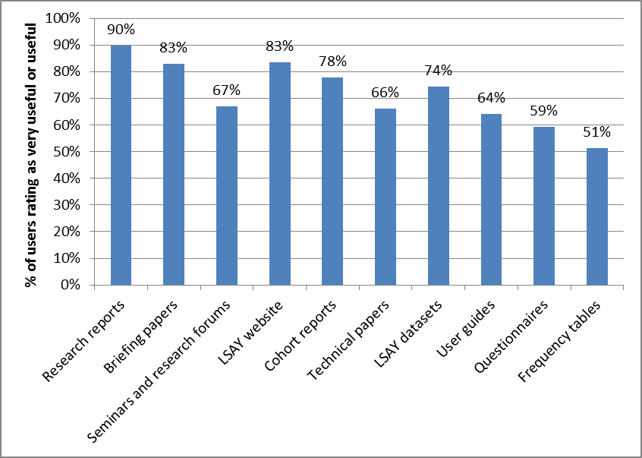

Source: LSAY User Survey 2013 Q18 to Q20. Expressed as a percentage of those who reported using them.

Figure 13 in section 2.2 showed that dissemination (mentioned by 11 respondents) was the second most commonly perceived weakness of LSAY after attrition (mentioned by 16 respondents). Comments ranged across a number of aspects including the quantitative and sometimes quite technical nature of research reports and their timeliness.

Suggestions for improved dissemination included:

* An annual statistical report comparing outcomes for cohorts over time and containing a mixture of data and some descriptive analysis (this may be addressed by the annual publication in development).
* Greater attention to distilling the story and key messages from research for a general audience and in a way that can easily be used in a policy context.
* More seminars/short forums to publicise the research and allow discussion with researchers.

Closely related to issues about dissemination were concerns about accessibility and use of the LSAY data files (8 respondents). Comments covered a variety of issues including:

* The need for special desk top statistical analytical tools and technical expertise to mine the data (this may be addressed in part through the table generation facility under development).
* The complex structure of the data and the set-up of variable names, which require a more substantial upfront investment of effort for researchers than is the case for other longitudinal data sets.

1. Most useful enhancements to LSAY dissemination

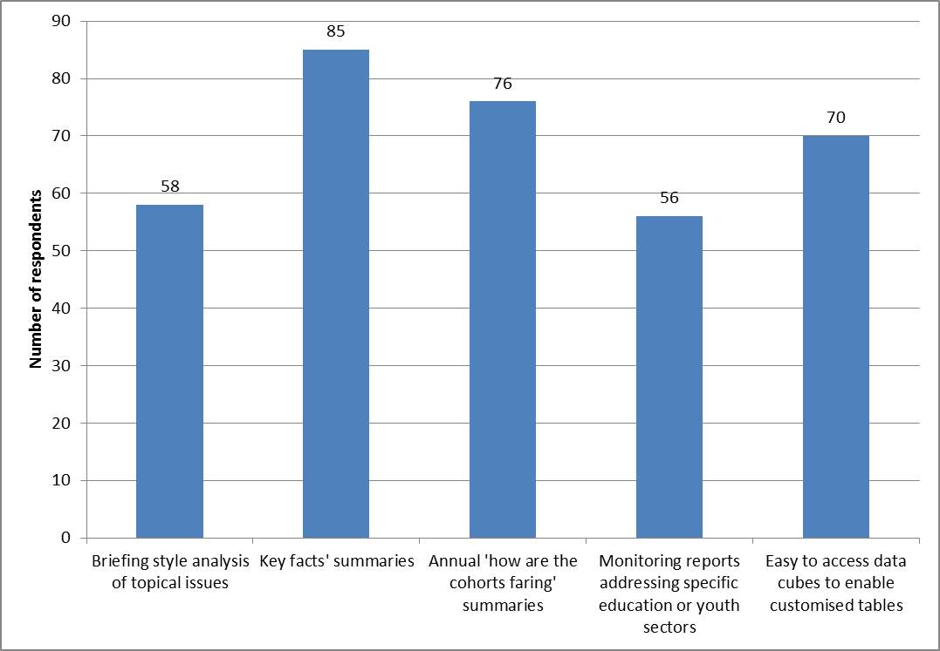

Source: LSAY User Survey 2013 Q25.

Suggestions for improvement here included:

* Renaming variables to achieve greater consistency over time and cohorts and to facilitate analysis rather than identifying their location in the questionnaire.
* Investing resources in developing more derived variables (i.e. pre-constructed variables that bring together multiple questions from the same survey and/or across time) to reduce the time and cost to researchers of constructing and using LSAY datasets.
* Improving the cleaning of deposited datasets for all cohorts and years so that they are ready to use with less set-up.

When asked “what additional forms of dissemination of LSAY information would be most useful to you?”, the most commonly mentioned were key fact summaries and annual reports on the progress of cohorts (Figure 33). Among those in government there was also strong support for access to data cubes.

### Timeliness

Timeliness can refer to either the relevance of research to public policy at the point at which it is published or the time elapsed in the research process from commencement to publication. Perceptions of the first sense are difficult to assess as they are essentially qualitative judgements and may be influenced, given the long lead times often involved in research, by the skill with which issues are anticipated as well as fortuitous timing. The stakeholder interviews and user survey provide the best source for this. Timeliness, in the second more narrow sense can be measured directly.

1. Time required to complete recent LSAY research outputs

|  |  |  |  |
| --- | --- | --- | --- |
| **Research reports** | **First draft to Department** | **Publication date** | **Months from first submission to publication** |
| Starting out in low-skill jobs (RR 64) | April 2012 | October 2013 | 18 |
| The impact of school academic quality on low socioeconomic status students (RR 63) | February 2013 | August 2013 | 6 |
| Student income support and education and training participation in Australia (RR 62) | November 2008 | June 2013 | 55 |
| The impact of schools on young people's transition to university (RR 61) | June 2012 | April 2013 | 10 |
| How did young people fare in the 1990s economic downturn? (RR 60) | August 2011 | August 2012 | 12 |
| School completion: what we learn from different measures of family background (RR 59) | October 2010 | July 2012 | 21 |
| The vocational equivalent to Year 12 (RR 58) | April 2010 | September 2011 | 17 |
| Which paths work for which young people? (RR 57) | April 2010 | August 2011 | 17 |
| Year 12 completion and youth transitions (RR 56) | August 2009 | June 2011 | 22 |

|  |  |  |  |
| --- | --- | --- | --- |
| **Briefing papers** | **First draft to Department** | **Publication date** | **Months from first submission to publication** |
| Who takes a gap year and why? (BP 28) | March 2010 | June 2012 | 27 |
| Trends in young people's wellbeing and the effects of the school-to-work transition (BP 27) | August 2010 | November 2011 | 15 |
| Social capital and young people (BP 26) | July 2010 | October 2011 | 15 |
| Successful youth transitions (BP 25) | August 2010 | September 2011 | 13 |
| Young people in an economic downturn (BP 23) | May 2010 | April 2011 | 11 |
| At risk youth: a transitory state? (BP 24) | July 2009 | March 2011 | 21 |

Source: Department records

Table 20 shows the time elapsed in months between the submission of a draft report to the Department and its ultimate publication date for the nine most recently released research reports and six briefing papers up to end 2013. This is an indicator of the time required to produce reports, but does not include the time for initial investigation, preparation of a research plan and preparing the first draft itself. As it is based on elapsed time, it is not a measure of total time on task. The table does not cover RIEF reports as these went through a different comment and clearance process than those that were part of the analytical program.

The analysis shows that most of the nine reports had an elapsed time between receipt of a first draft and final publication in excess of 12 months. Only two reports had an elapsed time less than 12 months. For one report the elapsed time was 55 months due to turnover in the team responsible for the report. Similarly, for the six briefing papers, only one had an elapsed time under 12 months. A number of factors may account for this including the clearance process itself, multiple projects being worked on by researchers, conflicting priorities for those commenting on draft reports, unexpected difficulties in analysing data, etc. It is not possible to identify from records the stage at which delays occur without an exhaustive review.

Nonetheless, the time required to complete LSAY reports seems in many cases to have been excessive. Aiming to publish each report or paper within 12 months of receipt of a first draft should be regarded as the standard. The current approval process is more streamlined than in the past and four research reports have been published so far in 2013, which is a significant improvement on the preceding years. Part of the streamlining involved a variation to contract in 2012 to introduce a 30 day turn-around for agreed final draft reports.

### Quantity and source

While the focus above has been on the LSAY analytical program, it is important to note that other researchers make a significant contribution to LSAY analysis. Requests for access to the LSAY data increased from 20 in 2008 to 40 in 2011, which may in part have been due to the RIEF initiatives (Hargreaves 2012). Figure 34 shows by source the total number of research publications (research reports and academic journal articles) that involve substantial analysis of LSAY data from 2008 to date. Of the total 66 research publications, the formal analytical program accounted for just over half. The RIEF and other publications using LSAY by NCVER supplemented this. Publications by researchers other than NCVER accounted for slightly less than a third of all publications.

A marked feature of Figure 34 is the reliance on the analytical program – LSAY has not attracted as much interest from other researchers as some other longitudinal surveys. Nonetheless, the contribution of research outside the formal LSAY analytical program is under-recognised at present, in part because it is not highly visible. While it is recorded in the VOCED database, the absence of an LSAY annual report has meant that there is not a ready vehicle to flag the work that has been done, as occurs in annual reports for HILDA and LSAC.

1. Number of LSAY research publications by source, 2008 to date

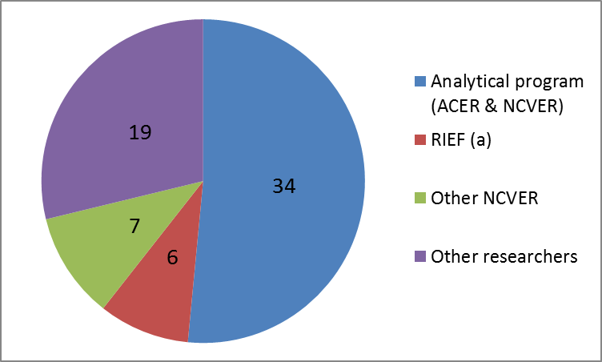

Source: VOCED database

Note: Analytical program includes forthcoming publications on the 2011-13 workplan.

(a) RIEF includes the report published from the work of the early career research fellow.

On an annual basis there has always been a degree of variability in the outputs of the LSAY analytical program. Taking a longer view back to the inception of LSAY, Figure 35 shows the number of research reports and briefing papers published as part of the LSAY analytical program each year. It demonstrates that there was generally a growth in the volume of reports in the early years up to 2005. There was a noticeable hiatus in publications over 2006 to 2009, which coincided with the transition in responsibility for the analytical program from ACER to NCVER in 2007. The RIEF was in part intended to offset this and the six reports it generated helped to return publications to a higher level in 2010 and 2011. Since then, the number of research reports published each year has held steady.

Nevertheless, the total quantity of research produced by LSAY is modest compared to some other Australian longitudinal surveys. For example, at September 2012 the HILDA research bibliography since its commencement in 2001 contained some 370 academic journal articles, seven books, 17 chapters in books, and more than 170 reports and other publications (Watson & Wooden 2012). HILDA’s larger scale of funding, organisation and use compared to LSAY is in part due to it being a general purpose household survey with a broad target population and wide scope of subject matter as well as its design. As a survey examining issues about youth and their transition to adulthood, LSAY is necessarily somewhat narrower in focus and appeal to potential users. In this respect LSAC is a closer comparator to LSAY, but even here research outputs are much higher, for example, in 2009 alone 31 research reports and journal articles as well as 53 conference papers (FAHCSIA 2011).

Obviously, the appropriate level of research in LSAY needs to be based on policy and research demand taking into account the quality and relevance of what is published. The point here is not simply that more research is needed based on LSAY, but rather to consider why other surveys have been more productive and whether any lessons from them might be applicable to LSAY, recognising that greater resourcing and the type of data they collect have also played a part in these surveys attracting more interest from researchers.

1. Number of LSAY research reports and briefing papers 1996-2013

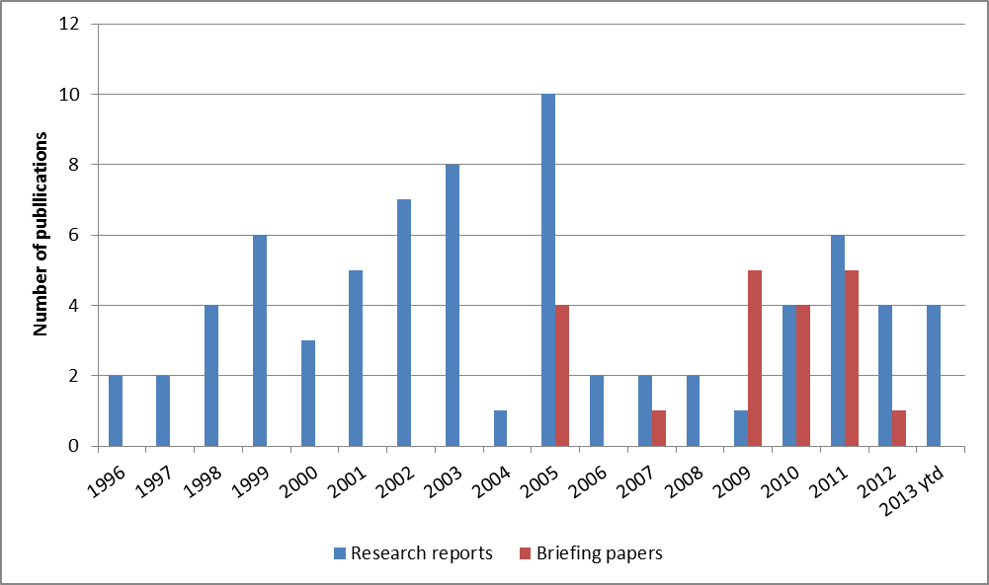

Source: LSAY website

Two points in particular arise from comparing LSAY with these other surveys:

* they use different processes for commissioning research; and
* they have been much more successful in engaging with and supporting external researchers.

The model used for LSAY of funding a research body to produce a certain number of publications each year reflects some of the particular characteristics of LSAY, but is different from the approach used in some other Australian or overseas longitudinal surveys.

For HILDA, the Melbourne Institute is funded to oversee the overall management of the survey, including design and development and sub-contracting data collection. This role includes producing a limited research summary in the form of an annual statistical report that contains short articles summarising key results from the data as well as articles on irregular topics, influenced by wave-specific questions in the survey (Wilkins 2013). Most of the analysis consists of graphs and tables of descriptive statistics, but with some results of regression analysis. The report does not aim to be comprehensive, but rather to show the types of analyses that can be undertaken with the data and encourage users to undertake their own analysis. Apart from this, the Institute is not funded through its contract with the Department of Social Services (DSS) to carry out research or analysis of the data, although it is funded in part to do so through the Australian Government’s Social Policy Research Services Contract between the former DEEWR and the Institute.

Most of the research based on HILDA is not commissioned directly as part of a formal program, but instead is generated by government and academic users of the data. The number of these – around 500 users for the latest waves (Watson & Wooden 2012) – reflects the breadth of topics and the general household nature of the HILDA survey. The number of users is also a reflection of active measures over the years to provide support to users. In addition to written documentation to help them and data files that are regarded as easier to use, there is a well-attended biennial research conference that provides a venue to showcase and discuss new work as well as frequent training courses for users at basic, intermediate and advanced levels (four in 2012).

With LSAC, the Australian Institute of Family Studies (AIFS) takes responsibility for some research and statistical reports. Research using the LSAC data is now commissioned and funded separately. In addition, support for external researchers is provided via a biennial research conference (together with LSIC) and, in conjunction with this, a data workshop for users. In mid-2010 there were approximately 370 registered users of LSAC data (FAHSCIA 2011).

### Selecting research topics

The role of the Department in commissioning and overseeing research projects involves balancing the interests of different funders and the broader group of those with policy and research interests in youth transitions and managing the implications of this for the quality and relevance of results. The Australian Government contributed 100% of the cost of data collection and just over 90% of the funding for the analytical program in 2012. In any program of research that is policy oriented and funded directly, it is reasonable that government departments will have views about what policy issues are important would want to have some influence on the shape of that research program. The issue is how to achieve this while also ensuring that research outputs are high quality and well-regarded.

The Department’s process for approving research publications which it funds requires final approval to be given by the same level of delegate as was required for the initial research project proposal, i.e. Group Manager level. The Department also informally briefs its Minister’s office on final reports in advance of their release so that they are aware of any potential media sensitivities beforehand, but this does not involve seeking approval for the report’s content or release. Arrangements for providing embargoed copies of reports in advance to state departments ensure that they have the same opportunity.

The perception that the Department has an undue level of control or involvement may in part be due to limited transparency about a number of aspects of the current process for commissioning and carrying out research. While the consultation process used by NCVER in 2010 to help set priorities and topics for the 2011-13 analytical program was an important step in widening input, it is important that it is repeated for future trienniums as awareness of this process needs time to consolidate. The discussion paper which NCVER prepared and the report on the outcomes of the process also provided a valuable snapshot of LSAY’s capability and the policy interests of a range of stakeholders.

Although the LSAY SAC provides some external input at the next step of determining the annual work program, there is a lack of transparency in how the triennial priorities translate into specific projects and reports. One way to address this would be to use the planned annual report to give stakeholders an update on what specific projects are planned for the coming year and some explanation of why they have been selected. The report could also cover progress with the current year’s reports, encouraging more timely completion.

More fundamentally, however, greater engagement with policy makers and researchers on the research topics for LSAY requires a greater level of engagement on their development. In relation to policy makers, more active use of Commonwealth/State ministerial and official committees would be one mechanism for doing this. Another would be to shift the way LSAY research is selected and managed towards the model used by NCVER for the National Vocational Education and Training Research Program (NVETR) (see box below).

|  |
| --- |
| **National Vocational Education and Training Research (NVETR) Program**   * NCVER is contracted to manage the program on a 3-yearly basis. In 2009-10 it consulted with over 150 stakeholders regarding new research priorities for 2011-13. * The Ministerial Council responsible for VET endorsed five national research priorities for tertiary education and training in June 2010: skills and productivity; structures in the tertiary education and training system; the contribution of education and training to social inclusion; learning and teaching; and the place and role of VET. * Research is commissioned under two principal categories: * Three-year programs under which four different research groups outside NCVER participated. * Open category funding rounds (usually annual) to commission research projects of one-two years duration, to encourage fresh thinking, address gaps in the research priorities, or to accommodate innovation and unanticipated needs. * In some years the Commonwealth provided additional funding to commission research in some areas. * In addition, a number of initiatives aim to build researcher capacity through fellowships and scholarships. * The process for selecting successful research projects is independent, transparent, comprehensive and competitive and emphasises quality assurance through double blind peer review and internal approval processes prior to publication. * To ensure projects are delivered on time, research managers ensure realistic establishment of timelines at the start of projects and invoke tighter management of timelines during the life of the research project. Payments are also weighted to final deliverables. * Total expenditure on commissioned research over 2009-12 was $4.1m. |

Source: NCVER (2012a)

While NVETR is a larger research program than LSAY needs to be, the same principles of collaborative priority setting, delegated responsibility for delivering high quality research outputs and independence could be applied to a future redesigned research component for LSAY.

### Conclusions

The above suggests that there is considerable scope to generate greater value from LSAY research than is being achieved at present.

Separating funding for survey design, management and reporting from funding for substantive research could have some risks in the short term. At present LSAY is highly dependent on the formal analytical program for the largest component of research undertaken and separating this from the role of survey custodian could actually reduce the volume of research produced and complicate the management of the program. Given its relatively small size and the investment in expertise required to analyse LSAY data, there is an argument for retaining an analytical program in the medium term, subject to periodic market testing of who should perform that role.

The volume of research which the analytical program aims to produce (around 3 research papers a year) may be too ambitious for a core research program in a survey of LSAY’s resourcing and nature. Effectively, little is produced in the first year of a contract as research takes time to carry out and so the pressure for publication increases in the final two years. A smaller research program (e.g. six research reports over a three year period) might be a better way of a delivering high quality, timely and relevant reports, although it could lead to lower visibility.

The current types of written products – the mix of research reports and briefing papers in particular – arising from the analytical program is broadly effective in meeting stakeholder needs. The possible addition of key fact summaries would meet a growing need among policy makers for short and sharp analyses and results that can be understood and used immediately. The recently completed website table generating facility and work underway on an annual report an updated research compendium will help meet existing gaps.

The main priority is to ensure that LSAY gains a reputation for high quality, timely and relevant research. Achieving this will require a sustained focus to ensure that reports from the LSAY analytical program better meet expectations in three key areas:

* improved timeliness, in particular reducing the existing lengthy delays in finalising many reports, so that results are released more quickly, but without compromising quality;
* the perceived independence and rigour of research, primarily through greater engagement in priority setting and transparency about the translation of triennial priorities into actual projects and how those progress; and
* over time some expansion in the scope of data collected so that new areas of policy interest can be explored through LSAY making it relevant to a wider group of stakeholders.

However, it is also critical to leverage greater interest in LSAY among the wider group of policy and research organisations with an interest in youth pathways. A number of steps are necessary to achieve this:

* The experience with the RIEF shows that a supplementary program of grants for other researchers and support for them through conferences, training and workshops can generate interest. Most critically, while the RIEF was a one-off initiative, what is required to reinvigorate interest in LSAY is a sustained effort over a period of years.
* An expert external review of the LSAY data file setup and documentation would help to ensure that as far as possible it is made easier to use and reflects contemporary best practice for longitudinal social surveys.
* Conducting a policy forum and data workshop for users of the data at least every second year.

## 3.8 Governance and funding

LSAY is governed and funded in ways that recognise the joint interests of federal and state governments in a strong evidence base for policies on education and training, employment and youth transitions generally as well as the broader public and research interest in the questions which LSAY addresses. Although the Australian Government has played the main role in funding and organising the survey, it has sought to do so in ways that recognise the key role of the states particularly in schooling and VET as well as in the design and delivery of PISA. This section discusses to what extent the current structures have been effective and the implications of changes to other aspects of LSAY for future governance and funding arrangements.

### Stakeholder views

Issues related to the overall use and usefulness of LSAY and processes for setting research priorities and topics and the timeliness of reporting were considered earlier (Sections 2.2 and 3.7). They raise broader questions about the evolving data environment in which LSAY operates and the value of the contribution it can make in the future to understanding youth pathways and transitions. Specific comments on the effectiveness of LSAY’s current governance and funding arrangements were limited.

Among stakeholders LSAY was seen as a survey designed primarily to meet Australian Government information needs and this impacts on views towards the involvement of others in governance and funding. Some saw LSAY as too close to government for approval and funding and suggested that more arms-length models were available to sponsor policy relevant research, while increasing the credibility of the outputs through greater independence.

Those in state governments were not major users of LSAY in their own right, preferring instead to draw on their own longitudinal study/destination surveys. Where these surveys are conducted, LSAY’s value is seen as marginal and limited to providing a national benchmark for comparison. In these jurisdictions, involvement in governance and contributing to funding LSAY is regarded as a low priority. Where states do not conduct their own study/destination surveys regularly, there was a greater interest in maximising LSAY’s potential contribution through greater integration with other education data trends and priorities such as strategic consideration through Senior Officials meetings.

Among Australian Government stakeholders there was a range of views about the level of influence different policy areas wanted to have over the content and research undertaken through LSAY. Some saw themselves more as users rather than drivers and consequently did not have strong views on governance or feel the need to engage with LSAY to shape its directions. The lack of some data was seen as a factor in this, e.g. without measures of foundation skills and mental health LSAY was limited in what it can contribute to explaining the pathways of the least employable and most disadvantaged.

### Governance

At present LSAY is governed through a formal structure involving two principal committees (Table 21). A Strategic Advisory Committee (SAC) provides strategic advice on the program from external stakeholders and research experts. This is comprised of representatives from relevant Australian Government departments, key intergovernmental bodies for the school and vocational education and training sectors (AEEYSOC and SCOTESE), the independent schools sector and experts with relevant academic and technical experience, including nominees from ABS, NCVER, ACER and the Melbourne Institute of Applied Economic and Social Research (MIAESR). The SAC’s role encompasses high level oversight and directions as well as advice on data collection and topics for research and analysis in the annual analytical program. A second committee comprised of representatives of the Department and NCVER is responsible for ongoing implementation of the program.

1. LSAY governance structure

|  |  |  |
| --- | --- | --- |
| Committee | LSAY Strategic Advisory Committee (SAC) | LSAY Management Group |
| Role | Provides strategic advice on all aspects of LSAY to ensure its relevance to current/emerging policy needs, including:   * aims and objectives * making the best use of it for policy making in Australia; * topics, themes and directions for data collection, analysis and research; * promotion/dissemination * improving accessibility and encouraging greater use of LSAY by policy makers and researchers. | Oversees progress with planning and implementing LSAY data collection and analysis including:   * contractual arrangements * analytical work programme * questionnaire development * dissemination activities * survey design issues * findings relating to research and analysis. |
| Membership | Chair (Australian Government Department of Education)  One nominee from each of:   * Australian Government departments with relevant policy interests (now Social Services, Employment and Industry) * senior officials responsible for school education, early childhood and youth affairs (AEEYSOC) * senior officials responsible for tertiary education, skills and employment (NSOC) * independent schools sector * ABS * NCVER * ACER * MIAESR * Wallis Consulting   Plus some with relevant policy, research and technical expertise (currently 4). | * Chair (Dept. of Education) plus representatives from the Department and NCVER. Others may be invited at the discretion of the chair. |
| Frequency of meetings | 1-2 a year | Up to 4 times a year. |

An internal Departmental Steering Committee was previously responsible for advice on program and research directions to meet Australian Government needs, but this has not operated since 2009.

The governance structures for LSAY broadly resemble those for other Australian longitudinal surveys such as HILDA and LSAC, in that as ‘government-owned’ studies, “all decisions about the design, content and administration…are subject to the approval of the funding agency” (Watson & Wooden 2012, p 378). Governance structures have been established, however, to incorporate essential technical expertise and the interests of a wider group of users in government and among researchers. Unlike HILDA and LSAC, LSAY’s governance includes explicit representation of state government interests, which is important given the extensive role of the states in the policy areas which LSAY covers.

While LSAY’s governance structures are similar to those of other surveys, stakeholder interviews suggested that generally stakeholders other than the Department had a low level of engagement with LSAY. This was reflected in comments about the limited relevance of research findings together with a level of disinterest in shaping how LSAY could be redirected. This lack of engagement presents a considerable hurdle to overcome in rejuvenating LSAY.

As discussed earlier in this report, the immediate challenge facing LSAY is to reposition the survey so that it is better able to provide useful information about youth transitions to stakeholders and policy makers more widely. A key aspect of this will be improving processes for commissioning and disseminating research. As noted in section 3.7, there is scope to improve the research commissioned from NCVER, primarily through greater engagement in shaping LSAY and transparency about the translation of triennial priorities into actual projects and how those are progressed.

### Funding

In 2012-13 LSAY cost approximately $2.1m and this was funded mainly by the Australian Government with a contribution from the states of $97,700 towards the analytical program. State funding shares are based on population as per an agreed formula. In 2007 senior education officials agreed that the state/territory contribution would be channelled to NCVER via DEEWR and paid as part of the research and analysis contract.

Prior to the recent Machinery of Government changes, the Australian Government contribution was sourced from the DEEWR Education Research Program (DERP). The DERP provided funding to enable various areas within DEEWR to undertake research activities that were aligned with the Department’s strategic goals. Following machinery of government changes in September 2013, which created separate departments of education and employment, future arrangements for research funding are still being considered. DERP was a part of departmental appropriations and so is subject to the efficiency dividend arrangements.

Table 22 sets out estimated commitments under existing contracts. The declining cost of data collection is due to 2013 being the last wave of the Y03 cohort as well as the decision to defer commencing a new cohort in 2012 to replace it. The lower cost of research and analysis is due to the narrower focus of work under the interim contract pending outcome of this review with a series of activities focussed on supporting the review and no new research reports being commissioned.

1. Estimated LSAY commitments (incl. GST)

|  |  |  |  |
| --- | --- | --- | --- |
|  | **2012-13** | **2013-14** | **2014-15** |
| **actual** | **est.** | **est.** |
| **$’000** | **$’000** | **$’000** |
| Data collection (contract expires March 2015) | 1,050 | 979 | 640 |
| Research and analysis (contract expires Dec. 2014) | 1,070 | 825 | 213 |
| LSAY Review |  | 50 |  |
| Total committed | 2,120 | 1,854 | 853 |

Note: Payments for the data collection contract for 2013-14 and 2014-15 have been estimated on the basis of a 90 per cent survey response rate in the preceding year. Actual payments are based on the achieved sample.

This review has recommended that consideration be given to a number of enhancements to LSAY that would improve the value for money it delivers, subject to the availability of a modest amount of additional funding. This will require consideration by governments in the context of their overall budgetary priorities and the significant fiscal challenges that all levels of government face at the present time.

Nevertheless, a longitudinal youth survey is an important part of the national data infrastructure to support evidence based policy development. LSAY provides important national benchmark data about youth transitions that is not available from other sources. All governments have an interest in ensuring that high quality, policy relevant data such as that which has been collected through LSAY continues to be available in future and is accessible and useful to a wide range of users.

As noted elsewhere in this report, there are mixed views at present among state departments about the value of LSAY in meeting their data needs, depending on areas of responsibility and each jurisdiction’s own data sources and capability. An important challenge in implementing recommendations and enhancements following this review will be to ensure that the value of LSAY to states increases over time.

Given also that it is closely linked to national initiatives such as PISA, it is highly desirable that a national approach is taken to funding LSAY. In particular, the value of a longitudinal survey cumulates over time and requires a long-term funding commitment that reflects the importance of the data and the willingness of all levels of government to invest both money and time in its development and maintenance.

### Conclusions

LSAY is situated in a complex policy environment in which many stakeholders have a potential interest in the findings it is able to deliver. As a national, cross-sectoral survey it is of use to all government agencies with a focus on youth education and employment.

While LSAY’s governance and funding structures provide scope for a range of stakeholders to help shape the program, there seems to have been a decline in the engagement of stakeholders other than the Department with LSAY. This is evident in views that LSAY’s research findings are of limited interest to many together with a level of disinterest in shaping how LSAY could be redirected. This lack of engagement presents a considerable hurdle to overcome in rejuvenating LSAY.

As discussed in Section 3.7, two particular areas of LSAY governance and management have been identified as matters of concern. First, management of research priorities and topic choice for specific research projects is seen to lack transparency and consultation. Second, quality control and publication processes are seen to be often very slow. Addressing these two critical areas will be an important way for the Department to convince stakeholders that it is serious about rejuvenating LSAY.

With respect to funding, it is highly desirable that a national approach is taken to funding LSAY is taken given its relevance to all levels of government and the important national benchmark data about youth transitions that LSAY provides. Given the long term commitment required to effectively run a longitudinal survey, future funding arrangements need to be stable, sustainable and long-term if the full potential value of LSAY is to be realised.

## References

ABS (2011) *Concept Paper: Australian Longitudinal Learning Database (ALLD)*, April, <http://www.abs.gov.au/ausstats/abs@.nsf/Lookup/4211.0main+features3August%202011>

ABS (2013) *Essential Statistical Assets for Australia*, Cat. No. 1395.0

ABS (2013a) *Education and Work, Australia*, 6227.0, May

ACER (1996) *Overview of the Longitudinal Surveys of Australian Youth Program*, Technical Paper No. 2, Australian Council for Educational Research

AIHW (2011) *Young Australians: their health and wellbeing 2011*, Australian Institute of Health and Welfare, Canberra

Ainley J, Buckley S, Beavis A, Rothman S & Tovey A (2011) *Analysis of Year 12 or Certificate II attainment of Indigenous young people - Stage 1*, ACER report prepared for COAG Reform Council

Ainley J, Holden S & Rothman S (2010) *Apprenticeships and Traineeships: Participation, progress and completion*, LSAY Briefing paper no. 19

Anlezark A & Lim P (2011) *Does combining school and work affect school and post-school outcomes?* LSAY Research report (RIEF)

Anlezark A (2011) *Young people in an economic downturn*, LSAY briefing paper no. 23

Anlezark A (2011a) *At risk youth: a transitory state?* LSAY Briefing Paper 24

Anlezark A, Lim P, Semo R & Nguyen N (2008) *From STEM to leaf: where are Australia’s science, mathematics, engineering and technology (STEM) students heading?* NCVER report

ARACY (2013) *Report Card: The wellbeing of young Australians*, Australian Research Alliance for Children and Youth

AWPA (2013) *Future focus: 2013 National Workforce Development Strategy*, Australian Workforce and Productivity Agency

AYAC (2012) *Beyond Learn or Earn: Young people tell how policy can better support those who need it most*, Australian Youth Affairs Coalition

Austen S & MacPhail F (2010) *Post-school education and labour force participation in Canada and Australia*, LSAY Research report (RIEF)

Bernard ME, Stephanou A & Urbach D (2007) *ASG Student Social and Emotional Health Report*, a Research Project conducted by the Australian Council for Educational Research and funded by the Australian Scholarships Group

Biddle N & Cameron T (2012) *Potential factors influencing Indigenous education participation and achievement*, Paper prepared by the Centre for Aboriginal Economic Policy Research (ANU) and published as a National Vocational Education and Training Research Program Research Report

Bishop G (2009) *Assessing the Likely Quality of the Statistical Longitudinal Census Dataset*, Australian Bureau of Statistics, Research Paper, 1351.0.55.026

Black D, Polidano C & Tabasso D (2012) *Outcomes from workplace learning in school-based vocational education*, Melbourne Institute of Applied Economic and Social Research paper commissioned by DEEWR

Bretherton T, Evesson J & Yu S (2012) *Working Indigenous Australians - Scoping study: Improving data collection and identifying effective labour market interventions for Indigenous peoples*,

Breunig R, Cobb‐Clark D, Gørgens T, Ryan C & Sartbayeva A (2009) *User’s Guide to the Youth in Focus Data - Version 2.0*, Youth in Focus Project Discussion Paper Series, No. 8

Brownell MD, Roos NP, MacWilliam L, Leclair L, Ekuma O & Fransoo R (2010) ‘Academic and social outcomes for high-risk youths in Manitoba’, *Canadian Journal of Education*, vol. 33(4), pp.804—36

Buddelmeyer H & Herault N (2010) *The role of VET in preventing the scarring effect of youth joblessness*, National Vocational Education and Training Research and Evaluation Program Report

Buddelmeyer H & Marks G (2010) *Annual transitions between labour market states for young Australians*, National Vocational Education and Training Research and Evaluation Program Report

Buddelmeyer H, Hanel B & Polidano C (2011) *The effect of schools in retaining disadvantaged youth in education*, Paper prepared by the Melbourne Institute of Applied Economic and Social Research paper and commissioned by DEEWR

Cardak B & Vecci J (2013) “Catholic school effectiveness in Australia: A reassessment using selection on observed and unobserved variables”, *Economics of Education Review*, 37, pp 34–45

Cebulla A & Tomaszewski W (2009) *Risky Behaviour and Social Activities*, National Centre for Social Research, Department for Children, Schools and Families Research Report DCSF-RR173

Chowdry H, Crawford C & Goodman A (2009) *Drivers and Barriers to Educational Success: Evidence from the Longitudinal Study of Young People in England*, Institute for Fiscal Studies, Department for Children, Schools and Families Research Report DCSF-RR102

Chowdry H, Crawford C, Dearden L, Goodman A & Vignoles A (2008) *Widening participation in higher education: analysis using linked administrative data*, Institute for Fiscal Studies, London

Circelli M & Oliver D (2012) *Youth transitions: what the research tells us?* NCVER, Adelaide

Coates H & Rothman S (2008) *Participation in VET in Schools*, LSAY Briefing Paper no. 15

Cobb-Clark D, Kassenboehmer S, Le T, McVicar D & Zhang R (2013) *“High”-School: The Relationship between Early Marijuana Use and Educational Outcomes*, Melbourne Institute of Applied Economic and Social Research Working Paper Series Working Paper No. 38/13

Crawford R & Maré DC (2013) *Investigation of Options for a New Longitudinal Household Survey: Issues and Options Paper*, Motu Working Paper 13-04, Motu Economic and Public Policy Research, May

Cuervo H & Wyn J (2011) *Rethinking youth transitions in Australia: A historical and multidimensional approach*, University of Melbourne, Youth Research Centre, Research Report 33

Curtis D & McMillan J (2008) *School non-completers: Profiles and initial destinations*, LSAY Research report no. 54

Curtis D (2008) *VET Pathways Taken by School Leavers*, LSAY Research report no. 52

Curtis D, Drummond A, Halsey J & Lawson MJ (2012b) *Peer-mentoring of students in rural and low-socioeconomic status schools: increasing aspirations for higher education*, School of Education, Flinders University, National VET Research and Evaluation Program Report

Curtis D, Mlotkowski P & Lumsden M (2012a) *Bridging the gap: who takes a gap year and why?* LSAY Research report (RIEF)

DAE (2012) *Youth Transitions Evidence Base: 2012 Update*, Department of Education, Employment and Workplace Relations, Deloitte Access Economics, November

DAE (2012a) *The socio-economic benefits of investing in the prevention of early school leaving*, Deloitte Access Economics, September

Daraganova G, Edwards B & Sipthorp M (2013) *Using National Assessment Program—Literacy and Numeracy (NAPLAN) data in the Longitudinal Study of Australian Children (LSAC)*, Australian Institute of Family Studies, LSAC Technical Paper no. 8

Dillman D (2009) “Some consequences of survey mode changes in longitudinal surveys”, in P Lynn (ed) *Methodology of Longitudinal Surveys*, Wiley

Dockery AM (2010) *Education and happiness in the school-to-work transition*, LSAY Research report (RIEF)

DoHA (2012) *Flexible Fund Guidelines - Health Social Surveys Fund*, Australian Government, Department of Health and Ageing

FAHCSIA (2011) *The Longitudinal Study of Australian Children 2009–10 Annual Report*, Australian Government Department of Families, Housing, Community Services and Indigenous Affairs, Research and Analysis Branch

FAHCSIA (2013) *Guide to Australian longitudinal studies*, Australian Government Department of Families, Housing, Community Services and Indigenous Affairs, Research and Analysis Branch

Fitzpatrick D, Lester L, Mavromaras K, Richardson S & Sun Y (2011) *From education to employment: how long does it take?* LSAY Research report (RIEF)

Fok YK & Tseng YP (2009) *Wage transitions of apprentices*, Paper commissioned by DEEWR and prepared by Melbourne Institute of Applied Economic and Social Research (MIAESR)

Fraillon J (2004) *Measuring Student Well-Being in the Context of Australian Schooling: Discussion Paper*, ACER, Commissioned by the South Australian Department of Education and Children’s Services as an agent of the Ministerial Council on Education, Employment, Training and Youth Affairs (MCEETYA)

Frees EW (2004) *Longitudinal and Panel Data – Analysis and Applications in the social Sciences*, Cambridge University Press

Fumagalli L, Laurie H & Lynn P (2009) *Methods to Reduce Attrition in Longitudinal Surveys - An experiment*, ISER, University of Essex, European Survey Research Association conference, Warsaw, June 29th -July 3rd

FYA (2013) *How young people are faring 2013 - The national report on the learning and earning of young Australians*, Foundation for Young Australians, prepared by John Stanwick, Tham Lu, Tom Karmel and Bridget Wibrow of the National Centre for Vocational Education Research

Gemici S & Curtis D (2012) “Senior secondary workplace learning and transition success in Australia”, *Education + training*, 54(1), pp. 36-49

Gemici S & Nguyen N (2013) *Data linkage and statistical matching: options for the Longitudinal Surveys of Australian Youth*, NCVER, Technical report no. 77

Gemici S, Bednarz A, Karmel T & Lim P (2014) *Factors affecting the educational and occupational aspirations of young Australians*, LSAY Research report 66

Gemici S, Lim P & Karmel T (2013) *The impact of schools on young people's transition to university*, LSAY Research report no. 61

Gemici S & Lu T (forthcoming) *Can schools influence student engagement?* NCVER, Draft LSAY Research report

Gong X, Cassells R & Duncan A (2012) *Does part-time work at school impact on going to university?* Paper prepared by NATSEM and published as a National Vocational Education and Training Research Program Research Report

Green R & Ross A (2010) *Young people’s alcohol consumption and its relationship to other outcomes and behaviour*, Department for Education, Research Brief, DFE-RB005

Gruen D (2011) “The resources boom and structural change in the Australian economy”, *Economic Roundup*, Issue 2, pp 123-135

Halliday Wynes S & Nguyen N (forthcoming) *The impact of financial stress on young people in tertiary study*, NCVER, Draft LSAY research report

Hamilton M, Redmond G & Muir K (2010) *Conceptualisation of social and emotional wellbeing for children and young people and policy implications*, Social Policy Research Centre, University of New South Wales, for the Australian Research Alliance for Children and Youth (ARACY) and Australian Institute of Health and Welfare (AIHW), Sydney

Hanel B, Tabasso D & Zakirova R (2012) *The outcomes of early school leaving for disadvantaged students: the role of non-cognitive skills*, Melbourne Institute of Applied Economic and Social Research, commissioned by DEEWR under the Social Policy Research Services Agreement (2010–12)

Hargreaves J (2012) *Assessing the impact of research: a case study of the LSAY Research Innovation and Expansion Fund*, National Centre for Vocational Education Research, LSAY Occasional Paper

Hérault N & Zakirova R (2011) *Sheepskin Effects in the Returns to Education: Accounting for Enrolment and Completion Effects*, Melbourne Institute Working Paper Series, Working Paper No. 4/11

Herault N, Kostenko W, Marks G & Zakirova R (2009) *The education and employment outcomes of youth in school-to-work transition*, University of Melbourne. Melbourne Institute of Applied Economic and Social Research (MIAESR)

Herault N, Kostenko W, Marks G & Zakirova R (2010) *The effects of macroeconomic conditions on the education and employment outcomes of youth*, Melbourne Institute of Applied Economic and Social Research (MIAESR)

Herault N, Zakirova R & Buddelmeyer H (2011) *The effect of VET completion on the wages of young people*, Report prepared by MIAESR and published as a National Vocational Education and Training Research and Evaluation Program Report

Hillman K (2008) *Initial educational experiences of tertiary students*, LSAY Briefing Paper no. 14

Hillman K (2010) *Attitudes, Intentions and Participation in Education: Year 12 and Beyond*, LSAY Briefing Paper no. 20

Homel J, Mavisakalyan A, Nguyen HT & Ryan C (2012) *School completion: what we learn from different measures of family background*, LSAY Research report no. 59

Homel J & Ryan C (2014) *Educational outcomes: the impact of aspirations and the role of student background characteristics*, LSAY Research report no. 65

Jerrim J, Vignoles A & Finnie R (2012) *University access for disadvantaged children: a comparison across English speaking countries*, Institute of Education, University of London, DoQSS Working Paper No. 12-11

Karmel T (2013) *Are we there yet? Overview of the Longitudinal Surveys of Australian Youth*, paper presented at the Longitudinal Surveys of Australian Youth research forum: Are We There Yet? Youth Transitions in Australia, 11 April 2013, Sydney, NCVER, Conference paper

Karmel T, Lu T & Oliver D (2013) *Starting out in low-skill jobs*, LSAY Research report 64

Karmel, T & Liu, S-H (2011) *Which pathways work for which young people?* LSAY research report no. 57

Karmel T, Roberts D & Lim P (forthcoming) *Apprentices aren’t what they used to be, or are they?* Draft LSAY Research report

Kays K, Gathercoal K & Buhrow W (2011) “Does survey format influence self-disclosure on sensitive question items?” *Computers in Human Behavior*, Vol. 28(1), pp 251-256

Laurie H & Lynn P (2009) “The use of respondent incentives on longitudinal surveys”, in Peter Lynn (ed), *Methodology of Longitudinal Surveys*, John Wiley & Sons, pp 205-233

Lee J-S (2010) *Returns from education: an occupational status approach*, LSAY Research report (RIEF)

Leuze K, Ludwig-Mayerhofer W & Solga H (2011) “The German National Educational Panel Study: a wealth of potential for research in school-to-work transitions”, *Longitudinal and Life Course Studies*, Volume 2, Issue 3, pp 346 – 355

Lim P & Gemici S (2011) *Measuring the socio-economic status of Australian youth*, NCVER, Technical paper

Lim P & Karmel T (2011) *The vocational equivalent to Year 12*, LSAY research report no. 58

Lim P, Anlezark A, Semo R & Nguyen N (2009) *VET pathways into science, technology, engineering and maths occupations*, AVETRA conference paper

Lim P, Gemici S & Karmel T (2013) *The impact of school academic quality on low socioeconomic status students*, LSAY Research report no. 63

Little TD, Card NA, Preacher KJ & McConnell E (2009) “Modelling Longitudinal Data from Research on Adolescence” in RM Lerner & L Steinberg (eds), *Handbook of Adolescent Psychology*, John Wiley & Sons, 3rd edition

Liu S-H & Nguyen N (2011) *Successful youth transitions*, LSAY Briefing Paper no 25

Lumsden, M & Stanwick J (2012) *Who takes a gap year and why?* LSAY briefing paper no. 28

Lynn P ed. (2009) *Methodology of Longitudinal Surveys*, John Wiley & Sons

Mahuteau S & Mavromaras K (2013) *An Analysis of the Impact of Socioeconomic Disadvantage and School Quality on the Probability of School Dropout*, IZA Discussion Paper No. 7566, August

Markiewicz & Associates (2010) *Evaluation of the Longitudinal Surveys of Australian Youth (LSAY) Program – Final Report*, confidential report prepared for DEEWR, 28 June 2010

Marks G (2008) *The occupations and earnings of young Australians: the role of education and training*, LSAY Research report no. 55

Marks G (2013) *Education, Social Background and Cognitive Ability: The decline of the social*, Routledge

Marriner C (2013) “Private schools no guarantee of higher NAPLAN scores, study finds”, *Sun-Herald*, 13 October

McLachlan R, Gilfillan G & Gordon J (2013) *Deep and Persistent Disadvantage in Australia*, rev., Productivity Commission Staff Working Paper, Canberra

McMillan J (2008) *University study in Australia: Persistence, completion and beyond*, LSAY Briefing Paper no. 18

McMillan J, Redway D & Rothman S (2002) *LSAY questionnaire review*, Draft report, unpublished, ACER, 16 September

Muir K, Mullan K, Powell A, Flaxman S, Thompson D & Griffiths M (2009) *The state of Australia’s young people: a report on the social, economic, health and family lives of young people*, Social Policy Research Centre, University of New South Wales, Office for Youth, Canberra

NCET (2013) *Assessing the Quality of Linking School Enrolment Records to 2011 Census Data*, Australian Bureau of Statistics, National Centre for Education and Training, Research Paper, 1351.0.55.041

NCVER (2010) *Identifying research directions for the Longitudinal Surveys of Australian Youth (LSAY) 2011–13 – Discussion paper*, National Centre for Vocational Education Research, November

NCVER (2011) *Outcomes of stakeholder consultations to identify the LSAY analytical program for 2011–13*, National Centre for Vocational Education Research

NCVER (2012) *Longitudinal Surveys of Australian Youth (LSAY) - 2009 cohort user guide*, National Centre for Vocational Education Research, Technical Paper no. 74

NCVER (2012a) *Final report on the 2009-2012 National VET Research and Evaluation Program*, National Centre for Vocational Education Research

NCVER (2012b) *LSAY 2009 cohort: wave 1 (2009) – frequency tables*, National Centre for Vocational Education Research

NCVER (2013) *Enhancements to the Longitudinal Surveys of Australian Youth*, Draft, October

NCVER (forthcoming) *What do we know about the experiences of Australian youth? Longitudinal Surveys of Australian Youth research compendium*, Draft report, NCVER, Adelaide

Nguyen N (2010a) *Early post-school outcomes of Indigenous youth: the role of literacy and numeracy*, LSAY briefing paper no. 22

Nguyen, N (2010b) *The impact of VET in Schools on the intentions and achievements of young people*, LSAY briefing paper no. 21

Nguyen N (2011) *Trends in young people’s wellbeing and the effects of the school-to-work transition*, NCVER, LSAY Briefing paper no. 27

Nguyen N, Cully M, Anlezark A & Dockery AM (2010) *A stocktake of the Longitudinal Surveys of Australian Youth*, NCVER, Technical paper no. 59

Noble T, McGrath H, Wyatt T, Carbines R & Robb L (2008), *Scoping study into approaches to student wellbeing*, report to the Department of Education, Employment and Workplace Relations, Australian Catholic University and Erebus International, Canberra

OECD (2012) *Learning beyond Fifteen: Ten Years after PISA*, OECD Publishing

OECD (2012) *PISA 2009 Technical Report*, OECD Publishing, http://dx.doi.org/10.1787/9789264167872-en

Oliver D (2012) *Lower-level qualifications as a stepping stone for young people*, NCVER Occasional Paper

Parkinson M (2011) “The implications of global economic transformations for Australia”, *Economic Roundup*, Issue 4, pp 15-32

Penman R (2004) *What do we know about the experiences of Australian youth? An easy reference guide to Longitudinal Surveys of Australian Youth research reports 1996–2003*, ACER

Phillips Curran (2000) *Review of the Longitudinal Surveys of Australian Youth program – Final report*, unpublished, October

Polidano C & Zakirova R (2011) *Outcomes from combining work and tertiary study*, Report prepared by the Melbourne Institute of Applied Economic and Social Research and published as a National VET Research and Evaluation Program Report

Polidano C, Tabasso D & Tseng Y-P (2012) *A Second Chance at Education for Early School Leavers*, IZA Discussion Paper No. 6769

Princeton (2009) *Overview: A cross-national comparison of longitudinal surveys on children and youth*, prepared for the “Migrant Youth and Children of Migrants in a Globalized World" Conference at Princeton University (Princeton, New Jersey) on August 27–28

Rothman S & Hillman K (2008) *Career advice in Australian secondary schools: Use and usefulness*, LSAY Research report no. 53

Rothman S (2008) *Participation in Vocational Education and Training to age 24*, LSAY Briefing Paper no. 17

Rothman S (2009) *Estimating Attrition Bias in the Year 9 Cohorts of the Longitudinal Surveys of Australian Youth*, Australian Council for Educational Research, Technical Paper 48

Ryan C (2011) *Year 12 completion and youth transitions*, LSAY research report no. 56

Ryan C (2013) *Student income support and education and training participation in Australia*, LSAY Research report no. 62

Schlotter M, Schwerdt G & Woessmann L (2010) *Econometric Methods for Causal Evaluation of Education Policies and Practices: A Non-Technical Guide*, IZA DP No. 4725, January

Schneider B, Carnoy M, Kilpatrick J, Schmidt W & Shavelson R (2007) *Estimating Causal Effects Using Experimental and Observational Designs: A Think Tank White Paper*, American Educational Research Association, Washington DC

Semo R & Karmel T (2011) *Social capital and youth transitions: do the networks of young people improve their participation in education and training?* NCVER Occasional paper

Semo R (2011) *Social capital and young people*, LSAY Briefing Paper no 26

Sikora J & Saha LJ (2011) *Lost talent? The occupational ambitions and attainments of young Australians*, LSAY Research report (RIEF)

Sikora J (2013) *Single-sex schools and science engagement*, NCVER, Occasional Paper

Stanwick J & Liu SH (2012) *An investigation of wellbeing questions in the Longitudinal Surveys of Australian Youth*, NCVER, Technical paper no. 68

Taylor J, Borlagdan J & Allan M (2012) *Turning 21: Life chances and uncertain transitions - Life Chances Study stage 10*, Brotherhood of St Laurence

Thomson S, De Bortoli L, Nicholas M, Hillman K & Buckley S (2010) *Challenges for Australian Education: Results from PISA 2009 - The PISA 2009 assessment of students’ reading, mathematical and scientific literacy*, ACER

Thomson S, De Bortoli L & Buckley S (2013) *PISA 2012: How Australia measures up: The PISA 2012 assessment of students’ mathematical, scientific and reading literacy*, ACER

Thomson, S & Hillman, K (2010) *Against the odds: influences of the post-school success of ‘low performers’*, LSAY Research report (RIEF)

UK DfE (2010) *Review of the Longitudinal Study of Young People in England (LSYPE): recommendations for a second cohort*, prepared by Aleks Collingwood, Hayley Cheshire, Gerry Nicolaas, John D’Souza, Andy Ross, Julia Hall, Cole Armstrong, Amanda Prosser, Rosie Green, Debbie Collins, Michelle Gray, Carol McNaughton Nicholls, UK Department for Education, Research Report DFE-RR048

UK DfE (2011) *LSYPE User Guide to the Datasets: Wave 1 to Wave 7*, Department for Education, UK Data Archive Study Number 5545 - Longitudinal Study of Young People in England

Underwood C & Rothman S (2008) *School experiences of 15 and 16 year-olds*, LSAY Briefing Paper no. 16

Vickers M, Lamb S & Hinkley J (2003) *Student workers in high school and beyond: the effects of part–time employment on participation in education, training and work*, LSAY research report no. 30, ACER, Melbourne

Vu H, Gorgens T & Bray J (2012) *How did young people fare in the 1990s economic downturn?* LSAY Research report no. 60

Wallis Consulting (2011) *Longitudinal Surveys of Australian Youth 2010 Y09 Methodological Report*, March, prepared for DEEWR

Wallis Consulting (2013) *LSAY Y03-06 2012 Methodological Report*, February, prepared for DEEWR

Wallis Consulting Group (2013a) *LSAY Y09 2012 Methodological Report*, prepared for DEEWR

Walsh L, Lemon B, Black R, Mangan C & Collin P (2011) *The role of technology in engaging disengaged youth: final report*, Australian Flexible Learning Framework

Warren D & Haisken-DeNew JP (2013) *Early Bird Catches the Worm: The Causal Impact of Pre-school Participation and Teacher Qualifications on Year 3 National NAPLAN Cognitive Tests*, Melbourne Institute of Applied Economic and Social Research, Working Paper No. 34/13, October

Watson N & Wooden M (2009) “Identifying Factors Affecting Longitudinal Survey Response”, in Peter Lynn (ed), *Methodology of Longitudinal Surveys*, John Wiley & Sons, pp 157-181

Watson N & Wooden M (2012) “The HILDA Survey: a case study in the design and development of a successful household panel study”, *Longitudinal and Life Course Studies*, 2012, Volume 3, Issue 3, pp 369 – 381

Wijesekere G (2009) *The role of household panel surveys in evidence based policy*, paper presented to the Australasian Evaluation Society International Evaluation Conference, 2009, 31 August–4 September 2009, Canberra

Wilkins R (ed.) (2013) *Families, Incomes and Jobs, Volume 8: A Statistical Report on Waves 1 to 10 of the Household, Income and Labour Dynamics in Australia Survey*, Melbourne Institute of Applied Economic and Social Research

Zhang G & Campbell P (2012) “Data Survey: Developing the Statistical Longitudinal Census Dataset and Identifying its Potential Uses”, *Australian Economic Review*, Vol. 45, Issue 1, pp. 125-133, February

# APPENDICES

### Appendix A: Terms of reference

#### Issues to be addressed

The review will:

1. Make an objective assessment of the value for money to policy makers, researchers and the wider community of continuing the LSAY program, including a review of actual use by policy makers and others in recent years.
2. Identify options and timelines for discontinuance and continuance, including at a reduced funding level, noting that the data collection contract with Wallis Consulting runs to 2015.
3. Identify the feasibility, implications and cost of proposed enhancements or changes to LSAY, including:
4. Reducing attrition loss, particularly from the initial PISA group;
5. Reconsidering the cycle for starting new cohorts;
6. Extending the age to which cohorts are followed to 30;
7. Linking to other educational databases such as NAPLAN and potentially to administrative databases such as for employment and social security.
8. Reviewing the survey question set – for example, to collect better information on health and wellbeing, building resilience, and earlier influences and experiences.
9. Introducing a parent questionnaire to collect more comprehensive background information on respondents.
10. Introducing supplementary topical surveys, focus groups or other means of enhancing the usefulness of LSAY to policymakers.
11. Enhancing LSAY’s ability to provide information at regional levels, noting sample size limitations.
12. Explore ways to improve LSAY to make it a better and more agile policy tool including in areas such as:
13. more nuanced evidence around disadvantaged groups, place and region;
14. what works for young people at risk;
15. use of up to date technology, data frameworks and communication tools including social media (these have evolved a lot since 1995);
16. an improved profile and communication strategy; and
17. options for funding of LSAY, whether enhanced or not, including through an NPP and contribution by other stakeholders;
18. Engage strongly with stakeholders on these matters; and
19. Conclude with an external assessment of the review and recommendations by an experienced person with a relevant policy background, within a cap of $50,000.

#### Management and reporting

The review will be an internal Departmental review conducted by the Research and Evaluation Team from the Schools and Youth Cluster of the Australian Government Department of Education. Technical support and analysis will be provided by the LSAY research and analysis program contractor (NCVER).

The review will be guided by a Steering Committee comprised of a small number of representatives from DEEWR and other agencies with a direct interest in LSAY. The LSAY Strategic Advisory Committee will act as a reference group.

The Department will be responsible for reporting on the review, taking into account feedback from the Steering and Strategic Advisory Committees. An external reviewer will be engaged to provide critical oversight of the report and prepare recommendations for the Department’s consideration.

#### Timing

The substantial work of the review is expected to be undertaken from June to September with the final report, incorporating feedback and recommendations from the external reviewer, to be completed in November 2013.

The Steering Committee is expected to meet in June and August, with up to two further meetings to follow to consider the outcomes of the review and the advice of the external reviewer. The LSAY Strategic Advisory Committee is expected to meet in August to consider and provide stakeholder input into the review.

The outcomes of the review will inform decisions in early 2014 regarding future arrangements for LSAY.

### Appendix B: LSAY User Survey

#### Purpose

A survey of users of LSAY data and analysis was undertaken to examine how LSAY is used, whether it provides value for money and whether it can be improved.

#### Conduct of the survey

The survey was undertaken by the then Department of Education, Employment and Workplace Relations (DEEWR) over the period 26 July to 22 August 2013. An invitation to participate was distributed to known users of LSAY and to senior professionals and researchers who were expected to have an interest in matters that fall within the scope of LSAY.

NCVER distributed the invitation to participate by email on behalf of DEEWR to known LSAY users including LSAY subscribers, LSAY research forum participants, LSAY workshop participants and other users of LSAY information registered with NCVER. The distribution included people from government, academia, service providers, education providers, peak organisations, and consultants. DEEWR separately sent the survey invitation by email to a list of stakeholders and interested parties that the review team in the Department compiled. Participation was voluntary and could be anonymous, although participants could provide contact details if they wished to be contacted further to discuss their comments.

The survey could be completed by clicking on a link to the Survey Monkey website. Most questions required a tick in the appropriate boxes. A small number of open-ended questions invited comment on the strengths and weaknesses of LSAY and on key changes that would make a difference to its usefulness.

A total of 207 persons responded to the survey by the date it closed.

#### Questions

Questions asked were:

* Respondent background (type of organisation worked for, whether working in a department or agency with responsibility for education or training, organisational role, state/territory in which mainly work, Australian Government agency worked for if applicable (Qs 1-6).
* Areas affecting youth in which you have a strong interest as part of your work (Q 7)?
* How much do you know about LSAY (Q 8)?
* Have you ever used LSAY research or data in your work (Q 9)?
* How long have you been using LSAY (Q 10)?
* How frequently do you use LSAY in your work (Q 11)?
* Why would you say you use LSAY rarely (Q 12)?
* Are there other sources of information on youth transitions that you use in preference to or instead of LSAY (Q 13)?
* What other sources of information do you use (Q 14)?
* Recalling the occasion in the last two years when LSAY information was of the most help to your work, how important was the LSAY information (Q 15)?
* On those occasions when you used LSAY information, could other sources have been used as effectively (Q 16)?
* How timely are LSAY publications such as research reports and briefing papers (Q 17)?
* Please rate your use and assessment of usefulness of the following LSAY research products (Q18 to Q20)? Covered research reports, briefing papers, seminars and research forums, the LSAY website, cohort reports, technical papers, LSAY datasets, user guides, questionnaires and frequency tables.
* Which of these aspects of LSAY is most useful to you - Longitudinal experience of a cohort as it ages; comparing cohorts over time or in different circumstances; what young people at different ages are doing or thinking in a particular year; other (Q 21)?
* In your view, what are the strong points of LSAY (Q22, open-ended)?
* And what are the weak points of LSAY (open-ended question) (Q 23)?
* If LSAY were to generate a wider range of information, which of the following areas would be of most benefit to you - information through to age 30; richer information on attitudes, opinions and beliefs; additional information on health, wellbeing and civil engagement; more robust information by state or territory; better information on small populations such as Indigenous young people; other (Q24)?
* What additional forms of dissemination of LSAY information would be most useful to you (Q25)?
* What are the two or three most important changes or enhancements you would recommend to improve LSAY's usefulness to you (Q26, open ended)?
* Why have you not used LSAY research or data in your work (Q27)?
* What research or data do you use in examining youth transition issues in your work (Q28)?
* Are there any changes or enhancements you could recommend to improve LSAY's usefulness to you (Q29, open ended)?

#### Characteristics of respondents

The three largest groups of respondents were those employed in the Australian Government, state governments and university or other research organisations (Figure B1). Twenty three respondents were employed in DEEWR, with FAHCSIA accounting for most of the other Australian Government respondents. New South Wales, Victoria and the ACT accounted for the three largest groups of respondents by location, with the ACT including Australian Government employees (Figure B2). Most respondents described their role within their organisations as researchers, team managers/leaders or executives (Figure B3).

**Figure B1: User survey respondents by organisational type**

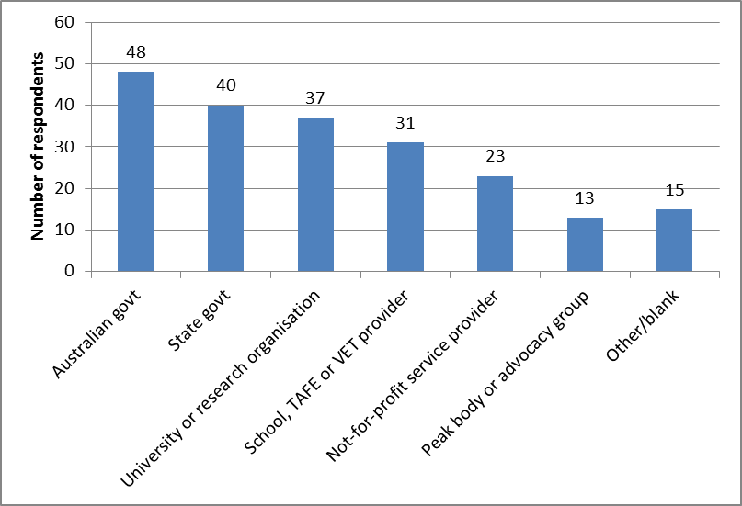

**Figure B2: User survey respondents by state and territory**

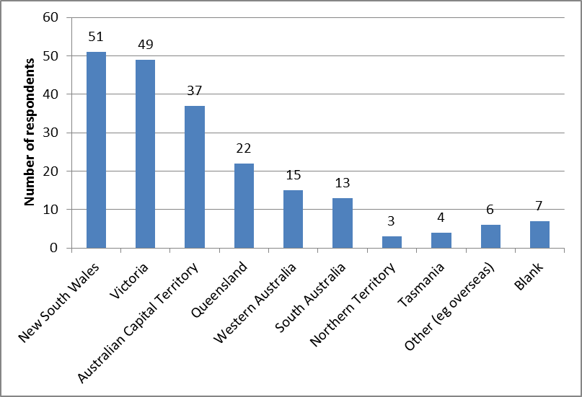

**Figure B3: User survey respondents by organisational role**

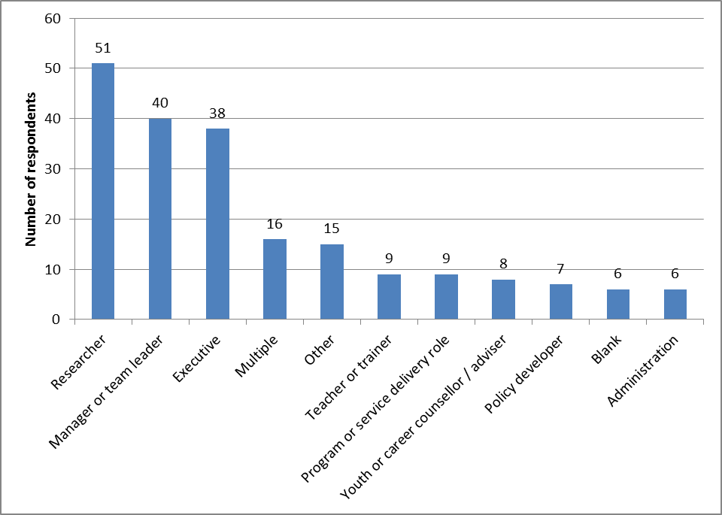

### Appendix C: Downloads and citations

**Table C1: Downloads of selected LSAY reports by release date and user type**

| Title | Author(s) | Release date | Page views: Publication summary page | Page views: Report downloads | Report downloads: Guest | Report downloads: University (a) | Report downloads: Government | Report downloads: Other | Report downloads: School | Report downloads: Non-TAFE provider | Report downloads: TAFE institute or college | Report downloads: Industry | Report downloads: Media | Report downloads: Union | Report downloads: Total |
| --- | --- | --- | --- | --- | --- | --- | --- | --- | --- | --- | --- | --- | --- | --- | --- |
| Education and happiness in the school-to-work transition | Dockery | 2010 | 2028 | 1477 | 676 | 162 | 94 | 88 | 54 | 37 | 31 | 9 | 8 | 0 | 1159 |
| Post-school education and labour force participation in Canada and Australia | Austen & MacPhail | 2010 | 981 | 840 | 441 | 141 | 99 | 58 | 19 | 12 | 44 | 2 | 5 | 2 | 823 |
| Against the odds: influences on the post-school success of ‘low performers’ | Thomson & Hillman | 2010 | 2288 | 1758 | 1001 | 214 | 181 | 115 | 75 | 37 | 68 | 11 | 18 | 0 | 1720 |
| Returns from education: an occupational status approach | Lee | 2010 | 815 | 661 | 620 | 80 | 86 | 28 | 19 | 10 | 20 | 19 | 2 | 0 | 884 |
| Lost talent? The occupational ambitions and attainments of young Australians | Sikora & Saha | 2011 | 2530 | 2078 | 1179 | 203 | 222 | 129 | 62 | 57 | 49 | 29 | 11 | 1 | 1942 |
| From education to employment: how long does it take? | Fitzpatrick, Lester, Mavromaras, Richardson & Sun | 2011 | 1833 | 1486 | 931 | 133 | 153 | 74 | 36 | 24 | 36 | 27 | 12 | 3 | 1429 |
| Measuring the socioeconomic status of Australian youth | Lim & Gemici | 2011 | 1100 | 949 | 513 | 201 | 86 | 58 | 8 | 16 | 34 | 8 | 12 | 6 | 942 |
| Which paths work for which young people? | Karmel & Liu | 2011 | 3253 | 2700 | 1495 | 258 | 300 | 178 | 95 | 70 | 135 | 49 | 17 | 12 | 2609 |
| Does combining school and work affect school and post-school outcomes? | Anlezark & Lim | 2011 | 2160 | 1771 | 907 | 211 | 223 | 137 | 114 | 69 | 65 | 27 | 17 | 2 | 1772 |
| The Vocational equivalent to Year 12 | Lim & Karmel | 2011 | 2061 | 1632 | 802 | 141 | 177 | 132 | 55 | 97 | 104 | 39 | 13 | 5 | 1565 |
| School completion: what we learn from different measures of family background | Homel, Mavisakalyan, Nguyen & Ryan | 2012 | 2392 | 2408 | 1266 | 329 | 352 | 196 | 95 | 45 | 69 | 35 | 14 | 5 | 2406 |
| The impact of schools on young people's transition to university | Gemici, Lim, & Karmel | 2013 | 3149 | 3093 | 1669 | 412 | 333 | 234 | 204 | 68 | 87 | 45 | 19 | 18 | 3089 |

**Table C2: Citations of selected LSAY reports by release date and citation type**

| Title | Author(s) | Release date | NCVER/ ACER research reports | Other commissioned research reports | Other research reports | Journal articles by report author | Other journal articles | Policy papers | Parliamentary | Presentations | Conference papers | Book chapters | Other | Total |
| --- | --- | --- | --- | --- | --- | --- | --- | --- | --- | --- | --- | --- | --- | --- |
| Assessing the value of additional years of schooling for the non-academically inclined | Dockery, AM | 2005 | 10 | 4 | 2 | 1 | 4 | 4 | 1 | 0 | 7 | 2 | 0 | 35 |
| The transition to full-time work of young people who do not go to university | Marks, GN | 2006 | 15 | 7 | 5 | 1 | 13 | 5 | 0 | 1 | 3 | 2 | 0 | 52 |
| VET pathways taken by school leavers | David, C | 2008 | 12 | 3 | 2 | 3 | 9 | 4 | 0 | 0 | 10 | 0 | 0 | 43 |
| Career advice in Australian secondary schools: use and usefulness | Rothman, S & Hillman, K | 2008 | 3 | 1 | 1 | 0 | 6 | 3 | 1 | 0 | 1 | 0 | 0 | 16 |
| Education and happiness in the school-to-work transition | Dockery, AM | 2010 | 6 | 4 | 2 | 0 | 0 | 0 | 0 | 6 | 3 | 1 | 0 | 22 |
| Post-school education and labour force participation in Canada and Australia | Austen, S & MacPhail, F | 2010 | 4 | 1 | 0 | 1 | 0 | 0 | 0 | 2 | 1 | 0 | 1 | 10 |
| Against the odds: influences on the post-school success of ‘low performers’ | Thomson, S & Hillman, K | 2010 | 4 | 0 | 0 | 0 | 3 | 1 | 0 | 2 | 4 | 1 | 0 | 15 |
| Returns from education: an occupational status approach | Lee, J | 2010 | 2 | 2 | 0 | 1 | 0 | 0 | 0 | 0 | 3 | 0 | 0 | 8 |
| Lost talent? The occupational ambitions and attainments of young Australians | Sikora, J & Saha, L J | 2011 | 6 | 0 | 0 | 4 | 1 | 0 | 0 | 0 | 4 | 0 | 2 | 17 |
| From education to employment: how long does it take? | Fitzpatrick, D, Lester, L, Mavromaras, K, Richardson, S & Sun, Y | 2011 | 3 | 1 | 0 | 0 | 1 | 2 | 2 | 0 | 1 | 0 | 0 | 10 |
| Measuring the socioeconomic status of Australian youth | Lim, P & Gemici, S | 2011 | 6 | 0 | 1 | 0 | 2 | 0 | 0 | 0 | 2 | 0 | 1 | 12 |
| Which paths work for which young people? | Karmel, T & Liu, S-H | 2011 | 6 | 1 | 0 | 0 | 4 | 0 | 0 | 0 | 4 | 0 | 0 | 15 |
| Does combining school and work affect school and post-school outcomes? | Anlezark, A & Lim, P | 2011 | 7 | 0 | 0 | 0 | 2 | 0 | 1 | 2 | 2 | 0 | 0 | 14 |
| The Vocational equivalent to Year 12 | Lim, P & Karmel, T | 2011 | 3 | 0 | 0 | 0 | 1 | 0 | 0 | 0 | 3 | 0 | 0 | 7 |
| School completion: what we learn from different measures of family background | Homel, J, Mavisakalyan, A, Nguyen, HT & Ryan, C | 2012 | 3 | 2 | 0 | 0 | 1 | 0 | 0 | 0 | 1 | 0 | 0 | 7 |
| The impact of schools on young people's transition to university | Gemici, S, Lim, P & Karmel, T | 2013 | 0 | 0 | 0 | 0 | 0 | 0 | 0 | 0 | 2 | 0 | 0 | 2 |

### Appendix D: Stakeholder interviews

Twenty five in-depth interviews with key stakeholders were conducted as part of the review. Bill Burmester and Meredith Edwards from the ANZSOG Institute for Governance at the University of Canberra were selected by the Department to conduct the interviews and prepare a report.

The interviews were semi-structured and covered the following broad areas:

* usage of LSAY;
* benefits of the LSAY program;
* views on continuance or discontinuance of LSAY and whether it represents value for money;
* options for continuance or discontinuance; and
* options for enhancements to LSAY including:
* data collection arrangements / methodology
* the linkage to PISA
* the frequency of LSAY cohorts
* sample size and attrition
* the age range for LSAY
* the range of issues covered by the questionnaires
* research and dissemination.
* the questions or issues LSAY will need to address in the future; and
* how the LSAY program could be improved to better meet stakeholder needs.

Interviewees included individuals from a range of organisations:

* Australian Government departments including Education, Employment, Industry, Human Services and Prime Minister and Cabinet as well as the Productivity Commission;
* six State and Territory education and/or training departments;
* the OECD;
* researchers from the University of Melbourne and ACER;
* non-government school peak bodies for the Catholic and independent sectors; and
* advocacy organisations such as The Foundation for Young Australians and The Smith Family.

### Appendix E: Case studies of LSAY use in policy development

This attachment describes eight particular instances (‘examples’) when LSAY made significant contributions to Commonwealth government policy development, review, evaluation or analysis in the period 2006 to 2013. These examples were chosen on the basis of:

* the project/initiative was policy-related and of high importance to Government. The focus therefore was on major policy initiatives, reviews leading to policy initiatives, Parliamentary inquiries and reports commissioned by Government from organisations such as the Productivity Commission.
* the contribution of LSAY research and data was critical or very important to one or more aspects of the initiative/project/report.

These examples are described in the form of case studies, using four headings:

* What the review was about and how conducted
* Information contributed by LSAY
* How significant/critical was the information from LSAY (and whether it could have been provided by other sources)
* What policy change the review led to/significance of the review/how the report has been used

The case studies are described in chronological order of the date of commencement of the review/policy.

|  |
| --- |
| **Case study 1: MCEETYA report to COAG on transition pathways from school (2006)** |

#### What the review was about and how conducted

In early 2006 COAG announced a new National Reform Agenda (NRA). The Human Capital reform stream of the NRA included “Transition from school to work or further study” as an area for attention.

In July 2006 MCEETYA was requested by the Prime Minister to prepare a report by November 2006 with recommendations for action on improving youth transitions ‘that could have the greatest impact on productivity and participation, within the framework and objectives of the human capital agenda’. The task was assigned by MCEETYA to its Advisory Committee on Pathways for Post-Compulsory Youth (the ‘Committee’), which included representatives from Commonwealth and state and territory agencies responsible for youth transitions. The Committee’s report Transition Pathways from school to work or further study was tabled in November 2006.

#### Information contributed by LSAY

In order to provide quantitative evidence for the policy development work of the Committee the then Department of Education, Science and Training (DEST) commissioned Access Economics to prepare a background report, based on available data and evidence, examining the pattern of transitions from school and the economic and social benefits of smoother transitions from school to further education, training and/or work. The Access Economics report became an attachment to the Committee’s report.

The key part of the Access Economics report[[7]](#footnote-7) was the analysis of the experiences in education and/or work of school leavers in the first four post school years. The analysis assessed whether school leavers were making “good”, “mixed” (ie bumpy) or “poor” transitions, and how those transitions were influenced by factors such as the socio-demographic characteristics of the school leavers and their school achievements and experiences (such as enrolment in VET in Schools and working while studying). The analysis was based on the Y98 cohort of LSAY.

A complementary analysis in the background report examined the experience in the first three years after completing a post school qualification in VET or at university. In addition to classifying the experience as a good, mixed or poor transition, those making good transitions were separated into those who were working in a job commensurate with their qualification (ie at “potential”) and those who were working “below potential”. This analysis was based on the Y95 cohort of LSAY.

Based on these analyses, and additional information in LSAY on earnings while working, the report also estimated the benefits to the economy from increased workforce participation and productivity if all young people had been making good transitions.

Apart from making direct use of LSAY data, the Access Economics report also made reference to 4 published LSAY research reports.

The analysis in the report was complemented by a range of other data sources, including the ABS Survey of Education and Work, the Victorian On Track study, and the 2003 DEST Young Visions study.

#### How significant/critical was the information from LSAY (and whether it could have been provided by other sources)

The analyses using LSAY were fundamental to the report. They provided information on the scale of the difficulties faced by some young people in the transition from school, a feel for the policy-relevant factors that influenced those transitions and the size of the likely economic benefits from action to improve transitions. As a result, the analyses were influential in framing the policy analysis of the report and the content of the proposed policy recommendations.

#### What policy change the review led to/significance of the review/how the report has been used

The Committee report was tabled with COAG in November 2006. However, COAG did not meet in December 2006, as planned, to discuss NRA matters, including this report. Because of other developments affecting COAG the report was never considered by it and the report remained unpublished. However the information from the unpublished Access Economics report was used by DEST on several occasions in the years following its preparation.

|  |
| --- |
| **Case study 2: Career, Transitions and Partnerships Pilot Strategic Review (2007)** |

#### What the review was about and how conducted

The review was conducted in March to September 2007 for the Australian Government Department of Finance and Administration. It was one of two strategic reviews conducted in 2007 under the then new Strategic Reviews Framework which enabled Government to consider a suite of programmes addressing a significant policy area, often across a number of agencies. The Career, Transitions and partnerships (CTP) Review team was headed by Dr David Rosalky, former head of three Commonwealth departments, and included seconded officials from relevant Departments.

The Review considered broadly the career preparation system for young people in Australia and the Commonwealth’s role in it. The review examined the role of schools and of VET in this system and focused especially on the appropriateness and effectiveness of the part played by the Department of Education, Science and Training (DEST)’s career development and transition support activities branded under the Career Advice Australia (CAA) initiative.

The CAA comprised a number of elements. These were: national networks providing career development and transition support services and industry leadership; safety net programmes for young people at risk of poor transitions; initiatives to expand professional opportunities for career practitioners and strategic initiatives to improve the quality of career and transition services and champion leading edge practice.

The report of the review was completed in October 2007.

#### Information contributed by LSAY

Information from LSAY was used extensively in the report to provide analytical and descriptive information about transitions and pathways. More specifically, LSAY research and analysis on the following topics was incorporated into the review report: destinations from school by student characteristics; pattern of transitions in the first four years after leaving school; factors that influence good and poor transitions; the size and characteristics of the pool of at risk (poor transitions) young people; characteristics of students in vocational education and training programs in schools, their impact on transition outcomes and the performance of different models of delivery; and Indigenous experience during transition.

The documents from which the LSAY information in the review report was drawn were:

* the report commissioned by DEST from Access Economics in 2006 titled “Youth Transitions Evidence Base”. The key element of that report for the purposes of the CTP Review was a detailed analysis of the transition experience of the Y98 cohort in the first four years after leaving school.
* a short paper by DEST Youth Transitions in Australia – an analytical snapshot prepared for the Review, which relied heavily on LSAY data
* six LSAY-based research reports (one of which was not in the ACER series) and one briefing paper
* the Productivity Commission report Overcoming Indigenous Disadvantage: Key Indicators 2007, which used data from Y98 by Indigenous status for one of its sections quoted in the Review report.

Additional ad-hoc information, requested by the review team from DEST in the preparation of the report, did not find its way in the report although it helped the team to gain a clearer understanding of the career preparation system in Australia. Much of that ad-hoc information was based on LSAY, with ABS data being the other main source.

#### How significant/critical was the information from LSAY (and whether it could have been replaced by other sources)

LSAY was the only source for the critical information needed in the Review about transition patterns and influencing factors, and about the size and nature of the pool of at risk young people. Program administrative data and cross-sectional ABS data were the other sources used in the report to describe and discuss broad trends.

#### What policy change the review led to/significance of the review

The report recommended structural changes to the career preparation system and to how the Commonwealth and states and territories could best operate in this policy area. These recommendations informed reforms of Commonwealth youth, career and transition policies and programs in subsequent years.

|  |
| --- |
| **Case study 3: Review of Australian Higher Education (Bradley review, 2008) and follow-up inquiries (2009 to 2011)** |

#### What the review (and related inquiries) were about and how conducted

The *Review of Australian Higher Education* (the Bradley Review) was announced in March 2008 to examine and report on the “future direction of the higher education sector, its fitness for purpose in meeting the needs of the Australian community and economy and options for reform”. The report was completed in December 2008.[[8]](#footnote-8)

The report’s analysis concluded that Australia’s supply of degree level qualifications would fall short of future demand and that Australia was falling behind other advanced economies in the proportion of its workforce with those qualifications. It argued that lifting overall participation in higher education required an increase among those currently under-represented, especially those from low SES backgrounds, from remote and regional areas, and Indigenous people. Hence the report recommended targets for degree level attainment and for participation of under-represented groups (low SES background in particular), stronger financial support based on need, and a student demand driven higher education system.

The Government accepted the thrust of the Bradley review recommendations and announced its formal response over the period March to May 2009, including in the 2009 Budget.

A key element of the response was significant income support reforms, announced in the 2009 Budget, aimed at redirecting assistance to students in greatest need to boost their higher education participation and attainment. This involved tightening the criteria for financial independence through Workforce Participation which had allowed students from high income backgrounds to qualify for income support. While there was general support for this change there was concern that, as an unintended consequence, young people in regional Australia had been disadvantaged by it.

Two inquiries dealing with regional and rural students were referred in the second half of 2009 to the Senate Regional, Rural Affairs and Transport References Committee. The inquiry on *Rural and regional access to secondary and tertiary education opportunities* commenced in June 2009 and was completed in December 2009. It addressed the adequacy of measures by Government to provide equitable access to secondary and post-secondary opportunities to students from rural and regional communities. The second inquiry focused specifically on the proposed changes to student income support and their impact on rural and regional students. This inquiry, the *Social Security and Other Legislation Amendment (Income Support for students) Bill 2009*, commenced in September 2009 and was completed in October 2009. As the two inquiries overlapped it was decided that the first inquiry would not tackle income support matters and concentrate on other issues affecting rural and regional participation in education.

In March 2010 the Government announced that, as a result of the inquiries and subsequent negotiations with other parties, the original Workforce Participation criteria would be re-instated for those living in outer regional, remote and very remote areas as of 1 January 2011 (in February 2011 this was extended to those living in inner regional areas to come into effect from 1 January 2012). The *Social Security and Other Legislation Amendment (Income Support for students) Act 2010* also required that a comprehensive review of the impact of the income support changes, especially on rural on rural and regional students, be undertaken by around the middle of 2012. In February 2011 the Government brought forward the legislated review by one year. The review was conducted by Professor Kwong Lee Dow under commission from DEEWR and was completed in July 2011.

#### Information contributed by LSAY

LSAY contributed to all of these reports, inquiries and reviews.

Bradley Review

The Bradley Review report made use of 3 LSAY publications in the chapter on participation and completion of university courses by young people and the performance of those from low SES background. Those publications were:

* The cohort report for Y95 in 2005 - used to provide baseline information on the proportion of 24-25 year olds who had participated in post school education (87%), including university, and the proportion that had completed a degree (32%).
* LSAY report No 51 - to make the point that if students from a low socio-economic background get to university, their background does not negatively affect their course completion.
* LSAY report No 52 - to demonstrate that overall the VET sector performs better than the higher education sector in attracting students from a low socio-economic background.

As a major stakeholder, Universities Australia (UA) put considerable effort in its submission to the Bradley review. The submission’s section on student support, equity and participation drew on UA’s Equity and Participation Action Plan and the report *Participation and Equity – a review of the participation in higher education of people from low socio-economic backgrounds and Indigenous people* which they had commissioned from the Centre for the study of Higher Education at Melbourne University. The latter report had an Appendix on key findings from LSAY on participation by young people from low SES and regional/rural regions and the way LSAY measured SES and location. This appendix made reference to six LSAY-based publications on higher education. Other parts of the Participation and Equity report referred to a further five LSAY-based publications.

Senate Committee inquiries

DEEWR made submissions to both inquiries of the Senate Regional, Rural Affairs and Transport References Committee in 2009. The submission to the Rural Education inquiry was the principal submission and it, together with a supplement, was submitted to the Income Support inquiry. The DEEWR Rural Education submission made reference to eight LSAY based reports to provide evidence on the influence of rural and regional status on matters such as post school aspirations, Year 12 completion, going to university and leaving home to study in metro area universities. The supplement focused on describing the Government’s income support initiatives and did not make further use of LSAY evidence.[[9]](#footnote-9)

The reports of the two inquiries relied heavily on submissions and witness statements at public hearings for their evidence, and placed emphasis on reporting information provided by individuals, education institutions and organisations from regional areas. The DEEWR submissions were referred to in several instances but more often in relation to programs and none of the references pertained to LSAY evidence.[[10]](#footnote-10) However, the Rural Education report also made use of the report from the Victorian Parliament Education and Training Committee’s inquiry into the *Geographical Differences in the Rate in which Victorian Students Participate in Higher Education* (of July 2009) which had just been released. This report made significant use of LSAY research, with 12 LSAY research reports and one LSAY technical report being cited.

Review of income support reforms

The report of Review of Student Income Support Reforms did not directly make reference to LSAY publications, but a DEEWR report that was used by the review did. That report was titled Regional Participation: The role of socio-economic status and access, 2010. This report consolidated and extended the work undertaken for the earlier DEEWR submission on factors responsible for lower education participation among regional youth. It included new analysis of census data at SLA level. LSAY played a key role to the literature review, with eight reports being referenced. Drawing in part on the literature review and the additional census based analysis the report concluded that lower SES was the single most important reason for lower participation in regional areas.

A related issue examined using LSAY data (although published after the review was completed) is the impact of previous Youth Allowance eligibility rules around independence on the increase in gap-year taking. Lumsden & Stanwick (2012) found that for the Y03 cohort a higher proportion of students from higher socioeconomic backgrounds received the Youth Allowance at university than those from lower socioeconomic backgrounds, and this applies even more so to gap-takers. Likewise Ryan (2013) finds evidence that receiving the Youth Allowance while in tertiary study was associated with an increased probability of taking a gap year.

#### How significant/critical was the information from LSAY (and whether it could have been replaced by other sources)

Although LSAY was used sparingly in the Bradley review, the information from LSAY was important in providing baseline information on young people’s participation in post school education and completion of university courses, including by socio-economic background. In addition, the information about low SES university completion rates was important in providing some assurance that having low SES students forming a higher proportion of enrolments would not have a detrimental impact on overall academic quality as those from low socio-economic backgrounds are able to succeed in higher education. There was not at the time another reliable source for this kind of information.

LSAY together with separate research by Richard James using other data were the two key sources of Australian information for the regional participation report by DEEWR. The report was important in assisting the Review come to the conclusion that “helping students from low-income backgrounds should more than proportionately assist regional students”.

#### What policy change the review (and follow-up inquiries) led to/significance of the review/how the report has been used

The Bradley Review led to far reaching changes to higher education (as described above). This included significant reforms to income support for students.

The Parliamentary inquiries into regional education and income support for regional students improved the understanding about the incentives and barriers to education participation among regional young people and contributed to the discussions which resulted in the re-instatement of the original Workforce Participation criteria for students outside metropolitan areas.

The Review of the Student Income Support Reforms concluded that the changes had increased participation among low and middle income families, and that rural and regional families had benefited more from these changes than families from major cities. It also made additional recommendations for change that were partially adopted by Government.

|  |
| --- |
| **Case study 4: OECD Jobs for Youth Thematic Review (2008 to 2010)** |

#### What the review was about and how conducted

During 2006 to 2009 the OECD undertook a thematic review of policies to facilitate the transition from school to work and improve the career prospects for youth (aged 15 to 29 years).[[11]](#footnote-11) It became known as the Jobs for Youth review. Australia was one of 16 OECD countries that took part in the review.

The thematic review had three main aims:

* examine barriers to youth employment and explore how education, training, labour market and social policies could help improve the school-to-work transition i.e. both supply and demand factors were to be considered
* understand how participating countries addressed these issues so as to identify good practices that all OECD countries could learn from
* make country-specific policy recommendations for each participating country in a country report.

The OECD prepared a report for each country against a common framework published in the series *Jobs for Youth*. Thus the Australian country report contained a review of labour market trends for young people, a critical survey of the role of education and training in helping young people lay the foundations for a good career, an analysis of the main demand-side barriers to youth employment, an assessment of the adequacy and effectiveness of existing measures to facilitate the transition from school to work and improve youth employment prospects, and a set of policy recommendations for further action by governments at Federal and state/territory level.

On completion of the thematic review the OECD published an over-arching report *Off to a good start? Jobs for Youth* that was released in 2010.

#### Information contributed by LSAY

The country report for Australia was based on responses from Australia to detailed OECD policy and data questionnaires (provided over December 2007-March 2008), a visit by the OECD team to Australia (April 2008), feedback from Australia on an interim report (October 2008) and a workshop with industry, research and the community sector framed around the findings from the interim report (October 2008). LSAY research and data were used by DEST for responding to the questionnaires and by the OECD in the published country report.

The response to the questionnaires by Australia was extensive and involved input from the education, employment and workplace relations areas of the newly formed DEEWR and from the NCVER. The use of LSAY research and data by DEST related in particular to school and post-school education and transition from school and was especially important in providing dis-aggregations by important variables (eg SES) and quantitative information about pathways and their outcomes. The information provided to the OECD was useful to them in order to better understand the operation and performance of the Australian education and transition systems. Some of the information provided was used in the published country report.

The Australia country report referenced a number of LSAY-based research report and the OECD analysed some LSAY data for the report:

* seven reports based on LSAY were referenced, although for most reports the connection with LSAY would not be obvious from the report’s bibliographic information:
* Access Economics (2006) *Youth Transitions evidence base 2006* (unpublished)
* Foundation for Young Australians (2008) *How Young People are Faring 2008* (both references to that report were in fact based on Y98 cohort data used in that report)
* Gorgens, T and Ryan, C (2006) *The impact of additional educational qualifications for early school leavers*
* Rothman, S (2003) *Young people from low SES families and participation in higher education*
* Anlezark, A et al (2006) *Have school vocational education and training programs been successful?*
* Marks, GN (2006) *Transition to Full-Time work of Young people who do not go to university*, LSAY Research Report No 49
* Marks, GN et al (2003) *Dynamics of the Australian Youth Labour market: the 1975 cohort, 1996 to 2000,* LSAY Research Report No 34.
* LSAY data for the Y98 cohort was analysed by the OECD to compare time to get a job after completing education in Australia with that for the UK and USA. This was the basis of the ‘time to first job’ after leaving education analysis, by educational attainment, reported on pages 62 to 65, which concluded that the education to work transition in Australia in the period 1998 to 2006 was faster than in the US during the same period and even more so than in the UK (analyses were only undertaken for these three participating countries).

#### How significant/critical was the information from LSAY (and whether it could have been replaced by other sources)

Although the OECD used previously published research and analysis for the country report, it also undertook a substantial amount of its own analysis. This primarily used HILDA which, unlike LSAY, was able to cover the age range 15 to 29 which was the definition of young people used in that report. LSAY, by contrast, could only provide information up to age 24/25 years. HILDA was also used in those instances where data for aged older than 29 were required. As a consequence HILDA featured extensively as the source of the tables and charts in the report, even when LSAY could have been used, in order to maintain consistency across charts and tables. Other important non-LSAY sources used were the census, ABS Survey of Education and Work and administrative data.

The contribution of LSAY research and data to the final country report was nonetheless quite significant as it provided supporting evidence for the charts and tables from HILDA (for example, on the stepping stone argument); additional and/or more detailed information not available from HILDA or other sources (for example, information on the consequences of early schooling leaving in the early post school years) and information about patterns of behaviour of young people before the advent of HILDA. In some cases LSAY-based research provided the only source available on the topic at hand. As a case in point, the OECD noted that the evidence on the impact of skill enhancing programs for unemployed youth was largely limited to one LSAY-based report.

#### What policy change the review led to/significance of the review/how the report has been used

The OECD report for Australia provided a positive assessment of Australia’s framework for school to work transitions but noted that Australia had a small but significant proportion of young people who were struggling to make a good transition even in a relatively strong labour market and that there were some aspects of the transition system that could be improved. The recommendations in general accorded with the Government’s policy directions and this was acknowledged by the OECD. The report was welcomed by the Government, which used the OECD support for its actions and initiatives to promote its policy agenda.

The OECD over-arching report included some Australian initiatives as examples of good practice.

|  |
| --- |
| **Case study 5: House of Representatives Inquiry into Combining school and work: supporting successful youth transitions (2008-2009)** |

#### What the review was about and how conducted

In October 2008 the House of Representatives Standing Committee on Education and Training commenced a review of the impact of combined study and work on the success of youth transitions and Year 12 attainment and how young people can be supported to continue combining work and study and achieve good transition and educational attainment outcomes.

DEEWR made a submission to the inquiry in February 2009. The Committee report was released in October 2009.

#### Information contributed by LSAY

The DEEWR submission comprised 4 chapters, and LSAY data and research was used in two of them.

The first chapter provided a statistical and analytical overview of school students combining study and work and included data and research about the extent of students combining study and work during their school years, student characteristics and motivations, and the effect that working while still at school had on Year 12 completion and on post-school destinations. Apart from the tables showing the proportion of school students aged 15-19 who worked while studying and the average hours they worked in 2007 (the latest year possible) which came from the ABS Survey of Education and Work, all other information in this chapter about Australian students experience was drawn from LSAY-based research. This comprised one Cohort report and five full research reports based on LSAY, including one in the process of being prepared at the time.

LSAY research was also used in chapter 3 to provide evidence about the nature, role and impact of career development in schools and VET in Schools programs. Evidence was used from three LSAY-based reports and one Briefing paper.

In total, the submission made use of ten separate LSAY-based publications.

The Committee report acknowledged at the beginning of the analytical chapter that LSAY provided a body of research for students combining school and work. Chapters 2 and 3 drew heavily on LSAY reports and on the DEEWR submission for statistical and research information. LSAY research on VET in Schools programs was also used significantly in chapters 6 and 7.

Overall, the Committee report used and referenced the following LSAY based research:

* 5 LSAY-based reports and one Briefing paper (these had also been referenced in the DEEWR submission)
* the Foundation for Young Australians submission which quoted data from the How Young People Are Faring 2008 report that was based on LSAY Y98
* a Productivity Commission staff paper whose data on part-time employment mentioned by the Committee report came from LSAY Y03
* a reference to evidence at hearings by Phil Mackenzie of the ACER based on LSAY research
* the LSAY-based sections of the DEEWR submission.

#### How significant/critical was the information from LSAY (and whether it could have been replaced by other sources)

LSAY was the central source of data and research on school student characteristics, motivations and impacts for both the DEEWR submission and the Committee report. LSAY was well suited to analysis of these issues and research undertaken in the years preceding the inquiry provided evidence directly relevant to the Committee’s terms of reference. The LSAY evidence was the obvious choice for this purpose, with no other source able to provide equivalent information.

During the hearings, the NCVER indicated that it was updating the earlier analyses and extending them, using more recent data (the Y03 cohort). It also provided some preliminary findings that were quoted in the report. The Committee noted in the report (paragraph 1.18) that it “eagerly anticipates the findings” from that research which was not available at the time the report was tabled. That NCVER report was published in 2011 as Anlezark, A and Lim, P Does combining school and work affect school and post school outcomes?.

Reinforcing its interest in this kind of work, the first recommendation of the Committee report called on Government to:

“ensure that further research is undertaken to examine student pathways and the impact of part-time employment and other extracurricular activities on students’ academic performance and retention, including the motivations of those students who work longer hours”.

#### What policy change the review led to/significance of the review/how the report has been used

The Government response to the Committee report has not yet been tabled due to delays caused by several Machinery of Government changes since the Committee’s report was completed. However, positive developments have taken place, whether because of the Committee’s report or for other reasons, in several of the areas identified in the Committee’s recommendations as needing to be addressed. For instance, additional research has been published on the impact of part time employment while at school on school retention and post-school outcomes (the Anlezark and Lim and the Deloitte Access Economics reports); key research on VET in Schools has been consolidated in an accessible form (Briefing Paper No 21); the National Children’s Commissioner has been established and structured workplace learning opportunities for students undertaking vocational education and training at school have been pursued by governments through a number of avenues.

|  |
| --- |
| **Case study 6: The Youth Compact and National Partnership on Youth Attainment and Transition (2009-2013)** |

#### What the review was about and how conducted

In April 2009 the Government introduced the Compact with Young Australians in response to the impact of the Global Recession on youth unemployment so as to ensure that young people were engaged in education and training that would benefit them in the recovery. At the same time it also announced the National Partnership for Youth Attainment and Transitions which, in conjunction with the Youth Compact, was to be a key mechanism for achieving two education attainment targets: 90% of 20-24 year olds to complete Year 12 or its vocational equivalent by 2015 (brought forward from 2020) and, secondly, the gap for Indigenous 20-24 year olds to be halved by 2020 (with a progress target established for 2015). Besides achieving these targets additional goals for these two initiatives were to also improve transitions from school and drive longer term reforms to ensure the gains from achieving the targets were sustained and improved upon over time.

State and Territory authorities were required to develop individual plans under the National Partnership. These were approved in April 2010.

The targets have been monitored annually by the COAG Reform Council (CRC). DEEWR commissioned an evaluation of the National Partnership from Dandolo Partners and the first two interim reports were published in February 2012 and December 2012 respectively.

#### Information contributed by LSAY

LSAY was an importance source of evidence in preparing policy papers and briefing the Minister and COAG on the benefits of completing Year 12 or a vocational equivalent for young people and of making a good start in the initial post school period. LSAY and LSAY-based research were well placed to show that these two factors contributed to young people experiencing, for example:

better transition experience overall;

* greater likelihood of undertaking further study in the post-school period and completing further qualifications;
* lower probability of experiencing unemployment, especially long term unemployment, and of becoming NEET (“Not in employment, education or training”);
* better chances of securing full time employment;
* being better placed to secure higher paying and more stable jobs into the future and to engage in lifelong learning.

The detailed evidence on which these conclusions were based was not published but provided the back-up to succinct information placed on the web about the rationale for the Youth Compact provisions and for the National Partnership arrangements, including requiring early school leavers to study towards a Year 12 or equivalent qualification in order to continue receipt of the Youth Allowance (other). The evidence was also used to support Ministers’ speeches, such as the Ministerial Statement on Education, Employment and Workplace Relations (Jobs, Productivity and Fairness - a foundation for recovery) following the 2009 Budget.

The first *Interim Evaluation of the National Partnership* report provided background and context for the evaluation and described how the evaluation would be carried out. The context for the evaluation was largely covered in “Attachment 1: The importance of youth attainment and transitions”. It considered the concept of a transition phase, why it matters, what influences it and what its characteristics are in Australia. The attachment used seven LSAY based reports, including the LSAY research findings compendium,[[12]](#footnote-12) in this section of the report.

The second Interim report was mainly concerned with charting progress made since the introduction of the National Partnership. LSAY data was not used for this purpose even though the first Interim report had identified LSAY as an important source of information for data analysis for the evaluation, together with administrative data sources (for schools, VET, higher education, Year 12 certification, VET in Schools), the population censuses and the ABS Survey of Education and Work. There seemed to be a reason, however. The report had noted that there were no existing national administrative data sets on transitions and that reliance on the ABS Survey of Education and Work and the labour force survey had limitations because they could not report on sub-groups of the youth population. The report then observed that while LSAY could address some of these limitations, LSAY data was not released quickly enough after collection to inform the report’s analysis.

#### How significant/critical was the information from LSAY (and whether it could have been replaced by other sources)

LSAY and the ABS *Survey of Education and Work* (SEW) were the two most important sources of evidence used to support and justify the Youth Compact and the National Partnership, with some input from HILDA. LSAY was the key source for describing the transitions process in Australia and the factors impacting on successful transitions, which are necessary to understand and take into account when using and interpreting year on year trends from other data, such as SEW. Data from SEW was the principal source of data to monitor changes in the targets and transitions over time (including in the evaluation reports), with administrative data and the censuses (2006 and 2011) providing additional supporting information.

#### What policy change the review led to/significance of the review/how the report has been used

The final Evaluation report, due at the end of 2013, has not yet been released. Based on the interim reports it is expected to show that overall the Youth Compact and the National Partnership policy initiatives have led to significant improvements in young people’s Year 12 or equivalent attainment (but probably not enough to achieve the 2015 target) and in the ‘transition from school’ arrangements and opportunities. The report is also expected to make recommendations on how to achieve further gains.

|  |
| --- |
| **Case study 7: COAG Reform Council (CRC) reporting on youth transitions (2009 -2013)** |

#### What the review was about and how conducted

In 2009 the COAG Reform Council (CRC) selected the area of the transition of young people from school to further education, training or employment for in-depth analysis because there appeared to be considerable variation in performance across jurisdictions and therefore scope to learn from the better performing ones. Transitions from school are relevant to the National Education Agreement and the National Agreement for Skills and Workforce Development as they both identify successful transitions as important outcomes of the school and vocational education and training systems.[[13]](#footnote-13) It is also an area that links the two systems together, highlighting the role that both systems play in young people‘s transition pathways to further study and employment.

The CRC undertook two major activities:

* commissioned three papers:
* *Transition Outcomes: The impact of context and institutions* by Prof Richard Sweet, which was published in September 2010 in conjunction with the National Agreement for Skills and Workforce Development: Performance report for 2009.
* *Youth Transitions: what the research tells us* by Circelli, M and Oliver, D of the NCVER, that was published in 2012 by the NCVER.
* *A curate’s egg: Good practice in school to work transitions* by Richard Sweet published in August 2012.
* organised the *Good practice in youth transitions National Conference* in August 2012. This comprised 10 papers.

#### Information contributed by LSAY

The CRC commissioned papers made significant use of LSAY as did three of the papers at the National Conference. One other paper at the conference made use of the On Track data from Victoria but other conference papers generally presented a practitioner’s rather than a researcher’s perspective on transitions. These six papers and their references to LSAY are shown below.

|  |  |
| --- | --- |
| Paper | LSAY reports referred  (number) |
| Sweet (Transition Outcomes, 2010) | 3, plus at least two reports in which LSAY provided significant input |
| Sweet (Curate’s egg, 2012) | 3, with references to other reports in which the LSAY was the likely source for the information |
| Circelli and Oliver (Youth transitions, 2012) | 39 |
| Karmel, T *Youth transitions in Australia: lessons for other countries?* | 6 |
| Vickers, M *Improving institutional arrangements: Increasing the effectiveness of pathways through upper secondary education* | 4 |
| Shreeve, R *An overview of youth transitions in the Australian context* | 1 |

#### How significant/critical was the information from LSAY (and whether it could have been replaced by other sources)

The different uses made of LSAY in these papers reflect in large part differences in focus and purpose of the papers. The authors from the NCVER focused on factors that impact on transition at the national level, for which LSAY is the pre-eminent source of information. The first paper by Richard Sweet compared the performance of different states across six education and employment indicators, and the second examined trends in youth education and labour market performance during the last decade. The author used ABS and administrative data for these reports, with LSAY research providing back-up and more detailed supporting evidence that strengthened the findings. Margaret Vickers used LSAY for evidence on aspects of her analysis, namely the effect of part time work while at school and of vocational education programs at school.

Overall, LSAY made a significant contribution to these activities.

#### What policy change the review led to/significance of the review

This is an ongoing activity of the CRC.

|  |
| --- |
| **Case study 8: Three smaller examples of contributions by LSAY to policy initiatives** |

School Funding Review

The School Funding (Gonski) Review of 2010-2011 among other analyses considered the economic cost of underperformance at school. In the commissioned research for the review the NOUS Group examined this issue by assessing the impact of achievement at school on non-completion of Year 12 and the subsequent long term costs of non-completion. The analysis of non-completion was undertaken using Y06 LSAY data, including the PISA 2006 information on schools attended provided by school principals. It was reported in Appendix E of the NOUS report. (The analysis of the costs of non-completion was based on HILDA).

The analysis used multivariate models to explore factors impacting on non-completion, with the view of isolating the net effect of key factors such as literacy and numeracy achievement (at age 15), SES background (through the economic, social and cultural status variable of the OECD) and school ‘quality’. The models used a broad range of factors on individuals, schools and geographic location available in the LSAY data. This information provided the review committee with up-to-date information about the relative importance of influences on Year 12 completion.

Vulnerable Youth report to Secretaries

The APS200 Engaging Vulnerable Youth Project main report was completed in March 2011. A follow up report was prepared for September 2011 and a final progress report was tabled in February 2013.

In the Project “vulnerable youth” were young people who, though a combination of their stage in life; individual, family and demographic circumstances; and barriers to participation were at risk of poor transitions into adulthood and negative ‘whole of life’ outcomes. The Project examined the sources of youth vulnerability from commencement of school onwards and explored prevention and early intervention strategies.

One area covered in the report was the transition from school and what research had shown to be the necessary ingredients for successful transitions. This discussion was based largely on LSAY evidence together with international research.

Productivity Commission Impacts of COAG Reforms: Youth Transitions

The Australian Government (following a request from COAG) has asked the Commission to report every two to three years on the economic impacts and benefits of COAG’s reform agenda. The broad framework for this work was published in 2010. For its first full report, published in 2012, the Commission was asked to focus on two reform areas, one of which was ‘vocational education and training (VET) reforms and initiatives that support successful transitions from school’.

The Commission has adopted the view that the reform(s) within the broader VET reform agenda relevant to youth transitions is the *National Partnership on Youth Attainment and Transition* but excludes the Year 12 or equivalent attainment target because this was established within the National Education Agreement and is therefore best considered in the analysis of school reforms. Further, the Commission defines “successful transition” as reaching an ‘end point’ consistent with a high probability of employment and social inclusion later in life. Hence a successful transition is likely to take time and involve a number of different activities. In this study, therefore, it is assumed that the youth transitions window closes when a person turns 25 and those who have not made a successful transition by then are likely to experience adverse conditions well into the future.

The Commission acknowledges that the National Partnership activities tend to focus on the early stages of the transition process and that it may take several years for the impact on 25 year olds to become visible. Because reform impacts will take so long to emerge, in the 2012 report the Commission has focused on providing information on 25 year olds who essentially have not been influenced by the National Partnership (the base case). For this purpose the Commission has used Y98 data and it has provided information on the proportion of young people aged 25 years in Y98 who have had a ”successful transition”, those who have failed to do so, those who are still studying and those who have child rearing responsibilities. (The Commission has developed its own definition of successful transitions for this purpose). It also analysed the characteristics of these four groups.

The report also foreshadows work that it plans to do in the future using LSAY. This relates to addressing questions on factors that influence different outcomes by age 25 and the determinants of the time taken to make a successful transition. It notes that LSAY is the best available data collection for this type of work as it includes key transition activities (work and study) for individuals tracked for up to 12 years through annual interviews.

### Appendix F: Summary of LSAY findings since 2008

#### Literacy and numeracy at school

Previous research has emphasised that the level of literacy and numeracy achieved by 14- and 15-year-olds is a major factor contributing to a successful transition from school to later education and work. The most recent analysis of LSAY data shows that low performance in numeracy as a 15-year-old did not necessarily mean poor employment and education outcomes post-school (Thomson & Hillman 2010). Almost three-quarters of those who were ‘low achievers’ at age 15 in 2003 went on to successfully make the transition into full-time work or study (or a combination of these) by age 19. Motivation to learn is a key determinant of students’ later outcomes, with those who see the value of study such as mathematics for their future success more likely to achieve success. A positive school experience is especially important in determining later success in life for low-performing students as is having some sort of career plan.

#### Subject choices in Years 11 and 12

The impact of VET in schools on youth transitions has been of ongoing interest. Nguyen (2010b) found that VET in schools programs do not necessarily increase Year 12 completion, but participation does have positive effects on attitudes to and satisfaction with school and contributes to post-school employment choices. In particular, for those students who are intent on getting a job straight after school, VET in schools can help to change their post-school plans to include further VET study or an apprenticeship or traineeship and, ultimately, a more successful employment outcome.

The more specific impact of workplace learning within VET in schools has been the focus of two recent pieces of research using LSAY data. Both Gemici & Curtis (2012) and Black et al (2012) use propensity score matching to create equivalent comparison groups for the purpose of estimating the impact of participation on school and post-school outcomes. They find that there are benefits from participation in workplace learning for senior school students. Gemici & Curtis conclude that, despite some previous research findings to the contrary, workplace learning may contribute to more successful transition outcomes for lower-achieving students and those taking VET courses. Black et al note that for some students there is a potential negative impact on higher education participation, particularly where workplace learning is intensive.

Recent LSAY research has also contributed to a deeper understanding of concerns over skill shortages in relation to science, mathematics, engineering and technology (STEM). Analysis of subject and career choices shows that despite over half of all school students studying two or more STEM subjects in Year 12, less than a third of these then go on to post-school STEM study (Anlezark et al 2008; Lim et al 2009). The greatest leakage from STEM is the pathway from commencing post-school STEM study into a STEM occupation. Overall two-thirds of those who undertake post-school STEM study, as well as STEM study in Year 12, do not go on to work in a STEM career.

In a related study Sikora (2013) examined the extent to which girls and boys in sex-segregated schools select science subjects and plan science-related careers. In contrast to an earlier study using Y95 data, this study using the Y09 cohort found that single-sex schooling moderately benefits girls by fostering higher rates of engagement in physical science courses in Year 11. However, while girls study physical science more frequently in these schools, they are no more likely than girls elsewhere to aspire to careers related to these subjects.

#### Working during school years

The percentage of 17-year-old students (in Years 11 and 12) who held part-time jobs increased from 26.5% in 1978 to 57.4% in 2005, with more females than males working. There has been interest in the effect of this growing participation on schooling and post school outcomes. Anlezark & Lim (2011) confirmed previous findings from research based on the cohort aged 17 at the time of the early 1990s recession that the effects of combining school and work of more than ten hours a week are moderately negative on school and post-school study outcomes, but positive on post-school full-time employment. A novel finding was that the negative effects of combining school and work on school retention are stronger for those who work in Year 10 than those who work in Year 11, perhaps because the latter group tend to moderate their hours.

Based on dynamic modelling of work-study choices among students in the Y98 cohort, Gong et al (2012) found that a student’s choice of working while at school and their chances of enrolling at university are not only driven by background characteristics, but also by the path they take. Previous choices affect subsequent school—work decisions and their educational outcomes. While combining work and study in previous school years does not affect a student’s desire to go to university, it may affect their ability to do so by limiting study time.

#### Leaving before or completing Year 12

An important focus of LSAY has been to identify the influence of student and school characteristics on the decision to leave school early rather than staying on to complete Year 12. Curtis & McMillan (2008) found that with the dramatic rise in Year 12 completion between the 1980s and the early 2000s, inequalities relating to gender and socioeconomic background declined, and the magnitude of differences between other socio-demographic groups fluctuated. This study also used multivariate modelling to identify the school-level factors associated with non-completion. This analysis indicated that school sector itself is not the key explanatory variable and a range of school-related factors emerged as significant. These included peer group effects such as the behaviour of students in the school, the quality of student–teacher relations and, to a lesser extent, teacher morale.

In particular, student and school effects on non-completion among both Indigenous students and low SES students have been the focus of recent work using LSAY.

In relation to Indigenous students in the LSAY population, Nguyen (2010a) found that the gap between Indigenous and non-Indigenous Year 12 completion rates fell from 27 percentage points in 1999 (Y95 cohort) 12 percentage points in 2007 (Y03 cohort). Close to half of the 2007 gap was attributed to lower levels of literacy and numeracy among Indigenous youths, with other aspects of disadvantage accounting for the rest. However, the Indigenous LSAY population may be a higher achieving sub-group than the overall Indigenous population. Biddle & Cameron (2012) found that 15 year old Indigenous students in the Y06 cohort are on average happier at school than their non-Indigenous counterparts of the same gender and broad region of usual residence and that this was unlikely to be a factor in low school completion rates (noting the risk of self-selection). Moreover, while there were differences in expectations of completing Year 12, these disappeared once a variety of background characteristics were controlled for. They argue for a greater focus on overcoming Indigenous disadvantage in early childhood. Ainley et al (2011) stress the complexity and uncertainty of the relationship between background characteristics, achievement and intentions on the attainment of Year 12 or Certificate II by Indigenous and non-Indigenous students. Based on a review of the literature and their own multivariate analysis of LSAY, they conclude that while there is some consensus about the importance of four factors – the student, their family, their school and their community – their relative importance and the extent to which this varies according to the setting of the students is unclear or contested.

The impact of low SES on school achievement and completion has been a long running area of educational research, marked by debate over the magnitude and mechanisms of influence. Recent studies using LSAY have contributed to a more sophisticated understanding of the relationship between SES and school completion by using improved measures of disadvantage and exploring the effect of school academic quality.

* Homel et al (2012) use a more multi-dimensional measure of disadvantage covering both its cultural and material aspects and found that poor school experiences, participation in risky activities and aspirations are the main predictors of Year 12 non-completion, while parental education and occupational status are less significant. Lim et al (2013) found that academic school quality – as measured by school average predicted TERs and university enrolment probabilities – has a strong differential effect on school completion for the most vulnerable of students: those who come from the lowest socioeconomic stratum and who are in the lowest academic achievement decile. In contrast, coming from an advantaged background can insulate students from early school leaving.
* Buddelmeyer et al (2011) found that the main contributing factors to the completion gap between low and high SES students are lower academic performance of low SES students at age 15 and lower own and parental educational aspirations at age 15, while differences in school characteristics are weaker.
* Gemici et al (2014) provide a deeper analysis of the collective impact on educational and occupational plans, including intention to complete Year 12 at age 15, of the different combinations of background factors (gender, Indigenous status, SES, location, family structure and immigration status) and how their influence is mediated by other factors, such as academic performance, parental and peer influences, or the overall perception of the school experience. The study suggests that the effect of background characteristics can be influenced by other factors (e.g., improved teacher quality) that directly affect academic performance, parental and peer expectations, or perception of school. The way in which students perceive their overall experience at school may be important because these perceptions can, perhaps, be influenced by policy via school organisation and resourcing.
* Analysis of the relationship between achievement in PISA and dropping out of education by age 18 shows that different factors exert their influence in different ways. A distinction is made between those which have a direct effect on the propensity of dropping out and an indirect effect through the standardised test scores in PISA. While socioeconomic status is associated with dropout rates both directly and indirectly, several other important factors (such as being male or indigenous, maternal occupation and school estimated value added) were found to be associated with dropout rates indirectly through the PISA scores but not directly. That is, most of their effect is mediated through lower PISA scores and their impact beyond this is limited (Mahuteau & Mavromaras 2013).

Cardak & Vecci (2013) examined the effect of Catholic school attendance on high school completion and university commencement and completion using LSAY data for Y98. They found that the effects are smaller than those estimated in previous studies and the authors speculate that this could be due to including a set of education aspiration and expectation variables from LSAY which are not available in the data used in previous studies. These variables appear to pick up some unobservable effects which seem to have been attributed to Catholic school effects in past studies.

Analysis of LSAY data confirms that student disengagement with school is associated with poorer longer-term outcomes in terms of Year 12 completion, labour market outcomes at age 25 (measured by working hours and occupational status) and life satisfaction at age 25 (Gemici & Lu forthcoming). Overall, school characteristics (school sector and demographics, resourcing, competition and academic orientation, principal leadership and teacher quality, and indicators of the overall school climate) have little influence on the engagement of 15 year-olds with school over and above individual characteristics. School factors play an even smaller role for the particular sub-group of at-risk students. If schools are to influence student engagement through the ways in which they are organised and run, then they must do so during the earlier years of schooling and leading up to age 15.

LSAY findings that Year 12 completions lead to better labour market outcomes, along with a range of other evidence, have supported government policies to promote Year 12 completion as embodied in COAG targets. However, it is recognised that completing Year 12 is not for all students and so a vocational ‘equivalent’ to Year 12 certification is one element of those targets. Lim & Karmel (2011) found that assumptions of equivalence between Certificate II and senior secondary certificates are problematic when compared in terms of the volume of learning involved, their complexity and learning outcomes and labour market and further study outcomes. They concluded that vocational pathways must be considered an alternative rather than a literal equivalent and, a ‘vocational equivalent’ is required for rhetorical purposes, it should be at least at Certificate III level.

An analysis of the impact of personality traits on dropping out of school and patterns of post-school education and employment shows that personality characteristics do matter for the successful completion of school level education, but not in shaping employment or education trajectories during the first year out of school. The probability of dropping out of school is higher for students that declare they are conscientious (very hard working), perhaps because it is interpreted as indicative of the willingness to work and not to study. Calmer and more agreeable students have a higher propensity to complete high school, and so do less extrovert students. However, personality traits do not play an important role in shaping employment or education trajectories during the first year out of school. While disadvantaged early school leavers have a higher probability of remaining inactive after leaving school, the differences in the post-school activities cannot be explained by observable characteristics and seem to be driven by disadvantage status per se (Hanel, Tabasso & Zakirova 2012). This tends to confirm other work using YIF data, although this survey collected data on a narrower range of traits (locus of control).

#### Going on to tertiary education and training

The effect of schools on tertiary participation has been the subject of several previous studies using LSAY and other data. The findings of this research have been somewhat inconsistent in relation to the magnitude of those effects and which school attributes are most influential. Differences in cohort experiences, modelling techniques and predictor variables such as SES may all contribute to this. Gemici et al (2013) examine a broader range of school-level characteristics and use a refined measure of socioeconomic status to paint a more comprehensive picture of how school attributes may influence the transition to higher education. The most influential factors to emerge from the analysis are the role of sector, academic orientation, differentiation from the norm (e.g. single sex schools) and resourcing. A school’s overall SES status matters for university enrolment at age 19, but does not influence students’ TER outcomes at the end of senior secondary schooling, conditioning on academic achievement at age 15. Other school attributes which influence (positively) this probability are a high proportion of non-English speaking background students, and being Catholic and Independent rather than Government. In a related study, Lim et al (2013) found that students from a low socioeconomic background benefit more from attending a high academic quality school than their high socioeconomic background counterparts. Gemici et al (2014) finds that peer plans have by far the strongest influence on a student’s university intentions, while academic performance and perceptions of school have only weak influences. The effect of background is almost entirely mediated by peer plans, academic performance and perceptions of school.

On the other hand, in a comparative study of Australia, England, Canada and the USA, Jerrim et al (2012), find that school-level factors (including school peer effects) explain only a very small amount of the socio-economic gap in university entrance over and above their potential influence on age 15 academic achievement. Instead, they report that school achievement is the most significant influence on cross-country differences in the differential rate of access of lower SES students to university study. Consistent with earlier studies, Curtis et al (2012) found that, when other background factors are taken into account, home location has no significant effect on participation in higher education.

Austen & MacPhail’s (2010) cross-national comparison of students who participate in non-university education found distinct differences in student characteristics, with a weaker relationship between participation and both family background and individual academic achievement at school in Australia than in Canada. Employment outcomes for these students by their mid-twenties were stronger in Canada than in Australia.

LSAY has not previously been used to analyse the level or patterns of gap-years being taken between school and commencement of university. The other studies that have been done have been limited to particular institutions or disciplines. Little was known about the incidence of gap-taking in Australia, about the individuals who chose to take time out between completing school and commencing university, or about their course and labour market outcomes. Two recent studies on this issue (Curtis et al 2012a; Lumsden & Stanwick 2012) have highlighted that the incidence of taking a gap year has increased from 10% in the period 1999–2000 to 24% in 2009–10 and that gap-takers are typically less academically inclined, live in regional locations when at school, have English speaking backgrounds, are employed when in Year 12 and are less likely to receive Youth Allowance payments while at school. In contrast to other research, Curtis et al (2012a) found no difference between the rates of course attrition or change between gappers and non-gappers, with 88% of both groups at age 23 either having completed or still continuing their courses. A modification to the LSAY questionnaire in 2008 has allowed this activity to be better captured.

A related issue examined in this work is the impact of previous Youth Allowance eligibility rules around independence on the increase in gap-year taking. Lumsden & Stanwick (2012) found that for the Y03 cohort a higher proportion of students from higher socioeconomic backgrounds received the Youth Allowance at university than those from lower socioeconomic backgrounds, and this applies even more so to gap-takers. Likewise Ryan (2013) finds evidence that receiving the Youth Allowance while in tertiary study was associated with an increased probability of taking a gap year. The effect of subsequent changes to Youth Allowance eligibility on gap-taking are yet to be explored. Ryan (2013) also found, contrary to existing research using LSAY data, that receipt of student income support has a positive and substantial effect on course completion but not on participation.

While there has been extensive previous work using LSAY to explore the impact of working while at school, only one previous study has explored this issue for those in tertiary level study (Vickers, Lamb & Hinkley 2003). Polidano & Zakirova (2011) used multivariate analysis and controlled for the possibility of self-selection bias to examine motivations and education and employment outcomes from working while studying for both VET students and higher education students aged 25 years and under. The earlier study found no significant effect for those who work fewer than 20 hours compared with those who do not work. Polidano & Zakirova found that for those studying full-time, working impacts on completion, with working 16–24 hours a week reducing the completion rate by eight percentage points. However, finding work in a job considered a ‘career’ job while studying has a significant and positive impact on course completion for both VET and higher education students and employment in the final year of study improves the chances of finding full-time employment, even three years after completing the course.

Polidano et al (2012) model the factors that influence re-engagement in post-school education and training among those who leave school without completing Year 12. This analysis is stated to be the first study to estimate the role of duration dependence in explaining the chances of re-engaging early school leavers with controls for both observed and unobserved heterogeneity by pooling early leavers over three LSAY cohorts. The study also takes into account the impact of school related factors such as student literacy and numeracy achievement and participation in VET courses while at school. They find that early career counselling is particularly important because of high re-engagement rates among those who report leaving school for employment or to commence a course that is not available in school and among those who find career jobs after leaving school.

#### Pathways to the labour market

A number of LSAY studies have highlighted the importance of career education at school in shaping post-school education and training choices as well as realistic occupational goals. Other research has found that there is some variation in the way career advice is delivered in schools and that a student-centred rather than an information centred approach is perceived as more useful by students. Rothman & Hillman (2008) found that for the Y03 cohort students were generally positive about the value of the career advice they received, although an individual conversation with the career advisor was perceived as the most useful and group discussion as the least useful. In contrast to some earlier studies, they study also found that student background and school factors had very little impact on perceptions of usefulness.

Sikora & Saha (2011) noted that few studies conducted overseas, and none in Australia, had to then examined the relationship between adolescent occupational plans and later occupational attainments, despite the accepted view that youth ambitions are important. They focused specifically on the lowering of occupational expectations during secondary school and examined whether ambitious occupational career plans help an early entry to high-status employment in order to establish whether having a specific occupational plan in high school, independent of an educational plan, carries a further benefit for students in attaining their goals. They also analysed the proportions of students in Y98 whose educational and occupational objectives were inconsistent, to estimate whether such discrepancy can be demonstrated to be detrimental to educational and occupation attainment (i.e. plan to work as either a manager or professional and the intention to attend university). They found that having ambitious occupational plans is important, with a strong relationship between holding these plans and having a professional or managerial job by the age of 25 years. Not having a career plan can be detrimental to later occupational attainment—more so for young women.

In a related study Gemici et al (2014) looked at how well initial occupational aspirations of 15 year-olds align with their actual occupational outcomes about a decade later. The results show that young people’s aspirations are somewhat unrealistic, with the distribution of aspirations being quite skewed towards high status jobs relative to a benchmark distribution of actual full-time jobs.

A number of recent studies have investigated the value of Year 12 completion using LSAY data.

* Karmel & Liu (2011) looked at the educational path chosen by young people, as opposed to the educational level attained, to determine whether some educational pathways are better than others. In general for the Y95 cohort, the successful path was Year 12 plus further study; Year 12 alone was not sufficient. For males, the more successful paths differ depending upon the outcome, but Year 12 completion was a key component of these paths. Doing an apprenticeship after completing Year 12 led to the highest pay at age 25 years; completing an apprenticeship or traineeship resulted in higher satisfaction with life in comparison to university study; and university study leads to jobs with higher occupational status (and presumably better pay prospects in the longer term. For females, the most successful pathway in terms of either working or studying full-time or part-time, and weekly pay was going from Year 12 to university. This is irrespective of academic ability.
* Fitzpatrick et al (2011) analysed a relatively unexplored part of the labour market to determine how quickly young Australians obtain their first job (both any job and first full-time continuing job) after completing their full-time education. This allows two competing views of the long-run implications of different transitions into work to be tested. The first view suggests that rushing to get any job is better than getting no job at all. The idea is that obtaining any job reduces the risk of scarring and the human capital deterioration that follows prolonged periods of being out of work. The second view suggests that rushing to get any job increases the risk of getting a bad or a mismatched job, which in itself may reduce the chances of getting a better job later, thus locking the employee into a vicious circle of low-quality employment. The matching and unemployment duration empirical literatures show that both views have elements of truth in them and that the level of education of employees has a strong influence on the speed of their transition to work. This study concludes that in terms of gaining a full-time permanent job in particular, as opposed to any job, having post-school qualifications is critical with the most disadvantaged group being those who did not complete school (about 25% of whom had not obtained any work by age 25).
* Some but not all LSAY analyses have found that completion of Year 12 tends to lead to better employment and wage outcomes and less unemployment. Ryan (2011) explored this issue further for two recent LSAY cohorts focussing on marginal decision-makers—those for whom the decision to complete Year 12 is a real one, by comparison with others whose achievement levels and social backgrounds meant they were always or never likely to complete Year 12. He also sought to take into account vocational ‘equivalents’ of Year 12, the potential role of unobserved differences between completers and non-completers (such as a person’s motivation and attitudes towards their study) and to address seriously the potential problems caused by attrition from the LSAY data. The study found widespread, but modest, effects from the completion of Year 12 among young Australians who do not proceed immediately from Year 12 to further studies. In contrast to previous LSAY research, it found that there were substantial benefits from completion of an apprenticeship for males and a traineeship for females (earlier studies have tended to find that VET qualifications have provided greater benefits to males rather than females).

Previous LSAY studies have provided a substantial body of information on the characteristics of those who undertake apprenticeship and non-apprenticeship VET programs. Curtis (2008) extended the findings from earlier investigations in two ways. First, it examined outcomes to the end of 2004 when the great majority of the Y95 cohort had completed their post-school study and had begun to establish themselves in the labour force. Second, it examined a broader range of outcomes including labour force status, earnings and involvement in subsequent education and training activity, particularly in comparing labour force outcomes for VET completers and non-completers.

Marks (2008) contributed to the understanding of post-secondary education and training in several areas. First, much of the research on the importance of education on occupational status and earnings focused on adults and did not distinguish between secondary and post-secondary education (for example, much of the returns to education literature), or the different types of post-secondary education. Research on youth tended to focus almost exclusively on earnings and did not consider occupation as an outcome. Furthermore, those analyses tended to be of cohorts born some time ago who underwent the school-to-work transition under different institutional arrangements and labour market conditions. Marks investigated the occupation and earnings associated with different types of post-secondary education and training during the early career, distinguishing between participation and qualifications, and analysing data from a cohort that had only recently completed the school-to-work transition. The study found that completing a bachelor degree has the largest impact on occupational status and earnings. Completing apprenticeships had a smaller but substantial effect on earnings, but little impact on occupational status, while completing lower level VET certificates had little impact on either occupational status or earnings.

Fok & Tseng (2009) sought to fill a gap in previous LSAY analysis of New Apprenticeships by looking at the wage gap between apprentices and their counterparts without training in terms of the positive incentive training provides for individuals to take up apprenticeships and stay in the trades sector. An earlier study using 1991 Census data had found substantial variations in returns across occupations and, in four trades, incomes were found to be less than those of unqualified workers. Fok & Tseng updated estimated returns using LSAY’s longitudinal data to determine how pay progresses over time and using a quasi-experimental matching method to create a comparison group. They found positive returns to apprenticeship and traineeship participation, not only in terms of weekly earnings, but also in terms of employment. For individuals, even though there are some costs associated with the training, the earnings of apprentices catch up very quickly, and the returns are considerable over the life-time.

Herault et al (2011) distinguished between the participation and completion effects on wages, especially for VET participants. They argued that most Australian studies compare VET graduates with Year 12 graduates and/or school dropouts, while no distinction is made between VET completers and partial completers. Their study focused not on estimating the average wage effects associated with VET qualifications, but rather on establishing whether or not there is a significant wage premium associated with VET enrolment compared with non-participation and with VET completion compared with partial completion. They found that participation in tertiary education brings wage advantages for young people, even if the course is not completed, although completion of a qualification in general brings a further wage advantage, especially for a degree. With respect to VET qualifications, the results revealed strong and convincing evidence that enrolling in a VET course increases subsequent wages. In other words, completion may not matter in terms of wages, with VET participants still enjoying higher wages than non-participants. A related study interpreted these results as support for the significance of signalling effects inflating the returns from higher education (Herault et al 2011b).

Lee (2010) used occupational status as a measure of potential returns from education and training and found that the gaps in occupational prestige among young people with different educational attainment become larger as time passes. The study also found that family background characteristics continue to influence young people’s occupational prestige above and beyond the influence of their educational attainment.

#### Being unemployed or marginalised

Anlezark (2011a) showed that being ‘at risk’ is a transitory state for most young people who are not in full-time employment or study. She argued for a reconsideration of the definition of ‘disengaged youth’ to avoid including those with only short periods out of work or away from study and to concentrate on those most at risk of persistent disengagement over an extended period of time.

Much analysis of youth transitions focuses on outcomes for groups of individuals at a specific age or point in time. Buddelmeyer & Marks (2010) took a different approach by considering the persistence of labour market outcomes over time by modelling year-on-year switching between permanent employment, casual employment, unemployment and being not in the labour force. Understanding these dynamics is crucial in order to develop initiatives that would, for instance, increase transitions out of unemployment and into permanent employment. Their study found that previous period labour market states trump all other factors that are important in predicting current labour market states, but that observed state dependence is reduced when controlling for unobservables except in labour market states other than casual employment in the case of men and not in the labour force in the case of women. Having at least a certificate IV for women or a bachelor degree or higher for men, was found to provide a buffer against these undesirable labour market states becoming persistent.

In a similar approach Buddelmeyer & Herault (2010) explored the ‘scarring effect’ of previous unemployment on future episodes. They found that prior unemployment plays a role in subsequent unemployment, but the effects diminish as time since being unemployed passes, and no scarring occurs after a year in employment. Scarring effects were found to be more pronounced in females than in males and for the younger 1998 cohort. In general, having a post-school qualification, at any level, lessened the scarring effect of unemployment and for the older cohort completion of a recognised post-school VET qualification appeared to offer protection against scarring.

A number of studies using LSAY and other data have shown that while higher-level VET qualifications generate positive economic returns, the economic benefit for an individual completing a lower-level qualification (certificate I or II) is negligible. Oliver (2012) tested whether lower level qualifications serve a broader purpose by functioning as a ‘stepping stone’ to further study or into the labour market. The study found that two years after completing a certificate I or II qualification, young males and females were more likely to have undertaken an apprenticeship or traineeship, when compared with other individuals with similar background characteristics with young females also more likely to be employed. However, by age 26 the benefits of completing a certificate I or II qualification were still apparent for males but not for females.

A related issue has been whether low-skill jobs taken by young people on the completion of their full-time education are a stepping stone or a low-skill trap. Karmel, Lu & Oliver (2013) found that young people starting out in low-skill jobs do experience higher wages and higher occupational status and a shift from part-time to full-time employment and from casual to permanent jobs five years after leaving full-time education. In this sense, part-time or casual low-skill jobs could be a positive pathway for young people to progress into full-time or permanent positions. Young people who have high human capital or work in a low-skill job with high occupational status have more opportunities to move to a high-skill job. Males are more likely to make a transition to high-skill jobs than females.

That economic recessions have a disproportionate short term effect on youth unemployment has been well established, but there has been debate over how persistent these effects are. A more limited set of research has concentrated on the long-term consequences of recessions. Two possible effects have been suggested. The first is scarring, that is, lower levels of employment during recessions can have long-lasting effects on the affected individuals because of skill depreciation and foregone work experience. Counter to this is the potential of recessions to result in higher levels of human capital for those who delay entering the labour market and who decide to undertake more schooling, thus improving their long-term employment prospects.

Anlezark (2011a) reported qualitative evidence from an open-ended question in relation to the impact of the economic downturn put to a 10% pilot sample of the 3 LSAY cohorts in the 2009 data collection. The responses indicated that work was harder to come by and there was an underlying threat of unemployment and it was particularly difficult to obtain an apprenticeship or traineeship. Some undertook study because it was harder to find a job and some changed their courses to improve employment prospects. The paper concluded that those unable to find a job or who have been made redundant are at risk of remaining unemployed for a significant time, with potential longer-term scarring effects.

While it will not be possible to assess the longer term consequences of the most recent economic downturn of the late 2000s until further time has elapsed, some analysis has been undertaken recently of the impact of the previous economic downturns in the 1980s and 1990s. These have been associated with disproportionately higher youth unemployment and increased education participation (particularly through high school completion). Herault et al (2009) and (2010) examined the effects of macroeconomic conditions on employment and post-secondary education participation. This had been considered by only one previous study using LSAY (Marks and Fleming 1998a) but this did not consider differences in macroeconomic conditions by state. Using data collected through LSAY and the Youth in Transition survey from 1985 to 2006, Herault modelled education and work outcomes as joint decisions in the context of state and gender differences in unemployment to capture changes in the macroeconomic environment and controlling for variation in the background characteristics of individuals and cohort effects over time. Herault et al (2010) found that poor macroeconomic conditions tend to drive young people out of full-time work and into inactivity or part-time work and to discourage further post-secondary education, while Herault et al (2009) concluded that high unemployment rates encourage further study, particularly for young people with a university degree.

Vu et al (2012) reached a different conclusion on the education participation impacts of higher unemployment using data from the Australian Youth Survey covering the period from 1989 to 1996. This study noted that a potential reason for the finding in Herault et al (2010) was the particular definition of post-school education adopted by the study, which included trainees and apprentices, as well as those undertaking other forms of post-school education. As the number of apprenticeship and trainee positions is sensitive to labour market conditions and tends to decline in poorer economic conditions, it is quite probable that the finding reflects this. In their analysis they investigated the impact on combinations of work and study (including full- and part-time study separately) as well as apprenticeships and traineeships for different age groups. They found that a 1 percentage point increase in the adult unemployment rate was associated with a 2.9% increase in school participation for males aged 17, compared with a 1.5% increase for females aged 17. The increase in full-time post-school education participation was 1.3-percentage-points for both young males and females aged 18 years and over. By implication, school participation seems to be more sensitive than post-school education to these changes in unemployment.

Interest in measuring social capital has strengthened in recent years as a social capital framework is seen as having the potential to address many of the problems facing modern society, including poor educational outcomes (Semo 2011). Previous research using LSAY has not been directly based on such a framework, although it has indirectly produced findings of relevance. Semo & Karmel (2011) applied a social capital framework to educational participation at age 17 for the LSAY Y03 cohort and found that social capital networks do influence educational participation over and above the effects of background characteristics such as parents’ education levels, parental occupation, geographic location, cultural background, school sector and academic achievement. Participation in a diverse range of school-based activities has the greatest influence for both males and females, while sport also increased participation for females and school connectedness increased participation for males. Their study also suggested that increased social capital can have a real effect on the educational outcomes of young people from disadvantaged backgrounds and does not merely load advantage on advantage.

Programs which direct resources to individuals using an area-based measure of SES will result in the misallocation of resources because the majority of such individuals are, in fact, not low-SES (Lim & Gemici 2011). Comparing the SES of young people aged 15 to 25 years using individual and area based measures, this study found that area based measures such as the ABS’s SEIFA misclassifies SES at the individual level for almost 40% of individuals. Area based measures perform better at aggregate levels.

#### Making the transition to adulthood

Recent research using overseas and Australian data (HILDA) has tended to suggest that attaining higher levels of education is linked to lower levels of happiness or satisfaction with life. This has led to some debate about whether attaining higher education sets people up to fail by encouraging expectations that cannot be met. Dockery (2011) used LSAY data to model the relationship between self-rated happiness with life and a range of factors such as family circumstances while at school, post-school study and training and transition to adulthood. The longitudinal nature of the LSAY data allowed happiness to be observed over time and to determine whether differences in happiness by level of educational attainment are simply due to pre-existing individual attributes and personalities or to happiness levels changing as people gain higher levels of education. They study concluded that undertaking vocational qualifications, such as an apprenticeship or traineeship, has a positive impact on happiness during the training period, with happiness continuing after completion. However, for university graduates, their high levels of happiness decline upon completion of their qualification, perhaps because their time in school and studying at university are particularly happy, with their subsequent work and life experiences seeming to be not quite as good in relative terms.

Trends in young people’s subjective assessment of their wellbeing are explored in Nguyen (2011). Over the period that the Y95 cohort was followed (1995 to 2006) there were notable changes to the average life satisfaction ratings with the period from late teens up to early 20s particularly happy for most young people, but satisfaction levels decrease as the cohort takes on the growing responsibility and financial obligations of living independently, which may be related to unmet expectations or not having a satisfying career.

### Appendix G: LSAY Y03 cohort – topic map by wave / year

| **Demographics – Student** | **Wave 1 2003** | **Wave 2 2004** | **Wave 3 2005** | **Wave 4 2006** | **Wave 5 2007** | **Wave 6 2008** | **Wave 7 2009** | **Wave 8 2010** | **Wave 9 2011** |
| --- | --- | --- | --- | --- | --- | --- | --- | --- | --- |
| Place of residence | Y | Y | Y | Y | Y | Y | Y | Y | Y |
| Gender | Y |  |  |  |  |  |  |  |  |
| Indigenous | Y |  |  |  |  |  |  |  |  |
| Date of birth/age | Y |  |  |  |  |  |  |  |  |
| Country of birth | Y |  |  |  |  |  |  |  |  |
| Language spoken at home | Y |  |  |  |  |  |  |  |  |
| Socioeconomic status | Y |  |  |  |  |  |  |  |  |

| **Demographics – Parent** | **Wave 1 2003** | **Wave 2 2004** | **Wave 3 2005** | **Wave 4 2006** | **Wave 5 2007** | **Wave 6 2008** | **Wave 7 2009** | **Wave 8 2010** | **Wave 9 2011** |
| --- | --- | --- | --- | --- | --- | --- | --- | --- | --- |
| Country of birth | Y |  |  |  |  |  |  |  |  |
| Occupation | Y | Y | Y |  |  |  |  |  |  |
| Education | Y | Y |  |  |  |  |  |  |  |

| **Education - School** | **Wave 1 2003** | **Wave 2 2004** | **Wave 3 2005** | **Wave 4 2006** | **Wave 5 2007** | **Wave 6 2008** | **Wave 7 2009** | **Wave 8 2010** | **Wave 9 2011** |
| --- | --- | --- | --- | --- | --- | --- | --- | --- | --- |
| School characteristics | Y | Y | Y | Y | Y |  |  |  |  |
| Student characteristics | Y | Y | Y | Y | Y | Y |  |  |  |
| Reasons for attending | Y |  |  |  |  |  |  |  |  |
| Activities | Y |  |  |  |  |  |  |  |  |
| Student achievement | Y |  |  |  |  |  |  |  |  |
| Perceptions about self and school | Y |  | Y | Y |  |  |  |  |  |
| Views on maths | Y |  |  |  |  |  |  |  |  |
| Use of computers | Y |  |  |  |  |  |  |  |  |
| Time spent learning | Y |  |  |  |  |  |  |  |  |
| Subjects/courses | Y | Y | Y | Y |  |  |  |  |  |
| Subjects/courses: VET | Y | Y | Y | Y |  |  |  |  |  |
| Careers advice | Y | Y | Y | Y | Y |  |  |  |  |
| Study plans | Y | Y | Y | Y |  |  |  |  |  |
| Work experience | Y | Y |  |  |  |  |  |  |  |
| Workplace learning | Y | Y | Y | Y |  |  |  |  |  |
| Qualifications and results | Y | Y | Y | Y | Y | Y | Y | Y | Y |
| Government payments |  | Y | Y | Y |  |  |  |  |  |

| **Education – School Transition** | **Wave 1 2003** | **Wave 2 2004** | **Wave 3 2005** | **Wave 4 2006** | **Wave 5 2007** | **Wave 6 2008** | **Wave 7 2009** | **Wave 8 2010** | **Wave 9 2011** |
| --- | --- | --- | --- | --- | --- | --- | --- | --- | --- |
| Plan to leave school | Y | Y |  |  |  |  |  |  |  |
| Post-school plans | Y | Y | Y | Y |  |  |  |  |  |
| School leavers |  | Y | Y | Y | Y | Y |  |  | Y |
| Main activity |  |  | Y | Y | Y | Y | Y | Y | Y |

| **Education – Post-school** | **Wave 1 2003** | **Wave 2 2004** | **Wave 3 2005** | **Wave 4 2006** | **Wave 5 2007** | **Wave 6 2008** | **Wave 7 2009** | **Wave 8 2010** | **Wave 9 2011** |
| --- | --- | --- | --- | --- | --- | --- | --- | --- | --- |
| Study | Y | Y | Y | Y | Y | Y | Y | Y | Y |
| Current study |  | Y | Y | Y | Y | Y | Y | Y | Y |
| Past study |  | Y | Y | Y | Y | Y | Y | Y | Y |
| Apprenticeships/traineeships |  | Y | Y | Y | Y | Y | Y | Y | Y |
| Deferred/withdrew from study |  | Y | Y | Y | Y | Y | Y | Y | Y |
| Changed institutions |  | Y | Y | Y | Y | Y | Y | Y | Y |
| Changed course |  | Y | Y | Y | Y | Y | Y | Y | Y |
| Changed/left employer |  | Y | Y | Y | Y | Y | Y | Y | Y |
| Changed/stopped apprenticeship / traineeship |  | Y | Y | Y | Y | Y | Y | Y | Y |
| Satisfaction with study |  | Y | Y | Y | Y | Y | Y | Y | Y |
| Careers advice |  | Y | Y | Y | Y | Y | Y | Y |  |
| Work experience |  |  |  |  |  |  |  | Y |  |
| Perceptions about post-school study |  |  |  | Y |  |  |  |  |  |
| Studying science, engineering, maths, IT |  |  |  |  | Y |  |  |  |  |
| Government payments and income |  | Y | Y | Y | Y | Y | Y | Y | Y |
| Economic climate |  |  |  |  |  |  | Y | Y |  |

| **Employment – Current** | **Wave 1 2003** | **Wave 2 2004** | **Wave 3 2005** | **Wave 4 2006** | **Wave 5 2007** | **Wave 6 2008** | **Wave 7 2009** | **Wave 8 2010** | **Wave 9 2011** |
| --- | --- | --- | --- | --- | --- | --- | --- | --- | --- |
| Employment characteristics | Y | Y | Y | Y | Y | Y | Y | Y | Y |
| Time worked | Y | Y | Y | Y | Y | Y | Y | Y | Y |
| Wages and benefits | Y | Y | Y | Y | Y | Y | Y | Y | Y |
| Starting work |  | Y | Y | Y | Y | Y | Y | Y | Y |
| Leaving work |  |  | Y | Y | Y | Y | Y | Y | Y |
| Looking for work |  | Y | Y | Y | Y | Y | Y | Y | Y |
| Working in a job while at school | Y |  |  |  |  |  |  |  |  |
| Working in a job post-school |  | Y | Y | Y | Y | Y |  |  |  |
| Job training |  | Y | Y | Y | Y | Y |  |  |  |
| Job satisfaction |  | Y | Y | Y | Y | Y | Y | Y | Y |
| Perceptions about apprenticeship/traineeship |  |  |  | Y |  |  |  |  |  |
| Perceptions about work |  |  |  | Y |  |  |  | Y | Y |
| Economic climate |  |  |  |  |  |  | Y | Y |  |
| Aspirations |  |  |  |  |  |  | Y |  |  |

| **Employment – job history & training** | **Wave 1 2003** | **Wave 2 2004** | **Wave 3 2005** | **Wave 4 2006** | **Wave 5 2007** | **Wave 6 2008** | **Wave 7 2009** | **Wave 8 2010** | **Wave 9 2011** |
| --- | --- | --- | --- | --- | --- | --- | --- | --- | --- |
| Employment characteristics |  | Y | Y | Y | Y | Y | Y | Y | Y |
| Time worked |  | Y | Y | Y | Y | Y | Y | Y | Y |
| Wages and benefits |  | Y | Y | Y | Y | Y | Y | Y | Y |
| Job training |  | Y | Y | Y | Y | Y | Y |  |  |
| Leaving work |  | Y | Y | Y | Y | Y | Y | Y | Y |

| **Employment – job search** | **Wave 1 2003** | **Wave 2 2004** | **Wave 3 2005** | **Wave 4 2006** | **Wave 5 2007** | **Wave 6 2008** | **Wave 7 2009** | **Wave 8 2010** | **Wave 9 2011** |
| --- | --- | --- | --- | --- | --- | --- | --- | --- | --- |
| Looking for work |  | Y | Y | Y | Y | Y | Y | Y | Y |
| Job search activity |  | Y | Y | Y | Y | Y | Y | Y | Y |
| Problems looking for work |  | Y | Y | Y | Y | Y | Y | Y | Y |

| **Employment – not in labour force** | **Wave 1 2003** | **Wave 2 2004** | **Wave 3 2005** | **Wave 4 2006** | **Wave 5 2007** | **Wave 6 2008** | **Wave 7 2009** | **Wave 8 2010** | **Wave 9 2011** |
| --- | --- | --- | --- | --- | --- | --- | --- | --- | --- |
| Main activity |  | Y | Y | Y | Y | Y | Y | Y | Y |
| Education |  | Y | Y | Y | Y | Y | Y | Y | Y |
| Employment |  | Y | Y | Y | Y | Y | Y | Y | Y |

| **Social – health, finance & living arrangements** | **Wave 1 2003** | **Wave 2 2004** | **Wave 3 2005** | **Wave 4 2006** | **Wave 5 2007** | **Wave 6 2008** | **Wave 7 2009** | **Wave 8 2010** | **Wave 9 2011** |
| --- | --- | --- | --- | --- | --- | --- | --- | --- | --- |
| Living arrangements | Y | Y | Y | Y | Y | Y | Y | Y | Y |
| Household possessions | Y |  |  |  |  |  |  |  |  |
| Children |  |  |  | Y | Y | Y | Y | Y | Y |
| Marriage |  |  |  | Y | Y | Y | Y | Y | Y |
| Disability and health |  |  | Y |  |  |  | Y |  |  |
| Government payments |  | Y | Y | Y | Y | Y | Y | Y | Y |
| Housing payments |  |  |  | Y | Y | Y | Y | Y | Y |
| Finance |  |  |  |  |  | Y | Y | Y | Y |

| **Employment – not in labour force** | **Wave 1 2003** | **Wave 2 2004** | **Wave 3 2005** | **Wave 4 2006** | **Wave 5 2007** | **Wave 6 2008** | **Wave 7 2009** | **Wave 8 2010** | **Wave 9 2011** |
| --- | --- | --- | --- | --- | --- | --- | --- | --- | --- |
| Leisure | Y | Y | Y | Y | Y | Y | Y | Y | Y |
| Interests |  | Y |  |  |  | Y |  |  |  |
| Life satisfaction |  | Y | Y | Y | Y | Y | Y | Y | Y |
| Job aspirations | Y |  |  |  |  |  |  |  |  |
| Community perceptions |  |  | Y |  |  |  |  |  |  |
| Problems |  |  | Y |  |  |  |  |  |  |
| Relationships |  |  | Y | Y |  |  |  |  |  |
| Volunteering |  |  |  |  | Y |  | Y |  |  |

Source: LSAY 2003 cohort user guide, Technical Report no. 54

1. Before Machinery of Government (MoG) changes in September 2013 this was a part of the then Department of Education, Employment and Workplace Relations (DEEWR). [↑](#footnote-ref-1)
2. There is a discrepancy of 43 between the total average reported downloads of 1,738 and the sum of the downloads by user type (1,695). This is due to several factors. One is a technical problem that occurred with Google Analytics between July and August 2011 where no download activity was recorded. This issue affected the data by user group for all reports published in that time period and prior to July 2011. The second is the order in which a user first logs into the website and clicks the link to download a report can affect the way unique page views are counted by user groups. [↑](#footnote-ref-2)
3. Respondents were asked how often, in the past 4 weeks, did you feel: nervous; hopeless; restless or fidgety; that everything was an effort; so sad that nothing would cheer you up; and worthless. [↑](#footnote-ref-3)
4. Note that this section refers to the PISA 2009 sample, and the sample design has changed slightly between cycles. [↑](#footnote-ref-4)
5. Note that the population of Canada and England are also significantly larger (England’s population is more than twice that of Australia, while Canada is about 1.5 times the size). [↑](#footnote-ref-5)
6. For example, based on an incentive of $35 per respondent as with HILDA, the cost would be around $350,000 per cohort around Wave 3 (assuming a sample of around 10,000 individuals). [↑](#footnote-ref-6)
7. Access Economics (2006) Youth Transitions evidence base, Report prepared for the Department of Education, Science and Training, October 2006 (unpublished). [↑](#footnote-ref-7)
8. Australian Government, Review of Australian Higher Education Final Report by the Expert Panel, December 2008. [↑](#footnote-ref-8)
9. At the time when the two inquiries were in progress LSAY data had not been explored to any great extent to provide significant information on the role of income support on university participation among regional students to inform the other inquiry. [↑](#footnote-ref-9)
10. The DEEWR submission appeared to have had an influence on the structure and issues examined in the Regional Education report. Those issues owed much to the information provided by the LSAY research about what are important barriers to regional education participation. [↑](#footnote-ref-10)
11. This was a follow-up to the earlier thematic review conducted during 1996 to 2000 and published as *From initial education to working life: making transitions work*. Australia also participated in that review, as one of 14 OECD participant countries. [↑](#footnote-ref-11)
12. Penman, R *LSAY Reference Guide, 1996-2003* ACER, September 2004. [↑](#footnote-ref-12)
13. The National Education Agreement in particular comprises five outcomes to be achieved and the performance indicators and targets to track governments’ progress towards these outcomes. One of the performance indicators is “young people make a successful transition from school to work and further study”. [↑](#footnote-ref-13)